Bearing Fruit—February 7, 2021
Souper Bowl and Blessing Bags

Souper Bowl of Caring
In 2020, over 5,000 groups collected over $10.6 million in dollars and food donations for hunger-relief charities across the country through the Souper Bowl of Caring. Over $163 million has been collected since Souper Bowl of Caring began in 1990.

Last year, as we have for a very long time, Southminster collected canned food during the Super Bowl for our Souper Bowl, but this year is a bit different. The 2021 game itself will have limited seating in the Raymond James Stadium, but for us the Souper Bowl is different because of the generous spirit of our faith community.

It has been close to a year that we have had to deal with the pandemic. For 45 weeks our Bobbi Frey has delivered groceries to the People’s Resource Center (PRC) from our “outpost” on the Freys’ front porch. People from both Southminster and the Lincoln Hill community have left donations to fill the PRC. It’s a great way for us to bring good to our community and to our nation. Thank you, Bobbi and Tom!

Another way for us to be community in our neighborhood was brought up at Mission this past Tuesday night, February 2 - Blessing Bags

What is a blessing bag? It’s a small but very tangible way that we can help people in need right here in our area. Blessing bags provide food and necessities to the homeless. Blessing bags say “I see you and I care.” Blessings bags are easy to make.

It all starts with a gallon plastic bag …

Suggested items: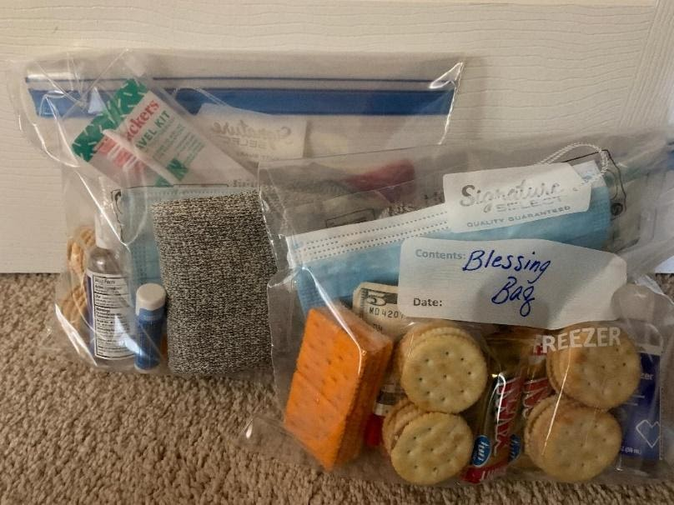

Personal:
- Warm socks
- Gloves
- Hat – warm knit or baseball
Toiletries (travel sizes work great)
- Toothbrush/paste/floss
- Deodorant
- Lip balm
- Hand sanitizer
- Face masks (individual/sealed)
- Comb/brush
Snacks:
- Beef sticks
- Crackers
- Chips
- Granola bars
- Energy bars
- Trail mix
- Raisins
- Bottle of water
Other:
- Card/note of encouragement
- Drawing from a child
- Small value gift card or small amount of cash
- Prepaid phone card

Keep a bag or two in your car. Pass out your bags when you see people on the street (be smart and safe when doing so as it is often at intersections). Look the recipient in the eye and smile. And remember, “We are blessed to be a blessing!” Let’s be the church that gives out Blessing Bags! We bear the fruit of God’s love in many ways. Here are two ideas. What might you think of? Let us know. 630 469-9149.

