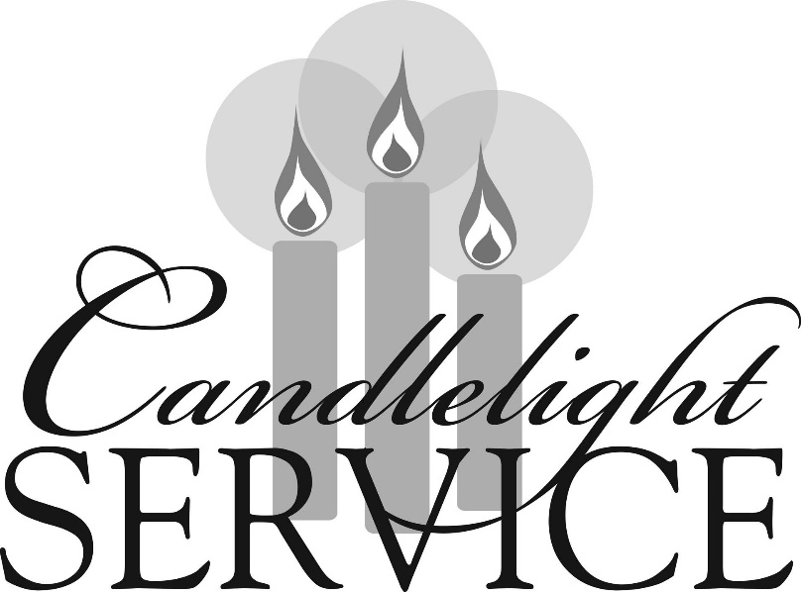

Southminster Presbyterian Church
Christmas Eve
December 24, 2021
6:30 p.m.

Find the link for the service on one of these sites:
1) our Facebook page: https://www.facebook.com/SouthminsterGlenEllyn/
2) our web site: https://www.southminsterpc.org/worship-videos
3) our YouTube channel:
https://www.youtube.com/channel/UCPgWICngOvkmR1OXgCG_wiA/videos

If the video feed is interrupted during the service, we will continue to record and then post the full video on Facebook and our web site as soon as possible.

1 Gathering Music: Trumpet and Piano Christmas Medley
2 Words of Welcome
3 Introit: O Holy Night
4 Call to Worship (Isaiah 9:6-7)
Leader: Unto us a Child is born, unto us a Son is given:
and the government shall be upon His shoulder.
People: And His name shall be called Wonderful Counselor,
Mighty God, Everlasting Father, Prince of Peace.
5 Opening Prayer: (unison)
O Emmanuel, you are our king and judge, the one whom the peoples await
and their Savior. O come and save us, Lord, our God. Amen.

6 Scripture Reading: Isaiah 9:2-7
7 Lighting of the Christ Candle Craig and Sarah Allen
Leader: We light these candles as a sign of the coming of Christ.
Advent means coming. We are preparing ourselves for the days
when the people who walked in darkness have seen a great light;
those who lived in a land of deep darkness, on them the light has shined.
People: Let us walk in the light of the Lord.

8 Carol 133: O Come, All Ye Faithful (verse 1)
O come, all ye faithful, joyful and triumphant;
O come ye, O come ye to Bethlehem!
Come, and behold him, born the King of angels!
O come, let us adore him; O come, let us adore him;
O come, let us adore him, Christ the Lord!

Public domain

9 Scripture Reading: Isaiah 11:1-6
10 Carol 129: Lo, How a Rose E’er Blooming (verse 1)
Lo, how a rose e’re blooming from tender stem hath sprung,
Of Jesse’s lineage coming, by faithful prophets sung.
It came, a floweret bright, amid the cold of winter,
When half spent was the night.

Public domain

11 Scripture Reading: Micah 5:2-5a
12 Carol 121: O Little Town of Bethlehem (verses 1, 4)
O little town of Bethlehem, how still we see thee lie!
Above the deep and dreamless sleep the silent stars go by.
Yet in thy dark street shineth the everlasting light;
The hopes and fears of all the years are met in thee tonight.
O holy child of Bethlehem, descend to us, we pray;
Cast out our sin and enter in, be born in us today.
We hear the Christmas angels the great glad tidings tell;
O come to us, abide with us, our Lord Emmanuel.

Public domain

13 Scripture Reading: Luke 2:1-7
14 Carol 119: Hark! The Herald Angels Sing (verses 1-3)
Hark! The herald angels sing, “Glory to the newborn king.
Peace on earth and mercy mild, God and sinners reconciled!”
Joyful, all ye nations, rise; join the triumph of the skies;
With angelic host proclaim, “Christ is born in Bethlehem!”
Hark! The herald angels sing, “Glory to the newborn king.”
Christ, by highest heaven adored, Christ the everlasting Lord,
Late in time behold him come, offspring of the virgin’s womb.
Veiled in flesh the Godhead see; hail the incarnate deity,
Pleased in flesh with us to dwell, Jesus, our Emmanuel.
Hark! The herald angels sing, “Glory to the newborn king.”
Hail the heaven-born Prince of Peace! Hail the sun of righteousness!
Light and life to all he brings, risen with healing in his wings.
Mild he lays his glory by, born that we no more may die,
Born to raise us from the earth, born to give us second birth.
Hark! The herald angels sing, “Glory to the newborn king.”

Public domain

15 Scripture Reading: Luke 2:8-20
16 Carol 136: Go, Tell It on the Mountain (verse 1)
Chorus
Go, tell it on the mountain, over the hills and ev'rywhere;
Go, tell it on the mountain that Jesus Christ is born!

Verse 1
While shepherds kept their watching o'er silent flocks by night,
Behold, throughout the heavens there shone a holy light.

Chorus
Go, tell it on the mountain, over the hills and ev'rywhere;
Go, tell it on the mountain that Jesus Christ is born!

Public domain

17 Meditation: “Light of the World”
Christmas Offering (see last page)
18 Offertory Anthem: Of the Father’s Love Begotten

19 Offering Response 145: What Child Is This (verse 3)
So bring him incense, gold, and myrrh;
Come, one and all, to own him.
The King of kings salvation brings;
Let loving hearts enthrone him.
Raise, raise the song on high.
The virgin sings her lullaby.
Joy, joy, for Christ is born,
The babe, the son of Mary!

Public domain

[Please stand in body or in spirit as we begin to sing.]
20 Lighting of the Candles
[The candle lighters will light the candle of the worshiper in the seat nearest the aisle. No lit candles should be dipped – dip only the unlit candle. During the candle lighting the lights in the sanctuary will be off. Extinguish your candle with the communion cup that is in the pew when the lights are turned on following the Benediction.]

21 Carol: Bring a Torch, Jeanette Isabella (tune: Hymnal 110)
Bring a torch, Jeannette Isabella,
Bring a torch, to the stable run!
It is Jesus good folk of the village;
Jesus is born, and Mary's calling,
Ah! Ah! Beautiful is the mother;
Ah! Ah! Beautiful is her son.

Public domain

[Ushers, please lower lights.]

22 Scripture Reading: John 1:1-18

23 Carol 122: Silent Night, Holy Night!
Silent Night! Holy Night! All is calm, all is bright
‘Round yon Virgin mother and child! Holy Infant, so tender and mild,
Sleep in heavenly peace, Sleep in heavenly peace.
Silent Night! Holy Night! Shepherds quake at the sight,
Glories stream from heaven afar, heavenly hosts sing “Alleluia;
Christ the Savior is born, Christ the Savior is born!”
Silent Night! Holy Night! Son of God, love's pure light
Radiant beams from thy holy face, with the dawn of redeeming grace,
Jesus, Lord, at thy birth, Jesus, Lord, at thy birth.
Silent Night! Holy Night! Wondrous star, lend thy light;
With the angels let us sing, Alleluia to our King;
Christ the Savior is born, Christ the Savior is born.

Public domain

24 Christmas Prayer: (unison)
O God, as you came in the stillness of the night, be born in our lives this night. Overcome darkness with the light of Christ’s presence, so that we may clearly see
the way to walk, the truth to speak, and the life to live, in the name of Jesus Christ,
our Lord and Savior. Amen.

25 Carol 134: Joy to the World!
Joy to the world! the Lord is come:
Let earth receive her king;
Let every heart prepare him room,
And heaven and nature sing,
And heaven and nature sing,
And heaven, and heaven and nature sing.
Joy to the world! the Savior reigns;
Let all their songs employ;
While fields and floods, rocks hills, and plains
Repeat the sounding joy,
Repeat the sounding joy,
Repeat, repeat the sounding joy.
No more let sins and sorrows grow,
Nor thorns infest the ground;
He comes to make his blessings flow
Far as the curse is found,
Far as the curse is found,
Far as, far as the curse is found.
He rules the world with truth and grace,
And makes the nations prove
The glories of his righteousness
And wonders of his love,
And wonders of his love,
And wonders, wonders of his love.

Public domain

26 Benediction
[Please raise lights after candles are extinguished.]

27 Postlude

Participants and Technical Crew
Rev. Wendy Boden
Liturgist: Blair Nelson
Christ candle lighters: Craig and Sarah Allen
Musicians: Tom Anderson; David Kozich, trumpet; Linda Wolf Jeziorski: Paul Jeziorski;
Lynn Ferino; Tim Archbold, cello; the Southminster singers
Worship Associate: David Kozich
Tech support: Ron Birchall, Steve Henkels, Chris Kozich, Blair Nelson

The poinsettias were given by the following people:
Craig and Sarah Allen Sue Knisely
Sue and Mike Ashpole Caroline and Ralph Linde
The Boden-Nelson family Lanny Russell
Sue and Walt Briney Angela Smith
Lynn Ferino Diane Swiss
Gretchen Fleming Barb Zink

Blessed Christmas!

You are invited to join us on Facebook (https://www.facebook.com/SouthminsterGlenEllyn/), where we have a live sharing of “Heart to Heart” Tuesday-Friday at 4:16 p.m. Wendy will host “Heart to Heart” through Wednesday, December 29, then take some time away. Regular “Heart to Heart” scheduling resumes Tuesday, January 11.
We’re also live on Sunday morning for worship at 9:30 a.m.
Find us at https://www.facebook.com/SouthminsterGlenEllyn/
You can also find links to recordings of the weekday sessions and Sunday services posted on our web site: https://www.southminsterpc.org/worship-videos or by going to our YouTube channel:
https://www.youtube.com/channel/UCPgWICngOvkmR1OXgCG_wiA/videos
 Tonight’s Offering supports the Southminster Mission Budget. 75% of monies go right into the Mission Budget and 25% to our special 2021 designee, Bridge Communities. Place your offering in the envelopes labeled “Southminster Local Mission” that you received in the mail. It is amazing what your love and gifts can do! Every gift makes a difference!
We are also receiving the Christmas Joy Offering, supporting education, leadership development, and assistance to church workers. Those envelopes were also sent by mail. Please give generously.
If you did not receive these offering envelopes and would like to contribute to either offering, mail or drop off a check to Southminster with “Christmas Joy” or “Local Mission” written on the memo line. If you want this contribution to be listed on your 2021 year-end statement, it needs to be received by 11:00 a.m. on January 4s.

 2022 Offering Envelopes are available inside the front entrance. You may pick up your own, and if there are some you could deliver (for family members, friends, or neighbors), get theirs, too. If you would like envelopes but there is no box prepared for you, please let the church office know.

Remember that we love God and neighbor. Our address is 680 South Park Blvd., Glen Ellyn, IL 60137 if you would like to set up an online account with your bank or mail in your pledge.

Grace and peace to you!

