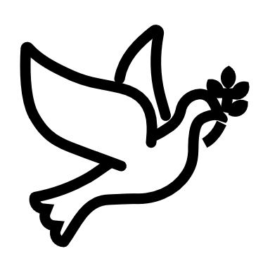

We listen | We pass the peace | We read along | We give our offering of time, talent and treasure | We stand | We sing if we are at home | We pray | We respond | We participate  in the Word  with Children
(Kids – use your worship packet and the tools listed at the end of the bulletin to do all these things.)

Southminster Presbyterian Church
6th Sunday of Easter or the 115th Sunday of Covid
May 22, 2022
9:30 a.m.

Find the link for the service on one of these sites:
1) our Facebook page: https://www.facebook.com/SouthminsterGlenEllyn/
2) our web site: https://www.southminsterpc.org/worship-videos
3) our YouTube channel:
https://www.youtube.com/channel/UCPgWICngOvkmR1OXgCG_wiA/videos

If the video feed is interrupted during the service, we will continue to record and then post the full video on Facebook and our web site as soon as possible.

1 Gathering Music: Shall Tribulation or Distress;
Let Us with a Gladsome Mind (Psalm 136);
We Give Thanks unto You (Your Love Is Never Ending – Psalm 136);
Where Charity and Love Prevail

Our slideshow today is “Beautiful British Columbia (Blair Nelson’s home province).”

2 Welcome and Announcements
3 Improvisational Prelude
4 Lighting the Candles (2 Corinthians 5:17)
So if anyone is in Christ, there is a new creation;
everything old has passed away; see, everything has become new!

5 Call to Worship
Leader: Give thanks to the Lord, for he is good! His love endures forever!
People: Give thanks to the Lord of lords! His love endures forever!
All: We worship God, whose love endures forever!

6 Hymn: Grace Alone (all) p. 14, blue supplement

7 Prayer of Confession: (inspired by Rev. Beth Merrill Neel)
Lord God, your love endures forever, and we cherish that gift, most of the time. We sometimes forget the great commitment of faith. We own that sometimes we are angry at the slightest insult and imagine recompense upon those who have wronged us. Forgive us and wrap us in your grace. Empower us through your Holy Spirit to welcome the new creation that is within each of us. We ask this in the name of Jesus Christ, who is both savior and Lord. Amen.

(Time of silence for personal prayer and confession)

8 Declaration of the Grace of God/Assurance of Pardon (Romans 8:33-34)
Leader: Hear the good news! Who is in a position to condemn?
People: Only Christ, and Christ died for us,
Leader: Christ rose for us; Christ reigns in power for us,
People: Christ intercedes for us.
All: In Jesus Christ we are forgiven! Alleluia!

9 Response 240: Alleluia, Alleluia! Give Thanks (verse 1)
10 The Passing of the Peace

11 Word with Children Deb Bohi
Children worshiping in the sanctuary, please come forward.

11a Jesus Loves Me
12 Prayer for Illumination
13 Scripture Lessons
First Lesson: Psalm 136:1-9, 26 Pew Bible, p. 576 (O.T.)
Gospel Lesson: John 13:31-35 Pew Bible, p. 108 (N.T.)
14 Sermon: “What’s Love Got to Do with It?” Rev. Grayson Van Camp

Children, as you listen to the sermon, you may want to choose an activity
from the children’s packet that will help you think about what you hear in the sermon.
Children present in worship may choose to go to Kids’ Corner with Miss Blair.

15 Saying What We Believe/Affirmation of Faith (unison)
from A Brief Statement of Faith (PCUSA)
With believers in every time and place, we rejoice that nothing in life or in death can separate us from the love of God in Christ Jesus our Lord. Glory be to the Father, and to the Son, and to the Holy Spirit. Amen.
16 Hymn 301: Let Us Build a House (All Are Welcome) (all verses)

17 Prayers of the People and the Lord’s Prayer
Leader: Lord, in your mercy,
People: hear our prayers.
The Lord’s Prayer:
Our Father who art in heaven, hallowed be thy name. Thy kingdom come,
thy will be done, on earth as it is in heaven. Give us this day our daily bread;
and forgive us our debts, as we forgive our debtors; and lead us not into
temptation, but deliver us from evil. For thine is the kingdom and the power
and the glory, forever. Amen.

Children, draw or write something you would like to say to God in prayer this morning.
If you want to share it with the church, you may also leave a message
on the church phone line.

Offering of Ourselves and Our Gifts
18 Offertory Anthem: Lamb of God Twila Paris, arr. Lloyd Larson

19 *Doxology Hymnal #606
Praise God, from whom all blessings flow;
Praise Him all creatures here below;
Praise Him above, ye heavenly host;
Praise Father, Son, and Holy Ghost. Amen.

Public domain

20 Prayer of Thanksgiving and Dedication
21 Hymn 39: Great Is Thy Faithfulness (all)

22 Charge and Benediction
Leader: Now go and serve the Lord,
People: For we are blessed to be a blessing!
Leader: The cross, All: We shall take it.
Leader: The bread, All: We shall break it.
Leader: The pain, All: We shall bear it.
Leader: The joy, All: We shall share it.
Leader: The Gospel, All: We shall live it.
Leader: The love, All: We shall give it.
Leader: The light, All: We shall cherish it.
Leader: The darkness, All: God shall perish it.
Leader: For the Lord is risen! All: He is risen, indeed! Alleluia!

23 Postlude

Participants and Technical Crew
Guest preacher: Rev. Grayson Van Camp
Liturgist: Sarah Allen
Deacon at the Door: Steve Sanders
Musicians: Tom Anderson, Southminster choir
Worship Associate: David Kozich
Tech support: Ron Birchall, Chris Kozich

Flowers today are given by Jim and Tricia Smith in remembrance of Jim’s mom, Eleanor.
Good Morning to our Children:

To complete all the activities in this worship folder you will need:
- ears to hear
- a mouth to sing
- hands to fold
- eyes to read
- a brain to think
- a worship kit including:
  - something to color with – crayons, markers or colored pencils
  - something to write with, like a pen or pencil
  - something to write on, like a table or a clipboard
  - scissors and tape
If you would like a worship kit for your child, please contact Pastor Wendy (wendy@southminsterpc.org) and one will come to you!

A Guide to Our Worship Symbols

We listen: “Basically, the sermon is God’s dynamic, eternal Word spoken to us in such a way that we might hear what God has to say to us and be encouraged to follow the Lord
in faith.

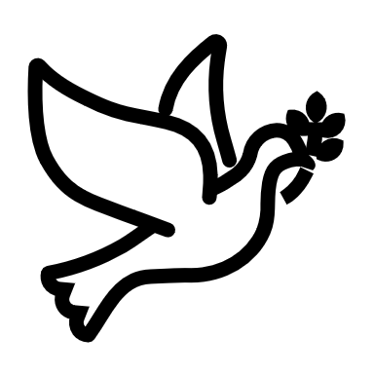 | We pass the peace: “…We greet one another with the peace of Christ as common forgiven sinners. As we are forgiven, so we forgive. This is also a good time to reconcile with those family members who drove us crazy trying to get to church on time, church members with whom we have tensions, or people we're not so happy to see.”
 | We read along: “God’s Word comes to us in many ways—through scripture, special music, sermons. Listen for God's eternal Word addressing you with good news about the Lord’s love for you and all people.”
 | We give our offering of time, talent, and treasure: “This is the time when we give ourselves, all that we are, and all that we have, to God’s service. As a symbol of what is of value to us, we make an offering… to promote the gospel.”
 | We stand: “We stand as a way of saying, “This is where I stand,” and as a way of standing in continuity with the people of God of ages past…”
 | We sing: “…We sing praise with hearts and minds (even if that's a little out of tune), just enjoying God for who God is. As we open up the pathways of breath to sing praise, we make space for the Spirit breath to fill us.” Even if we simply listen and read the words, we are praising God.
 | We pray: The first thing we do is pray—for our world, the church, other people, and ourselves. The prayer is our prayer as a church. One person may pray for us, but we are all praying together as one in our hearts, continuing Christ’s ministry of prayer for the world.”
 | We respond: Responding by writing or drawing helps us remember what we are hearing and is a chance to express our beliefs.

We participate in the Word with Children: It is called the Word WITH Children because the whole church is invited to listen with the fresh, faith-filled ears of children to the proclaimed message.

Quotations for our Worship Symbols Guide are taken from Our Order of Worship by Teresa Lockhart Stricklen, Associate for Worship, Presbyterian Church (USA), found at https://www.pcusa.org/site_media/media/uploads/theologyandworship/pdfs/order_of_worship_brochure_dec_2008.pdf. Edited.

