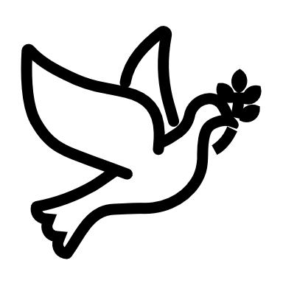

We listen | We pass the peace | We read along | We give our offering of time, talent and treasure | We stand | We sing if we are at home | We pray | We respond | We participate  in the Word  with Children
(Kids – use your worship packet and the tools listed at the end of the bulletin to do all these things.)

Southminster Presbyterian Church
10th Sunday after Pentecost
August 14, 2022
9:30 a.m.

Find the link for the service on one of these sites:
1) our Facebook page: https://www.facebook.com/SouthminsterGlenEllyn/
2) our web site: https://www.southminsterpc.org/worship-videos
3) our YouTube channel:
https://www.youtube.com/channel/UCPgWICngOvkmR1OXgCG_wiA/videos

If the video feed is interrupted during the service, we will continue to record and then post the full video on Facebook and our web site as soon as possible.

1 Gathering Music: Lord, Who May Dwell Within Your House;
We Are Your People; In Christ There Is No East or West
Our PowerPoint today is “Back to School.”

2 Welcome and Announcements
3 Prelude
4 Lighting the Candles (Romans 15:13)
May the God of hope fill you with all joy and peace in believing,
so that you may abound in hope by the power of the Holy Spirit.

5 Call to Worship
Leader: Welcome to this place of grace and love.
People: Welcome to this place of hope.
Leader: God invites us to welcome everyone, just as they are.
People: We are welcomed just as we are.
All: We are loved and grateful. In all of this we worship God.

6 Hymn 401: Here in This Place (Gather Us In) (verses 1, 2)
7 Prayer of Confession:
Gracious and loving God, we confess that we fear what is different from us. We find it is easier for us to turn away from those who do not look like us, act like us, think like us, or vote like us. Even so, we recognize that you ask us to love the stranger and see beyond what we may fear. Through your Holy Spirit alive within us, help us to love as you have called us to love. In the name of Jesus Christ, we pray. Amen.

(Time of silence for personal prayer and confession)

8 Declaration of the Grace of God/Assurance of Pardon (Titus 3:4-6, edited)
Leader: Through the loving kindness of God our Savior, we are saved,
People: Not by our righteousness, but by God’s mercy.
Leader: The Holy Spirit has been poured on us through Jesus Christ.
People: We are forgiven!
All: Thanks be to God.

9 Response 288: Spirit of the Living God (sing 2 times)
Spirit of the living God, fall afresh on me.
Spirit of the living God, fall afresh on me.
Melt me; mold me; fill me; use me.
Spirit of the living God, fall afresh on me.

CCLI Song # 23488
Daniel Iverson
© Words: 1935. Renewed 1963 Birdwing Music (Admin. by Capitol CMG Publishing)
Music: 1935. Renewed 1963 Birdwing Music (Admin. by Capitol CMG Publishing)
For use solely with the SongSelect® All rights reserved.
CCLI License # 21214429
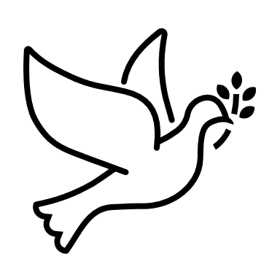
10 The Passing of the Peace

11 Word with Children: Blessing of Backpacks and Lunch Boxes Blair Baldwin

Congregational Prayer (unison)
Dear God, school begins this Wednesday. Help us to do our very best this year. Even when we don’t, help us to know you love us still, and nothing can separate us from you and your love. Bless not only us, but our teachers and friends, both old and new. In Jesus’ name, amen.

11a Jesus Loves Me
Jesus loves me! This I know,
For the Bible tells me so.
Little ones to him belong.
They are weak, but he is strong.
Yes, Jesus loves me! Yes, Jesus loves me!
Yes, Jesus loves me! The Bible tells me so.

Public domain
12 Prayer for Illumination
13 Scripture Lessons: Isaiah 56:1, 6-8 Pew Bible, p. 686 (O.T.)
Matthew 21:1-13 Pew Bible, p. 23 (N.T.)
14 Sermon: “When Warm Welcomes Lead to Overturned Tables” Rev. Keith Draper

Children, as you listen to the sermon, you may want to choose an activity
from the children’s packet that will help you think about what you hear in the sermon.
Children present in worship may choose to go to Kids’ Corner.

15 Saying What We Believe/Affirmation of Faith (unison)
from A Brief Statement of Faith (PCUSA)
In life and in death we belong to God. Through the grace of our Lord Jesus Christ, the love of God, and the communion of the Holy Spirit, we trust in the one triune God, the Holy One of Israel, whom alone we worship and serve.

16 Hymn 301: Let Us Build a House (All Are Welcome) (verses 1, 4, 5)

17 Prayers of the People and the Lord’s Prayer
Leader: Lord, in your mercy,
People: hear our prayers.
The Lord’s Prayer:
Our Father who art in heaven, hallowed be thy name. Thy kingdom come,
thy will be done, on earth as it is in heaven. Give us this day our daily bread;
and forgive us our debts, as we forgive our debtors; and lead us not into
temptation, but deliver us from evil. For thine is the kingdom and the power
and the glory, forever. Amen.

Children, draw or write something you would like to say to God in prayer this morning.
If you want to share it with the church, you may also leave a message
on the church phone line.

Offering of Ourselves and Our Gifts
18 Offertory: Lord, I Hope This Day Is Good Don Williams

19 *Doxology Hymnal #606
Praise God, from whom all blessings flow;
Praise Him all creatures here below;
Praise Him above, ye heavenly host;
Praise Father, Son, and Holy Ghost. Amen.

Public domain

20 Prayer of Thanksgiving and Dedication
21 Hymn 435: There’s a Wideness in God’s Mercy (both verses)

22 Charge and Benediction (2 Timothy 1:14)
Leader: Guard the good treasure entrusted to you.
People: We will with the help of the Holy Spirit living in us.
Leader: Now go and serve the Lord,
All: For we are blessed to be a blessing!
Alleluia, amen!
23 Postlude

Participants and Technical Crew
Guest preacher: Rev. Keith Draper
Liturgist/Worship Host: Terry Kline
Deacon at the Door: Angela Smith
Musicians: Tom Anderson, Ron Birchall, Paul Jeziorski, Southminster choir
Worship Associate: David Kozich
Tech support: Chris Kozich, Alec Parks

Flowers today are given by the Boden-Nelsons – happy anniversary to Wendy and Blair.

Good Morning to our Children:

To complete all the activities in this worship folder you will need:
- ears to hear
- a mouth to sing
- hands to fold
- eyes to read
- a brain to think
- a worship kit including:
  - something to color with – crayons, markers or colored pencils
  - something to write with, like a pen or pencil
  - something to write on, like a table or a clipboard
  - scissors and tape
If you would like a worship kit for your child, please contact Pastor Wendy (wendy@southminsterpc.org) and one will come to you!

A Guide to Our Worship Symbols

We listen: “Basically, the sermon is God’s dynamic, eternal Word spoken to us in such a way that we might hear what God has to say to us and be encouraged to follow the Lord
in faith.

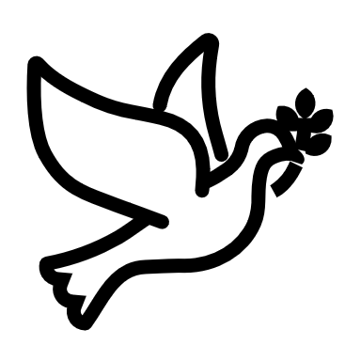 | We pass the peace: “…We greet one another with the peace of Christ as common forgiven sinners. As we are forgiven, so we forgive. This is also a good time to reconcile with those family members who drove us crazy trying to get to church on time, church members with whom we have tensions, or people we're not so happy to see.”
 | We read along: “God’s Word comes to us in many ways—through scripture, special music, sermons. Listen for God's eternal Word addressing you with good news about the Lord’s love for you and all people.”
 | We give our offering of time, talent, and treasure: “This is the time when we give ourselves, all that we are, and all that we have, to God’s service. As a symbol of what is of value to us, we make an offering… to promote the gospel.”

We stand: “We stand as a way of saying, “This is where I stand,” and as a way of standing in continuity with the people of God of ages past…”

We sing: “…We sing praise with hearts and minds (even if that's a little out of tune), just enjoying God for who God is. As we open up the pathways of breath to sing praise, we make space for the Spirit breath to fill us.” Even if we simply listen and read the words, we are praising God.

We pray: The first thing we do is pray—for our world, the church, other people, and ourselves. The prayer is our prayer as a church. One person may pray for us, but we are all praying together as one in our hearts, continuing Christ’s ministry of prayer for the world.”

We respond: Responding by writing or drawing helps us remember what we are hearing and is a chance to express our beliefs.

We participate in the Word with Children: It is called the Word WITH Children because the whole church is invited to listen with the fresh, faith-filled ears of children to the proclaimed message.

Quotations for our Worship Symbols Guide are taken from Our Order of Worship by Teresa Lockhart Stricklen, Associate for Worship, Presbyterian Church (USA), found at https://www.pcusa.org/site_media/media/uploads/theologyandworship/pdfs/order_of_worship_brochure_dec_2008.pdf. Edited.

