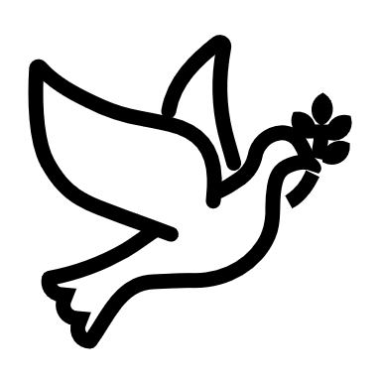

We listen | We pass the peace | We read along | We give our offering of time, talent and treasure | We stand | We sing if we are at home | We pray | We respond | We participate  in the Word  with Children
(Kids – use your worship packet and the tools listed at the end of the bulletin to do all these things.)

Southminster Presbyterian Church
Christ the King Sunday
November 20, 2022
9:30 a.m.

Find the link for the service on one of these sites:
1) our Facebook page: https://www.facebook.com/SouthminsterGlenEllyn/
2) our web site: https://www.southminsterpc.org/worship-videos
3) our YouTube channel:
https://www.youtube.com/channel/UCPgWICngOvkmR1OXgCG_wiA/videos

If the video feed is interrupted during the service, we will continue to record and then post the full video on Facebook and our web site as soon as possible.

1 Gathering Music: Peoples, Clap Your Hands!; O Come and Sing Unto the Lord;
Psalm 103; I Will Give Thanks with My Whole Heart;
Give to Me, Lord, a Thankful Heart; For the Fruit of All Creation

Our Photo Story today is “Fall Beauty.”

2a Welcome and Announcements
3 Prelude
4 Lighting the Candles (Romans 5:5)
God’s love has been poured into our hearts through the gift
of the Holy Spirit.

5 Call to Worship (Psalm 100)
Leader: Make a joyful noise to the Lord.
People: Let us worship the Lord with gladness and singing.
All: We enter your gates with thanksgiving and your courts with praise.

6a Hymn 367: Come, Ye Thankful People, Come (verses 1, 2)

6b Hymn 368: We Fall Down

6c Hymn: Bless the Lord (10,000 Reasons) (verses 1, 2) pg. 6, blue supplement

7 Prayer of Confession: (unison)
Lord of All and Eternal King, your faithfulness and love endure forever; even so our gratitude can be small. For failing to see and acknowledge your blessings, please forgive us. Open our eyes to see all that your hand has provided. It is with grateful hearts that we pray. In the name of Jesus Christ, our Lord and Savior, we pray. Amen.

(Time of silence for personal prayer and confession)

8 The Good News of Jesus Christ (Psalm 103:8-12)
Leader: The Lord is compassionate and gracious, slow to anger,
abounding in love.
People: For as high as the heavens are above the earth,
Leader: So great is his love for those who fear him;
People: As far as the east is from the west,
so far has he removed our transgressions from us.
All: In the name of Jesus Christ, we are forgiven.

9 Response 581: Glory Be to the Father (Gloria Patri)
Glory be to the Father, and to the Son, and to the Holy Ghost;
As it was in the beginning, is now and ever shall be,
World without end. Amen, amen.

Public domain
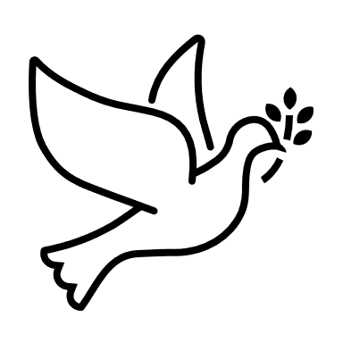
10 The Passing of the Peace
11a Word with Children: The Thank Offering Caroline Linde
Children worshiping in the sanctuary, please come forward.

People will sing as they come forward:

11b Hymn 647: Give Thanks
Give thanks with a grateful heart;
Give thanks to the Holy One,
Give thanks because we’re given
Jesus Christ, the Son.
Give thanks with a grateful heart;
Give thanks to the Holy One,
Give thanks because we’re given
Jesus Christ, the Son.
And now let the weak say, “We are strong”;
Let the poor say, “We are rich
Because of what the Lord has done for us!”
And now let the weak say, “We are strong”;
Let the poor say, “We are rich
Because of what the Lord has done for us!”
Give thanks. Give thanks.

CCLI Song # 20285
Henry Smith
© 1978 Integrity's Hosanna! Music (Admin. by Integrity Music)
For use solely with the SongSelect® Terms of Use. All rights reserved. www.ccli.com
CCLI License # 21214429

11c Give Thanks (sing twice)
Give thanks with a grateful heart;
Give thanks to the Holy One,
Give thanks because we’re given
Jesus Christ, the Son.

12 Prayer for Illumination
13 Scripture Lessons: James 5:13-20 Pew Bible, p. 231, (N.T.)
Esther 4:1-17 Pew Bible, p. 446 (O.T.)
14 Sermon: “Be in the Moment”

Children, as you listen to the sermon, you may want to choose an activity
from the children’s packet that will help you think about what you hear in the sermon.
Children present in worship may choose to go to Kids’ Corner with Miss Blair.
15 Hymn 336: We Gather Together (verses 1, 2)

16 Hymn 37: Let All Things Now Living (verse 1)

17 Prayers of the People and the Lord’s Prayer
Leader: Lord, in your mercy,
People: hear our prayers.
The Lord’s Prayer:
Our Father who art in heaven, hallowed be thy name. Thy kingdom come,
thy will be done, on earth as it is in heaven. Give us this day our daily bread;
and forgive us our debts, as we forgive our debtors; and lead us not into
temptation, but deliver us from evil. For thine is the kingdom and the power
and the glory, forever. Amen.

Children, draw or write something you would like to say to God in prayer this morning.
If you want to share it with the church, you may also leave a message
on the church phone line.

Offering of Ourselves and Our Gifts
[The offering plate is at the back of the sanctuary. Please leave your gift or pledge
in the plate on your way into or out of worship.]

18 Offertory: The Great Pumpkin Waltz Vince Guaraldi

19 Response: For the Beauty of the Earth Hymnal #14, verse 5
For thyself, best gift divine
To the world so freely given;
For that great, great love of thine,
Peace on earth and joy in heaven:
Lord of all, to thee we raise
This our hymn of grateful praise.

Public domain

20 Prayer of Thanksgiving and Dedication

21 Hymn 643: Now Thank We All Our God (all 3 verses)

22 Charge and Benediction
Leader: Now go and serve the Lord,
All: For we are blessed to be a blessing!
Alleluia, amen!

23 Postlude

Participants and Technical Crew
Pastor Wendy Boden
Liturgist: Sarah Allen
Deacon Greeter/Fellowship: Barb Kocinski, with all deacons hosting pie fellowship
Musicians: Tom Anderson, David Kozich, Southminster Choir
Word with Children: Blair Baldwin
Worship Associate: David Kozich
Tech support: Chris Kozich, Daniel Kozich, Blair Nelson

Flowers today are from Tricia and Jim Smith in memory of Tricia’s mother, Mary Jackson.

Good Morning to our Children:

To complete all the activities in this worship folder you will need:
- ears to hear
- a mouth to sing
- hands to fold
- eyes to read
- a brain to think
- a worship kit including:
  - something to color with – crayons, markers or colored pencils
  - something to write with, like a pen or pencil
  - something to write on, like a table or a clipboard
  - scissors and tape
If you would like a worship kit for your child, please contact Pastor Wendy (wendy@southminsterpc.org) and one will come to you!

A Guide to Our Worship Symbols

We listen: “Basically, the sermon is God’s dynamic, eternal Word spoken to us in such a way that we might hear what God has to say to us and be encouraged to follow the Lord
in faith.

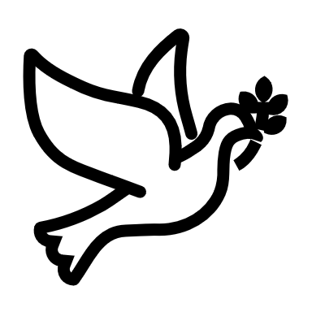 | We pass the peace: “…We greet one another with the peace of Christ as common forgiven sinners. As we are forgiven, so we forgive. This is also a good time to reconcile with those family members who drove us crazy trying to get to church on time, church members with whom we have tensions, or people we're not so happy to see.”
 | We read along: “God’s Word comes to us in many ways—through scripture, special music, sermons. Listen for God's eternal Word addressing you with good news about the Lord’s love for you and all people.”
 | We give our offering of time, talent, and treasure: “This is the time when we give ourselves, all that we are, and all that we have, to God’s service. As a symbol of what is of value to us, we make an offering… to promote the gospel.”
 | We stand: “We stand as a way of saying, “This is where I stand,” and as a way of standing in continuity with the people of God of ages past…”
 | We sing: “…We sing praise with hearts and minds (even if that's a little out of tune), just enjoying God for who God is. As we open up the pathways of breath to sing praise, we make space for the Spirit breath to fill us.” Even if we simply listen and read the words, we are praising God.
 | We pray: The first thing we do is pray—for our world, the church, other people, and ourselves. The prayer is our prayer as a church. One person may pray for us, but we are all praying together as one in our hearts, continuing Christ’s ministry of prayer for the world.”
 | We respond: Responding by writing or drawing helps us remember what we are hearing and is a chance to express our beliefs.
 | We participate in the Word with Children: It is called the Word WITH Children because the whole church is invited to listen with the fresh, faith-filled ears of children to the proclaimed message.

Quotations for our Worship Symbols Guide are taken from Our Order of Worship by Teresa Lockhart Stricklen, Associate for Worship, Presbyterian Church (USA), found at https://www.pcusa.org/site_media/media/uploads/theologyandworship/pdfs/order_of_worship_brochure_dec_2008.pdf. Edited.

