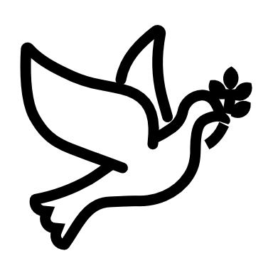

We listen | We pass the peace | We read along | We give our offering of time, talent and treasure | We stand | We sing if we are at home | We pray | We respond | We participate  in the Word  with Children
(Kids – use your worship packet and the tools listed at the end of the bulletin to do all these things.)

Southminster Presbyterian Church
3rd Sunday of Advent
December 11, 2022
9:30 a.m.

Find the link for the service on one of these sites:
1) our Facebook page: https://www.facebook.com/SouthminsterGlenEllyn/
2) our web site: https://www.southminsterpc.org/worship-videos
3) our YouTube channel:
https://www.youtube.com/channel/UCPgWICngOvkmR1OXgCG_wiA/videos

If the video feed is interrupted during the service, we will continue to record and then post the full video on Facebook and our web site as soon as possible.

1 Gathering Music: O Lord, How Shall I Meet You?;
Savior of the Nations, Come; The Angel Gabriel from Heaven Came

Our Photo Story today is “Christmas Lights.”

2 Welcome, Announcements, and Moment for Mission
3 Lighting the Advent Wreath (Isaiah 35:1)
Leader: As the Lord says, “The wilderness and the dry land shall be glad…”
All: We light these candles as a sign of the coming light of Christ.

4 Hymn 314: Longing for Light, We Wait in Darkness (verses 1, 4)
(Christ, Be Our Light)

5 Prelude

6 Call to Worship (Isaiah 35:1)
Leader: The wilderness and the dry land shall be glad;
the desert shall rejoice and blossom;
People: Like the crocus it shall blossom abundantly
and rejoice with joy and singing.
All: Let us walk in the light of the Lord.

7 Hymn: Shine on Us (all verses) pg. 36, blue supplement

8 Prayer of Confession: (unison)
God of the future, you are coming in power to bring all nations under your rule. We confess that we have not expected your kingdom. We accept lies as truth and refuse your justice and peace. In your mercy, forgive us and empower us by your Holy Spirit to seek things that will endure when Christ comes to judge the world. Amen.

(Time of silence for personal prayer and confession)

9 The Good News of Jesus Christ (Isaiah 40:4-5)
Leader: Every valley is lifted up; every mountain made low.
Now the glory of the Lord is revealed,
for the mouth of the Lord has spoken.
All: In the name of Jesus Christ, we are forgiven!
Thanks be to God.
10 Response 84: Creator of the Stars of Night (verse 1)
Creator of the stars of night,
Your people’s everlasting light,
O Christ, redeemer of us all,
We pray you, hear us when we call.
Amen.

Public domain
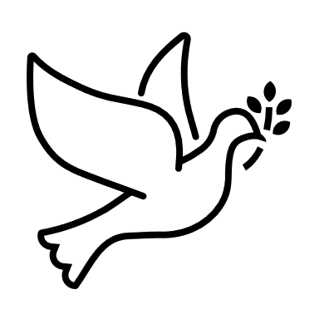
11 The Passing of the Peace
12a Word with Children Blair Baldwin
Children worshiping in the sanctuary, please come forward.

12b Jesus Loves Me
Jesus loves me! This I know,
For the Bible tells me so.
Little ones to him belong.
They are weak, but he is strong.
Yes, Jesus loves me! Yes, Jesus loves me!
Yes, Jesus loves me! The Bible tells me so.

Public domain

13 Prayer for Illumination
14 Scripture Lessons: Isaiah 35:1-7 Pew Bible, p. 663, (O.T.)
Isaiah 35:8-10 Pew Bible, p. 663 (O.T.)
15 Sermon: “On a Dark Desert Highway”

Children, as you listen to the sermon, you may want to choose an activity
from the children’s packet that will help you think about what you hear in the sermon.
Children present in worship may choose to go to Kids’ Corner with Miss Blair.

16 Singing What We Believe/Affirmation of Faith
Hymn 71: Surely It Is God Who Saves Me (all verses)

17 Prayers of the People and the Lord’s Prayer
Leader: Lord, in your mercy,
People: hear our prayers.
The Lord’s Prayer:
Our Father who art in heaven, hallowed be thy name. Thy kingdom come,
thy will be done, on earth as it is in heaven. Give us this day our daily bread;
and forgive us our debts, as we forgive our debtors; and lead us not into
temptation, but deliver us from evil. For thine is the kingdom and the power
and the glory, forever. Amen.

Children, draw or write something you would like to say to God in prayer this morning.
If you want to share it with the church, you may also leave a message
on the church phone line.

Offering of Ourselves and Our Gifts
[The offering plate is at the back of the sanctuary. Please leave your gift or pledge
in the plate on your way into or out of worship.]

18 Offertory: Safe Within Your Arms Mark Hayes

19 Response: Longing for Light, We Wait in Darkness Hymnal #314, verse 5
Many the gifts, many the people,
Many the hearts that yearn to belong.
Let us be servants to one another,
Making your kingdom come.
Christ, be our light! Shine in our hearts. Shine through the darkness.
Christ, be our light! Shine in your church gathered today.

Text and Music © 1993 Bernadette Farrell (Published by OCP)
Reprinted/Streamed with permission under OneLicense.net #A-739517. All rights reserved.

20 Prayer of Thanksgiving and Dedication

21a Hymn 87: Comfort, Comfort Now My People ( all verses)

21b Hymn 106: Prepare the Way, O Zion (all verses)

22 Charge and Benediction
Leader: Now go and serve the Lord,
All: For we are blessed to be a blessing!
Alleluia, amen!

23 Postlude

Participants and Technical Crew
Pastor Wendy Boden
Liturgist: Lynn Ferino
Greeter/Fellowship: Caroline Linde
Musicians: Tom Anderson, Victor King, Southminster Choir
Advent Wreath: the Birchalls
Word with Children: Blair Baldwin
Worship Associate: David Kozich
Tech support: Chris Kozich, Blair Nelson

Flowers today are from Sue Knisely in memory of her father, Howie Duell.

Good Morning to our Children:

To complete all the activities in this worship folder you will need:
- ears to hear
- a mouth to sing
- hands to fold
- eyes to read
- a brain to think
- a worship kit including:
  - something to color with – crayons, markers or colored pencils
  - something to write with, like a pen or pencil
  - something to write on, like a table or a clipboard
  - scissors and tape
If you would like a worship kit for your child, please contact Pastor Wendy (wendy@southminsterpc.org) and one will come to you!

A Guide to Our Worship Symbols

We listen: “Basically, the sermon is God’s dynamic, eternal Word spoken to us in such a way that we might hear what God has to say to us and be encouraged to follow the Lord
in faith.

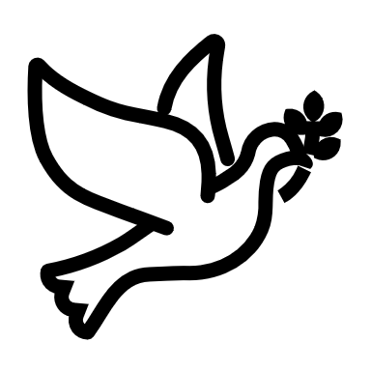 | We pass the peace: “…We greet one another with the peace of Christ as common forgiven sinners. As we are forgiven, so we forgive. This is also a good time to reconcile with those family members who drove us crazy trying to get to church on time, church members with whom we have tensions, or people we're not so happy to see.”
 | We read along: “God’s Word comes to us in many ways—through scripture, special music, sermons. Listen for God's eternal Word addressing you with good news about the Lord’s love for you and all people.”
 | We give our offering of time, talent, and treasure: “This is the time when we give ourselves, all that we are, and all that we have, to God’s service. As a symbol of what is of value to us, we make an offering… to promote the gospel.”
 | We stand: “We stand as a way of saying, “This is where I stand,” and as a way of standing in continuity with the people of God of ages past…”

We sing: “…We sing praise with hearts and minds (even if that's a little out of tune), just enjoying God for who God is. As we open up the pathways of breath to sing praise, we make space for the Spirit breath to fill us.” Even if we simply listen and read the words, we are praising God.

We pray: The first thing we do is pray—for our world, the church, other people, and ourselves. The prayer is our prayer as a church. One person may pray for us, but we are all praying together as one in our hearts, continuing Christ’s ministry of prayer for the world.”

We respond: Responding by writing or drawing helps us remember what we are hearing and is a chance to express our beliefs.

We participate in the Word with Children: It is called the Word WITH Children because the whole church is invited to listen with the fresh, faith-filled ears of children to the proclaimed message.

Quotations for our Worship Symbols Guide are taken from Our Order of Worship by Teresa Lockhart Stricklen, Associate for Worship, Presbyterian Church (USA), found at https://www.pcusa.org/site_media/media/uploads/theologyandworship/pdfs/order_of_worship_brochure_dec_2008.pdf. Edited.

