Southminster Presbyterian Church
Transfiguration of the Lord
February 19, 2023
9:30 a.m.

Find the link for the service on one of these sites:
1) on Facebook: https://www.facebook.com/SouthminsterGlenEllyn/
2) our YouTube channel:
https://www.youtube.com/channel/UCPgWICngOvkmR1OXgCG_wiA/live
3) our web site: https://www.southminsterpc.org/
If the video feed is interrupted during the service, we will continue to record and then post the full video on Facebook and our web site as soon as possible.

Gathering Music: Swiftly Pass the Clouds of Glory; Jesus on the Mountain Peak;
The Heavens Above Declare God's Praise; Christ, You Are the Fullness;
Arise, Your Light Has Come; Christ, Whose Glory Fills the Skies

Our Photo Story today is “Cuba.”

Welcome and Announcements
Prelude

Lighting the Candles (Matthew 11:28)
Come to me, all you who are weary and are carrying heavy burdens,
and I will give you rest.

Hymn 192: Lord, the Light of Your Love Is Shining (verse 1)
(Shine, Jesus, Shine)

Call to Worship (Matthew 17:1-2 5; 2 Corinthians 4:6)
Leader: On a high mountain, Jesus was transfigured.
People: God said, “This is my beloved Son.”
All: God’s glory shines in the face of Jesus Christ.

Hymn: Bring Forth the Kingdom (all)
The music for this song is on the last page of the bulletin.

Prayer of Confession: (unison)
Lord God, there are times when we have not welcomed the stranger, nor shared the good news with others. There are times when we have tried to hide rather than be your light in the world. Illumine our lives with the radiance of Christ’s love that we may love as Christ loves. We ask this in the name of Jesus Christ, who is both Savior and Lord. Amen.

(Time of silence for personal prayer and confession)

The Good News of Jesus Christ
Leader: For by grace you have been saved through faith,
and this is not your own doing; it is the gift of God.
People: It is not the result of works, so that no one may boast.
All: For we are what he has made us, created in Christ Jesus
for good works, which God prepared beforehand
so that we may walk in them.

Response 581: Glory Be to the Father (Gloria Patri)
Glory be to the Father, and to the Son, and to the Holy Ghost;
As it was in the beginning, is now and ever shall be,
World without end. Amen, amen.

Public domain

The Passing of the Peace

Word with Children Sarah Allen
Children worshiping in the sanctuary, please come forward.

Jesus Loves Me
Jesus loves me! This I know,
For the Bible tells me so.
Little ones to him belong.
They are weak, but he is strong.
Yes, Jesus loves me! Yes, Jesus loves me!
Yes, Jesus loves me! The Bible tells me so.

Public domain

Prayer for Illumination

Scripture Lessons: Matthew 17:1-8 Pew Bible, p. 18, (N.T.)

Sermon: “Brillar”

Saying What We Believe/Affirmation of Faith (unison) (Galatians 3:26-29)
For in Christ Jesus you are all children of God through faith. As many of you as were baptized into Christ have clothed yourselves with Christ. There is no longer Jew or Greek; there is no longer slave or free; there is no longer male and female, for all of you are one in Christ Jesus. And if you belong to Christ, then you are Abraham’s offspring, heirs according to the promise.

Hymn 300: We Are One in the Spirit (all 4 verses)
They’ll Know We Are Christians by Our Love)

Prayers of the People and the Lord’s Prayer
Leader: Lord, in your mercy,
People: hear our prayers.
The Lord’s Prayer:
Our Father who art in heaven, hallowed be thy name. Thy kingdom come,
thy will be done, on earth as it is in heaven. Give us this day our daily bread;
and forgive us our debts, as we forgive our debtors; and lead us not into
temptation, but deliver us from evil. For thine is the kingdom and the power
and the glory, forever. Amen.

Offering of Ourselves and Our Gifts
[The offering plate is at the back of the sanctuary. Please leave your gift or pledge
in the plate on your way into or out of worship.]

Offertory: Lágrimas Negras Miguel Matamoros

*Doxology Hymnal #606
Praise God, from whom all blessings flow;
Praise Him all creatures here below;
Praise Him above, ye heavenly host;
Praise Father, Son, and Holy Ghost. Amen.

Public domain

Prayer of Thanksgiving and Dedication

Hymn 625: How Great Thou Art (all 4 verses)

Charge and Benediction
Leader: Now go and serve the Lord,
All: For we are blessed to be a blessing!
Alleluia, amen!

Postlude

Participants and Technical Crew
Rev. Wendy Boden
Liturgist: Steve Henkels
Deacon Greeter/Fellowship: Anny Davidson
Musicians: Tom Anderson, David Kozich, Southminster Choir
Worship Associate: David Kozich
Tech support: Chris Kozich, Blair Nelson

Our 2023 Cuba Mission Team:
Pastor Wendy Boden
Sarah Allen
Gretchen Fleming
Nalani Johnson
Roxane Johnson

Flowers today are given by Sue Knisely “in grateful appreciation of the loving care by my Southminster family with my recent surgery.”

If you are present for worship, following the service and the meeting, you are invited by the deacons to gather for in-person fellowship in the narthex. Coffee and canned beverages will be served; masks and social distancing are at your discretion.
If you are online, we’re glad to have you! Note that we no longer offer Zoom fellowship.
Sunday Morning Adult Ed. Bible Study, 11:15 a.m.: Join us by using this link: https://meet.google.com/fna-eojg-uye. If you’re already at church and wish to join us, find Blair at his computer in the parlor/library.
You are invited to join us on Facebook (https://www.facebook.com/SouthminsterGlenEllyn/), where we have a live sharing of “Heart to Heart” with Pastor Wendy Boden at 4:20 p.m. most weeks Tuesday through Friday.
Even though we have returned to in-person worship, we will also continue to be live on Sunday morning for worship at 9:30 a.m. (slideshow beginning at 9:15) on YouTube at https://www.youtube.com/channel/UCPgWICngOvkmR1OXgCG_wiA/live
or on Facebook at https://www.facebook.com/SouthminsterGlenEllyn/
If you are watching from home on Facebook, please check in and say hello so we can see that you have joined us. This is one way to make worship less “remote” and strengthen community at Southminster.
The live video will appear about 15 minutes before the scheduled start time.
If for any reason the feed falters, rest assured that a recording will be posted to Facebook and You Tube as soon as possible.

You can also find links to recordings of the weekday sessions, special services, and Sunday worship posted on our web site: https://www.southminsterpc.org/ or by going to our YouTube channel:
https://www.youtube.com/channel/UCPgWICngOvkmR1OXgCG_wiA/videos

Photo Stories/PowerPoints help us feel connected!
Photo Stories/PowerPoints help us prepare for worship, connect with one another, and make sure that our at-home people get both sound and sight. Watch this space for the next opportunity to share your photos.

Notes from Blair Nelson:
Adult Education Bible Study: Today our after-worship adult Bible class turns to the post-exilic prophet, Zechariah. Come and see what the prophet had to say to the restored Jewish community. Join us at 11:15 either in the Parlor or through this Google Meets link: https://meet.google.com/fna-eojg-uye.
Youth: Up for food and fun today? Come to Pizza & Games in Fellowship Hall from 4:00 to 6:00 p.m. Be sure to let Blair know that you are coming. Bring a friend. Bring $5 (if you plan to eat). Bring a smile and a joke. Bring a curiosity about God and our faith. See you there!
Chili Cook-Off: OK, so we did not starve during the pandemic, but we did miss eating together as a congregation. So, it is time to get together and share a meal. What better way to do that than adding in a bit of competition. Our annual Chili Cook-Off is coming March 19th, so cook up a batch of your best chili; bring it to church on March 19th (to the Fellowship Hall kitchen); join us for a wonderful meal after worship, and vote on the best batch of chili. Aren't a chili cook? No problem, you can still eat and judge. On top of that, you can donate toward our Youth Mission Team, who are heading to a workcamp in Imperial, PA, this June. Sign-up sheets for those who cook and those who eat will be in the Narthex.
Used Book Sale: The Presbyterian Women’s Circle is holding their bi-annual used book sale today through next Sunday in the hallway between the office and the narthex. Please plan to browse the collection and find books that you would like to have.
From the Mission Ministry
SCARCE is no longer collecting used (zero balance) gift cards, so we will stop collecting them, but we are still collecting bread tags and buttons. The jars are on the shelf in the main hallway opposite the pastor’s office.
From the Christian Education Ministry
The Super Bowl is over, but the “Souper Bowl” goes on! Remember that we will continue to collect soup through all of February.

The Easter Celebration is coming, and you can help!
Yes, you may now take home Easter eggs to be stuffed! Stop by the nursery, and please be sure to sign out each bag that you are taking home.

What else can you do to help?
- Donate wrapped candy (small enough to fit in an Easter egg)
Please, no nuts, no peanut butter, no chewing gum, and no hard candy
- Check this week’s wish list for craft supplies and bags – in the literature rack
on the name tag shelf
- Look for other items to be taken home to help us prepare for crafts – in the nursery

Please return take-home bags to the nursery and bring donations to the black plastic bin outside of the nursery. Thank you!
From the Worship Ministry
This Wednesday – February 22 – is Ash Wednesday, which marks the beginning of the Season of Lent, a yearly spiritual journey culminating with Easter. Plan to join us as Southminster observes Ash Wednesday with a Taizé Prayer Service at 7:30 p.m. in the sanctuary. (Choir will rehearse after the service.)
The flower chart for the first half of 2023 is posted in the narthex. Sign up to provide flowers in memory or in honor of someone, a special occasion, or simply in thanks for God’s grace—the flower arrangements are $35. If you’re not at church to sign up, contact Sarah Allen (630-988-8231 or ridesrowdy@aol.com) and let her know the date(s) you want and who/what you wish to honor. Several dates are still available (two in March); check the chart or talk to Sarah to reserve a date.
Jubilee Bucks (from Bobbi Frey):
Thanks to all who order Jubilee Bucks. So far this year we have earned $193.41 in “free money” for Southminster. (Southminster receives a rebate from the sale of each card, which we call “free money.”)
Your next opportunity to purchase gift cards will be March 5.
Donations for PRC (People’s Resource Center) (also from Bobbi Frey):
We started the year with a trunk full of food, personal care items, and cleaning products for our weekly delivery to PRC. The number of families utilizing their services is growing weekly. Any donation is greatly appreciated! Many thanks for all the contributions.
Care Notes:
“In everything by prayer and supplication with thanksgiving let your requests be made known to God.” -Philippians 4:6
Even though we aren’t all together for worship, we are still collecting prayer requests! Please email or leave a message on our answering machine at 630-469-9149 if you won’t be present to fill out a prayer request slip.
Joys and Concerns
The flowers today are from Sue Knisely in gratitude for the loving care she received from our Southminster family before and after her recent surgery.
We celebrate joys:
- Sue Knisely came through her surgery well and is recuperating at home. Please, no visitors at this time, but she would welcome cards.
- Eugenia, one of our international students from Ghana who studied at COD, just had a baby girl, Petera
We pray for the whole world and our nation:
- All those affected by the devastating earthquake in Turkey and Syria and the rescue workers rushing to their aid. Presbyterian Disaster Assistance is working with partners on the ground in the area and is inviting churches and everyone interested in helping to donate by going to this site: https://pda.pcusa.org/.
- The people of Ukraine, the Holy Land, Pakistan, and Iran as they face war, civil unrest, and the fight for civil rights
- The people of Cuba and our Cuba church as they face severe shortages and runaway inflation.
- We pray for an end to gun violence in our nation: we lift up communities where lives have been lost to gun violence. We especially remember those killed and injured in the shooting at NIU 15 years ago on February 14, 2008, and we pray for the Michigan State community and the families of the victims of the shooting there this past Monday.
We pray for those who mourn. Please lift up grieving families and friends.
- Jill Stoffel’s, Rita Zapel’s neighbor and friend to many at Southminster, on the sudden death of her twin sister, Linda, last week
- The family and many friends of Dan Bohi, and especially Deb, Jessica and Megan and their spouses, and all the grandchildren.
We pray for those who are near death and their families and caregivers.
We lift up those who are affected by cancer, as well as their support systems:
- Nikki Petersen Mendoza, Sam Cvengross, Steve, Cameron Anthony, Peggy, Tracy J., Tracy Nelson, Rod Boehmer, Tammy Grey, Jan Mazur, Margaret Rolando, Charlene Simpson, Jim Sundquist, Jon Sutherland, Connie Vernon, Beverly Webb, and others we name in our hearts.
We pray for all who are infected with and/or affected by Covid.
We pray for all who are recovering or dealing with mental or physical health or other challenges:
- All during February, American Heart Month, we emphasize heart health and pray for a cure for heart disease.
- Continuing prayers for Linda Wolf Jeziorski as she rests at home
- Jim, undergoing tests
- Felicita, who is recovering nicely from surgery last week. She is the mother of Maykel, our translator in Cuba.
- Our members who are in long term care: Ed Koska at Tabor Hills, Gail Johnston, in hospice care at Du Page Convalescent Center (If you send a card, please send to Andrea Schmidt, whose address is in the directory.), and Grace Van Beveren at Oak Brook Care
- Bob Welsh, Cathy Hoffman, Vicki, the Kevorkian family, Bill L., Linda Murray
- Those who have chronic or progressive illnesses
- People receiving new treatments
- People struggling with difficult family concerns/marital circumstances
- Prayers for personal peace
- The many people who struggle with depression
We pray for the Jeremiah 29 discernment task force as they seek God’s will for Southminster in the 21st century. May we reach out beyond our doors to invite people to share in our spiritual journey with Jesus Christ.
We continue to pray for our friends and family who work in the health fields: nurses, doctors, and all other health care workers.
Food Pantries: Glen Ellyn Food Pantry, People’s Resource Center, and our members who serve them
Local government bodies/boards: Prayers for the DuPage County Board, the Village of Glen Ellyn Board, the Village of Glen Ellyn Task Force on Affordable Housing, the boards of the local school districts: 41, 44, 87, 89, 200, COD, and our library boards

Caring for you!
Our Congregational Care Committee is ready to assist in time of need. If you need assistance from the Congregational Care Ministry or Helping Hands) in February/March, call Heidi Shierry (630-853-6836). You may call Pastor Wendy Boden on her cell or home phone (if she has shared the numbers with you) or leave a message for her at the church office: 630-469-9149. Email Wendy at wendy@southminsterpc.org. (Please note that she can only read email when she is in the office.) You may also call your deacon if you need help from the church.
Office Schedule: Barb’s regular schedule is to be in the office Tuesdays, Thursdays, and Fridays from approximately 9:00 a.m.-3:00 p.m. while her son attends his day program on those days. Mondays and Wednesdays she works from home.
Grace and peace to you! Remember that we love God and neighbor. Our address is 680 South Park Blvd., Glen Ellyn, IL 60137 if you would like to set up an online account with your bank or mail in your pledge. Online giving through Vanco is also now an option –for details contact Ron Birchall.

Dates to remember this week:
Sunday, February 19
Used Book Sale before and after worship
Worship at 9:30 a.m. in person and also live on Facebook.
In-person Fellowship in the Narthex following worship
Staff Meeting at 10:45 a.m. in the Sanctuary
Adult Ed. at 11:15 a.m. either by Google Meet or by joining Blair in
the McHenry Parlor/Library
Youth: Pizza & Games from 4:00-6:00 p.m.
Monday, February 20 – Pastor’s Sabbath
Tuesday-Friday – Pastor Wendy’s Heart to Heart on Facebook live at 4:20 p.m.
Tuesday, February 21
Session meets at 7:30 p.m. in the Parlor/Library
A.A. at 7:30 p.m. in Fellowship Hall
Wednesday, February 22 – Ash Wednesday
eNotes go out, but it is also the deadline for the March Dialog
Taizé Prayer Service at 7:30 p.m. in the Sanctuary
Choir will rehearse after the service
Friday, February 24
A.A. at 6:30 p.m. in Fellowship Hall
Sunday, February 26 – Luminaria Sunday
Used Book Sale before and after worship
Worship at 9:30 a.m. in person and also live on Facebook.
In-person Fellowship in the Narthex following worship.
Staff Meeting at 10:45 a.m. in the Sanctuary
Adult Ed. at 11:15 a.m. either by Google Meet or by joining Blair in
the McHenry Parlor/Library
Youth: Pizza & Games from 4:00-6:00 p.m.

Bearing Fruit – February 19, 2023
Our 2023 Cuba Mission Trip

Today’s sermon will be a shared reflection of our 2023 Cuba Mission Trip in light of the transfiguration of Christ (Matthew 16:24–17:8). You will hear from our pastor, Rev. Wendy Boden, Sarah Allen, Gretchen Fleming, Nalani Johnson, and Roxane Johnson.
Each of our hymns today was chosen by the team. Our closing hymn, How Great Thou Art, was often sung by Bill Curry when he was in Guanabacoa visiting. He and his wife, Gretchen Fleming, were instrumental in helping to build our relationship with our sister church in the early years. We Are One in the Spirit is a hymn that both our congregations share with one another and is often sung when we visit them or they visit us. We all felt that our trip would help Bring Forth the Kingdom, something we as Christians endeavor to live out in our lives. Shine, Jesus, Shine is in recognition of Transfiguration Sunday.
Our offertory, Lágrimas Negras, which means “black tears”, is a classic of Cuban music. It is an example of a bolero, which is a love song that existed in Cuba at the end of the 1920’s. A story of suffering and despair became the inspiration for composing Lágrimas Negras. Our pastor went on WhatsApp to ask Yoelkis, the pastor of our sister church, if that song would be appropriate for church. His answer was that because it is a beautiful love song, it is appropriate. Pastor Yoelkis said that it represented Cuba well.
Our mission team never goes alone – not only do with go with the Holy Spirit, we are also supported by the people of Southminster with their prayers and with the special collections we take each trip: prayer shawls, toys and books for children, medical supplies, sheets, towels, etc. At this time Cuba is experiencing a shortage of many items, and our gifts are deeply appreciated.
Our original mission team included Sue Knisely, who was unable to join us because of an upcoming surgery. Even so, she was instrumental in helping us get ready and was in our hearts each day of our trip. Please consider going on our future trips. Our sister church relationship is a ministry of presence and one of the ways that we bear the fruit of God's love as we love one another, both near and far. Together we are God’s people in the world.

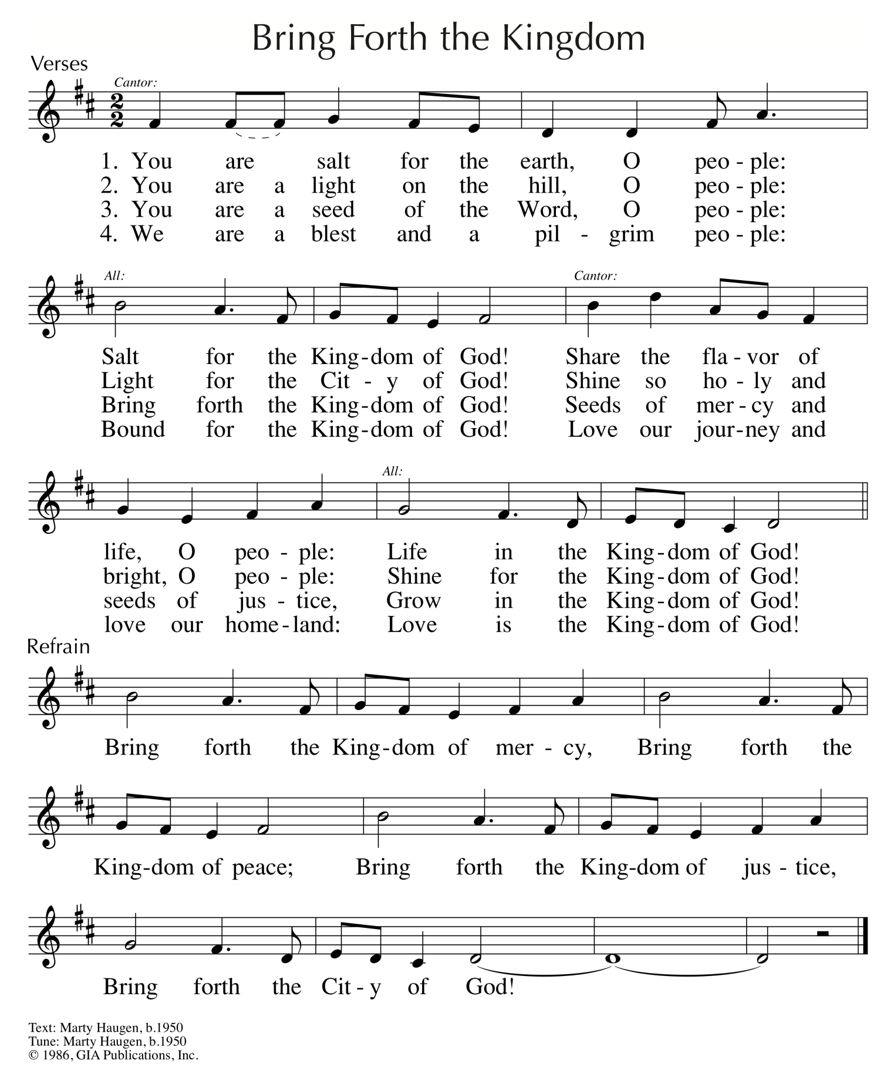
Reprinted/Streamed with permission under OneLicense.net #A-739517. All rights reserved.

