We listen | We pass the peace | We read along | We give our offering of time, talent and treasure | We stand | We sing if we are at home | We pray | We respond | We participate  in the Word  with Children
(Kids – use your worship packet and the tools listed at the end of the bulletin to do all these things.)

Southminster Presbyterian Church
Transfiguration of the Lord
February 19, 2023
9:30 a.m.

Find the link for the service on one of these sites:
1) on Facebook: https://www.facebook.com/SouthminsterGlenEllyn/
2) our YouTube channel:
https://www.youtube.com/channel/UCPgWICngOvkmR1OXgCG_wiA/live
3) our web site: https://www.southminsterpc.org/
If the video feed is interrupted during the service, we will continue to record and then post the full video on Facebook and our web site as soon as possible.

1 Gathering Music: Swiftly Pass the Clouds of Glory; Jesus on the Mountain Peak;
The Heavens Above Declare God's Praise; Christ, You Are the Fullness;
Arise, Your Light Has Come; Christ, Whose Glory Fills the Skies

Our Photo Story today is “Cuba.”

2 Welcome and Announcements
3a Prelude
3b Lighting the Candles (Matthew 11:28)
Come to me, all you who are weary and are carrying heavy burdens,
and I will give you rest.

4 Hymn 192: Lord, the Light of Your Love Is Shining (verse 1)
(Shine, Jesus, Shine)

5 Call to Worship (Matthew 17:1-2 5; 2 Corinthians 4:6)
Leader: On a high mountain, Jesus was transfigured.
People: God said, “This is my beloved Son.”
All: God’s glory shines in the face of Jesus Christ.
6 Hymn: Bring Forth the Kingdom (all)
The music for this song is on the last page of the bulletin.

7 Prayer of Confession: (unison)
Lord God, there are times when we have not welcomed the stranger, nor shared the good news with others. There are times when we have tried to hide rather than be your light in the world. Illumine our lives with the radiance of Christ’s love that we may love as Christ loves. We ask this in the name of Jesus Christ, who is both Savior and Lord. Amen.

(Time of silence for personal prayer and confession)

8 The Good News of Jesus Christ
Leader: For by grace you have been saved through faith,
and this is not your own doing; it is the gift of God.
People: It is not the result of works, so that no one may boast.
All: For we are what he has made us, created in Christ Jesus
for good works, which God prepared beforehand
so that we may walk in them.
9 Response 581: Glory Be to the Father (Gloria Patri)
Glory be to the Father, and to the Son, and to the Holy Ghost;
As it was in the beginning, is now and ever shall be,
World without end. Amen, amen.

Public domain
10 The Passing of the Peace
11a Word with Children Sarah Allen
Children worshiping in the sanctuary, please come forward.

11b Jesus Loves Me
Jesus loves me! This I know,
For the Bible tells me so.
Little ones to him belong.
They are weak, but he is strong.
Yes, Jesus loves me! Yes, Jesus loves me!
Yes, Jesus loves me! The Bible tells me so.

Public domain

12 Prayer for Illumination
13 Scripture Lessons: Matthew 17:1-8 Pew Bible, p. 18, (N.T.)
14 Sermon: “Brillar”

Children, as you listen to the sermon, you may want to choose an activity
from the children’s packet that will help you think about what you hear in the sermon.
Children present in worship may choose to go to Kids’ Corner with Miss Blair.
15 Saying What We Believe/Affirmation of Faith (unison) (Galatians 3:26-29)
For in Christ Jesus you are all children of God through faith. As many of you as were baptized into Christ have clothed yourselves with Christ. There is no longer Jew or Greek; there is no longer slave or free; there is no longer male and female, for all of you are one in Christ Jesus. And if you belong to Christ, then you are Abraham’s offspring, heirs according to the promise.

16 Hymn 300: We Are One in the Spirit (all 4 verses)
They’ll Know We Are Christians by Our Love)

17 Prayers of the People and the Lord’s Prayer
Leader: Lord, in your mercy,
People: hear our prayers.
The Lord’s Prayer:
Our Father who art in heaven, hallowed be thy name. Thy kingdom come,
thy will be done, on earth as it is in heaven. Give us this day our daily bread;
and forgive us our debts, as we forgive our debtors; and lead us not into
temptation, but deliver us from evil. For thine is the kingdom and the power
and the glory, forever. Amen.

Children, draw or write something you would like to say to God in prayer this morning.
If you want to share it with the church, you may also leave a message
on the church phone line.

Offering of Ourselves and Our Gifts
[The offering plate is at the back of the sanctuary. Please leave your gift or pledge
in the plate on your way into or out of worship.]

18 Offertory: Lágrimas Negras Miguel Matamoros

19 *Doxology Hymnal #606
Praise God, from whom all blessings flow;
Praise Him all creatures here below;
Praise Him above, ye heavenly host;
Praise Father, Son, and Holy Ghost. Amen.

Public domain

20 Prayer of Thanksgiving and Dedication

21 Hymn 625: How Great Thou Art (all 4 verses)

22 Charge and Benediction
Leader: Now go and serve the Lord,
All: For we are blessed to be a blessing!
Alleluia, amen!

23 Postlude

Participants and Technical Crew
Rev. Wendy Boden
Liturgist: Steve Henkels
Deacon Greeter/Fellowship: Anny Davidson
Musicians: Tom Anderson, David Kozich, Southminster Choir
Worship Associate: David Kozich
Tech support: Chris Kozich, Blair Nelson

Our 2023 Cuba Mission Team:
Pastor Wendy Boden
Sarah Allen
Gretchen Fleming
Nalani Johnson
Roxane Johnson

Flowers today are given by Sue Knisely “in grateful appreciation of the loving care by my Southminster family with my recent surgery.”

Good Morning to our Children:

To complete all the activities in this worship folder you will need:
- ears to hear
- a mouth to sing
- hands to fold
- eyes to read
- a brain to think
- a worship kit including:
  - something to color with – crayons, markers or colored pencils
  - something to write with, like a pen or pencil
  - something to write on, like a table or a clipboard
  - scissors and tape
If you would like a worship kit for your child, please contact Pastor Wendy (wendy@southminsterpc.org) and one will come to you!

A Guide to Our Worship Symbols

We listen: “Basically, the sermon is God’s dynamic, eternal Word spoken to us in such a way that we might hear what God has to say to us and be encouraged to follow the Lord
in faith.

We pass the peace: “…We greet one another with the peace of Christ as common forgiven sinners. As we are forgiven, so we forgive. This is also a good time to reconcile with those family members who drove us crazy trying to get to church on time, church members with whom we have tensions, or people we're not so happy to see.”
We read along: “God’s Word comes to us in many ways—through scripture, special music, sermons. Listen for God's eternal Word addressing you with good news about the Lord’s love for you and all people.”

We give our offering of time, talent, and treasure: “This is the time when we give ourselves, all that we are, and all that we have, to God’s service. As a symbol of what is of value to us, we make an offering… to promote the gospel.”

We stand: “We stand as a way of saying, “This is where I stand,” and as a way of standing in continuity with the people of God of ages past…”

We sing: “…We sing praise with hearts and minds (even if that's a little out of tune), just enjoying God for who God is. As we open up the pathways of breath to sing praise, we make space for the Spirit breath to fill us.” Even if we simply listen and read the words, we are praising God.

We pray: The first thing we do is pray—for our world, the church, other people, and ourselves. The prayer is our prayer as a church. One person may pray for us, but we are all praying together as one in our hearts, continuing Christ’s ministry of prayer for the world.”

We respond: Responding by writing or drawing helps us remember what we are hearing and is a chance to express our beliefs.

We participate in the Word with Children: It is called the Word WITH Children because the whole church is invited to listen with the fresh, faith-filled ears of children to the proclaimed message.

Quotations for our Worship Symbols Guide are taken from Our Order of Worship by Teresa Lockhart Stricklen, Associate for Worship, Presbyterian Church (USA), found at https://www.pcusa.org/site_media/media/uploads/theologyandworship/pdfs/order_of_worship_brochure_dec_2008.pdf. Edited.

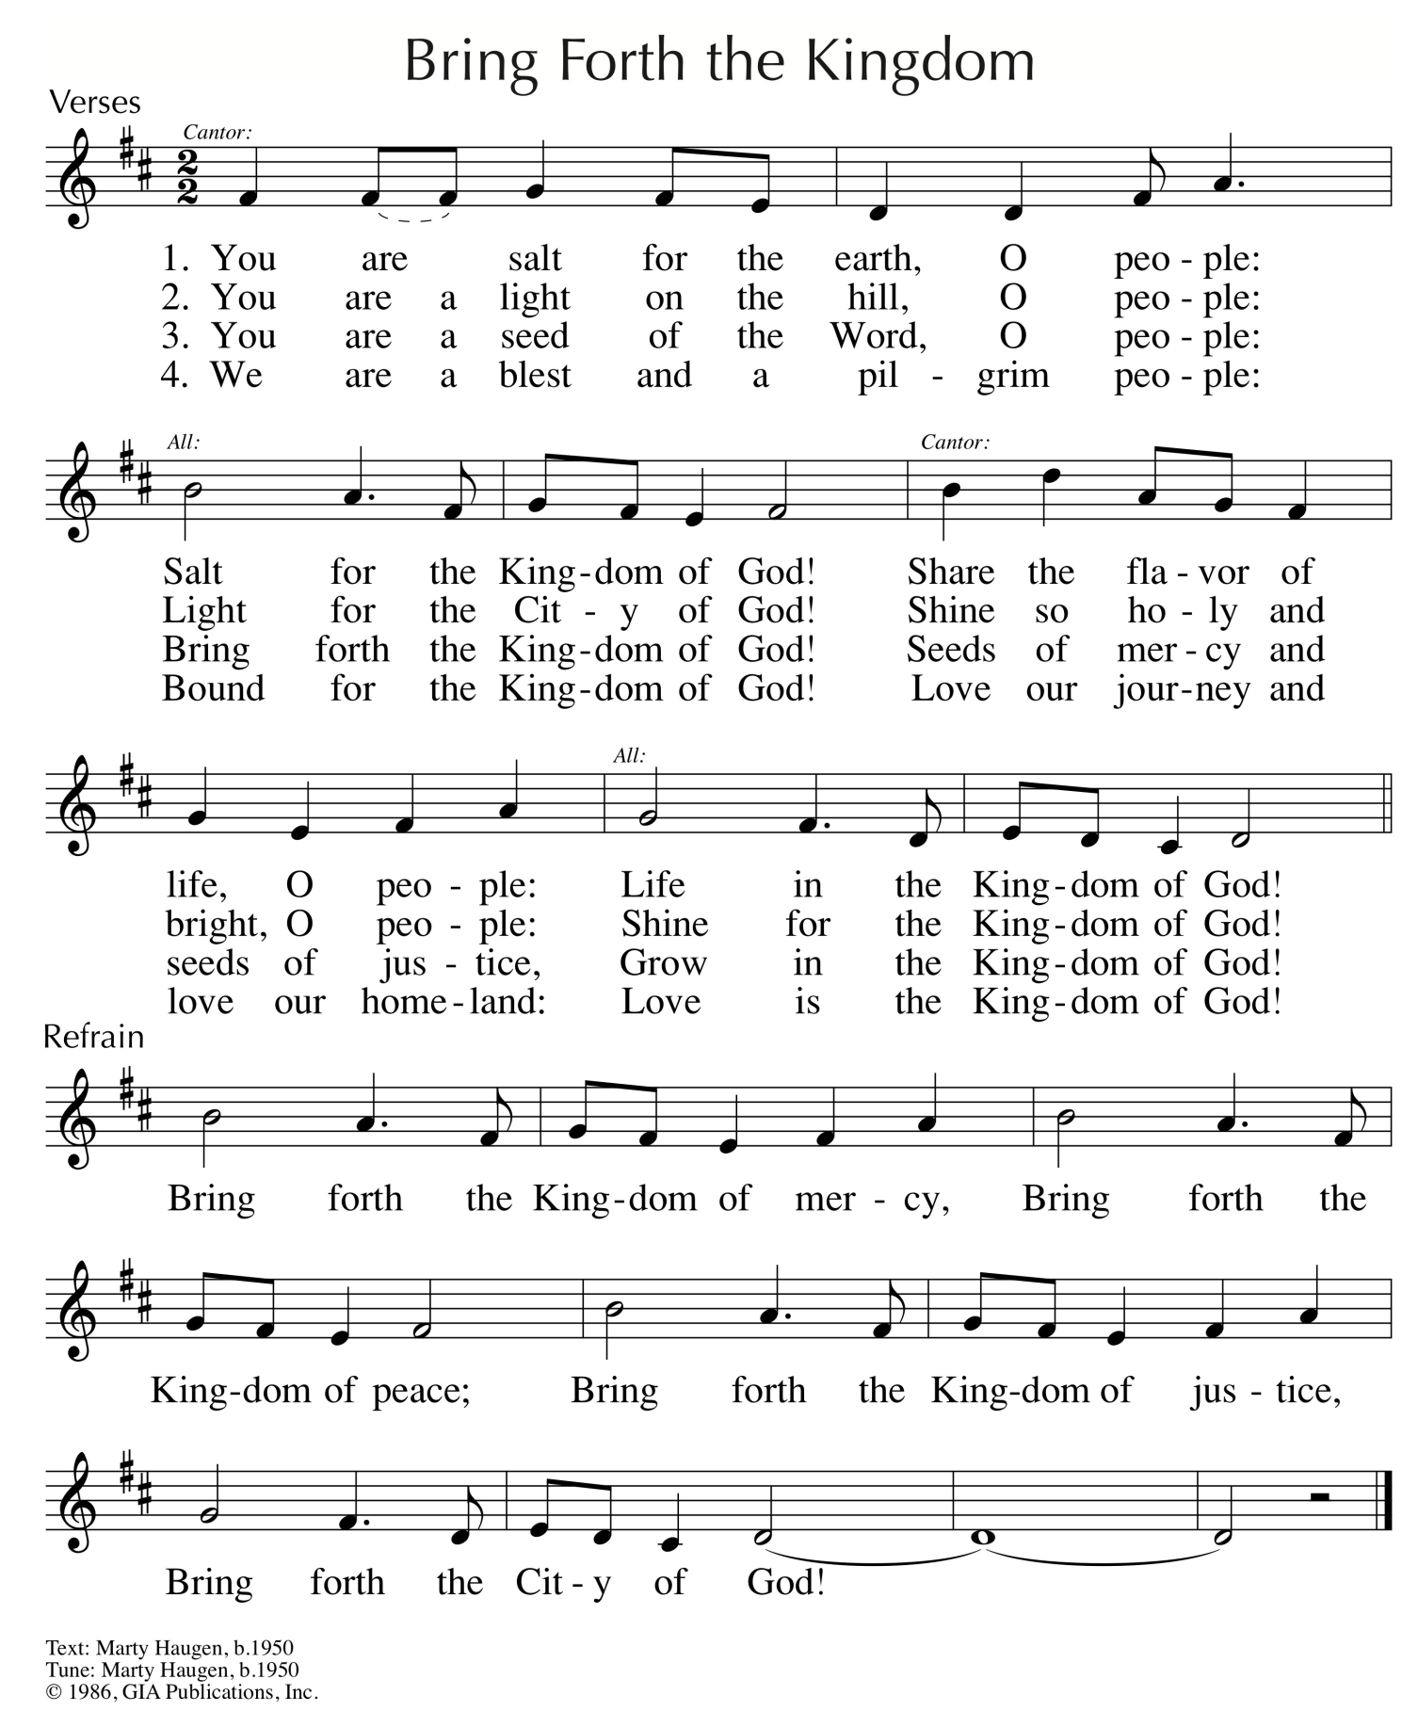
Reprinted/Streamed with permission under OneLicense.net #A-739517. All rights reserved.

