Southminster Presbyterian Church
5th Sunday in Lent
March 26, 2023
9:30 a.m.

Find the link for the service on one of these sites:
1) on Facebook: https://www.facebook.com/SouthminsterGlenEllyn/
2) our YouTube channel:
https://www.youtube.com/channel/UCPgWICngOvkmR1OXgCG_wiA/live
3) our web site: https://www.southminsterpc.org/
If the video feed is interrupted during the service, we will continue to record and then post the full video on Facebook and our web site as soon as possible.

Gathering Music: Would I Have Answered When You Called;
Make Me a Servant; Sent Out in Jesus’ Name;
Bless Now, O God, the Journey

Our Photo Story today is “Our Mission in Pictures.”

Welcome, Announcements, and Moment for Mission
Prelude

Remembering Our Baptism (Revelation 7:17)
“For the Lamb in the midst of the throne will be their shepherd,
and he will guide them to springs of living water;
and God will wipe away every tear from their eyes.”

Hymn: Hold Me Fast (all 4 verses) p. 19, blue worship supplement

Call to Worship
Leader: In this season of Lent we make our way to the cross.
People: We remember your call upon our lives:
Leader: To love you Lord, with all our hearts, minds, souls, and strength;
People: To love both neighbor and enemy.
All: We come to worship you!

Hymn: Here I Am to Worship p. 18, blue worship supplement

Prayer of Confession: (unison)
Lord of All, we confess that we fear change and that which is different, but a new day is dawning in the world, and you have called us to represent you. We continue to face new challenges. Help us rest in you each and every day. Through your Holy Spirit, enable us to share the good news with others and to live out the good news in this world of hurt and brokenness. We ask this in the name of Jesus Christ, who is both savior and Lord. Amen.

(Time of silence for personal prayer and confession)

The Good News of Jesus Christ (Romans 8:34)
Leader: Hear the good news! Who is in a position to condemn?
People: Only Christ and Christ died for us!
Leader: Christ rose for us!
People: Christ reigns in power for us, Christ prays for us.
Leader: Friends, believe the good news of the gospel.
All: In Jesus Christ, we are forgiven!

Response: Kyrie pg. 2, blue worship supplement
Kyrie, Kyrie eleison.
Kyrie, Kyrie eleison.
Christe, Christe eleison.
Christe, Christe eleison.
Kyrie, Kyrie eleison.
Kyrie, Kyrie eleison, eleison.
(The words are Greek for Lord have mercy, Christ have mercy.)
CCLI Song # 2691048
Antonin Leopold Dvorak | Ruth Elaine Schram
© Words: Public Domain
Music: 1998, 2014 Alfred Publishing Co., Inc. (Admin. by Jubilate Music Group, LLC)
For use solely with the SongSelect® Terms of Use. All rights reserved. www.ccli.com
CCLI License # 21214429

The Passing of the Peace

Word with Children Caroline Linde
Children worshiping in the sanctuary, please come forward.

Jesus Loves Me
Jesus loves me! This I know,
For the Bible tells me so.
Little ones to him belong.
They are weak, but he is strong.
Yes, Jesus loves me! Yes, Jesus loves me!
Yes, Jesus loves me! The Bible tells me so.

Public domain

Prayer for Illumination

Scripture Lessons: Matthew 28:18-21 Pew Bible, p. 34, (N.T.)
Matthew 25:31-46 Pew Bible, p. 29, (N.T.)

Sermon: “Stories for the Journey: Goats and Sheep.”

Saying What We Believe/Affirmation of Faith (unison)
from A Brief Statement of Faith (PCUSA)
In gratitude to God, empowered by the Spirit, we strive to serve Christ in our daily tasks and to live holy and joyful lives, even as we watch for God’s new heaven and new earth, praying, “Come, Lord Jesus!” With believers in every time and place, we rejoice that nothing in life or in death can separate us from the love of God in Christ Jesus our Lord.

Hymn: Bring Forth the Kingdom
This hymn is on the last page of the bulletin.

Prayers of the People and the Lord’s Prayer
Leader: Lord, in your mercy,
People: hear our prayers.
The Lord’s Prayer:
Our Father who art in heaven, hallowed be thy name. Thy kingdom come,
thy will be done, on earth as it is in heaven. Give us this day our daily bread;
and forgive us our debts, as we forgive our debtors; and lead us not into
temptation, but deliver us from evil. For thine is the kingdom and the power
and the glory, forever. Amen.

Offering of Ourselves and Our Gifts
[The offering plate is at the back of the sanctuary. Please leave your gift or pledge
in the plate on your way into or out of worship.]

Offertory: Who You Say I Am Fielding/Morgan

*Doxology Hymnal #606
Praise God, from whom all blessings flow;
Praise Him all creatures here below;
Praise Him above, ye heavenly host;
Praise Father, Son, and Holy Ghost. Amen.

Public domain

Prayer of Thanksgiving and Dedication

Hymn 726: Will You Come and Follow Me (all 5 verses)
(The Summons)

Charge and Benediction
Leader: Now go and serve the Lord,
People: For we are blessed to be a blessing!
Leader: The cross, All: We shall take it.
Leader: The bread, All: We shall break it.
Leader: The pain, All: We shall bear it.
Leader: The joy, All: We shall share it.
Leader: The Gospel, All: We shall live it.
Leader: The love, All: We shall give it.
Leader: The light, All: We shall cherish it.
Leader: The darkness, All: God shall perish it.
Leader: For Jesus’ sake. All: Amen.

Please be seated for the Annual Meeting of the Congregation.

Postlude

Participants and Technical Crew
Rev. Wendy Boden
Liturgist: Lynn Ferino
Deacon Greeter/Fellowship: Nick Kaskovich
Musicians: Tom Anderson, Southminster Choir
Worship Associate: David Kozich
Tech support: Chris Kozich, Blair Nelson
Flowers today are given by Barb Doppelt celebrating her grandson Clark’s first birthday.

If you are present for worship, following the service and the congregational meeting, you are invited by the deacons to gather for in-person fellowship in the narthex. Coffee and canned beverages will be served; masks and social distancing are at your discretion.
If you are online, we’re glad to have you! Note that we no longer offer Zoom fellowship.
Sunday Morning Adult Ed. Bible Study is not meeting this week. Come downstairs and eat chili instead!
You are invited to join us on Facebook (https://www.facebook.com/SouthminsterGlenEllyn/), where we have a live sharing of “Heart to Heart” with Pastor Wendy Boden at 4:20 p.m. most weeks Tuesday through Friday.
Even though we have returned to in-person worship, we will also continue to be live on Sunday morning for worship at 9:30 a.m. (slideshow beginning at 9:15) on YouTube at https://www.youtube.com/channel/UCPgWICngOvkmR1OXgCG_wiA/live
or on Facebook at https://www.facebook.com/SouthminsterGlenEllyn/
If you are watching from home on Facebook, please check in and say hello so we can see that you have joined us. This is one way to make worship less “remote” and strengthen community at Southminster.
The live video will appear about 15 minutes before the scheduled start time.
If for any reason the feed falters, rest assured that a recording will be posted to Facebook and You Tube as soon as possible.

You can also find links to recordings of the weekday sessions, special services, and Sunday worship posted on our web site: https://www.southminsterpc.org/ or by going to our YouTube channel:
https://www.youtube.com/channel/UCPgWICngOvkmR1OXgCG_wiA/videos

Photo Stories/PowerPoints help us feel connected!
Photo Stories/PowerPoints help us prepare for worship, connect with one another, and make sure that our at-home people get both sound and sight. Watch here for future opportunities to share your photos.

Notes from Blair Nelson:
Adult Education: So last Sunday we ate, and this Sunday we will study. That is a balanced lifestyle. Join at 11:15 a.m. in the McHenry Parlor or online via the link in the bulletin as we continue our study of Zechariah’s prophecy.
Youth: Great work on the Chili Cook-Off! Spring Break is coming up, so no youth event this weekend. Watch for a text about whether to have an event on April 2. Remember that April 16 is the Talent Show.
The Chili Cook-Off was yummy and fun. Thanks to all who came, and especially those who cooked: Barb Kocinski, Blair Baldwin, Steve Kozich, Jessica Parks, Francine Long, Andrea Schmidt, Jake Falkman, Paul Davidson, and Eugene the Penguin. Blair and Barb took the glory of first place. Thanks to the generosity of those who came and ate (and a few others), the event raised $700 for our Youth Mission Trip.
Talent Show is coming Sunday, April 16. So now is the time to get your act together. You can enter as an individual, group, or ministry. You can sing, dance, tell jokes, look pretty, or anything else that can be conceived of as entertaining. The goal is for us to have a fun evening together. Sign-ups for talent will be on the CA/Youth office door.
From the Easter Celebration Task Force
Please return your stuffed Easter eggs to the table in the hallway as soon as possible.
We need volunteers!
- If you can help with the Easter Celebration on the morning of Saturday, April 8, please let Chris Kozich know: 630-673-4286
- Invite families to attend the party! Here are the details:
Southminster invites all children to an Easter Saturday Celebration on April 8. Arrive any time between 9:30 and 11:30 a.m. Take a walk through the Holy Week story, receive crafts to take home, and join in an egg hunt. No cost – no RSVP – just come and celebrate Easter!
From the Worship Ministry
An invitation from Tom Anderson, our Music Director: We are always in need of volunteers to give the gift if music in worship, but especially for Holy Week, which this year is the first full week of April. The additional services give us more opportunities to celebrate and reflect on our faith together, and music is a special part of that shared worship. If you, or someone you know, might be interested in contributing musical gifts – singing, playing, even temporarily adding your voice to our choir – or if you have questions about doing so, even if you’re on the fence, please contact me at tomanderson101@gmail.com or (651) 246-5129.
Plan to join us for worship services during Holy Week:
Sunday, April 2 – Palm/Passion Sunday – worship service with communion at 9:30 a.m.
Thursday, April 6 – Maundy Thursday– worship service with communion at 7:30 p.m.
Friday, April 7 – Good Friday – worship service at 7:30 p.m.
Sunday, April 9 – Easter/The Resurrection of the Lord! Worship with us at 9:30 a.m.

From the Mission Ministry
March Madness – and March Mission Madness – are in top gear! How well is your bracket doing? Even if you aren’t one of the top finishers, the winners in the end are the missions we support! If you haven’t yet contributed your $15 per bracket (or more, if you feel like it!), please write a check to Southminster and add your bracket name(s) on the memo line so our treasurer can reconcile the contributions.

One Great Hour of Sharing – a Special Offering during Lent
Join with Presbyterians worldwide in sharing God’s love with your neighbors-in-need around the world by providing relief from natural disasters, food for the hungry, and support for the poor and oppressed through an offering to One Great Hour of Sharing. Envelopes for the OGHS offering are on the table outside the Sanctuary, or you may write a check to Southminster with “OGHS” on the memo line and mail it, drop it off, or put it in the offering any time before Easter.

From the Christian Ed. Ministry
Kids’ Corner Proudly Presents...
Next Sunday, April 2, Kids’ Corner will proudly present “Palm and Light,” a shadow play created and prepared by the children of Southminster. If you have children (or youthful friends) who may want to participate, please contact Blair Baldwin at blairbaldwin@southminsterpc.org.

Connect with Our Kids!
Southminster is looking for volunteers to be available on Sunday mornings in the event we need nursery + Sunday School services! Hopefully, we’ll have some new chicks hatching this spring, which means we need YOU! Yes, you – the adults of the church – to step up and nurture our future generations. If you are willing to be on an “on call” list of volunteers, please contact Blair Baldwin at the email address above. This is not a weekly commitment but rather an attempt to gain a list of folks who can potentially help out if we need additional adults.

Women, you are invited to breakfast!
Our next informal women’s breakfast will be held at Danby’s Station at 8:30 a.m. on Wednesday, April 5. All women are invited to join us! Call, text, or email Gretchen Fleming—(630) 517-0926; gretchen_fleming@yahoo.com—if you have any questions. All women are invited to join us!
Community Invitation
Our friends at the Ahmadiyya Muslim Community invite us to join them for an Interfaith Iftar. Iftar is a dinner eaten after sunset during the month of Ramadan. It is “a universal message of peace and security.” The dinner will take place on Saturday, April 1, at the Baitul Jaamay Mosque (2S510 IL Rt. 53, Glen Ellyn 60137) beginning at 6:00 p.m. with dinner being served around 7:20 p.m.
To register for the dinner, click here or send an email to Iftekhar Ahmad at iftekhar.ahmad@ahmadiyya.us.
Jubilee Bucks (from Bobbi Frey):
To date, we have earned $288.46 in “free money” from the sale of gift cards. The next opportunity to order will be April 2, Palm Sunday. Cards should be delivered 2 days later, so it can work for Easter baskets or cards. Cards can also be used to purchase food for your Easter dinner. Contact Bobbi Frey by 9:00 p.m. that Sunday (April 2) by email (bobbifrey@aol.com) or text with your order. Include the amount of the desired card, number ordered, and total amount of your order. You will be notified when the cards are in and a delivery time set.
Donations for PRC (People’s Resource Center) (also from Bobbi Frey):
The number of clients at the PRC keeps rising, which means the need continues to be great. All donations are appreciated! Collection bins continue to be on a bench in the main entryway of the church.
Care Notes:
“In everything by prayer and supplication with thanksgiving let your requests be made known to God.” -Philippians 4:6
Even though we aren’t all together for worship, we are still collecting prayer requests! Please email or leave a message on our answering machine at 630-469-9149 if you won’t be present to fill out a prayer request slip.
Joys and Concerns
The flowers today are given by Barb Doppelt celebrating the first birthday of her grandson, Clark, this past Wednesday.
We give thanks to God for:
- The wedding anniversary of Steve and Heidi Shierry on March 17
- The birth of Hayes Andres Leuders on March 13, son of Lanny Russell’s good friends Ali and Brian Leuders
- The approval for ordination of Elias Cabarcas, husband of Traci Smith and nephew of our own Kathy and Steve Sanders. His ordination will be June 4, 4:00 p.m., at Elmhurst Presbyterian Church, where Traci is the pastor.
We pray for the whole world and our nation:
- Former President Jimmy Carter and his family, as he is under in-home hospice care
- We continue to pray for peace in the world Ukraine, the Holy Land, Pakistan, Iran, and everywhere that people face war, civil unrest, and the fight for civil rights
- We pray for an end to gun violence in our nation: Thus far, in 2023 there have been more mass shootings than there have been days in the year. Click on data from the Gun Violence Archive to see the statistics. We thank God that there was no mass shooting in our nation on Sunday, March 19.
We pray for those who mourn. Please lift up grieving families and friends:
- The family and many friends of Dan Bohi, and especially Deb, Jessica and Megan and their spouses, and the four grandchildren.
We lift up those who are affected by cancer, as well as their support systems:
- Nikki Petersen Mendoza, adult daughter of Pete Petersen, who is home from the Mayo Clinic
- Continuing prayers for Linda Wolf Jeziorski as she rests at home
- We continue to pray for: Steve, Peggy, Cameron A., Rod B., Sam C., Tammy G., Tracy J., Tracy N., Jan M., Margaret R, Charlene S., Helen S, Jim S., Jon S., Connie V., Beverly W., and others we name in our hearts.
We pray for all who are infected with and/or affected by Covid.
We pray for all who are recovering or dealing with mental or physical health or other challenges:
- Floyd Rogers, health concerns
- Jim, undergoing tests
- Our members who are in long term care: Ed Koska at Tabor Hills, Gail Johnston, in hospice care at Du Page Convalescent Center (If you send a card, please send to Andrea Schmidt, whose address is in the directory.), and Grace Van Beveren at Oak Brook Care
We pray for the Jeremiah 29 discernment task force as they seek God’s will for Southminster in the 21st century. May we reach out beyond our doors to invite people to share in our spiritual journey with Jesus Christ.
The upcoming school board and other local elections

Caring for you!
Our Congregational Care Committee is ready to assist in time of need. If you need assistance from the Congregational Care Ministry or Helping Hands) in March, call Heidi Shierry (630-853-6836); April 1-9 call Deacon Angela Smith (630-235-1376). You may call Pastor Wendy Boden on her cell or home phone (if she has shared the numbers with you) or leave a message for her at the church office: 630-469-9149. Email Wendy at wendy@southminsterpc.org. (Please note that she can only read email when she is in the office.) You may also call your deacon if you need help from the church.
Office Schedule: The church office is closed on Mondays.
Barb’s regular schedule is to be in the office Tuesdays, Thursdays, and Fridays from approximately 9:00 a.m.-3:00 p.m. while her son attends his day program on those days. Mondays and Wednesdays she works from home.
Grace and peace to you! Remember that we love God and neighbor. Our address is 680 South Park Blvd., Glen Ellyn, IL 60137 if you would like to set up an online account with your bank or mail in your pledge. Online giving through Vanco is also now an option –for details contact Ron Birchall.

Dates to remember this week:
Sunday, March 26 – 5th Sunday in Lent
Worship at 9:30 a.m. in person and also live on Facebook.
Session has called the Annual Meeting of the Congregation to be held at the conclusion of worship
In-person Fellowship in the Narthex following the meeting.
Staff Meeting at 10:45 a.m. in the Pastor’s Office
Adult Ed. at 11:15 a.m. either by Google Meet or by joining Blair in
the McHenry Parlor/Library
Youth: No meeting – enjoy spring break!
Monday, March 27 – Pastor’s Sabbath. The church office is closed.
Tuesday-Friday – Pastor Wendy’s Heart to Heart on Facebook live at 4:20 p.m.
Tuesday, March 28
A.A. meets at 7:30 p.m. in Fellowship Hall
Wednesday, March 29
The April Dialog goes out! We want you to have it before Holy Week begins
on April 2 – Palm/Passion Sunday.

Thursday, March 30
Choir rehearsal at 7:00 p.m. in the Sanctuary
Friday, March 31
A.A. meets at 6:30 p.m. in Fellowship Hall
Next Sunday, April 2 – Palm/Passion Sunday
Order Jubilee Bucks gift cards by emailing bobbifrey!aol.com before 9:00 p.m.
Worship with communion at 9:30 a.m. in person and also live on Facebook.
In-person Fellowship in the Narthex following the meeting.
Staff Meeting at 10:45 a.m. in the Pastor’s Office
Adult Ed. at 11:15 a.m. either by Google Meet or by joining Blair in
the McHenry Parlor/Library
Youth: It’s the end of spring break. Parents and kids, watch for a text to see
if we want to plan something for this day.

Bearing Fruit – March 26, 2023
Presbyterians are connectors!
Presbyterians are known for faithfulness in action, intentional connection, and entrepreneurial innovation. That’s a mouthful, but true. A common example is the Rev. John Witherspoon, the only clergyman to sign the Declaration of Independence. Dr. James Naismith was the inventor of basketball when a new winter sport was needed. John Muir saw the wilds of the American west and sought to protect it.
Rev. Fred Rogers is a modern example. Before Mr. Roger’s neighborhood there were shows like Kukla, Fran, and Ollie, Howdy Doody, and Captain Kangaroo, but the shows were aimed at older children. Mr. Roger’s Neighborhood was aimed at preschoolers, though it is enjoyable no matter your age. Another important difference is that Rev Rogers kept commercials out of the program. There is gentleness in the show that connected with his audience. A favorite phrase was, “I knew you could.” Rev. Rogers took a modern innovation, television, and used it to connect with preschoolers.
We are in a period of innovation, as well. For those of you at home watching on Facebook, we are experimenting with connecting during worship. If you would like to pass the peace, simply type the word Peace in the comment section as you watch. We won’t mention your name if you don’t want it mentioned, but if it is ok let us know. We can share your peace before of the Word with Children. If you have a prayer request, you may type that as well and an usher (Lanny) will write it down on a blue prayer slip and bring it up. Please type your request during the announcements and they will be shared during the Prayers of the People.
Today we will have our annual congregational meeting following worship. For those at home, the streaming of the service will end with the opening prayer of the meeting. We will elect officers, vote on the pastor’s salary, and answer questions. Presbyterians are faithful connectors and innovators. Serving as an officer of the church is one of the ways we bear the fruit of God’s love. May our new officers be faithful as they seek to serve God with energy, intelligence, imagination, and love. We thank God for all our officers the years, particularly during these past 3 years of the pandemic – your faithfulness and love are inspiring!

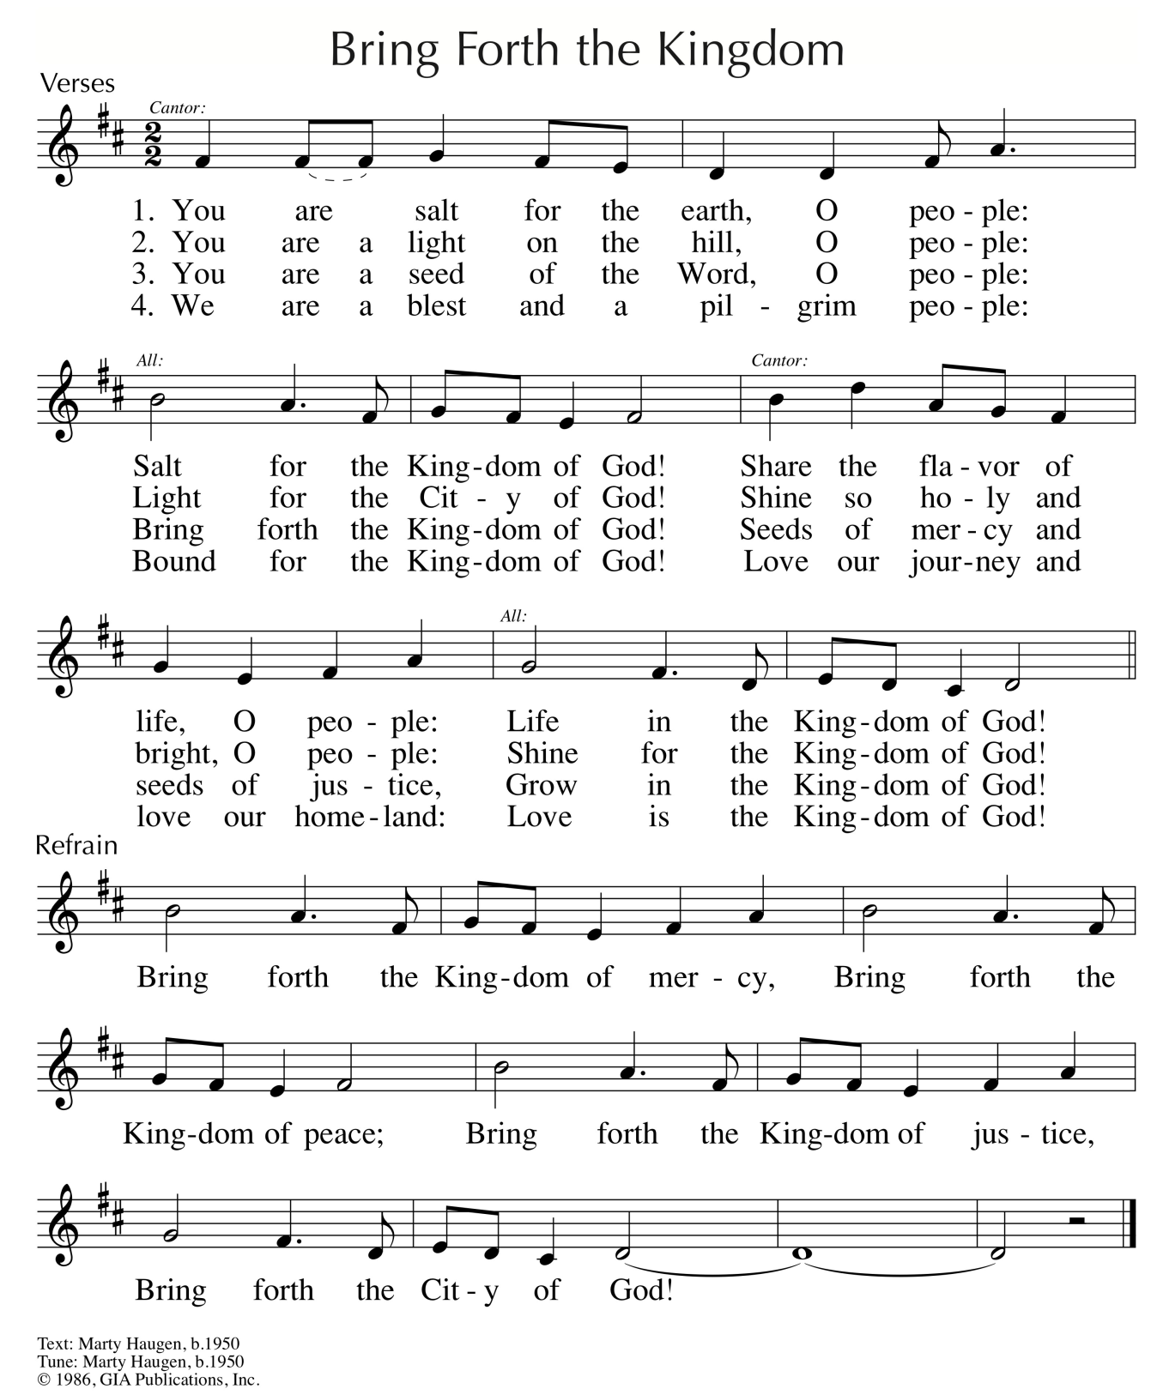
Reprinted/Streamed with permission under OneLicense.net #A-739517. All rights reserved.

