We listen | We pass the peace | We read along | We give our offering of time, talent and treasure | We stand | We sing if we are at home | We pray | We respond | We participate  in the Word  with Children
(Kids – use your worship packet and the tools listed at the end of the bulletin to do all these things.)

Southminster Presbyterian Church
5th Sunday in Lent
March 26, 2023
9:30 a.m.

Find the link for the service on one of these sites:
1) on Facebook: https://www.facebook.com/SouthminsterGlenEllyn/
2) our YouTube channel:
https://www.youtube.com/channel/UCPgWICngOvkmR1OXgCG_wiA/live
3) our web site: https://www.southminsterpc.org/
If the video feed is interrupted during the service, we will continue to record and then post the full video on Facebook and our web site as soon as possible.

1 Gathering Music: Would I Have Answered When You Called;
Make Me a Servant; Sent Out in Jesus’ Name;
Bless Now, O God, the Journey

Our Photo Story today is “Our Mission in Pictures.”

2 Welcome, Announcements, and Moment for Mission
3a Prelude
3b Remembering Our Baptism (Revelation 7:17)
“For the Lamb in the midst of the throne will be their shepherd,
and he will guide them to springs of living water;
and God will wipe away every tear from their eyes.”

4 Hymn: Hold Me Fast (all 4 verses) p. 19, blue worship supplement

5 Call to Worship
Leader: In this season of Lent we make our way to the cross.
People: We remember your call upon our lives:
Leader: To love you Lord, with all our hearts, minds, souls, and strength;
People: To love both neighbor and enemy.
All: We come to worship you!

6 Hymn: Here I Am to Worship p. 18, blue worship supplement

7 Prayer of Confession: (unison)
Lord of All, we confess that we fear change and that which is different, but a new day is dawning in the world, and you have called us to represent you. We continue to face new challenges. Help us rest in you each and every day. Through your Holy Spirit, enable us to share the good news with others and to live out the good news in this world of hurt and brokenness. We ask this in the name of Jesus Christ, who is both savior and Lord. Amen.

(Time of silence for personal prayer and confession)

8 The Good News of Jesus Christ (Romans 8:34)
Leader: Hear the good news! Who is in a position to condemn?
People: Only Christ and Christ died for us!
Leader: Christ rose for us!
People: Christ reigns in power for us, Christ prays for us.
Leader: Friends, believe the good news of the gospel.
All: In Jesus Christ, we are forgiven!
9 Response: Kyrie pg. 2, blue worship supplement
Kyrie, Kyrie eleison.
Kyrie, Kyrie eleison.
Christe, Christe eleison.
Christe, Christe eleison.
Kyrie, Kyrie eleison.
Kyrie, Kyrie eleison, eleison.
(The words are Greek for Lord have mercy, Christ have mercy.)
CCLI Song # 2691048
Antonin Leopold Dvorak | Ruth Elaine Schram
© Words: Public Domain
Music: 1998, 2014 Alfred Publishing Co., Inc. (Admin. by Jubilate Music Group, LLC)
For use solely with the SongSelect® Terms of Use. All rights reserved. www.ccli.com
CCLI License # 21214429
10 The Passing of the Peace
11a Word with Children Caroline Linde
Children worshiping in the sanctuary, please come forward.

11b Jesus Loves Me
Jesus loves me! This I know,
For the Bible tells me so.
Little ones to him belong.
They are weak, but he is strong.
Yes, Jesus loves me! Yes, Jesus loves me!
Yes, Jesus loves me! The Bible tells me so.

Public domain

12 Prayer for Illumination
13 Scripture Lessons: Matthew 28:18-21 Pew Bible, p. 34, (N.T.)
Matthew 25:31-46 Pew Bible, p. 29, (N.T.)
14 Sermon: “Stories for the Journey: Goats and Sheep.”

Children, as you listen to the sermon, you may want to choose an activity
from the children’s packet that will help you think about what you hear in the sermon.
Children present in worship may choose to go to Kids’ Corner with Miss Blair.
15 Saying What We Believe/Affirmation of Faith (unison)
from A Brief Statement of Faith (PCUSA)
In gratitude to God, empowered by the Spirit, we strive to serve Christ in our daily tasks and to live holy and joyful lives, even as we watch for God’s new heaven and new earth, praying, “Come, Lord Jesus!” With believers in every time and place, we rejoice that nothing in life or in death can separate us from the love of God in Christ Jesus our Lord.

16 Hymn: Bring Forth the Kingdom
This hymn is on the last page of the bulletin.

17 Prayers of the People and the Lord’s Prayer
Leader: Lord, in your mercy,
People: hear our prayers.
The Lord’s Prayer:
Our Father who art in heaven, hallowed be thy name. Thy kingdom come,
thy will be done, on earth as it is in heaven. Give us this day our daily bread;
and forgive us our debts, as we forgive our debtors; and lead us not into
temptation, but deliver us from evil. For thine is the kingdom and the power
and the glory, forever. Amen.

Children, draw or write something you would like to say to God in prayer this morning.
If you want to share it with the church, you may also leave a message
on the church phone line.

Offering of Ourselves and Our Gifts
[The offering plate is at the back of the sanctuary. Please leave your gift or pledge
in the plate on your way into or out of worship.]

18 Offertory: Who You Say I Am Fielding/Morgan

19 *Doxology Hymnal #606
Praise God, from whom all blessings flow;
Praise Him all creatures here below;
Praise Him above, ye heavenly host;
Praise Father, Son, and Holy Ghost. Amen.

Public domain

20 Prayer of Thanksgiving and Dedication

21 Hymn 726: Will You Come and Follow Me (all 5 verses)
(The Summons)

22 Charge and Benediction
Leader: Now go and serve the Lord,
People: For we are blessed to be a blessing!
Leader: The cross, All: We shall take it.
Leader: The bread, All: We shall break it.
Leader: The pain, All: We shall bear it.
Leader: The joy, All: We shall share it.
Leader: The Gospel, All: We shall live it.
Leader: The love, All: We shall give it.
Leader: The light, All: We shall cherish it.
Leader: The darkness, All: God shall perish it.
Leader: For Jesus’ sake. All: Amen.

23 Please be seated for the Annual Meeting of the Congregation.

24 Postlude

Participants and Technical Crew
Rev. Wendy Boden
Liturgist: Lynn Ferino
Deacon Greeter/Fellowship: Nick Kaskovich
Musicians: Tom Anderson, Southminster Choir
Worship Associate: David Kozich
Tech support: Chris Kozich, Blair Nelson
Flowers today are given by Barb Doppelt celebrating her grandson Clark’s first birthday.

Good Morning to our Children:

To complete all the activities in this worship folder you will need:
- ears to hear
- a mouth to sing
- hands to fold
- eyes to read
- a brain to think
- a worship kit including:
  - something to color with – crayons, markers or colored pencils
  - something to write with, like a pen or pencil
  - something to write on, like a table or a clipboard
  - scissors and tape
If you would like a worship kit for your child, please contact Pastor Wendy (wendy@southminsterpc.org) and one will come to you!

A Guide to Our Worship Symbols

We listen: “Basically, the sermon is God’s dynamic, eternal Word spoken to us in such a way that we might hear what God has to say to us and be encouraged to follow the Lord
in faith.

We pass the peace: “…We greet one another with the peace of Christ as common forgiven sinners. As we are forgiven, so we forgive. This is also a good time to reconcile with those family members who drove us crazy trying to get to church on time, church members with whom we have tensions, or people we're not so happy to see.”
We read along: “God’s Word comes to us in many ways—through scripture, special music, sermons. Listen for God's eternal Word addressing you with good news about the Lord’s love for you and all people.”

We give our offering of time, talent, and treasure: “This is the time when we give ourselves, all that we are, and all that we have, to God’s service. As a symbol of what is of value to us, we make an offering… to promote the gospel.”

We stand: “We stand as a way of saying, “This is where I stand,” and as a way of standing in continuity with the people of God of ages past…”

We sing: “…We sing praise with hearts and minds (even if that's a little out of tune), just enjoying God for who God is. As we open up the pathways of breath to sing praise, we make space for the Spirit breath to fill us.” Even if we simply listen and read the words, we are praising God.

We pray: The first thing we do is pray—for our world, the church, other people, and ourselves. The prayer is our prayer as a church. One person may pray for us, but we are all praying together as one in our hearts, continuing Christ’s ministry of prayer for the world.”

We respond: Responding by writing or drawing helps us remember what we are hearing and is a chance to express our beliefs.

We participate in the Word with Children: It is called the Word WITH Children because the whole church is invited to listen with the fresh, faith-filled ears of children to the proclaimed message.

Quotations for our Worship Symbols Guide are taken from Our Order of Worship by Teresa Lockhart Stricklen, Associate for Worship, Presbyterian Church (USA), found at https://www.pcusa.org/site_media/media/uploads/theologyandworship/pdfs/order_of_worship_brochure_dec_2008.pdf. Edited.

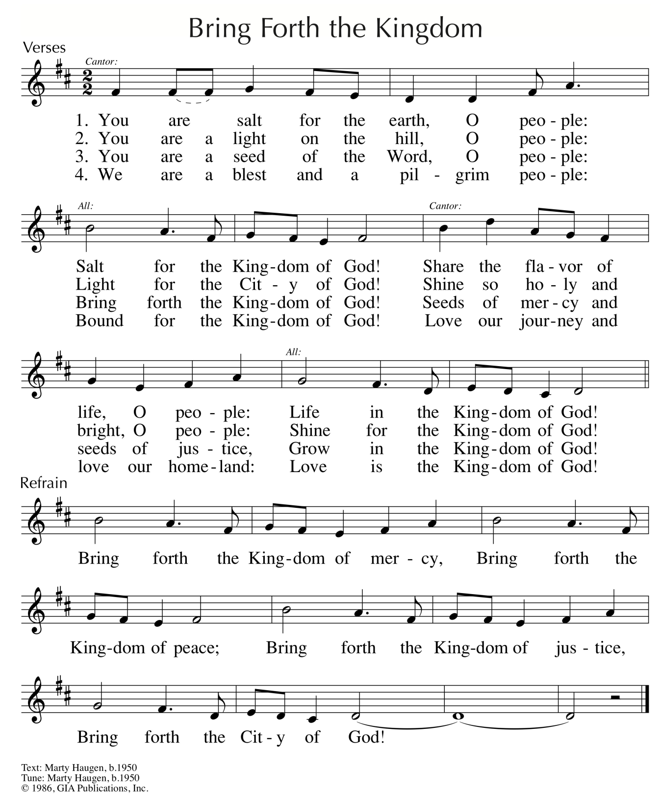
Reprinted/Streamed with permission under OneLicense.net #A-739517. All rights reserved.

