The Service for Maundy Thursday
April 6, 2023
7:30 p.m.

Find the link for the service on one of these sites:
1) on Facebook: https://www.facebook.com/SouthminsterGlenEllyn/
2) our YouTube channel:
https://www.youtube.com/channel/UCPgWICngOvkmR1OXgCG_wiA/live
3) our web site: https://www.southminsterpc.org/
If the video feed is interrupted during the service, we will continue to record and then post the full video on Facebook and our web site as soon as possible.

Gathering Music
Welcome and Lighting of the Tenebrae Candles
Improvisational Prelude: When I Survey the Wondrous Cross
[A time of quiet and prayerful preparation for worship]
Call to Worship
Leader: Jesus said, “I am the light of the world.
People: Anyone who follows me will not walk in darkness,
but will have the light of life.”

Prayer of Adoration (unison) Blair Nelson
Gracious God, you give us the sun to illumine the day and the moon and stars to shine by night. Kindle in us the flame of your love that our lives may shed abroad the radiance of your light and the world may be full of the splendor of your glory; through Jesus Christ, the Sun of Righteousness, in whose name we pray. Amen.

Hymn: Jesus Paid It All p. 29, blue book

Prayer of Confession (unison) Blair Nelson
Gracious God, our sins are too heavy to carry, too real to hide, and too deep to undo. Forgive what our lips tremble to name, what our hearts can no longer bear, and what has become for us a consuming fire of judgment. Set us free from a past that we cannot change; open for us a future in which we will be changed; and grant us grace to grow more and more in your likeness and image; through Jesus Christ, the Light of the world. Now hear our silent and personal prayers. Amen.

Time of Silence for Personal Prayer and Confession

Assurance of Pardon
Leader: This is the message we have heard from Christ and proclaim to you:
Jesus is the light of the world.
People: If we walk in the light as Christ is in the light, we have communion
with one another, and the blood of Jesus Christ cleanses us from all sin.

Hymn 498: Loaves Were Broken, Words Were Spoken (verses 1, 2)
Prayer for Illumination

Scripture: Matthew 26:26-30

Meditation: “Do This in Remembrance”

Anthem: Ah, Holy Jesus Crüger

Service of the Lord’s Supper
Invitation
[We extend an invitation to the Lord’s Supper to all who have been baptized. You do
not need to be a member of this congregation or a Presbyterian to share in this meal.
We remember that access to the Table is not a right conferred upon the worthy, but a
privilege given to believers who come in faith, repentance, and love.]

Great Prayer of Thanksgiving
Leader: The Lord be with you.
People: And also with you.
Leader: Lift up your hearts.
People: We lift them to the Lord.
Leader: Let us give thanks to the Lord our God.
People: It is right to give our thanks and praise.

The minister gives thanks…

The congregation sings:
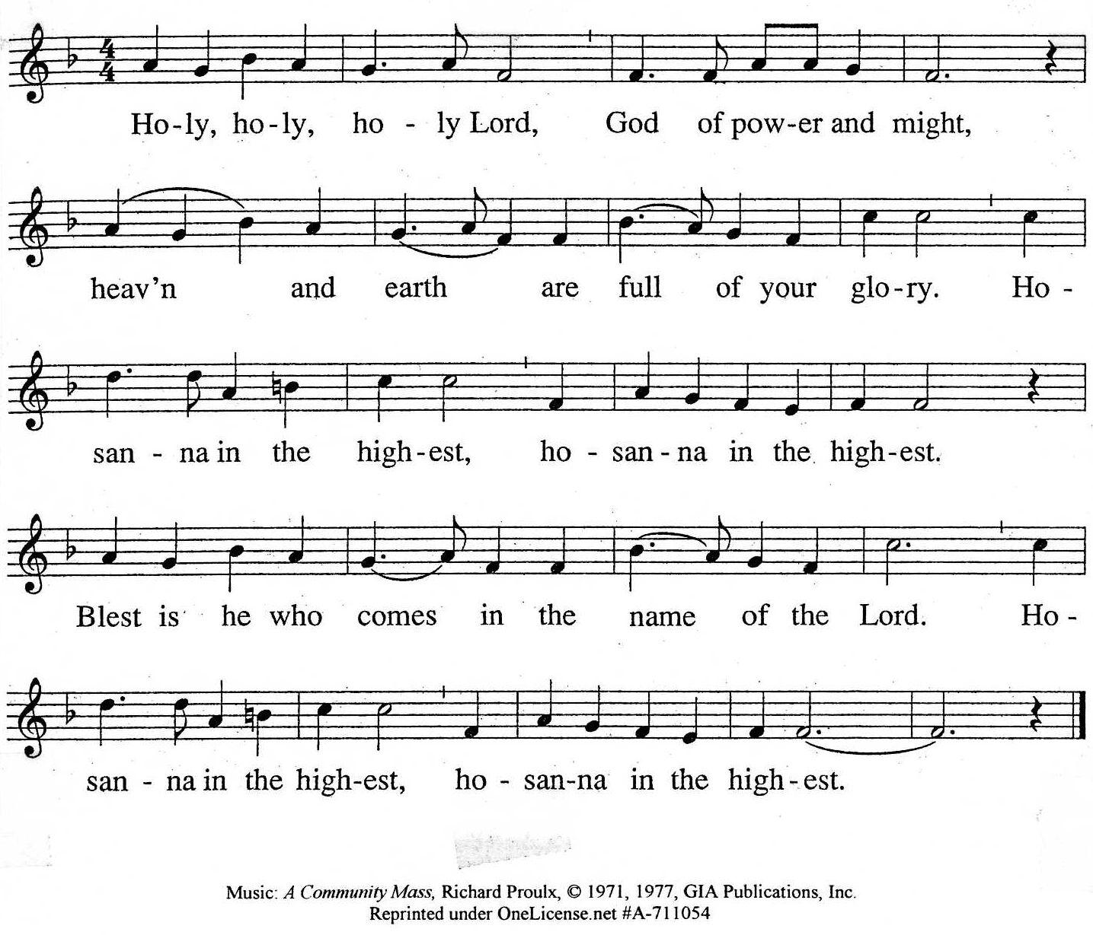
Music: A Community Mass, Richard Proulx, © 1971, 1977, GIA Publications, Inc.
Reprinted/Streamed with permission under OneLicense.net #A-739517. All rights reserved.

The minister continues the Thanksgiving…

Dying you destroyed our death,
Rising you restored our life.
Lord Jesus, come in glory.

The minister continues with Intercessions for the Church and the World
and Prayers of the People…
Leader: Lord, in your mercy,
People: hear our prayers.
Our Lord’s Prayer
Our Father who art in heaven, hallowed be thy name. Thy kingdom come, thy will be done, on earth as it is in heaven. Give us this day our daily bread; and forgive us our debts,
as we forgive our debtors; and lead us not into temptation, but deliver us from evil. For thine is the kingdom and the power and the glory, forever. Amen.

Words of Institution
Communion
Communion Music: Via Dolorosa Sprague/Borop
The music during communion gives us time to reflect on God's love and grace
found in the sacrament of the Lord's Supper.
As the music is played, an usher will invite you to partake of the elements – the bread and the fruit
of the vine. Please consume the elements when you are comfortable doing so.

Prayer

Invitation to Discipleship

Hymnal 220 Go to Dark Gethsemane (verses 1, 2, 3)

Tenebrae: The Service of Shadows
Readings and Extinguishing of Lights
First Reading: Andrea Schmidt
THE SHADOW OF BETRAYAL Matthew 26:20-25

Second Reading: Sarah Allen
THE SHADOW OF INNER AGONY Luke 22:39-44

Third Reading: Lynn Ferino
THE SHADOW OF LONELINESS Matthew 26:40-46

Fourth Reading: Tom Anderson
THE SHADOW OF DESERTION Matthew 26:47-50, 55-56

Fifth Reading: Gretchen Fleming
THE SHADOW OF ACCUSATION Matthew 26:59-68

Sixth Reading: Blair Nelson
THE SHADOW OF MOCKERY Mark 15:12-20

Seventh Reading: Victor King
THE SHADOW OF DEATH Luke 23:33-46

Eighth Reading: Pastor Wendy Boden
THE LIGHT SHINES IN THE DARKNESS John 1:1-12; 3:19

The candle representing Christ will exit, signifying Christ’s death.

Postlude

Departure in Silence

Participants and Technical Crew
Rev. Wendy Boden
Liturgist: Blair Nelson
Musicians: Tom Anderson; Southminster Choir
Worship Associate: David Kozich
Tech support: Chris Kozich, Blair Nelson

Please join us!

Tomorrow (Friday, April 7) we will have a Good Friday Service at 7:30 p.m. You may attend in person or view online; if you are on our email list, you will have received Maundy Thursday and Good Friday bulletins and hymns in the same email or you can find them on our website: southminsterpc.org.

Join us, and invite your friends, family, and neighbors!
Easter Saturday (April 8) Egg Hunt & Story – outdoors, rain or shine.
This is a free event – no reservations needed!

Arrive at any time between 9:30 and 11:30 a.m., to:
- Walk through the Easter story
- Make a cross from palm fronds
- Pick up crafts to take home
- Hunt for Easter eggs (for kids up to 5th grade)

In case of rain, come anyway, and pick up a bag of eggs and take-home craft projects for each child in your vehicle.

Sunday, April 9, is Easter, the Resurrection of the Lord! Join us at 9:30 a.m. (the slideshow begins at 9:15) in person or online via Facebook Live: https://www.facebook.com/SouthminsterGlenEllyn/.
Our fellowship time after the service will include baked goodies compliments of our deacons.

During the week, you are invited to join us on Facebook (https://www.facebook.com/SouthminsterGlenEllyn/), where we have a live sharing of “Heart
to Heart” Tuesday-Friday at 4:16 p.m.

