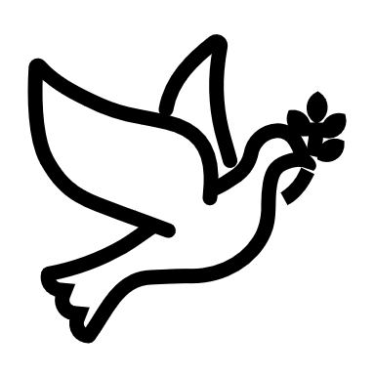

We listen | We pass the peace | We read along | We give our offering of time, talent and treasure | We stand | We sing if we are at home | We pray | We respond | We participate  in the Word  with Children
(Kids – use your worship packet and the tools listed at the end of the bulletin to do all these things.)

Southminster Presbyterian Church
Christ the King/Reign of Christ
November 26, 2023
9:30 a.m.

Find the link for the service on one of these sites:
1) on Facebook: https://www.facebook.com/SouthminsterGlenEllyn/
2) our YouTube channel:
https://www.youtube.com/channel/UCPgWICngOvkmR1OXgCG_wiA/live
3) our web site: https://www.southminsterpc.org/
If the video feed is interrupted during the service, we will continue to record and then post the full video on Facebook and our web site as soon as possible.

1 Gathering Music
Our Photo Story today is “Fall 2023 by Carol McHaley.”

2 Welcome, Announcements, and Moment for Mission
3a Lighting the Candles (2 Timothy 1:7)
“For God gave us a spirit not of fear
but of power and love and self-control.”

3b Prelude: Jesu, Joy of Man’s Desiring

[Please remain seated while singing the opening song.]
4 Hymn: You Are My King (Amazing Love) p. 42, gold supplement

5 Call to Worship
Leader: In the name of the One with plans for us all,
People: In the name of the One who listens when we pray,
Leader: In the name of the One who loves us,
People: The one who cherishes us and reigns forever more,
All: Let us worship the Lord our God.
6 Hymn 268: Crown Him with Many Crowns

7 Prayer of Confession: (unison)
God, we thank you that, wherever we are, you have work for us to do.
We thank you that, whoever we are, there is a place for us in your kingdom.
Help us to always include others, to rejoice when they rejoice, to mourn when they mourn. When we forget to reach and include others, we thank you for forgiving us, turning us around, and putting our feet on a straight path. Together, we celebrate the family you have created through Jesus Christ, who is our Lord, Savior, and King of Kings. Amen.

(Time of silence for personal prayer and confession)

8 Declaration of God’s Grace/The Good News of Jesus Christ (Psalm 103:8-12)
Leader: The Lord is compassionate and gracious.
People: The Lord is slow to anger, abounding in love.
All: In the name of Jesus Christ, we are forgiven.
9 Response 581: Glory Be to the Father
Glory be to the Father, and to the Son, and to the Holy Ghost;
As it was in the beginning, is now and ever shall be,
World without end. Amen, amen.

Public domain

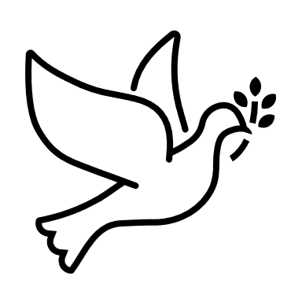
10 The Passing of the Peace
11a Word with Children
Children worshiping in the sanctuary, please come forward.

11b God Welcomes All Hymnal 399
God welcomes all, strangers and friends;
God’s love is strong and it never ends.

Text: John L. Bell, 2008
Music: South African song, transc, John L. Bell, 2008
Text and Music Transcr. © 2008 WGRG, Iona Community (admin. GIA Publications, Inc.)
Reprinted/Streamed with permission under OneLicense.net #A-739517. All rights reserved.

12 Prayer for Illumination
13 Scripture Lessons: 2 Kings 23:1-3 Pew Bible, p. 356, O.T.)
Matthew 25:31-40 Pew Bible, p. 29 (N.T.)
14 Sermon: “Sheep and Goats”

15 Reception of New Members
15a Presentation of New Members
15b Words of Scripture
15c Reaffirmation of Faith
Renunciation
Affirmation of Faith: The Apostles’ Creed
Leader: Do you believe in God the Father?
All: I believe in God, the Father almighty, creator of
heaven and earth.
Leader: Do you believe in Jesus Christ, the Son of God?
All: I believe in Jesus Christ, God’s only Son, our Lord,
who was conceived by the Holy Spirit, born of the Virgin Mary,
suffered under Pontius Pilate, was crucified, died, and was buried;
he descended to the dead.
On the third day he rose again; he ascended into heaven,
he is seated at the right hand of the Father,
and he will come to judge the living and the dead.
Leader: Do you believe in God the Holy Spirit?
All: I believe in the Holy Spirit, the holy catholic Church,
the communion of saints, the forgiveness of sins,
the resurrection of the body, and the life everlasting. Amen.

15d Question of Membership
Leader: Do you promise to be a faithful member of this
congregation, giving of yourself in every way, and
so fulfill your calling as a disciple of Jesus Christ
the Lord?
New Members: I do.

15e Congregational Prayer (unison)
O God our Father: we praise you for calling us to be a servant people, and for gathering us into the body of Christ. We thank you for choosing to add to our family brothers and sisters in faith. Together, may we live in your Spirit, and so love one another, that we may have the mind of Jesus Christ our Lord, to whom we give honor and glory forever. Amen.
15f Welcome New Members
Leader: Welcome to this ministry of Jesus Christ.
15g Congregational Response (unison)
With joy and thanksgiving we welcome you to share with us
in the ministry of Christ, for we are all one in him.

16 Hymn 260: Alleluia! Sing to Jesus

17 Prayers of the People and the Lord’s Prayer
Leader: Lord, in your mercy,
People: hear our prayers.
The Lord’s Prayer: (unison)
Our Father who art in heaven, hallowed be thy name. Thy kingdom come,
thy will be done, on earth as it is in heaven. Give us this day our daily bread;
and forgive us our debts, as we forgive our debtors; and lead us not into
temptation, but deliver us from evil. For thine is the kingdom and the power
and the glory, forever. Amen.
Offering of Ourselves and Our Gifts
[The offering plate is at the back of the sanctuary. Please leave your gift or pledge
in the plate on your way into or out of worship.]

18 Offertory: Thankful

19 *Doxology Hymnal #606
Praise God, from whom all blessings flow;
Praise Him all creatures here below;
Praise Him above, ye heavenly host;
Praise Father, Son, and Holy Ghost. Amen.

Public domain

20 Prayer of Thanksgiving and Dedication

21 Hymn 263: All Hail the Power of Jesus’ Name

22 Charge and Benediction
Leader: Now go and serve the Lord,
All: For we are blessed to be a blessing!
Alleluia, amen!
23 Postlude: Now Thank We All Our God

Participants and Technical Crew
Rev. Wendy Boden
Liturgist: Gretchen Fleming
Greeter/Fellowship: Barb Zink and Lynn Ferino
Music: Derek A. Buckley
Worship Assistant: David Kozich
Tech support: Chris Kozich, Blair Nelson
The flowers today are given by the Bohi family in memory of Dan’s birthday.

Good Morning to our Children:

To complete all the activities in this worship folder you will need:
- ears to hear
- a mouth to sing
- hands to fold
- eyes to read
- a brain to think
- a worship kit including:
  - something to color with – crayons, markers or colored pencils
  - something to write with, like a pen or pencil
  - something to write on, like a table or a clipboard
  - scissors and tape
If you would like a worship kit for your child, please contact Pastor Wendy (wendy@southminsterpc.org) and one will come to you!

A Guide to Our Worship Symbols

We listen: “Basically, the sermon is God’s dynamic, eternal Word spoken to us in such a way that we might hear what God has to say to us and be encouraged to follow the Lord
in faith.

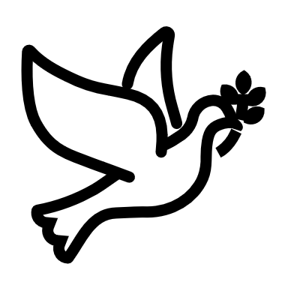 | We pass the peace: “…We greet one another with the peace of Christ as common forgiven sinners. As we are forgiven, so we forgive. This is also a good time to reconcile with those family members who drove us crazy trying to get to church on time, church members with whom we have tensions, or people we're not so happy to see.”
 | We read along: “God’s Word comes to us in many ways—through scripture, special music, sermons. Listen for God's eternal Word addressing you with good news about the Lord’s love for you and all people.”
 | We give our offering of time, talent, and treasure: “This is the time when we give ourselves, all that we are, and all that we have, to God’s service. As a symbol of what is of value to us, we make an offering… to promote the gospel.”
 | We stand: “We stand as a way of saying, “This is where I stand,” and as a way of standing in continuity with the people of God of ages past…”
 | We sing: “…We sing praise with hearts and minds (even if that's a little out of tune), just enjoying God for who God is. As we open up the pathways of breath to sing praise, we make space for the Spirit breath to fill us.” Even if we simply listen and read the words, we are praising God.
 | We pray: The first thing we do is pray—for our world, the church, other people, and ourselves. The prayer is our prayer as a church. One person may pray for us, but we are all praying together as one in our hearts, continuing Christ’s ministry of prayer for the world.”
 | We respond: Responding by writing or drawing helps us remember what we are hearing and is a chance to express our beliefs.
 | We participate in the Word with Children: It is called the Word WITH Children because the whole church is invited to listen with the fresh, faith-filled ears of children to the proclaimed message.

Worship Symbols Guide based on Our Order of Worship by Teresa Lockhart Stricklen, Associate for Worship, Presbyterian Church (USA) found at:
https://www.pcusa.org/site_media/media/uploads/theologyandworship/pdfs/order_of_worship_brochure_dec_2008.pdf. Edited.

