Southminster Presbyterian Church
First Sunday of Advent
December 3, 2023
9:30 a.m.

Find the link for the service on one of these sites:
1) on Facebook: https://www.facebook.com/SouthminsterGlenEllyn/
2) our YouTube channel:
https://www.youtube.com/channel/UCPgWICngOvkmR1OXgCG_wiA/live
3) our web site: https://www.southminsterpc.org/
If the video feed is interrupted during the service, we will continue to record and then post the full video on Facebook and our web site as soon as possible.

For those who are in the sanctuary, please put your phone in airplane mode.

Today we are having communion. Those at home may want to gather the elements (“bread” and “wine” or whatever you have) before the service begins.

Gathering Music

Our Photo Story today is “Advent Candles.”

Welcome, Announcements, and Moment for Mission
Lighting the Advent Wreath Lighters: Jay and Max Lerch
Lighters: We light this candle as a sign of the coming light of Christ.
All: We wait in hope!

Response 314: Longing for Light, We Wait in Darkness (verse 1)
(Christ, Be Our Light)
Longing for light, we wait in darkness.
Longing for truth, we turn to you.
Make us your own, your holy people,
Light for the world to see.
Christ, be our light! Shine in our hearts. Shine through the darkness.
Christ, be our light! Shine in your church gathered today.

Text and Music © 1993 Bernadette Farrell (Published by OCP)
Reprinted/Streamed with permission under OneLicense.net #A-739517. All rights reserved.

Call to Worship (Romans 13:11-12)
Leader: Awake from your sleep: salvation is near!
People: The night is far gone; the day is at hand.
All: Let us walk in the light of the Lord.

Hymn 100: My Soul Cries Out with a Joyful Shout (all 4 verses)

Prayer for Advent: (unison) (PCUSA website)
Faithful God, you are at work to restore all of creation in its intended harmony. Give us your shalom, that we may be reconciled to all enemies in the peace that passes all understanding through Christ Jesus our Lord. God of promise, God of hope, into our darkness come. Amen.

(Time of silence for personal prayer and confession)

The Good News of Jesus Christ (Isaiah 35: 1, 10)
Leader: The wilderness will rejoice; the dry land will blossom.
The people of God will return with joy and singing.
All: In the name of Jesus Christ, we are forgiven!
Thanks be to God.

Response 84: Creator of the Stars of Night (verse 1)
Creator of the stars of night,
Your people’s everlasting light,
O Christ, redeemer of us all,
We pray you, hear us when we call.
Amen.

Public domain

The Passing of the Peace

Word with Children: Blair Baldwin
Children worshiping in the sanctuary, please come forward.

God Welcomes All Hymnal 399
God welcomes all, strangers and friends;
God’s love is strong and it never ends.

Text: John L. Bell, 2008
Music: South African song, transc, John L. Bell, 2008
Text and Music Transcr. © 2008 WGRG, Iona Community (admin. GIA Publications, Inc.)
Reprinted/Streamed with permission under OneLicense.net #A-739517. All rights reserved.

Prayer for Illumination

Scripture Lessons: Isaiah 6:1-5 Pew Bible, p. 635 (O.T.)
Isaiah 11:1-5 Pew Bible, p. 640 (O.T.)

Sermon: “Hope”

Saying What We Believe/Affirmation of Faith (unison)
The Apostles’ Creed [Ecumenical]
I believe in God, the Father almighty, creator of heaven and earth.
I believe in Jesus Christ, God’s only Son, our Lord, who was conceived by the Holy Spirit, born of the Virgin Mary, suffered under Pontius Pilate, was crucified, died, and was buried; he descended to the dead. On the third day he rose again; he ascended into heaven, he is seated at the right hand of the Father, and he will come to judge the living and the dead.
I believe in the Holy Spirit, the holy catholic Church, the communion of saints, the forgiveness of sins, the resurrection of the body, and the life everlasting. Amen.

Hymn 377: I Want to Walk as a Child of the Light (all 3 verses)

Offering of Ourselves and Our Gifts
[The offering plate is at the back of the sanctuary. Please leave your gift or pledge
in the plate on your way into or out of worship.]
Offertory Anthem: Prepare Ye Marc A. Robinson

Response 314 : Longing for Light, We Wait in Darkness (verse 5)
Many the gifts, many the people,
Many the hearts that yearn to belong.
Let us be servants to one another,
Making your kingdom come.
Christ, be our light! Shine in our hearts. Shine through the darkness.
Christ, be our light! Shine in your church gathered today.

Text and Music © 1993 Bernadette Farrell (Published by OCP)
Reprinted/Streamed with permission under OneLicense.net #A-739517. All rights reserved.

Prayer of Dedication

Service of the Lord’s Supper
Invitation
[We extend an invitation to the Lord’s Supper to all who have been baptized. You do
not need to be a member of this congregation or a Presbyterian to share in this meal.
We remember that access to the Table is not a right conferred upon the worthy, but a
privilege given to believers who come in faith, repentance, and love.]

Great Prayer of Thanksgiving
Leader: The Lord be with you.
People: And also with you.
Leader: Lift up your hearts.
People: We lift them to the Lord.
Leader: Let us give thanks to the Lord our God.
People: It is right to give our thanks and praise.

The minister gives thanks…

The congregation responds by singing together:
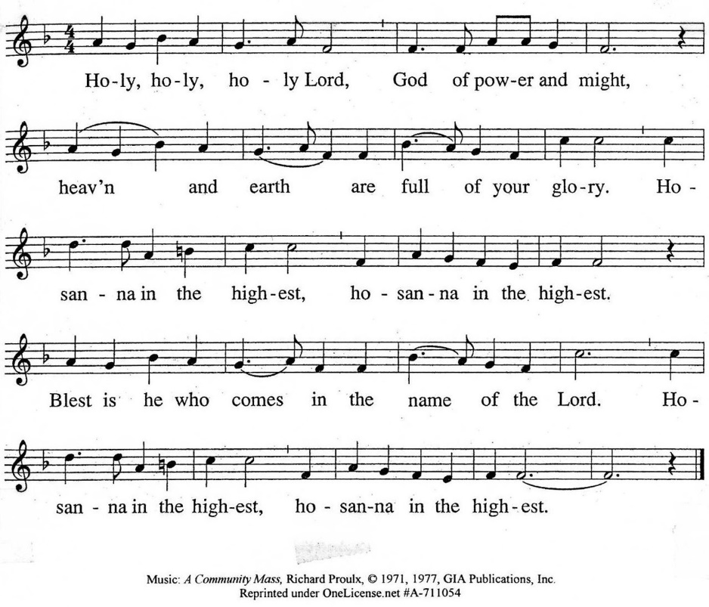

The minister continues the Thanksgiving…

According to Christ’s commandment
We remember his death,
We proclaim his resurrection,
We await his coming in glory.

The minister continues with Intercessions for the Church and the World
and Prayers of the People…
Leader: Lord, in your mercy,
People: hear our prayers.
Our Lord’s Prayer
Our Father who art in heaven, hallowed be thy name. Thy kingdom come,
thy will be done, on earth as it is in heaven. Give us this day our daily bread;
and forgive us our debts, as we forgive our debtors; and lead us not into temptation, but deliver us from evil. For thine is the kingdom and the power
and the glory, forever. Amen.

Words of Institution
Communion
Communion Music: For You, O Lord, My Soul in Stillness Waits (Hymnal 89)

We all will receive communion by intinction. Our usher will invite you to come forward by pew, beginning from the back. If you are unable to come forward, a server will come to you after everyone else has received. Please consume the elements when you are comfortable doing so. You do not need to wait – please do so as the Spirit leads (right away, as you pause after receiving, or back in your seats).
With Christian love we serve gluten-free communion bread and alcohol-free grape juice.

Prayer after Communion

Hymn 105: People, Look East (verses 1, 2)

Charge and Benediction
Leader: Now go and serve the Lord,
All: For we are blessed to be a blessing!
Amen! Amen!

Postlude

Participants and Technical Crew
Rev. Wendy Boden
Liturgist: Pete Petersen
Deacon Greeter/Fellowship: Linda Ellinghausen
Musicians: Tom Anderson, Southminster Choir, David Kozich
Worship Associate: David Kozich
Tech support: Chris Kozich, Blair Nelson

The flowers today are given by Heidi Shierry in honor of her foster brother, Ravi Parekh.

If you are present for worship, following the service you are invited by the deacons to gather for in-person fellowship in the narthex. Coffee and canned beverages will be served; masks and social distancing are at your discretion.
If you are online, we’re glad to have you! Using the comments section on Facebook, you can say hello, ask for words of peace, or request prayers.
Sunday Morning Adult Ed. Bible Study, 11:15 a.m.: Join us by using this link: https://meet.google.com/fna-eojg-uye. If you’re already at church and wish to join us, find Blair at his computer in the parlor/library.
You are invited to join us on Facebook (https://www.facebook.com/SouthminsterGlenEllyn/), where we have a live sharing of “Heart to Heart” with Pastor Wendy Boden at 4:20 p.m. most weeks Tuesday through Friday.
Even though we have returned to in-person worship, we will also continue to be live on Sunday morning for worship at 9:30 a.m. (slideshow beginning at 9:15) on YouTube at https://www.youtube.com/channel/UCPgWICngOvkmR1OXgCG_wiA/live
or on Facebook at https://www.facebook.com/SouthminsterGlenEllyn/
If you are watching from home on Facebook, please check in and say hello so we can see that you have joined us. This is one way to make worship less “remote” and strengthen community at Southminster.
The live video will appear about 15 minutes before the scheduled start time.
If for any reason the feed falters, rest assured that a recording will be posted to Facebook and You Tube as soon as possible.

You can also find links to recordings of the weekday sessions, special services, and Sunday worship posted on our web site: https://www.southminsterpc.org/ or by going to our YouTube channel:
https://www.youtube.com/channel/UCPgWICngOvkmR1OXgCG_wiA/videos

Photo Stories/PowerPoints help us feel connected!
Photo Stories/PowerPoints help us prepare for worship, connect with one another, and make sure that our at-home people get both sound and sight. Coming up we’ll be looking for these:
December 10: “Angels” – Christmas angels are everywhere! Please send us
your photos of angels by this Thursday, December 7.
December 17: “Christmas Trees” –Please send us photos of decorated Christmas
trees (or maybe of your cat resting inside the tree?!) by Thursday, December 14.
December 24: “Nativity Scenes” –Please send us your photos by Thursday,
December 21.
December 31: “Timekeepers” – Clocks, watches, calendars, hourglasses, sundials…
ways we keep time! Please send us your photos by Thursday, December 28.
Send photos to our dedicated email address, used just for photos:
PhotoStory@Southminsterpc.org. (If you only have hard copies of your photos, please leave them in the photo box on Pastor Wendy’s desk, labeled with your name and the date they are to be used.)
Elders, staff, and ministry moderators: Session is meeting a week earlier than usual this month: Tuesday, December 12. That means we need all reports, motions, and information items for the docket by this Thursday, December 7, at noon.
Notes from Blair Nelson:
Adult Education: Sundays after worship (11:15 a.m.-12:15 p.m.) a group of fine folks gather in the Parlor/Library to read and discuss scripture. The Bible is for us, for our community. Ever thought of reading it with the community—our church family? Join us and grow with us. If you can’t be with us in person, join us virtually through this link: https://meet.google.com/fna-eojg-uye.
Men of Southminster: Mark your calendars for Wednesday, January 17, at 7:30 p.m. for a dessert fellowship. What shall we eat? Contact Blair N with your suggestions.
Youth: December is Christmas month, and that means Christmas Program. Let Blair N know if you want to be a scripture reader. The rehearsal is December 10, after worship, and the program is the December 17th worship service.
From the Worship Ministry:
Add these December worship services to your calendars:
- Our Christmas program is during the worship service on Sunday, December 17.
- Longest Night Service at 7:30 p.m. on Thursday, December 21, is a special service acknowledging challenges during the holidays, when Christmas may not seem “merry.” (This service will not be streamed.)
- Christmas Eve is on a Sunday this year, which means there will be two services on December 24!
+ The 9:30 a.m. service will celebrate the 4th Sunday of Advent.
+ The Christmas Eve service will again be at 4:30 p.m.! It will be a traditional service including Scripture, carols, choir, and candle lighting. (The earlier time accommodates choir members and others who wish to gather with their families later that evening.)
Women’s Circle Christmas Luncheon
The Presbyterian Women’s Circle will celebrate Christmas with our annual salad luncheon on Friday, December 15, starting at 11:30 a.m. Women who wish to come and have not yet signed up should sign on the list posted on the Presbyterian Women’s bulletin board just outside the Parlor/Library. Please bring a salad to contribute to the salad luncheon. You are also free to bring a guest if you wish (guests do not bring salads). We are pleased this year to have Derek Buckley providing a program of Christmas music. If you have any questions, please contact Gretchen Fleming (phone or text to 630-517-0926) or Sue Knisely (phone or text to 630-776-7998).
Women’s Breakfast meets the first Wednesday of the month, which is this` Wednesday, December 6, at 8:30 a.m. at Danby’s Station, 750 Roosevelt Road, Glen Ellyn. All women are invited to join the group – no reservations needed, just come!
A community invitation: Christmas music tomorrow evening!
The Village Vocal Chords, a Glen-Ellyn based women’s barbershop chorus, will present a festive Christmas concert on Monday, December 4, 7:30 p.m. at 1st United Methodist Church, 424 Forest Ave., Glen Ellyn. “Sounds of the Season” will feature the award-winning chorus, a proud member of Harmony, Inc., an international association of women singers. The public is invited! Tickets are $10.00 each, available at the door. (If you want advance tickets – but there’s no discount for early purchase – talk to Barb in the SPC office.)
Jubilee Bucks: Order next Sunday, December 10
We had a wonderful month of ordering Jubilee Bucks in November! Southminster’s total of “free” money ordered this year thru the sale of gift cards is $1,763.60! Also, many thanks to all who ordered gift cards for Share the Spirit! 89 cards, totaling $2,225 were purchased! Along with benefiting PRC, these orders also gave us $72.49 in “free” money!
The last time to order gift cards before the holidays will be next Sunday, December 10. In January, we will return to ordering the first Sunday of the month, which is January 7.
Donations for PRC (People’s Resource Center):
Southminster has been faithfully providing donations of food items and personal care products for PRC for many years. If you would like suggestions for what to give, PRC has provided a list of the items that are most needed. Copies are printed on bright green paper and are in the stand on the nametag shelf (main hallway – across from the offices). You can view the list online at the PRC website: https://www.peoplesrc.org/give-food-or-goods/.
Many thanks to all who continue to support PRC’s mission to meet our communities’ needs, neighbor to neighbor.
Care Notes: “In everything by prayer and supplication with thanksgiving let your requests be made known to God.” -Philippians 4:6
Even though we aren’t all together for worship, we are still collecting prayer requests! Please email or leave a message on our answering machine at 630-469-9149 if you won’t be present to fill out a prayer request slip.
Friends,
You are all invited to offer prayer for people whether they are members or not. It would be a joy and very helpful to know how people are doing. If you have submitted a person to be prayed for, can you send an update to the office, please, once in a while? Thank you! Pastor Wendy
Joys and Concerns
The flowers today are from Heidi Shierry in honor of her foster brother, Ravi Parekh.
We give thanks to God for joys:
- This fall World Relief welcomed 100 new arrivals, 25 apartment setups. Families arrived from: Afghanistan, Venezuela, Peru, Somalia, Congo, Iran, Syria, Iraq, Myanmar, and Pakistan.
- the new members we welcomed in worship last Sunday. Others will be welcomed in worship as they are available.
- the birth of Blaire Elizabeth Benson, daughter of Andee and Brad Benson and granddaughter of Pete and Pam Petersen
- Thanksgiving gatherings with family and friends
- Tricia Smith is grateful for the care and concern of Southminster during the past several years.
- Linda Wolf Jeziorski, as she continues to heal
We pray for the whole world and our nation:
- We pray for former President Jimmy Carter and family on the death of his wife, Rosalynn, whose memorial service and funeral were held this week. Rosalynn Carter was the First Lady from 1977 to 1981; she was a strong advocate for humanitarian causes and mental health care.
- We pray for an end to gun violence in our nation. In just one day (this past Sunday, November 26) there were 88 shootings, leaving 40 dead and 60 injured. Click on https://www.gunviolencearchive.org/last-72-hours to see the current national statistics for recent shootings.
- We pray for safety in our schools and any place where people gather.
- We pray for our nation as we continue to wrestle with race relations.
- All throughout the world who are recovering from earthquakes, floods, and other natural disasters
- We continue to pray for peace in the world, especially Ukraine/Russia, Israel/Gaza, and the Sudan
Blessed are those who mourn:
- Tom Corcoran, a friend of Bohis, passed away on Monday from Covid complications.
- Prayers for Drew Price, a Chicago firefighter who died from injuries suffered while fighting a fire
- Barb’s sister-in-law, Jean, and her family on the death of her mother
- Heidi Shierry requests prayers for Carlie Hasselbring and her family for the loss of her baby boy, Carter, who died in her womb on November 12.
- We continue to pray for the Baldwin family and for the other passenger who was in the car in the death of John Clyde Baldwin, Blair’s uncle.
- The family of Nancy Eberhardt, a former Southminster member, who died November 7. Her Service of Witness to the Resurrection will be held at Southminster on Saturday, December 16.
- We mourn all the innocents caught up in violence.
- We continue to pray for the family of Grace Van Beveren
- We pray for Joan and for the Koska sons and their families, mourning the loss of Ed.
- The family and many friends of Dan Bohi, and especially Deb, Jessica and Megan and their spouses, and the four grandchildren.
We lift up those who are affected by cancer, as well as their support systems:
Please help us pray for your family and friends by updating your loved ones’ information with the church office. We support them and you in their journey.
- Frank Lucchesi, friend of the Birchalls, facing cancer surgery
- We continue to pray for: Dean, Bobby B., Rod B., Annette C., Tom G., Dean L., Jan M., Nikki M., Rebecca M., Tim O., Helen S., Marta S., Gerry S., Beverly W., and others we name in our hearts.
We pray for all who are recovering or dealing with mental or physical health or other challenges:
- Derek Buckley asks prayers for healing and speedy recovery for Ruth Ewing, who is hospitalized with MERSA.
- Tom Corcoran, a friend of the Bohis, hospitalized with Covid
- Prayers for all who have Covid
- Curt, brother of Elise Henkels, recovering from diabetic concerns, now receiving inpatient physical therapy
- Pain relief for Paul Anderson
- Jim Smith, recovering at Brookdale
- We pray for those who are in hospice care: Gail Johnston at Du Page Convalescent Center (If you send a card to Gail, please mail it to Andrea Schmidt, whose address is in the directory.); former President Jimmy Carter.
- We continue to pray for Viola’s family, Miles, Mary, Maykel, Edem, and others we name in our hearts.
We pray for the Jeremiah 29 discernment task force and all of us as we seek God’s will for Southminster in the 21st century. May we all be attentive to the Holy Spirit’s leading.
Caring for you!
Our Congregational Care Committee is ready to assist in time of need. If you need assistance from the Congregational Care Ministry or Helping Hands) in December, call Angela Smith (630-235-1376). You may call Pastor Wendy Boden on her cell or home phone (if she has shared the numbers with you) or leave a message for her at the church office: 630-469-9149. Email Wendy at wendy@southminsterpc.org. (Please note that she can only read email when she is in the office.) You may also call your deacon if you need help from the church.
Office Schedule: The church office is closed on Mondays and Wednesdays.
Barb’s regular schedule is to be in the office Tuesdays, Thursdays, and Fridays from approximately 9:00 a.m.-3:00 p.m. while her son attends his day program on those days. Mondays and Wednesdays she works from home.
Grace and peace to you! Remember that we love God, neighbor, and one another. Our address is 680 South Park Blvd., Glen Ellyn, IL 60137 if you would like to set up an online account with your bank or mail in your pledge. Online giving through Vanco is also now an option –for details contact Ron Birchall.
Dates to remember this week:
Sunday, December 3 – First Sunday of Advent
Worship, communion at 9:30 a.m. in person and also live on Facebook
In-person Fellowship in the Narthex following the service
Staff Meeting at 10:45 a.m. in the Pastor’s Office
Adult Ed. at 11:15 a.m. either online via Google Meet or by joining Blair
in person in the McHenry Parlor/Library
Monday, December 4 – Pastor’s Sabbath
DuPage Care Center quilting group at 7:00 p.m. in the Narthex
Tuesday-Friday – Pastor Wendy’s Heart to Heart on Facebook live at 4:20 p.m.
Tuesday, December 5
Mission Ministry at 7:30 p.m. in McHenry Parlor/Library
A.A. meets at 7:30 p.m. in Fellowship Hall
Wednesday, December 6
December Dialog goes out
Women’s Breakfast at 8:30 a.m. at Danby’s Station
Pastor’s Prelude Bible Study at 4:00 p.m. at Donona Marton’s home
Thursday, December 7
Session docket deadline at noon (Yes, it’s a week early. Session is meeting
Tuesday, December 12, rather than the usual 3rd Tuesday.)
Friday, December 8
A.A. meets at 6:30 p.m. in Fellowship Hall
Next Sunday, December 10 – 2nd Sunday of Advent
Order Jubilee Bucks gift cards by emailing bobbifrey@aol.com before 9:00 p.m.
This is your last chance to order before Christmas!
Worship at 9:30 a.m. in person and also live on Facebook
In-person Fellowship in the Narthex following the service
Rehearsal for the Christmas Program at 10:45 following worship and
fellowship; all staff present at rehearsal; no Adult Ed.

Bearing Fruit – December 3, 2023
Make way for the Christ Child

Many years ago, Celtic Christians began Advent on November 16, which made for an extended period of time for preparation for Christmas. For us, Advent 2023 begins today, December 3.
There are two ways to prepare for Christmas.
We prepare by writing letters and cards, buying gifts, food, and drinks, and cleaning and decorating our homes. That is the first things people think about when they prepare for Christmas. The Celtics had another form of preparation in mind. We can also prepare by cleaning our hearts and minds. Think of the prophet Isiah’s words:
A voice cries out: “In the wilderness prepare the way for the LORD; make straight in the desert a highway for our God. Every valley shall be raised up, every mountain and hill made low; the rough ground shall become level, the rugged places a plain...”
Let us seek a way to prepare to make Christ the center of our lives. Jonathan Martin writes, “Every valley and pothole should be filled in, every mountain and hill levelled and every obstacle removed. The mountains are the wrongs we do, and the potholes are the good things we fail to do.
Our deacons have bought you an Advent calendar that begins with December 1. There is a Bible verse behind each door. Perhaps pausing and opening the door each day may be a new way for you to open your heart’s door for the Christ child.
It is said that the door to the stable where the Christ-child has been born is very low – and only those who kneel find access. The more we prepare in this way, the less we will be overwhelmed by the commercialization of Christmas.
That way we can better bear the fruit of God’s love.

