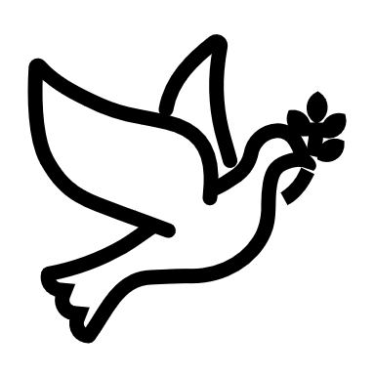

We listen | We pass the peace | We read along | We give our offering of time, talent and treasure | We stand | We sing if we are at home | We pray | We respond | We participate  in the Word  with Children
(Kids – use your worship packet and the tools listed at the end of the bulletin to do all these things.)

Southminster Presbyterian Church
2nd Sunday of Advent
December 10, 2023
9:30 a.m.

Find the link for the service on one of these sites:
1) on Facebook: https://www.facebook.com/SouthminsterGlenEllyn/
2) our YouTube channel:
https://www.youtube.com/channel/UCPgWICngOvkmR1OXgCG_wiA/live
3) our web site: https://www.southminsterpc.org/
If the video feed is interrupted during the service, we will continue to record and then post the full video on Facebook and our web site as soon as possible.

1 Gathering Music
Our Photo Story today is “Angels.”

2 Welcome and Announcements
3 Lighting the Advent Wreath Lighters: the Storey family
Lighters: We light this candle in hope.
We light this candle for peace.
We light the candles of hope and peace as a sign
of the coming light of Christ.
All: Come, let us walk in the light of the Lord!
4 Response 314: Longing for Light, We Wait in Darkness (verses 1, 2)
(Christ, Be Our Light)
Longing for light, we wait in darkness.
Longing for truth, we turn to you.
Make us your own, your holy people,
Light for the world to see.
Christ, be our light! Shine in our hearts. Shine through the darkness.
Christ, be our light! Shine in your church gathered today.

Longing for peace, our world is troubled.
Longing for hope, many despair.
Your word alone has power to save us.
Make us your living voice.
Christ, be our light! Shine in our hearts. Shine through the darkness.
Christ, be our light! Shine in your church gathered today.

Text and Music © 1993 Bernadette Farrell (Published by OCP)
Reprinted/Streamed with permission under OneLicense.net #A-739517. All rights reserved.

5 Call to Worship (Psalm 27:14; James 5:8)
Leader: Wait for the Lord; be strong,
People: And let your heart take courage; wait for the Lord!
All: The Lord is near!
6 Hymn: Here I Am to Worship Pg. 19, gold worship supplement

7 Prayer of Confession: (unison)
Faithful God, you are at work to restore all of creation in its intended harmony. Give us your shalom that we may be reconciled to all enemies in the peace that passes all understanding through Christ Jesus our Lord. God of promise, God of hope, into our darkness come. Amen.

(Time of silence for personal prayer and confession)

8 The Good News of Jesus Christ (Isaiah 35: 1, 10)
Leader: The wilderness will rejoice; the dry land will blossom.
The people of God will return with joy and singing.
All: In the name of Jesus Christ, we are forgiven!
Thanks be to God.
9 Response 83: Come, Thou Long-Expected Jesus (verses 1, 2)
Come, though long-expected Jesus,
Born to set thy people free,
From our fears and sins release us;
Let us find our rest in thee.

Israel’s strength and consolation,
Hope of all the earth thou art;
Dear desire of every nation,
Joy of every longing heart.

Public domain

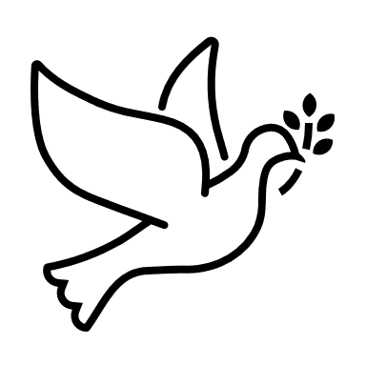
10 The Passing of the Peace
11a Word with Children (Blair Baldwin)
Children worshiping in the sanctuary, please come forward.

11b God Welcomes All Hymnal 399
God welcomes all, strangers and friends;
God’s love is strong and it never ends.

Text: John L. Bell, 2008
Music: South African song, transc, John L. Bell, 2008
Text and Music Transcr. © 2008 WGRG, Iona Community (admin. GIA Publications, Inc.)
Reprinted/Streamed with permission under OneLicense.net #A-739517. All rights reserved.

12 Prayer for Illumination
13 Scripture Lessons: Isaiah 40:1-5 Pew Bible, p. 667, O.T.)
Isaiah 40:6-11 Pew Bible, p. 667 (O.T.)
14 Sermon: “Peace”

15 Saying What We Believe/Affirmation of Faith (unison) 2 Corinthians 1:3-4

Blessed be the God and Father of our Lord Jesus Christ, the Father of mercies and the God of all consolation, who consoles us in all our affliction, so that we may be able to console those who are in any affliction with the consolation with which we ourselves are consoled by God.

16 Hymn 87: Comfort, Comfort Now My People (all 3 verses)

17 Prayers of the People and the Lord’s Prayer
Leader: Lord, in your mercy,
People: hear our prayers.
The Lord’s Prayer: (unison)
Our Father who art in heaven, hallowed be thy name. Thy kingdom come,
thy will be done, on earth as it is in heaven. Give us this day our daily bread;
and forgive us our debts, as we forgive our debtors; and lead us not into
temptation, but deliver us from evil. For thine is the kingdom and the power
and the glory, forever. Amen.
Offering of Ourselves and Our Gifts
[The offering plate is at the back of the sanctuary. Please leave your gift or pledge
in the plate on your way into or out of worship.]

18 Offertory: Comfort Ye My People Handel

19 *Response 93: Lift Up Your Heads, Ye Might Gates (verse 1)
Lift up your heads, ye mighty gates;
Behold the King of glory waits;
The king of kings is drawing near;
The Savior of the world is here.

Public domain

20 Prayer of Thanksgiving and Dedication

21 Hymn 106: Prepare the Way, O Zion (all 3 verses)

22 Charge and Benediction
Leader: Now go and serve the Lord,
All: For we are blessed to be a blessing!
Amen! Amen!
23 Postlude: Every Valley Shall Be Exalted Handel

Participants and Technical Crew
Rev. Wendy Boden
Liturgist: Ann Anderson
Greeter/Fellowship: Sue Knisely
Music: Tom Anderson; Derek Buckley
Worship Assistant: David Kozich
Tech support: Chris Kozich, Blair Nelson
The flowers today are given by the Bohi/Parks family celebrating Elspeth’s birthday.

Good Morning to our Children:

To complete all the activities in this worship folder you will need:
- ears to hear
- a mouth to sing
- hands to fold
- eyes to read
- a brain to think
- a worship kit including:
  - something to color with – crayons, markers or colored pencils
  - something to write with, like a pen or pencil
  - something to write on, like a table or a clipboard
  - scissors and tape
If you would like a worship kit for your child, please contact Pastor Wendy (wendy@southminsterpc.org) and one will come to you!

A Guide to Our Worship Symbols

We listen: “Basically, the sermon is God’s dynamic, eternal Word spoken to us in such a way that we might hear what God has to say to us and be encouraged to follow the Lord
in faith.

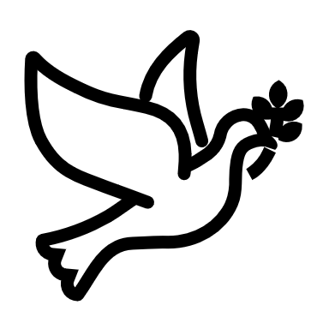 | We pass the peace: “…We greet one another with the peace of Christ as common forgiven sinners. As we are forgiven, so we forgive. This is also a good time to reconcile with those family members who drove us crazy trying to get to church on time, church members with whom we have tensions, or people we're not so happy to see.”
 | We read along: “God’s Word comes to us in many ways—through scripture, special music, sermons. Listen for God's eternal Word addressing you with good news about the Lord’s love for you and all people.”
 | We give our offering of time, talent, and treasure: “This is the time when we give ourselves, all that we are, and all that we have, to God’s service. As a symbol of what is of value to us, we make an offering… to promote the gospel.”
 | We stand: “We stand as a way of saying, “This is where I stand,” and as a way of standing in continuity with the people of God of ages past…”
 | We sing: “…We sing praise with hearts and minds (even if that's a little out of tune), just enjoying God for who God is. As we open up the pathways of breath to sing praise, we make space for the Spirit breath to fill us.” Even if we simply listen and read the words, we are praising God.
 | We pray: The first thing we do is pray—for our world, the church, other people, and ourselves. The prayer is our prayer as a church. One person may pray for us, but we are all praying together as one in our hearts, continuing Christ’s ministry of prayer for the world.”
 | We respond: Responding by writing or drawing helps us remember what we are hearing and is a chance to express our beliefs.
 | We participate in the Word with Children: It is called the Word WITH Children because the whole church is invited to listen with the fresh, faith-filled ears of children to the proclaimed message.

Worship Symbols Guide based on Our Order of Worship by Teresa Lockhart Stricklen, Associate for Worship, Presbyterian Church (USA) found at:
https://www.pcusa.org/site_media/media/uploads/theologyandworship/pdfs/order_of_worship_brochure_dec_2008.pdf. Edited.

