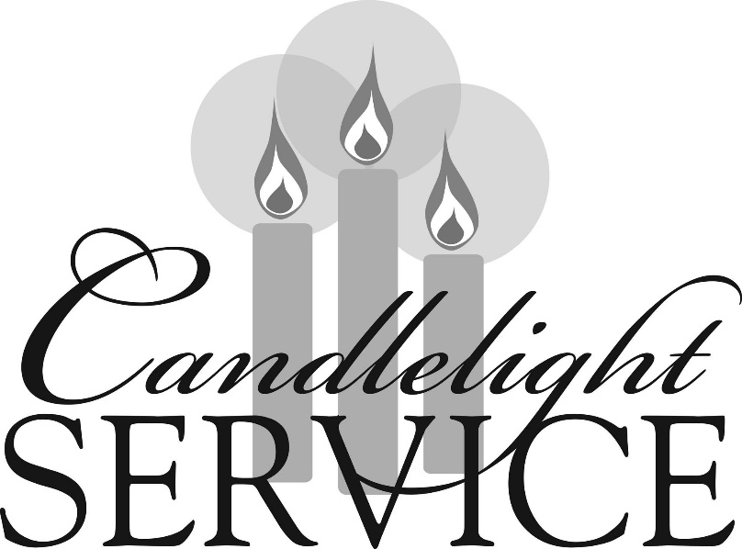

Southminster Presbyterian Church
Christmas Eve
December 24, 2023
4:30 p.m.

Find the link for the service on one of these sites:
1) on Facebook: https://www.facebook.com/SouthminsterGlenEllyn/
2) our YouTube channel:
https://www.youtube.com/channel/UCPgWICngOvkmR1OXgCG_wiA/live
3) our web site: https://www.southminsterpc.org/
If the video feed is interrupted during the service, we will continue to record and then post the full video on Facebook and our web site as soon as possible.

- Gathering Music:
The Snow Lay on the Ground (116)
While Shepherds Watched Their Flocks (117)
While Shepherds Watched Their Flocks (118)
Still, Still, Still (124)
Once in Royal David’s City (140)

Our Photo Story tonight is “Nativity Scenes.”

2 Words of Welcome
3 Piano and Trumpet Prelude: O Come, All Ye Faithful
4 Introit: O Holy Night Adolphe Adam
5 Call to Worship (Isaiah 9:6-7)
Leader: Unto us a Child is born, unto us a Son is given:
and the government shall be upon His shoulder.
People: And His name shall be called Wonderful Counselor,
Mighty God, Everlasting Father, Prince of Peace.
6 Opening Prayer: (unison)
O Emmanuel, you are our king and judge, the one whom the peoples await
and their Savior. O come and save us, Lord, our God. Amen.

7 Scripture Reading: Isaiah 9:2-7
8 Lighting of the Christ Candle Koska Family
Leader: We light these candles as a sign of the coming of Christ.
Advent means coming. We are preparing ourselves for the days
when the people who walked in darkness have seen a great light;
those who lived in a land of deep darkness, on them the light has shined.
People: Let us walk in the light of the Lord.

9 Carol 133: O Come, All Ye Faithful (verse 1)
O come, all ye faithful, joyful and triumphant;
O come ye, O come ye to Bethlehem!
Come, and behold him, born the King of angels!
O come, let us adore him; O come, let us adore him;
O come, let us adore him, Christ the Lord!

Public domain

10 Scripture Reading: Isaiah 11:1-6
11 Hymn 108: Of the Father’s Love Begotten (verses 1. 3. 5)
Of the Father's love begotten,
Ere the worlds began to be,
He is Alpha and Omega;
He the source, the ending he,
Of the things that are, that have been,
And that future years shall see,
Evermore and evermore!

O, that birth forever blessed
When the Virgin, full of grace,
By the Holy Ghost conceiving,
Bore the Savior of our race,
And the babe, the world’s redeemer,
First revealed his sacred face,
Evermore and evermore!

Christ, to thee with God the Father,
And, O Holy Ghost, to thee,
Hymn and chant and high thanksgiving
And unwearied praises be.
Honor, glory, and dominion,
And eternal victory,
Evermore and evermore!

Public domain

12 Scripture Reading: Micah 5:2-5a
13 Carol 121: O Little Town of Bethlehem (verses 1, 4)
O little town of Bethlehem, how still we see thee lie!
Above the deep and dreamless sleep the silent stars go by.
Yet in thy dark street shineth the everlasting light;
The hopes and fears of all the years are met in thee tonight.
O holy child of Bethlehem, descend to us, we pray;
Cast out our sin and enter in, be born in us today.
We hear the Christmas angels the great glad tidings tell;
O come to us, abide with us, our Lord Emmanuel.

Public domain

14 Scripture Reading: Luke 2:1-7
15 Carol 143: Angels from the Realms of Glory (verses 1, 4)
Angels from the realms of glory, wing your flight o’er all the earth;
You who sang creation’s story, now proclaim Messiah’s birth:
Come and worship, come and worship, worship Christ the newborn king!

All creation join in praising God the Father, Spirit, Son,
Evermore your voices raising to the eternal Three in One:
Come and worship, come and worship, worship Christ the newborn king!

Public domain

16 Scripture Reading: Luke 2:8-20
17 Carol 119: Hark! The Herald Angels Sing (verses 1-3)
Hark! The herald angels sing, “Glory to the newborn king.
Peace on earth and mercy mild, God and sinners reconciled!”
Joyful, all ye nations, rise; join the triumph of the skies;
With angelic host proclaim, “Christ is born in Bethlehem!”
Hark! The herald angels sing, “Glory to the newborn king.”

Christ, by highest heaven adored, Christ the everlasting Lord,
Late in time behold him come, offspring of the virgin’s womb.
Veiled in flesh the Godhead see; hail the incarnate deity,
Pleased in flesh with us to dwell, Jesus, our Emmanuel.
Hark! The herald angels sing, “Glory to the newborn king.”

Hail the heaven-born Prince of Peace! Hail the sun of righteousness!
Light and life to all he brings, risen with healing in his wings.
Mild he lays his glory by, born that we no more may die,
Born to raise us from the earth, born to give us second birth.
Hark! The herald angels sing, “Glory to the newborn king.”

Public domain

18 Meditation: “What Will You Sing?”
18a Carol 123: It Came Upon the Midnight Clear (verses 1, 5)
It came upon the midnight clear,
That glorious song of old,
From angels bending near the earth,
To touch their harps of gold:
“Peace on the earth, good will to all,
From heaven's all gracious King”:
The world in solemn stillness lay,
To hear the angels sing.

For lo, the days are hastening on,
By prophets seen of old,
When with the ever-circling years
Shall come the time foretold,
When peace shall over all the earth
Its ancient splendors fling,
And the whole world give back the song
Which now the angels sing.

Public domain

Special Christmas Offerings (see last page)
[The offering plate is at the back of the sanctuary. Please leave your gift or pledge
in the plate on your way into or out of worship.]
19 Offertory Anthem: African Noel Patrick M. Liebergen

20 Response: Bring a Torch, Jeanette Isabella tune: Hymnal #110
Bring a torch, Jeanette Isabella,
Bring a torch, to the stable run!
Christ is born; tell the folk of the village;
Jesus is born, and Mary’s calling,
Ah! Ah! Beautiful is the mother;
Ah! Ah! Beautiful is her child.

Public domain

[Please stand in body or in spirit as we begin to sing.]
21 Lighting of the Candles
[The candle lighters will light the candle of the worshiper in the seat nearest the aisle.
No lit candles should be dipped – dip only the unlit candle. During the candle lighting,
the lights in the sanctuary will be off. Extinguish your candle when the lights are turned on following the Benediction.]

[Ushers, please lower lights.]

22 Scripture Reading: John 1:1-18

23 Carol 122: Silent Night, Holy Night!
Silent Night! Holy Night! All is calm, all is bright
‘Round yon Virgin mother and child! Holy Infant, so tender and mild,
Sleep in heavenly peace, Sleep in heavenly peace.
Silent Night! Holy Night! Shepherds quake at the sight,
Glories stream from heaven afar, heavenly hosts sing “Alleluia;
Christ the Savior is born, Christ the Savior is born!”
Silent Night! Holy Night! Son of God, love's pure light
Radiant beams from thy holy face, with the dawn of redeeming grace,
Jesus, Lord, at thy birth, Jesus, Lord, at thy birth.
Silent Night! Holy Night! Wondrous star, lend thy light;
With the angels let us sing, Alleluia to our King;
Christ the Savior is born, Christ the Savior is born.

Public domain

24 Christmas Prayer: (unison)
O God, as you came in the stillness of the night, be born in our lives this night. Overcome darkness with the light of Christ’s presence, so that we may clearly see
the way to walk, the truth to speak, and the life to live, in the name of Jesus Christ,
our Lord and Savior. Amen.

25 Carol 134: Joy to the World!
Joy to the world! the Lord is come:
Let earth receive her king;
Let every heart prepare him room,
And heaven and nature sing,
And heaven and nature sing,
And heaven, and heaven and nature sing.
Joy to the world! the Savior reigns;
Let all their songs employ;
While fields and floods, rocks hills, and plains
Repeat the sounding joy,
Repeat the sounding joy,
Repeat, repeat the sounding joy.
No more let sins and sorrows grow,
Nor thorns infest the ground;
He comes to make his blessings flow
Far as the curse is found,
Far as the curse is found,
Far as, far as the curse is found.
He rules the world with truth and grace,
And makes the nations prove
The glories of his righteousness
And wonders of his love,
And wonders of his love,
And wonders, wonders of his love.

Public domain

26 Benediction
[Please raise lights after candles are extinguished.]

27 Postlude

Participants and Technical Crew
Rev. Wendy Boden
Liturgist: Sarah Allen
Greeter: Barb Kocinski
Christ candle lighters: Koska Family
Musicians: Tom Anderson; David Kozich, trumpet; Derek Buckley; Southminster Choir
Worship Associate: David Kozich
Tech support: Chris Kozich, Blair Nelson

The poinsettias were given by the following people:
Craig and Sarah Allen Caroline and Ralph Linde
Sue and Walt Briney Del Meester
Jonathan and Derek Buckley Lanny Russell
Linda Ellinghausen The Sanders family
Lynn Ferino Angela Smith
Victor King Diane Swiss
Barb and Joe Kocinski Rita Zapel
The Kozich family Barb Zink

Blessed Christmas!

You are invited to join us on Facebook (https://www.facebook.com/SouthminsterGlenEllyn/), where we have a live sharing of “Heart to Heart” with Pastor Wendy Boden at 4:20 p.m. most weeks Tuesday through Friday. This week and next, because of the holidays “Heart to Heart” will be live on Wednesday-Friday.
We’re also live on Sunday morning for worship at 9:30 a.m. (slideshow beginning at 9:15) on YouTube at https://www.youtube.com/channel/UCPgWICngOvkmR1OXgCG_wiA/live
or on Facebook at https://www.facebook.com/SouthminsterGlenEllyn/
You can also find links to recordings of the weekday sessions, special services, and Sunday worship posted on our web site: https://www.southminsterpc.org/ or by going to our YouTube channel:
https://www.youtube.com/channel/UCPgWICngOvkmR1OXgCG_wiA/videos

 Tonight’s Local Mission Offering supports the Southminster Mission Budget. 75% of monies go right into the Mission Budget and 25% to our special 2023 designee, Glen Ellyn Walk-In Ministry. Place your offering in the envelopes labeled “Southminster Local Mission.” It is amazing what your love and gifts can do! Every gift makes a difference!
We are also receiving the Christmas Joy Offering, supporting education, leadership development, and assistance to retired church workers. Please give generously.
If you did not receive these offering envelopes by mail and would like to contribute to either offering, write, mail, or drop off a check to Southminster with “Christmas Joy” or “Local Mission” written on the memo line. If you want this contribution to be listed on your 2023 year-end statement, it needs to be received by noon on Tuesday, January 2.

 2024 Offering Envelopes will be available in the new year.

Remember that we love God and neighbor. Our address is 680 South Park Blvd., Glen Ellyn, IL 60137 if you would like to set up an online account with your bank or mail in your pledge. Online giving through Vanco is also now an option – contact Ron Birchall for instructions for setting up this method of giving.

Grace and peace to you!

