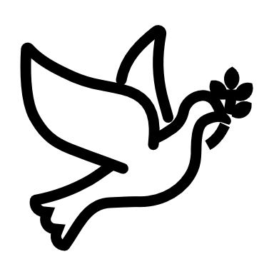

We listen | We pass the peace | We read along | We give our offering of time, talent and treasure | We stand | We sing if we are at home | We pray | We respond | We participate  in the Word  with Children
(Kids – use your worship packet and the tools listed at the end of the bulletin to do all these things.)

Southminster Presbyterian Church
1st Sunday of Christmas
December 31, 2023
9:30 a.m.

Find the link for the service on one of these sites:
1) on Facebook: https://www.facebook.com/SouthminsterGlenEllyn/
2) our YouTube channel:
https://www.youtube.com/channel/UCPgWICngOvkmR1OXgCG_wiA/live
3) our web site: https://www.southminsterpc.org/
If the video feed is interrupted during the service, we will continue to record and then post the full video on Facebook and our web site as soon as possible.

1 Gathering Music
Our Photo Story today is “Timekeepers.”

2 Welcome and Announcements
3a Lighting the Candles (Isaiah 43:18-19a)
“Forget the former things; do not dwell on the past.
See, I am doing a new thing! Now it springs forth;
do you not perceive it?”

3b Prelude: He Is Born, the Divine Christ Child arr. Alexander

[Please remain seated while singing the opening song.]
4 Hymn 111: From Heaven Above (verses 1, 5)

5 Call to Worship
Leader: It is time to celebrate new beginnings.
People: With faith in God we greet in the New Year!
Leader: It is time to look ahead with hope in God.
People: Into the unknown we step forward with love!
Leader: People, it is time to walk in the footsteps of Jesus.
All: Together we step forward as God’s community.
6 Hymn 150: As with Gladness Men of Old (all 4 verses)

7 Prayer of Confession: (unison)
Lord God, it is in admitting the truth of our lives that we make the first step forward wholeness and healing. Forgive the wrong we have done and bless the good we have accomplished. We ask in the name of Jesus Christ, who is both savior and Lord. Amen.

(Time of silence for personal prayer and confession)

8 Declaration of God’s Grace/The Good News of Jesus Christ (1 John 1:4-7)
Leader: What you are longing and hoping for is nearer than you know:
People: Jesus Christ is Emmanuel, God with us.
We rejoice in the good news.
All: In Jesus Christ we are forgiven and made new.
9 Response 137: He Came Down (all 4 verses)
He came down that we may have love;
He came down that we may have love;
He came down that we may have love;
Hallelujah forever more.

2. He came down that we may have light…
3. He came down that we may have peace…
4. He came down that we may have joy…

Text: Camaroon traditional
Tune: Camaroon traditional, transcribed and arr. by John L. Bell © 1990, Iona Community,
GIA Publications, Inc., agent
Reprinted/Streamed with permission under OneLicense.net #A-739517. All rights reserved.

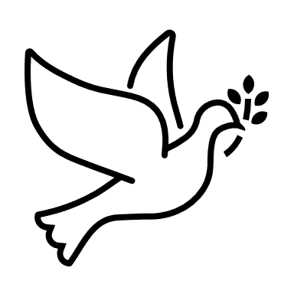
10 The Passing of the Peace
11a Word with Children
Children worshiping in the sanctuary, please come forward.

11b Carol: Good King Wenceslas
Verse 1
Good King Wenceslas looked out on the Feast of Stephen,
When the snow lay round about, deep and crisp and even.
Brightly shone the moon that night, though the frost was cruel,
When a poor man came in sight, gath’ring winter fuel.

Public domain

12 Prayer for Illumination
13 Scripture Lessons: Matthew 2:1-8 Pew Bible, p. 2, N.T.)
Mark 1:1-8 Pew Bible, p. 34, (N.T.)
14 Sermon: “We Are Not the Star”

15 Singing What We Believe/Affirmation of Faith
I Heard the Bells on Christmas Day
Verse 1
I heard the bells on Christmas day
Their old familiar carols play,
And wild and sweet the words repeat
Of peace of earth, good will to men.

Verse 2
I thought how, as the day had come,
The belfries of all Christendom
Had rolled along th'unbroken song
Of peace on earth, good will to men.

Verse 3
And in despair I bowed my head:
"There is no peace on earth," I said,
"For hate is strong, and mocks the song
Of peace on earth, good will to men."

Verse 4
Then pealed the bells more loud and deep:
"God is not dead, nor doth He sleep;
The wrong shall fail, the right prevail,
With peace on earth, good will to men."

Verse 5
Till ringing singing on its way
The world revolved from night to day,
A voice, a chime, a chant sublime
Of peace on earth goodwill to men.

Public domain

16 Prayers of the People and the Lord’s Prayer
Leader: Lord, in your mercy,
People: hear our prayers.
The Lord’s Prayer: (unison)
Our Father who art in heaven, hallowed be thy name. Thy kingdom come,
thy will be done, on earth as it is in heaven. Give us this day our daily bread;
and forgive us our debts, as we forgive our debtors; and lead us not into
temptation, but deliver us from evil. For thine is the kingdom and the power
and the glory, forever. Amen.
Offering of Ourselves and Our Gifts
[The offering plate is at the back of the sanctuary. Please leave your gift or pledge
in the plate on your way into or out of worship.]

17 Offertory: Star Carol Wihla Hutson/Alfred Burt

18 Response 151: We Three Kings of Orient Are (refrain)
O star of wonder, star of night,
Star with royal beauty bright,
Westward leading, still proceeding,
Guide us to thy perfect light.

Public domain

19 Prayer of Thanksgiving and Dedication

20 Hymn 152: What Star Is This with Beams So Bright (verse 1)
What star is this with beams so bright,
More lovely than the noonday light?
'Tis sent to announce a newborn king,
Glad tiding of our God to bring.

Public domain

21 Charge and Benediction
Leader: Now go and serve the Lord,
All: For we are blessed to be a blessing!
Amen, amen!
22 Postlude: Auld Lang Syne

Participants and Technical Crew
Rev. Wendy Boden
Liturgist: Gretchen Fleming
Greeter/Fellowship: Louanne Jourdan
Music: Cindy Trowbridge, piano; Victor King; Nick Kaskovich, accordion
Worship Assistant: David Kozich
Tech support: Chris Kozich, Blair Nelson
Poinsettia plant(s) are in appreciation of all the beautiful musical talent shared during Advent and Christmas.

Good Morning to our Children:

To complete all the activities in this worship folder you will need:
- ears to hear
- a mouth to sing
- hands to fold
- eyes to read
- a brain to think
- a worship kit including:
  - something to color with – crayons, markers or colored pencils
  - something to write with, like a pen or pencil
  - something to write on, like a table or a clipboard
  - scissors and tape
If you would like a worship kit for your child, please contact Pastor Wendy (wendy@southminsterpc.org) and one will come to you!

A Guide to Our Worship Symbols

We listen: “Basically, the sermon is God’s dynamic, eternal Word spoken to us in such a way that we might hear what God has to say to us and be encouraged to follow the Lord
in faith.

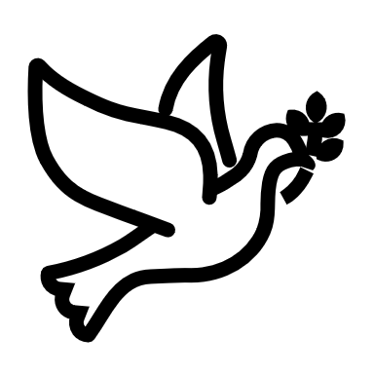 | We pass the peace: “…We greet one another with the peace of Christ as common forgiven sinners. As we are forgiven, so we forgive. This is also a good time to reconcile with those family members who drove us crazy trying to get to church on time, church members with whom we have tensions, or people we're not so happy to see.”
 | We read along: “God’s Word comes to us in many ways—through scripture, special music, sermons. Listen for God's eternal Word addressing you with good news about the Lord’s love for you and all people.”
 | We give our offering of time, talent, and treasure: “This is the time when we give ourselves, all that we are, and all that we have, to God’s service. As a symbol of what is of value to us, we make an offering… to promote the gospel.”
 | We stand: “We stand as a way of saying, “This is where I stand,” and as a way of standing in continuity with the people of God of ages past…”
 | We sing: “…We sing praise with hearts and minds (even if that's a little out of tune), just enjoying God for who God is. As we open up the pathways of breath to sing praise, we make space for the Spirit breath to fill us.” Even if we simply listen and read the words, we are praising God.
 | We pray: The first thing we do is pray—for our world, the church, other people, and ourselves. The prayer is our prayer as a church. One person may pray for us, but we are all praying together as one in our hearts, continuing Christ’s ministry of prayer for the world.”
 | We respond: Responding by writing or drawing helps us remember what we are hearing and is a chance to express our beliefs.
 | We participate in the Word with Children: It is called the Word WITH Children because the whole church is invited to listen with the fresh, faith-filled ears of children to the proclaimed message.

Worship Symbols Guide based on Our Order of Worship by Teresa Lockhart Stricklen, Associate for Worship, Presbyterian Church (USA) found at:
https://www.pcusa.org/site_media/media/uploads/theologyandworship/pdfs/order_of_worship_brochure_dec_2008.pdf. Edited.

