Southminster Presbyterian Church
8th Sunday after Pentecost
August 3, 2025
9:30 a.m.

Find the link for the service on one of these sites:
1) on Facebook: https://www.facebook.com/SouthminsterGlenEllyn/
2) our YouTube channel:
https://www.youtube.com/channel/UCPgWICngOvkmR1OXgCG_wiA/live
3) our web site: https://www.southminsterpc.org/
If the video feed is interrupted during the service, we will continue to record and then post the full video on Facebook and our web site as soon as possible.

For those who are in the sanctuary, please put your phone in airplane mode.

Today we are having communion. Those at home may want to gather the elements (“bread” and “wine” or whatever you have) before the service begins.

Gathering Music/Photo Story: “Gardens”

Welcome and Announcements
Lighting the Candles (Matthew 6:9-10)
Pray then like this: “Our Father in heaven, hallowed be your name. Your kingdom come, your will be done, on earth as it is in heaven.”

Prelude

[Please remain seated while singing the opening song.]
Hymn: Bring Forth the Kingdom pg. 6, gold worship supplement

Call to Worship
Leader: God of goodness, we give thanks for the gift of life, wonder beyond words.
People: For the awareness of soul, our light within.
Leader: For the world around us, so filled with beauty.
People: For the richness of the earth, which sustains us day by day.
All: With thanksgiving in our hearts, we worship God.

Hymn 506: Look Who Gathers at Christ’s Table (all)

Prayer of Confession: (unison)
Lord God, there are times when we forget who we are and whose we are- We are your beloved children. Another thing we forget is people—we want to avoid the difficult, the needy, the jagged, and the irrational people. We do not seek you; instead, we seek the shiny people, the ones who make us look good. We ask for forgiveness for our sins—such a strange word, so we also ask for forgiveness for our mistakes. Through your grace, the Holy Spirit’s power, alive in our hearts, helps us remember your love and grace in each moment. We ask this in the name of Jesus Christ, we pray. Amen.

(Time of silence for personal prayer and confession)

Declaration of God’s Grace/The Good News of Jesus Christ (2 Corinthians 5:17)
Leader: Anyone who is in Christ is a new creation.
People: The old life has gone; a new life has begun.
All: In Jesus Christ, we are forgiven.

Response 582: Glory to God, Whose Goodness Shines on Me
Glory to God, whose goodness shines on me,
And to the Son, whose grace has pardoned me,
And to the Spirit, whose love has set me free.
As it was in the beginning, is now and ever shall be. Amen.
World without end, without end. Amen.
World without end, without end. Amen.
World without end, without end. Amen.
As it was in the beginning, is now and ever shall be. Amen.

Text Adapt. and Music ©2008 Paul M. Vasile
Reprinted/Streamed with permission under OneLicense.net #A-739517. All rights reserved.

The Passing of the Peace

Word with Children Blair Baldwin
Children worshiping in the sanctuary, please come forward.

As the children leave:
He’s Got the Whole World in His Hands
He’s got the whole world in his hands,
He’s got the whole world in his hands,
He’s got the whole world in his hands,
He’s got the whole world in his hands!

He’s got the little tiny baby in his hands,
He’s got the little tiny baby in his hands,
He’s got the little tiny baby in his hands,
He’s got the whole world in his hands!

Public domain

Prayer for Illumination

Scripture Lessons: Leviticus 2:11-13; 7:11-13; 23:17 Pew Bible, pgs. 89, 93, 110 (O.T.)
Luke 13:18-21 Pew Bible, p. 76 (N.T.)
Matthew 13:33-34 Pew Bible, p. 15 (N.T.)

Sermon: “The Kingdom of God Is Like Hidden Yeast”

Saying What We Believe/Affirmation of Faith (unison)
from The Book of Order (PCUSA) [F-1.0302d]

The Church is sent to be Christ’s faithful evangelist:
making disciples of all nations in the name of the Father, the Son,
and the Holy Spirit;
sharing with others a deep life of worship, prayer, fellowship, and service;
and participating in God’s mission to care for the needs of the sick,
poor, and lonely; to free people from sin, suffering, and oppression;
and to establish Christ’s just, loving, and peaceable rule in the world.

Hymn 771: What Is the World Like (all)

Offering of Ourselves and Our Gifts
[The offering plate is at the back of the sanctuary. Please leave your gift or pledge
in the plate on your way into or out of worship.]

Offertory: How Great Thou Art
Jessica Bohi Parks

*Doxology Hymnal #606
Praise God, from whom all blessings flow;
Praise Him all creatures here below;
Praise Him above, ye heavenly host;
Praise Father, Son, and Holy Ghost. Amen.

Public domain

Prayer of Dedication

Service of the Lord’s Supper
Invitation
[You do not need to wait to consume the elements – please do so as the Spirit
leads (right away, as you pause after receiving, or back in your seats).
We extend an invitation to the Lord’s Supper to all who have been baptized. You do
not need to be a member of this congregation or a Presbyterian to share in this meal.
We remember that access to the Table is not a right conferred upon the worthy, but a
privilege given to believers who come in faith, repentance, and love.]

Great Prayer of Thanksgiving
Leader: The Lord be with you.
People: And also with you.
Leader: Lift up your hearts.
People: We lift them to the Lord.
Leader: Let us give thanks to the Lord our God.
People: It is right to give our thanks and praise.

The minister gives thanks…

The congregation responds by singing together:

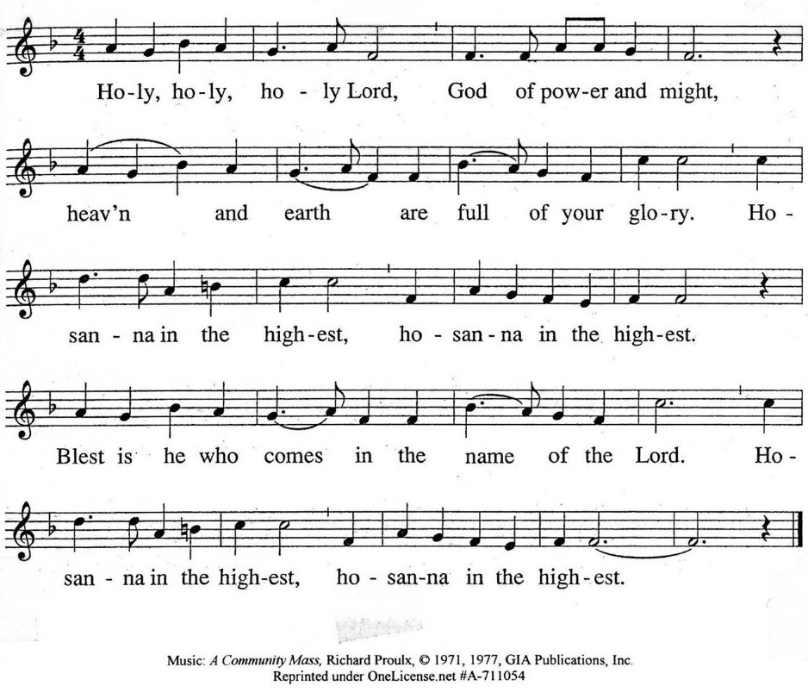

The minister continues the Thanksgiving…
“Together we proclaim the great mystery of faith:”
According to Christ’s commandment
We remember his death,
We proclaim his resurrection,
We await his coming in glory.

The minister continues with Intercessions for the Church and the World
and Prayers of the People…
Leader: Lord, in your mercy,
People: hear our prayers.
Our Lord’s Prayer
Our Father who art in heaven, hallowed be thy name. Thy kingdom come,
thy will be done, on earth as it is in heaven. Give us this day our daily bread;
and forgive us our debts, as we forgive our debtors; and lead us not into temptation, but deliver us from evil. For thine is the kingdom and the power
and the glory, forever. Amen.

Words of Institution
Communion
Communion Music: Come Sunday Duke Ellington
David Kozich, trumpet

We all will receive communion by coming to the Lord’s Table. Our usher will invite you to come forward by pew, beginning from the back. If you are unable to come forward, a server will come to you after everyone else has received. Choir members will remain seated and receive after the congregation.
Please consume the elements when you are comfortable doing so. You do not need to wait – please do so as the Spirit leads (right away, as you pause after receiving, or back in your seats).
With Christian love we serve gluten-free communion bread and alcohol-free grape juice.
Also with Christian love the elements were prepared with strict attention to health concerns.
You are invited to partake of the prepackaged communion juice and wafer if you choose; we now offer prepackaged cups that include gluten-free wafers.

Prayer after Communion

Hymn 749: Come! Live in the Light! (We Are Called) (all)

Charge and Benediction
Leader: Now go and serve the Lord,
People: For we are blessed to be a blessing! Alleluia!

Postlude

Participants and Technical Crew
Rev. Wendy Boden
Liturgist: Deb Bohi
Greeter/Fellowship: Kathy Sanders
Elder at the Door: Angela Smith
Musicians: Tom Anderson, Jessica Bohi Parks, David Kozich
Worship Associate: David Kozich
Tech support: Chris Kozich, Blair Nelson

The flowers today are in honor of the life of Caroline Linde.

Care Notes: “In everything by prayer and supplication with thanksgiving let your requests be made known to God.” -Philippians 4:6
Even though we aren’t all together for worship, we are still collecting prayer requests! Please email or leave a message on our answering machine at 630-469-9149 if you won’t be present to fill out a prayer request slip.

Friends,
Please make a point of sending an email, text, phone call, or filling out a blue prayer request and letting the people of Southminster know who you would like us to keep in prayer. All prayer requests are welcome. We want to be able to know who to talk to in order to follow up on all the people we pray for each week.

New requests and updates are italicized in our prayer list.

Joys and Concerns
The flowers today are in honor of the life of Caroline Linde.
We give thanks to God for joys: (Romans 12:15) “Rejoice with those who rejoice, weep with those who weep.”
- We thank you that Lynn Ferino’s friend, Cis, had a clear scan.
- Welcome baby Celeste, brand new daughter of our nursery worker, Jessica Abuseini!
- Welcome baby Evelyn MaryAnn, born at 7.3 pounds, 20.5 inches, daughter of Eric and Rebecca Storey!
- Rebecca Storey’s friend, Brian received his heart transplant. We pray for his recovery and pray for comfort for the family that donated his new heart..
- We thank you that Marta had a stable scan.
We pray for the whole world and our nation: (1 Timothy 2:1-2) “I urge, then, first of all, that petitions, prayers, intercession, and thanksgiving be made for all people— for kings and all those in authority, that we may live peaceful and quiet lives in all godliness and holiness.”
- All who have been affected by the devastating flooding in Texas, New Mexico, and North Carolina. (The area affected in North Carolina is in Alamance and Orange Counties, where Blair Baldwin is from.)
- May everyone have food, shelter, clean water, clothing, health, and loving relationships.
- To our trans siblings and families, we offer our prayers for serenity and peace.
- Lord, may you guide all our leaders to live peaceful and quiet lives.
- We bless the judicial branch of our nation with wisdom, discernment, and courage.
- We lift up a world burning with hate: quench the fires and pour out your love that all may live in peace.
- We pray for people in prison, that they may know you have not forgotten them.
- We pray for an end to gun violence in our nation; particularly we hold before you those that use force and guns as political weapons. Reach out to those who are desperate enough to resort to guns to resolve their issues and pain. Bring comfort to those who have suffered loss due to gun violence. May our public servants collaborate to address this critical issue.
Blessed are those who mourn: (Romans 12:15) “Rejoice with those who rejoice, weep with those who weep.”
- The family of Davina J. Anderson-Burnett, the Rev. Danita Anderson’s sister, whose celebration of life was held on Friday, August 1.
- The family and friends of Lori Davis, a coworker of Steve Shierry, who died of metastatic cancer
We continue to lift up the families and friends of:
- Blanche “Buzz” Hays, Heather Kralicek’s mother
- William Briney, Walter’s brother
- Brooke Nicole McMorris, the Brineys’ granddaughter
- Alicia Rasnic
- Bobette Barfod, our pastor’s mother
- Joan Koska
- Linda Wolf Jeziorski and her husband, Paul
- Those we name in our hearts and hold dear.
We lift up those affected by cancer, along with their support systems:
Please help us pray for your family and friends by updating the church office with information about your loved ones. We support them and you in this journey.
- Heather Kralicek requests prayers for Sue Booker, recently diagnosed with bile duct cancer and is back in the hospital.
We continue to pray for Alyssa, Kerri, Margaret F., Marge H., Ginny O., Marta S., Meagan S., Shelayne, Kurt Parent, who is now in palliative care, former President Joe Biden, and those we name in our hearts.
We pray for all who are recovering from or dealing with mental, physical, or other health challenges:
- Francine Long asks for prayers for family members with mental health struggles
- Prayers for Brad Gary, having serious ramifications from kidney disease
- Prayers for a diagnosis soon for Sue M., Barb Doppelt’s friend, who has been hospitalized all week with a fever of unknown origin that has persisted for almost 3 weeks
- We pray for a complete clean-up and renovation of their basement for Eric and Becca Storey, after a flood… all while they’re also caring for a newborn.
- Sandy Phee asks prayers for her sister, Linda, as she adjusts to her lack of eyesight.
- Donna Marton requests prayers for her brother, Richard, who is in ICU at UW Hospital with several medical issues
- Please continue praying for Deb Bohi, who is healing well from surgery.
- Please also continue prayers for Deb Bohi’s brother, Tom; doctors are not in agreement about his treatment.
- Baby “Sonny,” child of Meghan and Quinn (friends of Rebecca Storey), who was born at 26 weeks, is growing – he’s up to 6 lbs. 6 oz. and 18.5 inches now! He remains in the NICU on CPAP.
- John Pezl’s friend, Terry McGrath, has improved and has “graduated” to Marianjoy.
- Gretchen Fleming’s sister-in-law, Ruth, hospitalized with a broken hip - Helen Shierry is now in hospice care. We continue to pray for Steve and Heidi as they support her in her declining health.
- We lift up people struggling with anxiety and depression.
- Heather Kralicek’s father, Carl Hays, who has suffered several silent strokes.
- Jim Smith, at Brookdale, and all those in care centers.
Prayers for our worshiping community and the Jeremiah Task Force as we discern God’s call to SPC for the 21st century.

This week at Southminster:
Sunday, August 3
Worship with communion at 9:30 a.m. in person and also live on Facebook.
Fellowship will follow the service
Staff Meeting, 11:00 a.m., Pastor’s Office
Adult Ed. Bible Study, 11:15 a.m. in McHenry Parlor/Library
No Youth activity
Monday, August 4 – Pastor’s Sabbath
Tuesday, August 5
Staff calendar meeting, 12:30 p.m., McHenry Parlor/Library
Mission, 7:00 p.m., McHenry Parlor/Library (Note new time!)
A.A., 7:30 p.m., Fellowship Hall
Wednesday, August 6
Women’s Breakfast, 8:30 a.m., Danby’s Station
August Dialog goes out
Thursday, August 7
Young Adult Video Club, 8:30 p.m.
Friday, August 8
A.A., 6:30 p.m., Fellowship Hall
Next Sunday, August 10
Worship at 9:30 a.m. in person and also live on Facebook.
Fellowship will follow the service
Staff Meeting, 11:00 a.m., Pastor’s Office
No Adult Ed. Bible Study or Youth activity
If you are online, we’re glad to have you! Using the comments section on Facebook, you can say hello, ask for words of peace, or request prayers.
If you are present for worship, please wear a name tag; they are on the Mission shelf in the Narthex and on the shelf across from the church offices. Following the service, you are invited by the deacons to gather for a time of fellowship in the narthex.

Our “Comfort Zone” – It is always contagion season, so we continue to have a “comfort zone” toward the back of the sanctuary. You may wear a mask, of course, if you so choose.
Sunday Morning Adult Ed. Bible Study, 11:15 a.m.: If you’re at church and wish to join us, get your coffee at fellowship time and then find Blair in the parlor/library.
You are invited to join us on Facebook (https://www.facebook.com/SouthminsterGlenEllyn/), where we have a live sharing of “Heart to Heart” with Pastor Wendy Boden at - note this change of time! – 4:20 p.m. most weeks Tuesday through Friday.
We continue to be live on Sunday morning for worship at 9:30 a.m. (slideshow beginning at 9:15) on YouTube at
https://www.youtube.com/channel/UCPgWICngOvkmR1OXgCG_wiA/live
or on Facebook at https://www.facebook.com/SouthminsterGlenEllyn/
If you are watching from home on Facebook, please check in and say hello so we can see that you have joined us. This is one way to make worship less “remote” and strengthen community at Southminster.
The live video will appear about 15 minutes before the scheduled start time.
If for any reason the feed falters, rest assured that a recording will be posted to Facebook and You Tube as soon as possible.

You can also find links to recordings of the weekday sessions, special services, and Sunday worship posted on our web site: https://www.southminsterpc.org/ or by going to our YouTube channel:
https://www.youtube.com/channel/UCPgWICngOvkmR1OXgCG_wiA/videos

Photo Stories/PowerPoints help us feel connected!
Photo Stories/PowerPoints help us prepare for worship, connect with one another, and make sure that our at-home people get both sound and sight. Here are some coming opportunities for you to share your photos:
September 14: “Vacations” – Share the places you went and things you did over
this summer. Please send photos by Thursday, Sept. 11.
September 21: “Pets” – share photos of the furry, feathery, or scaly friends you
share your life with. Please send photos by Thursday, Sept. 18.
Send photos to our dedicated email address, used just for photos:
PhotoStory@Southminsterpc.org. (If you only have hard copies of your photos, please leave them in the photo box on Pastor Wendy’s desk, labeled with your name and the date they are to be used.

Notes from Blair Nelson:
Adult Education: Our study of Philippians continues today at 11:15 a.m. in the Parlor. Bring your coffee and snacks and join us for an enriching study and discussion of the important letter. We grow together when we study together. Note that Blair is out of town Aug. 10 and 17, so there will be no Adult Ed. those days.
Men of Southminster: Be sure to have Saturday, August 23, 9:00 a.m., marked on your calendar for our next get-together. Things are happening. Be sure not to miss out!
Youth: Aug. 24 will be our next Pizzaless Games. Be sure to let Blair N. know whether you will be there.
From the Mission Ministry
Mission Ministry meets this Tuesday, August 5. Remember that our new meeting time is 7:00 p.m.
Looking ahead… we’re planning another visit to our Sister Church in Cuba
Southminster church members will be making our next trip to visit our sister church in Cuba from November 13 through November 20, 2025.
Members of the church who are interested in participating in this trip should make their interest known as soon as feasible to either Pastor Wendy Boden or the Moderator of Mission, Gretchen Fleming. Visa applications are due August 13, so you need to make your interest known now. Please also feel free to ask either of them any questions you have about the trip. Gretchen Fleming can be reached at gretchen_fleming@yahoo.com or by phone or text at (630) 517-0926.
August 6: Women’s Breakfast
Ladies, take a break from the hustle and bustle of everyday life and join us for a refreshing morning of food, fun, and fellowship! The Women’s Breakfast gathers on the first Wednesday of each month. Coming up, we’ll meet on Wednesday, August 6, at 8:30 a.m. at Danby’s Station. Whether you are new to the group or a familiar face, all women are warmly welcome.
Come hungry, leave inspired – and enjoy meaningful connections in a relaxed, welcoming atmosphere. If you need more information, contact Gretchen Fleming by phone or text to 630-517-0926 or talk to her in person at church if you see her.
Jubilee Bucks – order today!
Whether you’re giving them as gifts or using them for your own purchases, Jubilee Bucks gift cards are a win-win for you and for Southminster. Each card you purchase means a small rebate that comes back to the church, and so far this year the church has earned $1,185.87 in “free” money from the sale of the cards.
You can order Jubilee Bucks at any time up to 9:00 p.m. today – just contact Bobbi Frey at church today or by email to bobbifrey@aol.com or text at 630-643-3858.
Next chance to order: September 7
Donations for PRC (People’s Resource Center):
People’s Resource Center responds to basic human needs. In 2024 they provided 62,831 grocery carts of healthy food. They also responded to 5,342 calls for social services for help with rent or utility assistance or referrals. Recently they have reopened their clothing closet with many items for clients to choose from. We have a collection site in the main hallway where you can bring donations at any time for PRC.
Caring for you!
Our Congregational Care Committee is ready to assist in time of need. If you need assistance from the Congregational Care Ministry or Helping Hands until August 12, call Deacon Sue Knisely (630-776-7998). You may call Pastor Wendy Boden on her cell or home phone (if she has shared the numbers with you) or leave a message for her at the church office: 630-469-9149. You may email Wendy at wendy@southminsterpc.org. (Please note that she can only read email when she is in the office.) You may also call your deacon if you need help from the church.
Regular Office Schedule: The church office is closed on Mondays and Wednesdays.
Barb’s regular schedule is to be in the office Tuesdays, Thursdays, and Fridays from approximately 9:00 a.m.-3:00 p.m. while her son attends his day program on those days. Mondays and Wednesdays she works from home.
Grace and peace to you! Remember that we love God, neighbor, and one another. Our address is 680 South Park Blvd., Glen Ellyn, IL 60137 if you would like to set up an online account with your bank or mail in your pledge. Online giving through Vanco is also now an option –for details contact Ron Birchall.

Bearing Fruit – August 3, 2025
“Who is my neighbor?”

Someone asked Jesus, “Who is my neighbor?” What followed was the well-known parable of the Good Samaritan. Southminster has many neighbors.
A few months ago, a man who lives near Southminster looked at the church building and was drawn to the door of Fellowship Hall, which is located on the east side of our building, specifically on the Chicago side. He felt invited by God.
His name is Pastor Bertino Nguangua of the Centre DeReveil Spirituel La Chaudiere Church, a Congolese congregation, and he was looking for a place for his congregation to worship, about forty people. They had been worshiping in homes. The session appointed Elders Deb Bohi, Gretchen Fleming, and Angela Smith to meet, pray, and work with that congregation. The session voted at their May meeting to allow them to use Fellowship Hall on Sunday afternoons, 1:00 to 3:00, but we needed to draw up a contract or covenant. Since then, a copy of the contract covenant has been sent to The Chicago Presbytery with the understanding that this contract is a year-to-year agreement, to be renewed or not annually. The Centre DeReveil Spirituel La Chaudiere Church has secured insurance under its own name and is conducting background checks for child protection purposes. Someone from the Congo is our neighbor!
Displayed in front of our sanctuary on the chancel steps (the stage or platform area) are school supplies gathered by our guests for our first Family Fun Day, members of Southminster, and our youth group. These school supplies are for clients of World Relief. Founded in the aftermath of World War II, World Relief is a global Christian humanitarian organization that partners with local churches and communities to develop sustainable, locally-driven solutions to some of our world's most urgent problems. World Relief has been doing this work for 80 years in more than 100 countries. The supplies we have collected will help give local immigrant children a great start to the upcoming school year. These children are our neighbors.
Southminster has family and neighbors in Cuba, as well. We’re planning another visit to our Sister Church in Cuba from November 13 through November 20, 2025. If you are interested in attending, contact either the moderator of Mission, Gretchen Fleming, or our Pastor Wendy Boden. The visa application deadline is mid-August. Would you like to meet our Cuban neighbors and family?
When we are loving neighbors, we bear the fruit of God’s love.

