Southminster Presbyterian Church
2nd Sunday of Advent
December 7, 2025
9:30 a.m.

Find the link for the service on one of these sites:
1) on Facebook: https://www.facebook.com/SouthminsterGlenEllyn/
2) our YouTube channel:
https://www.youtube.com/channel/UCPgWICngOvkmR1OXgCG_wiA/live
3) our web site: https://www.southminsterpc.org/
If the video feed is interrupted during the service, we will continue to record and then post the full video on Facebook and our web site as soon as possible.

For those who are in the sanctuary, please put your phone in airplane mode.

Today we are having communion. Those at home may want to gather the elements (“bread” and “wine” or whatever you have) before the service begins.

Gathering Music/Photo Story: “Artist’s Reception”

Welcome, Announcements, and Moment for Mission
Prelude

Lighting the Advent Wreath Lighters: the Storey family
Lighters: Today, we choose to be peacemakers,
believing that the time of God’s reign has come
and is coming among us.
Prepare the way of the Lord.
All: We light these candles of peace and hope
as a sign of our promise to follow the light of Christ
as we live into peace and hope.
Lighters: Let us prepare the way of the Lord!

Advent Wreath Response (Week 2)
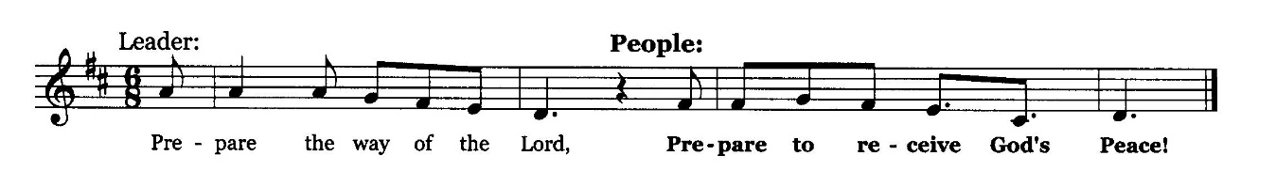

Call to Worship
Leader: God of peace, sustain us.
People: God’s house will be the home for all people.
Leader: We prepare the way of the Lord as we lay the groundwork
for hope, peace, joy, and love.
All: We prepare together as we worship God.

Hymn 83: Come, Thou Long-Expected Jesus (all)

Prayer of Confession: (unison)
Lord God, in Jesus Christ you have called us to be peacemakers, to forgive from the heart, to love our enemies, and to go the extra mile. The truth is, there are times when we simply do not want to forgive, apologize, or love our enemies. We feel that we have walked many extra miles. Renew your Spirit in us so that we may prepare the way of the Lord and make peace in our lives as we seek to bring peace to the world. We ask this in the name of the coming one, Jesus Christ, who is both Savior and Lord. Amen.

(Time of silence for personal prayer and confession)

Declaration of God’s Grace/The Good News of Jesus Christ
Leader: Hear the glad tidings of the gospel of Jesus Christ:
People: The people who walked in darkness have seen a great light!
Leader: In Jesus Christ, we are forgiven!

Response: Joy to the World Hymnal 134, verse 3
No more let sins and sorrows grow,
Nor thorns infest the ground;
He comes to make his blessings flow
Far as the curse is found,
Far as the curse is found,
Far as, far as the curse is found.

Public domain

The Passing of the Peace

Word with Children Blair Baldwin
Children worshiping in the sanctuary, please come forward.

As the children leave:
People, Look East Hymnal 105, verse 1
People look east, the time is near
Of the crowning of the year.
Make your house fair as you are able;
Trim the hearth and set the table.
People look east and sing today:
Love, the Guest, is on the way.

CCLI Song # 3011380
Eleanor Farjeon | John Ferguson
© 1999 Neil A. Kjos Music Company
For use solely with the SongSelect® Terms of Use. All rights reserved. www.ccli.com
CCLI License # 21214429

Prayer for Illumination

Scripture Lessons: Isaiah 11:1-10 Pew Bible, p. 640 (O.T.)
Luke 4:14-22 Pew Bible, p. 61 (N.T.)

Sermon: “Preparing for Peace”

Saying What We Believe/Affirmation of Faith (unison)
The Apostles’ Creed [Ecumenical]
I believe in God, the Father almighty, creator of heaven and earth.
I believe in Jesus Christ, God’s only Son, our Lord, who was conceived by the Holy Spirit, born of the Virgin Mary, suffered under Pontius Pilate, was crucified, died, and was buried; he descended to the dead. On the third day he rose again; he ascended into heaven, he is seated at the right hand of the Father, and he will come to judge the living and the dead.
I believe in the Holy Spirit, the holy catholic Church, the communion of saints, the forgiveness of sins, the resurrection of the body, and the life everlasting. Amen.

Hymn 104: O Lord, How Shall I Meet You

Offering of Ourselves and Our Gifts
[The offering plate is at the back of the sanctuary. Please leave your gift or pledge
in the plate on your way into or out of worship.]

Offertory: Behold the Lamb Keith & Kristyn Getty, Stuart Townend

*Doxology Hymnal #606
Praise God, from whom all blessings flow;
Praise Him all creatures here below;
Praise Him above, ye heavenly host;
Praise Father, Son, and Holy Ghost. Amen.

Public domain

Prayer of Dedication

Service of the Lord’s Supper
Invitation
[You do not need to wait to consume the elements – please do so as the Spirit
leads (right away, as you pause after receiving, or back in your seats).
We extend an invitation to the Lord’s Supper to all who have been baptized. You do
not need to be a member of this congregation or a Presbyterian to share in this meal.
We remember that access to the Table is not a right conferred upon the worthy, but a
privilege given to believers who come in faith, repentance, and love.]

Great Prayer of Thanksgiving
Leader: The Lord be with you.
People: And also with you.
Leader: Lift up your hearts.
People: We lift them to the Lord.
Leader: Let us give thanks to the Lord our God.
People: It is right to give our thanks and praise.

The minister gives thanks…

The congregation responds by singing together:

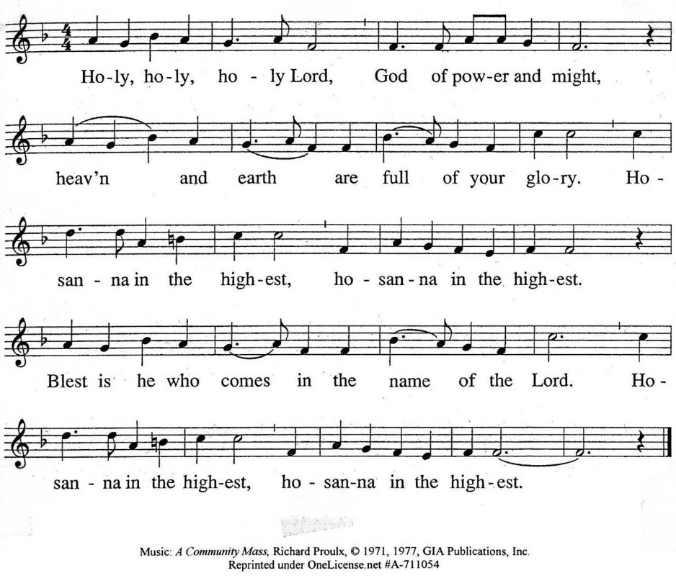

The minister continues the Thanksgiving…
“Together we proclaim the great mystery of faith:”
According to Christ’s commandment
We remember his death,
We proclaim his resurrection,
We await his coming in glory.

The minister continues with Intercessions for the Church and the World
and Prayers of the People…
Leader: Lord, in your mercy,
People: hear our prayers.
Our Lord’s Prayer
Our Father who art in heaven, hallowed be thy name. Thy kingdom come,
thy will be done, on earth as it is in heaven. Give us this day our daily bread;
and forgive us our debts, as we forgive our debtors; and lead us not into temptation, but deliver us from evil. For thine is the kingdom and the power
and the glory, forever. Amen.

Words of Institution
Communion
Communion Music: River Joni Mitchell

We all will receive communion by coming to the Lord’s Table. Our usher will invite you to come forward by pew, beginning from the back. If you are unable to come forward, a server will come to you after everyone else has received.
Please consume the elements when you are comfortable doing so. You do not need to wait – please do so as the Spirit leads (right away, as you pause after receiving, or back in your seats).
With Christian love we serve gluten-free communion bread and alcohol-free grape juice.
Also with Christian love the elements were prepared with strict attention to health concerns.
You are invited to partake of the prepackaged communion juice and wafer if you choose; we now offer prepackaged cups that include gluten-free wafers.

Prayer after Communion
Hymn 100: My Soul Cries Out with a Joyful Shout (all 4 verses)

Charge and Benediction
Leader: Now go and serve the Lord,
People: For we are blessed to be a blessing! Alleluia!

Southminster Benediction Response
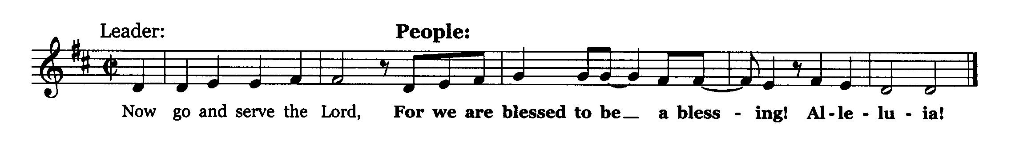

Postlude

Participants and Technical Crew
Rev. Wendy Boden
Liturgist: Deb Bohi
Deacon Greeter/Fellowship: Anny Davidson
Elder at the Door: Julie Storey
Advent Candle Lighters: Julie, Dana, Eric, Becca, Clementine, and Evelyn Storey
Word with Children: Blair Baldwin
Musicians: Tom Anderson, Victor King, David Kozich
Worship Assistant: David Kozich
Tech support: Chris Kozich, Blair Nelson
The flowers today are given by the Bohi-Parks family celebrating Echo’s 11th birthday.

Care Notes: “In everything by prayer and supplication with thanksgiving let your requests be made known to God.” -Philippians 4:6
Even though we aren’t all together for worship, we are still collecting prayer requests! Please email or leave a message on our answering machine at 630-469-9149 if you won’t be present to fill out a prayer request slip.

Friends,
Please make a point of sending an email, text, phone call, or filling out a blue prayer request and letting the people of Southminster know who you would like us to keep in prayer. All prayer requests are welcome. We want to be able to know who to talk to in order to follow up on all the people we pray for each week.

New requests and updates are italicized in our prayer list.
Joys and Concerns
The flowers today are given by the Bohi-Parks family to celebrate Echo’s 11th birthday.
We give thanks to God for joys: (Romans 12:15) “Rejoice with those who rejoice...”
- We give thanks for all our blessings at Thanksgiving… and every day!
We pray for the whole world and our nation: (1 Timothy 2:1-2) “I urge, then, first of all, that petitions, prayers, intercession, and thanksgiving be made for all people…”
- All those affected by the shooting in the Loop following the Chicago Christmas tree lighting
- We pray for the people of Iraq, where there is a water shortage.
- We pray for the people of the Philippines following multiple typhoons.
- We pray for the Christians and those of other faiths in Nigeria and around the world who are persecuted and killed.
- We lift all people and children who have had to carry the weight of witnessing gun deaths in their minds and hearts.
- Prayers for peace and serenity to all families in their varied configurations – siblings, brothers, and sisters.
- We pray for all branches of government, that they will be just and wise.
- We lift up a world at war – bring peace.
- We pray for people in prison and detention camps, that they may know you have not forgotten them.
Blessed are those who mourn: (Romans 12:15) “...weep with those who weep.”
We continue to lift up the families and friends of:
- We pray for Tricia Smith and family—Tricia’s sister, Betty, passed away last Wednesday (November 26).
- Helen Shierry, Steve Shierry. mother
- Joe McHaley, Carol McHaley’s husband
And all those we name in our hearts and hold dear.
We lift up those affected by cancer, along with their support systems:
- We lift up Amie Cantarella, who is continuing her recovery at Marianjoy .
Please help us pray for your family and friends by updating the church office with information about your loved ones. We support them and you in this journey.
We continue to pray for Alyssa, Bob, Kerri, Margaret F. (doing better), Anthony H., Bob J., Karen L., Ginny O., Tim O., Cis R., Heidi S., Marta S., Meagan S., Shelayne, Kurt Parent, who is now in palliative care, former President Joe Biden, and those we name in our hearts.
We pray for all who are recovering from or dealing with mental, physical, or other health challenges:
- Heidi Shierry, recovering from strep throat and pneumonia, in addition to dealing with her other illnesses
- Ann Anderson requests prayers for healing for Paul
- Jack Thorne, recovering at home.
- All those seeking meaningful employment, especially Josh, Ian, Amy, and Laura
- Sandy Phee asks prayers for her sister, Linda Talaga, as she adjusts to her lack of eyesight.
- We lift up people struggling with anxiety and depression.
- Jim Smith, at Brookdale, Betty Eichin in assisted living, and all those in care centers.
Prayers for our worshiping community and the Jeremiah Task Force as we discern God’s call to SPC for the 21st century. God, bring a harvest and lovers of the harvest. We welcome all, but we long for more children, teens, and families to be blessed by us and to join is in blessing the community. Help us share our stories with one another.
We lift up the men of Southminster as they discern a way to serve our neighbors.

This week at Southminster:
Sunday, December 7 – 2nd Sunday of Advent
Worship at 9:30 a.m. in person and also live on Facebook.
Fellowship in the Narthex following worship
Staff Meeting, 11:00 a.m. in the Pastor’s office
Adult Ed. Bible Study, 11:15 a.m., Parlor/Library
Congolese Church, 1:00-3:00 p.m. in Fellowship Hall
Youth: Pizzaless Games, 4:00-6:00 p.m., Fellowship Hall
Monday, December 8 – Pastor’s Sabbath
Pastor Wendy’s Heart to Heart on Facebook is live Tu-Th 4:20 p.m.;
Fridays only: Heart to Heart at 4:30 p.m.
Tuesday, December 9
Knitting Circle, 10:00 a.m., McHenry Parlor/Library
Staff calendar meeting at 12:30 p.m. in McHenry Parlor/Library
Session, 7:00 p.m., McHenry Parlor/Library (No deacons’ meeting)
A.A., 7:30 p.m., Fellowship Hall
Wednesday, December 10
eNotes go out
Thursday, December 11
Midwinter Light Service, 7:00-7:30 p.m. (Some places erroneously list it
beginning at 7:30. The correct starting time is 7:00.)
Choir rehearsal will follow the service.
Friday, December 12
A.A., 6:30 p.m., Fellowship Hall
Saturday, December 13
Congolese Church music practice, 1:00-4:00 p.m. in Fellowship Hall
Next Sunday, December 14 – 3rd Sunday of Advent
Worship at 9:30 a.m. in person and also live on Facebook.
Rehearsal for Christmas program participants after the service
Fellowship in the Narthex following worship
Staff Meeting, 11:00 a.m. in the Pastor’s office
Adult Ed. Bible Study, 11:15 a.m., Parlor/Library
Congolese Church, 1:00-3:00 p.m. in Fellowship Hall
Pathfinders (online),
Youth: Pizzaless Games, 4:00-6:00 p.m., Fellowship Hall
If you are online, we’re glad to have you! Using the comments section on Facebook, you can say hello, ask for words of peace, or request prayers.
If you are present for worship, please wear a name tag; they are on the Mission shelf in the Narthex and on the shelf across from the church offices. Following the service, you are invited by the deacons to gather for a time of fellowship in the narthex.
Our “Comfort Zone” – It is always contagion season, so we continue to have a “comfort zone” toward the back of the sanctuary. You may wear a mask, of course, if you so choose.
Sunday Morning Adult Ed. Bible Study: Enjoy some fellowship time and coffee and then join us at 11:15 a.m. in McHenry Parlor/Library.
You are invited to join us on Facebook (https://www.facebook.com/SouthminsterGlenEllyn/), where we have a live sharing of “Heart to Heart” with Pastor Wendy Boden at about 4:20 p.m. most weeks Tuesday through Thursday, about 4:30 p.m. on Fridays.
We continue to be live on Sunday morning for worship at 9:30 a.m. (slideshow beginning at 9:15) on YouTube at
https://www.youtube.com/channel/UCPgWICngOvkmR1OXgCG_wiA/live
or on Facebook at https://www.facebook.com/SouthminsterGlenEllyn/
If you are watching from home on Facebook, please check in and say hello so we can see that you have joined us. This is one way to make worship less “remote” and strengthen community at Southminster.
The live video will appear about 15 minutes before the scheduled start time.
If for any reason the feed falters, rest assured that a recording will be posted to Facebook and You Tube as soon as possible.

You can also find links to recordings of the weekday sessions, special services, and Sunday worship posted on our web site: https://www.southminsterpc.org/ or by going to our YouTube channel:
https://www.youtube.com/channel/UCPgWICngOvkmR1OXgCG_wiA/videos
Photo Stories help us feel connected! You can help...
Photo Stories/PowerPoints help us prepare for worship, connect with one another, and make sure that our at-home people get both sound and sight. Here are some opportunities for you to share your photos (Please note the deadlines—they are somewhat different than usual because of the holidays.):
December 21: “Light in the Darkness” We’re looking for Christmas lights, stars, the
moon, candles… sources of light. Please send photos by Thursday, December 18.
December 24 (Christmas Eve): “Nativity Scenes” Please send photos by Thursday,
December 18.
January 4, 2026: Let it snow!” Snowy scenes of all kinds! Please send photos by
Tuesday, December 30.
Send photos to our dedicated email address, used just for photos:
PhotoStory@Southminsterpc.org. (If you only have hard copies of your photos, please leave
them in the photo box on Pastor Wendy’s desk, labeled with your name and the date they are to be used.)
Notes from Blair Nelson:
Adult Education: We just began a study of Proverbs, the wisdom of ancient Israel. Proverbs is just that, a collection of proverbs, so you can dip in and out of our classes without missing anything. Never joined us? Why not give it a try some Sunday morning or even this morning? Money back guarantee! We meet in the Parlor/Library at 11:15, so bring your fellowship coffee and snack in and enjoy the fellowship.
Men of Southminster: We have an email thread going for ideas for our project. Our next meeting will be Saturday, January 10, at 9:00 a.m. Have a wonderful holiday and let us know via that email thread what your thoughts are on our block party idea.
Youth: Join us for Pizzaless Games today at 4:00-6:00 p.m. Be sure Blair N knows that you are coming. Remember that the 21st is the Christmas Program, and we need some folks to be readers. You will be hearing from Blair N if you have not already. There will be a brief practice on the 14th immediately after church
From the Worship Ministry
Midwinter Light! Thursday, December 11, from 7:00 to 7:30 p.m.
“A place of warmth, hope, and love in the cold of December”
Come in from the cold and into the warmth and light of our Midwinter Light service on Thursday evening, December 11, from 7:00 to 7:30. The holiday season can be difficult for those who are feeling alone, isolated, or grieving. Our Midwinter Light service offers a moment to sit and pause amid the hustle and rush of the season. It is a time of music and reflection, followed by coffee, tea, and hot cider. Perhaps you know someone who would benefit from such a service. Please invite them. If you have a song to share, please contact Tom Anderson at tomanderson101@gmail.com.
The choir will rehearse following the service.
It’s not too early to think about Christmas poinsettias!
In anticipation and celebration of Christmas, poinsettias will grace the sanctuary on Christmas Eve – Wednesday, December 24. They may be taken home after the Christmas Eve service.
We are ordering 12 red 2-stem 6.5” plants and 4 white (slightly larger) 2-stem 7.5” plants. Order yours by signing up in the narthex by Sunday, December 14. Thank you to everyone who orders, helping keep this beautiful tradition of poinsettias adorning the sanctuary on Christmas Eve.
Our annual Christmas program featuring our children, youth, and choir will be the worship service on Sunday, December 21. (Rehearsal for all participants is December 14 following the worship service.)
Christmas Eve Candlelight Service: Wednesday, December 24, at 4:30 p.m.
This will be a traditional service including Scripture, carols, the choir, and concluding with the singing of Silent Night by candlelight. (The earlier time accommodates choir members and others who wish to gather with their families later in the evening.)
From the Mission Ministry
Special Christmas Offerings
As we prepare to celebrate our Savior’s birth during this Advent season, we have
two key opportunities to help our brothers and sisters in Christ.
First, is the Christmas Joy Offering. The theme this year is “Prepare the Way.” The offering goes to the PCUSA to honor and celebrate leaders like retired pastors, church workers, and their families who helped prepare the way for us and now find themselves in financial need for a variety of reasons. It also supports students in communities of color still developing the leadership skills they will need to Prepare the Way for upcoming generations of Presbyterians. The envelopes for this offering are purple and white with a manger scene printed on them.
The second is our Local Mission Offering. This offering directly helps missions that we have long supported, providing an early boost to their 2026 operations. It’s a tough time for many of these organizations trying to provide services to more families on tighter budgets than last year due to changes in government support. These envelopes are red and black.
At this special holy time of year please consider not one, but two donations to help those in need. These special collections will be dedicated on Sunday, January 4.
Special Holiday Deadlines!
All information for the following is due on the following dates:
By Tuesday, 12/23: eNotes for Dec. 24, bulletin for Dec. 28
By Tuesday, 12/30: eNotes for Dec. 31, bulletin for Jan. 04, January Dialog!
The church office will be closed December 25 and 26, January 1 and 2.
Online Sign-Up for Valet Parking:
In order to make it easier to sign up for valet parking we are going to an online sign-up. This will allow you to access the sign-up list from anywhere that you have a phone or computer and an internet connection.
The link to the sign-up sheet is: https://volunteersignup.org/Q7W9J. If you are at church, use the QR code posted on the bulletin board opposite the church office.
When you go to the link you will see a list of dates where a valet is needed. To sign up to valet for a service, hover the cursor over a date that is available and click. You will be directed to a page where you can enter your first name, last name, email and phone number. If you don't want to enter your email or phone number just enter "no" in the email field and "1234567" in the phone number field. Then click on the green box "Agree and sign up". A message should appear signaling a successful sign-up.
If you enter your email you will receive an email reminder the day before your valet service (typically Saturday).
If you need to cancel once you have signed up, contact Steve Kozich via email(skozich@yahoo.com) or text (630-207-4525) and your name will be removed for that week.
If you have any questions about signing up or run into a problem when trying to sign up contact Steve Kozich.
Sign up to donate flowers for worship!
The flower chart for the first half of 2026 is posted in the narthex. The price is the same as last year: $35 per arrangement. If you are unable to sign up at church, contact Sarah Allen (sarah.cleland.allen@gmail.com) with your requests.
Presbyterian Women (Women’s Circle) Christmas Luncheon:
ALL women are invited!

ALL women of Southminster (and their guests) are invited to our annual Christmas Luncheon on Friday, December 19, at 11:30 a.m. in the narthex. The signup sheet is posted in the narthex on the bulletin board just outside of the parlor. Please sign up by December 14 so that we can have a seat for you. All are welcome!

Please plan to bring a salad to share and a serving utensil. Drinks will be provided. After eating we will enjoy hearing the musical talents of Karen and Tim Archbold. A free will offering will be taken to cover the cost of the music program.

If you have any questions, please contact Sue Knisely (phone or text to 630-776-7998 or email to sueknisely@gmail.com).

Looking ahead to the purse auction!
Remember that December 19 is also the first day we will begin collecting purses and white elephant gifts for the annual purse auction. This year it will be held on Saturday, January 17, at 9:30 a.m. in Fellowship Hall.
Jubilee Bucks
Wow! Thanks to all who ordered gift cards in November! We just had our biggest order ever!! We sold 253 gift cards totaling $9,750! This gave us $401.97 in “free” money for just that one sale date! This year was also incredible for the sale of gift cards—we made a total of $2,397.69 in “free” money for Southminster!
People’s Resource Center’s Share the Spirit (STS): The 2 opportunities during November to support STS gave us 113 gift cards to donate! This totaled $2,825 in value and produced $89.69 in “free” money for our church. What an incredible donation!!

Your next chance to order will be January 4. Remember two things: 1) Gift cards are not just for giving away! You can order for purchases you regularly make for yourself (i.e. for groceries, gas, dining out, and more), and 2) You can order at any time—Bobbi will just hold on to your order until she places the next church order. Email her at bobbifrey@aol.com or call/text her at 630-643-3858.
Southminster’s PRC video stars!
PRC recently made a video to celebrate their 50th anniversary of service to DuPage County, and it features two loyal PRC volunteers from Southminster – Bobbi Frey and Joe Kocinski. Please be sure to watch! https://youtu.be/TrL9AoRdVFA?si=HU9ajNd2dLS2-MUx
Caring for you!
Our Congregational Care Committee is ready to assist in time of need. If you need assistance from the Congregational Care Ministry or Helping Hands through December 10, call Deacon Lynn Ferino (630-)272-2269; from December 11-January 13, call Deacon Sue Knisely (630-776-7998). You may call Pastor Wendy Boden on her cell or home phone (if she has shared the numbers with you) or leave a message for her at the church office: 630-469-9149. You may email Wendy at wendy@southminsterpc.org. (Please note that she can only read email when she is in the office.) You may also call your deacon if you need help from the church.
Who is your deacon? The assignments have changed. The new list is posted in the narthex – be sure to check there to see who your deacon is. Or you can contact the church (630-469-9149 or admin@southminsterpc.org) and ask.
Regular Office Schedule:
The church office is closed on Mondays and Wednesdays.
Barb’s regular schedule is to be in the office Tuesdays, Thursdays, and Fridays from approximately 9:00 a.m.-3:00 p.m. while her son attends his day program on those days. Mondays and Wednesdays she works from home.
Grace and peace to you! Remember that we love God, neighbor, and one another. Our address is 680 South Park Blvd., Glen Ellyn, IL 60137 if you would like to set up an online account with your bank or mail in your pledge. Online giving through Vanco is also now an option –for details contact Ron Birchall.

Bearing Fruit – December 7, 2025
Preparing the Way through Our Christmas Offerings
The Advent season is upon us, and Christmas, with all its joy, is not far away. During the seasons of Advent and Christmas, we collect two offerings—the Christmas Offering for Local Mission and the Christmas Joy Offering.
Our Mission Ministry leads the congregation of Southminster Presbyterian Church of Glen Ellyn in sharing spiritual, financial, and “hands-on” gifts as modeled by our Lord and Savior Jesus Christ. One of the ways we support Local Mission is the Christmas Offering for Local Mission.
When we give to the Christmas Offering for Local Mission, we join together as a church family to care for our local community. We love our neighbors!
Our local missions are:
- Bridge Communities
- Cuba Sister Church
- DuPage PADS
- Metropolitan Family Services (formerly Family Shelter Service)
- People’s Resource Center
- Walk-In Ministry
- World Relief

The Christmas Joy Offering combines gifts from congregations throughout our denomination, PC(USA), to support church leaders and communities in need. The Christmas Joy Offering provides critical financial assistance to current and retired church workers and their families. The Christmas Joy offering also supports PC(USA) schools and colleges that empower communities of color and foster leadership development. These schools offer transformative education and leadership opportunities for students from diverse backgrounds. The Christmas Joy Offering has been a cherished tradition since the 1930s, supporting church workers and educational institutions. It embodies Presbyterians' commitment to helping those in need and to promoting education and leadership development.
One of the ways we bear the fruit of God’s love is by preparing the way of the Lord through our two Christmas offerings, the Christmas Offering for Local Mission and the Christmas Joy Offering, which reflect the perfect gift of Jesus Christ.

