Southminster Presbyterian Church
Epiphany Sunday
January 4, 2026
9:30 a.m.

Find the link for the service on one of these sites:
1) on Facebook: https://www.facebook.com/SouthminsterGlenEllyn/
2) our YouTube channel:
https://www.youtube.com/channel/UCPgWICngOvkmR1OXgCG_wiA/live
3) our web site: https://www.southminsterpc.org/
If the video feed is interrupted during the service, we will continue to record and then post the full video on Facebook and our web site as soon as possible.

For those who are in the sanctuary, please put your phone in airplane mode.

Today we are having communion. Those at home may want to gather the elements (“bread” and “wine” or whatever you have) before the service begins.

Gathering Music/Photo Story: “Let It Snow”

Welcome and Announcements
Faith Story
Lighting the Candles
Congregational Prayer of Dedication for Christmas Offerings (unison)
Loving God, we thank you for the ultimate gift of Christmas, your Son, Jesus. As we present these gifts, bless them and bless our giving, that they may meet needs and spread your love, fulfilling your promise of hope, peace, and justice. May we, empowered by your Spirit, follow these gifts into the world, becoming bearers of your light, serving the most vulnerable, and sharing the joy of your presence with all people. In Jesus’ holy name, Amen.

Prelude
[Please remain seated while singing the opening song.]
Hymn 150: As with Gladness Men of Old

Call to Worship
Leader: Wise men came from the East to worship one they had never seen.
People: They were outsiders, yet their offerings were accepted.
Leader: They were dreamers who saw beyond the facts to the reality,
and they went home changed.
All: Come, come, everyone, from the East and from everywhere,
come and worship Christ, the new-born King and Lamb of God.

Hymn 152: What Star Is This with Beams So Bright (all)

Prayer of Confession: (unison)
God of all people, you have called many by name, asking them to follow and obey Jesus. Help us to hear you call us by name. Forgive us for the times we have closed our ears, hearts, or minds to you and your message. Through your grace and the power of your Holy Spirit, help us to follow and obey. In the name of Jesus Christ, we pray. Amen.

(Time of silence for personal prayer and confession)

Declaration of God’s Grace/The Good News of Jesus Christ
Leader: Friends in Christ, know this:
the mercy of God is from everlasting to everlasting.
People: We remember the amazing grace of God.
All: In Jesus Christ, we are forgiven. Alleluia, Amen.

Response 582: Glory to God, Whose Goodness Shines on Me
Glory to God, whose goodness shines on me,
And to the Son, whose grace has pardoned me,
And to the Spirit, whose love has set me free.
As it was in the beginning, is now and ever shall be. Amen.
World without end, without end. Amen.
World without end, without end. Amen.
World without end, without end. Amen.
As it was in the beginning, is now and ever shall be. Amen.

Text Adapt. and Music ©2008 Paul M. Vasile
Reprinted/Streamed with permission under OneLicense.net #A-739517. All rights reserved.

The Passing of the Peace

Word with Children
Children worshiping in the sanctuary, please come forward.

As the children leave:
We Three Kings of Orient Are Hymnal 151, verse 1 and refrain
We three kings of Orient are
Bearing gifts we traverse afar,
Field and fountain, moor and mountain,
Following yonder star.
O star of wonder, star of night,
Star with royal beauty bright,
Westward leading, still proceeding,
Guide us to thy perfect light.

Public domain

Prayer for Illumination

Scripture Lessons: John 1:19-23, 29 Pew Bible, p. 92 (N.T.)
John 1:35-43 Pew Bible, p. 92 (N.T.)

Sermon: “Look, here is the Lamb of God”

Saying What We Believe/Affirmation of Faith (unison)
The Apostles’ Creed [Ecumenical]
I believe in God, the Father almighty, creator of heaven and earth.
I believe in Jesus Christ, God’s only Son, our Lord, who was conceived by the Holy Spirit, born of the Virgin Mary, suffered under Pontius Pilate, was crucified, died, and was buried; he descended to the dead. On the third day he rose again; he ascended into heaven, he is seated at the right hand of the Father, and he will come to judge the living and the dead.
I believe in the Holy Spirit, the holy catholic Church, the communion of saints, the forgiveness of sins, the resurrection of the body, and the life everlasting. Amen.

Hymn: He Knows My Name pg. 18, gold worship supplement

Offering of Ourselves and Our Gifts
[The offering plate is at the back of the sanctuary. Please leave your gift or pledge
in the plate on your way into or out of worship.]

Offertory: Behold the Lamb Keith & Kristyn Getty, Stuart Townend

*Doxology Hymnal #606
Praise God, from whom all blessings flow;
Praise Him all creatures here below;
Praise Him above, ye heavenly host;
Praise Father, Son, and Holy Ghost. Amen.

Public domain

Prayer of Dedication

Service of the Lord’s Supper
Invitation
[You do not need to wait to consume the elements – please do so as the Spirit
leads (right away, as you pause after receiving, or back in your seats).
We extend an invitation to the Lord’s Supper to all who have been baptized. You do
not need to be a member of this congregation or a Presbyterian to share in this meal.
We remember that access to the Table is not a right conferred upon the worthy, but a
privilege given to believers who come in faith, repentance, and love.]

Great Prayer of Thanksgiving
Leader: The Lord be with you.
People: And also with you.
Leader: Lift up your hearts.
People: We lift them to the Lord.
Leader: Let us give thanks to the Lord our God.
People: It is right to give our thanks and praise.

The minister gives thanks…

The congregation responds by singing together:

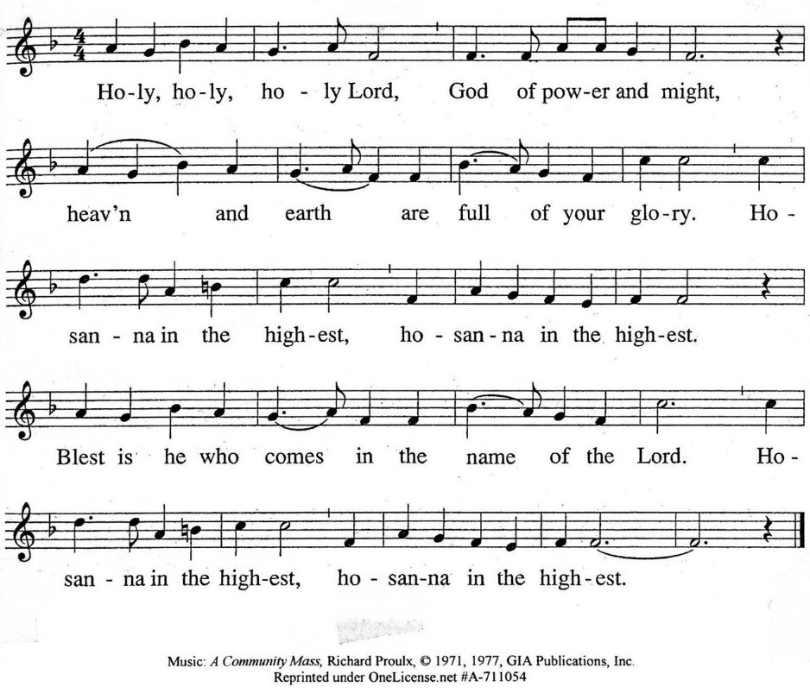

The minister continues the Thanksgiving…
“Together we proclaim the great mystery of faith:”
According to Christ’s commandment
We remember his death,
We proclaim his resurrection,
We await his coming in glory.

The minister continues with Intercessions for the Church and the World
and Prayers of the People…
Leader: Lord, in your mercy,
People: hear our prayers.
Our Lord’s Prayer
Our Father who art in heaven, hallowed be thy name. Thy kingdom come,
thy will be done, on earth as it is in heaven. Give us this day our daily bread;
and forgive us our debts, as we forgive our debtors; and lead us not into temptation, but deliver us from evil. For thine is the kingdom and the power
and the glory, forever. Amen.

Words of Institution
Communion
Communion Music: Lord, We Have Come at Your Own Invitation

We all will receive communion by coming to the Lord’s Table. Our usher will invite you to come forward by pew, beginning from the back. If you are unable to come forward, a server will come to you after everyone else has received.
Please consume the elements when you are comfortable doing so. You do not need to wait – please do so as the Spirit leads (right away, as you pause after receiving, or back in your seats).
With Christian love we serve gluten-free communion bread and alcohol-free grape juice.
Also with Christian love the elements were prepared with strict attention to health concerns.
You are invited to partake of the prepackaged communion juice and wafer if you choose; we now offer prepackaged cups that include gluten-free wafers.

Prayer after Communion
Hymn 163: Wild and Lone the Prophet’s Voice (all)

Charge and Benediction
Southminster Benediction Response
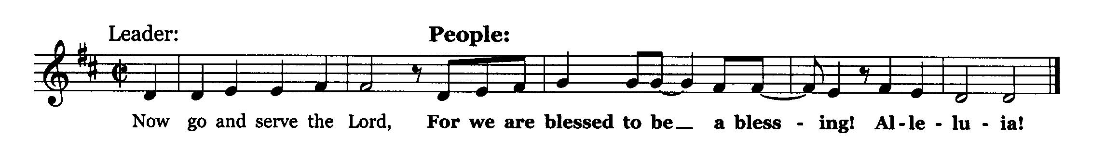

Postlude

Participants and Technical Crew
Rev. Wendy Boden
Liturgist: Terry Kline
Deacon Greeter/Fellowship: Heather Kralicek
Elder at the Door: Steve Sanders
Musicians: Tom Anderson, Victor King, David Kozich
Worship Assistant: David Kozich
Tech support: Chris Kozich, Blair Nelson
The flowers today are given by Andrea, Kayla, and Kevin Schmidt to celebrate Parin’s birthday.

Care Notes: “In everything by prayer and supplication with thanksgiving let your requests be made known to God.” -Philippians 4:6
Even though we aren’t all together for worship, we are still collecting prayer requests! Please email or leave a message on our answering machine at 630-469-9149 if you won’t be present to fill out a prayer request slip.

Friends,
Please make a point of sending an email, text, phone call, or filling out a blue prayer request and letting the people of Southminster know who you would like us to keep in prayer. All prayer requests are welcome. We want to be able to know who to talk to in order to follow up on all the people we pray for each week.

New requests and updates are italicized in our prayer list.
Joys and Concerns
The flowers today are given by Andrea, Kayla, and Kevin Schmidt to celebrate Parin’s birthday.
We give thanks to God for joys: (Romans 12:15) “Rejoice with those who rejoice...”
- We thank God that Marta’s most recent cancer scan was clear!
- From the Boden-Nelsons: Their friend Meagan Severson, who we have been praying for, has been OK’d for a liver transplant.
We pray for the whole world and our nation: (1 Timothy 2:1-2) “I urge, then, first of all, that petitions, prayers, intercession, and thanksgiving be made for all people…”
- We lift all people and children who have had to carry the weight of witnessing gun deaths in their minds and hearts.
- Prayers for peace and serenity to all families in their varied configurations – siblings, brothers, and sisters.
- We pray for all branches of government, that they will be just and wise.
- We lift up a world at war – bring peace.
- We pray for people in prison and detention camps, that they may know you have not forgotten them.
Blessed are those who mourn: (Romans 12:15) “...weep with those who weep.”
- We mourn with Sandy Phee in the death last month of her daughter-in-law, Cherrie, and pray for her son, Bill, as he mourns and is selling his house.
- We also mourn with Angela Smith in the recent death of her dear friend, Shelayne Larson. Angela shared this: Shelayne passed away peacefully and is out of pain after an over 4-year battle with cancer. Doctors did not think she would survive 6 months. Her strong relationship with Jesus helped guide her through this devastating illness.
Shelayne identified with this from Timothy:
“I have fought the good fight, I have finished the race, I have kept the faith. Now there is in store for me the crown of righteousness, which the Lord, the righteous Judge, will award to me on that day—and not only to me, but also to all who have longed for his appearing.” -2 Timothy 4:7-8
We offer our prayers and support for Shelayne’s husband, David, and the Larson family along with all her friends.
- We remember Tricia’s dear friend, Patty, who died recently.
- We pray for Tricia Smith and family—Tricia’s sister, Betty, passed away in November.
We continue to lift up the families and friends of:
- Our dear friend, Jack Harris
- Helen Shierry, Steve Shierry. mother
- Joe McHaley, Carol McHaley’s husband
And all those we name in our hearts and hold dear.
We lift up those affected by cancer, along with their support systems:
- We lift up Amie Cantarella, who came home for Christmas from Marianjoy. May she continue to gain strength and heal.
Please help us pray for your family and friends by updating the church office with information about your loved ones. We support them and you in this journey.
We continue to pray for Alyssa, Bob, Kerri, Margaret F., Anthony H., Bob J., Karen L., Ginny O., Tim O., Cis R., Heidi S., Marta S., Meagan S., Kurt Parent, who is now in palliative care, former President Joe Biden, and those we name in our hearts.
We pray for all who are recovering from or dealing with mental, physical, or other health challenges:
- We pray that Jonathan Buckley would get answers about his gall bladder trouble.
- Barb’s sister-in-law, Michaele, debilitated by chronic pain.
- Donna Marton, recovering after an accident
- Heidi Shierry, ongoing health issues
- Ann Anderson requests prayers for healing for Paul
- Jack Thorne, recovering at home.
- All those seeking meaningful employment, especially Josh, Ian, Amy, and Laura
- Sandy Phee asks prayers for her sister, Linda Talaga, as she adjusts to her lack of eyesight.
- We lift up people struggling with anxiety and depression.
- Jim Smith, at Brookdale, Betty Eichin in assisted living, and all those in care centers.
Prayers for our worshiping community and the Jeremiah Task Force as we discern God’s call to SPC for the 21st century. God, bring a harvest and lovers of the harvest. We welcome all, but we long for more children, teens, and families to be blessed by us and to join is in blessing the community. Help us share our stories with one another.
We lift up the men of Southminster as they discern a way to serve our neighbors.

This week at Southminster:
Sunday, January 4
Order Jubilee Bucks gift cards by emailing bobbifrey@aol.com by 9:00 p.m.
Worship with communion at 9:30 a.m. in person and also live on Facebook.
Fellowship in the Narthex following worship
Staff Meeting, 11:00 a.m., Pastor’s Office
Adult Ed. Bible Study, 11:15 a.m., Parlor/Library
Congolese Church, 1:00-3:00 p.m. in Fellowship Hall
Monday, January 5 – Pastor’s Sabbath
Tuesday, January 6
No staff calendar meeting
Mission, 7:00 p.m., Parlor/Library
A.A., 7:30 p.m., Fellowship Hall
Wednesday, January 7
Women’s Breakfast, 8:30 a.m., Danby’s Station
January Dialog goes out
Thursday, January 8
Hawthorn Garden Club, 12:00 p.m., Fellowship Hall
Choir rehearsal, 7:00 p.m., Sanctuary
Young Adults Video Club, 8:30 p.m.
Friday, January 9
A.A., 6:30 p.m., Fellowship Hall
Saturday, January 10
Men of Southminster, 9:00 a.m., McHenry Parlor/Library
Congolese Church music practice, 1:00-4:00 p.m. in Fellowship Hall
Next Sunday, January 11
Worship at 9:30 a.m. in person and also live on Facebook.
Fellowship in the Narthex following worship
Staff Meeting, 11:00 a.m., Pastor’s Office
Combined meeting of Program Ministries, 11:15 a.m., McHenry Parlor/Library
No Adult Ed. Bible Study
Congolese Church, 1:00-3:00 p.m. in Fellowship Hall
If you are online, we’re glad to have you! Using the comments section on Facebook, you can say hello, ask for words of peace, or request prayers.
If you are present for worship, please wear a name tag; they are on the Mission shelf in the Narthex and on the shelf across from the church offices. Following the service, you are invited by the deacons to gather for a time of fellowship in the narthex.
Our “Comfort Zone” – It is always contagion season, so we continue to have a “comfort zone” toward the back of the sanctuary. You may wear a mask, of course, if you so choose.
Sunday Morning Adult Ed. Bible Study: Enjoy some fellowship time and coffee and then join us at 11:15 a.m. in McHenry Parlor/Library.
You are invited to join us on Facebook (https://www.facebook.com/SouthminsterGlenEllyn/), where most weeks we have a live sharing of “Heart to Heart” with Pastor Wendy Boden Tuesdays through Fridays at – new time! – 5:00 p.m.
We continue to be live on Sunday morning for worship at 9:30 a.m. (slideshow beginning at 9:15) on YouTube at
https://www.youtube.com/channel/UCPgWICngOvkmR1OXgCG_wiA/live
or on Facebook at https://www.facebook.com/SouthminsterGlenEllyn/
If you are watching from home on Facebook, please check in and say hello so we can see that you have joined us. This is one way to make worship less “remote” and strengthen community at Southminster.
The live video will appear about 15 minutes before the scheduled start time.
If for any reason the feed falters, rest assured that a recording will be posted to Facebook and You Tube as soon as possible.

You can also find links to recordings of the weekday sessions, special services, and Sunday worship posted on our web site: https://www.southminsterpc.org/ or by going to our YouTube channel:
https://www.youtube.com/channel/UCPgWICngOvkmR1OXgCG_wiA/videos
Photo Stories help us feel connected! You can help...
Photo Stories/PowerPoints help us prepare for worship, connect with one another, and make sure that our at-home people get both sound and sight. Watch for the next opportunity to share your photos.
Notes from Blair Nelson:
Adult Education: Our adult class has begun a study of Proverbs, one of the books of the Old Testament classified as wisdom literature. Wanna be a wise guy? Join us today at 11:15 a.m. in the Parlor/Library (bring your Fellowship coffee and goodies with you, if you like), as we read together, think together, share our thoughts together, and grow in wisdom together.
Men of Southminster: We will gather on Saturday, Jan. 10, at 9:00 a.m. to share our lives together, work on our project to raise the profile of Southminster in our community, and, of course, drink coffee and eat donuts.
Youth: Events for January and February are in the works. Information will be in the January Dialog and coming by email.
From the Worship Ministry
Sign up to donate flowers for worship!
The flower chart for the first half of 2026 is posted in the narthex. The price is the same as last year: $35 per arrangement. If you are unable to sign up at church, contact Sarah Allen (sarah.cleland.allen@gmail.com) with your requests.
The worship and music schedule for the first few months of 2026 will soon be posted on the choir room door. Singers and instrumentalists, please sign up for dates you might want to provide an offertory or communion music.
2026 offering envelopes are available in the narthex. Pick yours up today. If there is no box labeled for you and you would like one, contact Rita Zapel.
Online Sign-Up for Valet Parking:
In order to make it easier to sign up for valet parking we are going to an online sign-up. This will allow you to access the sign-up list from anywhere that you have a phone or computer and an internet connection.
The link to the sign-up sheet is: https://volunteersignup.org/Q7W9J. If you are at church, use the QR code posted on the bulletin board opposite the church office.
When you go to the link you will see a list of dates where a valet is needed. To sign up to valet for a service, hover the cursor over a date that is available and click. You will be directed to a page where you can enter your first name, last name, email and phone number. If you don't want to enter your email or phone number just enter "no" in the email field and "1234567" in the phone number field. Then click on the green box "Agree and sign up". A message should appear signaling a successful sign-up.
If you enter your email you will receive an email reminder the day before your valet service (typically Saturday).
If you need to cancel once you have signed up, contact Steve Kozich via email(skozich@yahoo.com) or text (630-207-4525) and your name will be removed for that week.
If you have any questions about signing up or run into a problem when trying to sign up contact Steve Kozich.
All women are invited!
Women’s Breakfast meets the first Wednesday of the month. Join us this Wednesday, January 7, at 8:30 a.m. at Danby’s Station, 750 Roosevelt Road, Glen Ellyn. Come enjoy good food, great conversation, and a refreshing break from your usual routine. All women are always welcome. For more information, contact Gretchen Fleming by phone or text to 630-517-0926.
Presbyterian Women’s Purse Auction
All women of Southminster are invited to our Purse Auction on Saturday, January 17, in the Sanctuary. The doors open at 9:15 a.m. to browse the purse selection, with the auction beginning promptly at 9:45 a.m.
Bring your friends and neighbors for a fun morning of friendly bidding on gently-used purses of every style. Attendance is free, and reservations are not required. Cash only, please. ALL are welcome!
Remember, we are collecting gently-used purses and white elephant gifts for the purse auction. Items can be brought to church and placed in the box located in the coat room.
Jubilee Bucks: Order today!
Today is your only chance to order Jubilee Bucks gift cards this month. Remember that gift cards are not just for giving away! You can also order for purchases you regularly make for yourself (i.e. for groceries, gas, dining out, and more). If you don’t see Bobbi Frey at church today to place your order, contact her by 9:00 this evening: 630-643-3858 or bobbifrey@aol.com.
Caring for you!
Our Congregational Care Committee is ready to assist in time of need. If you need assistance from the Congregational Care Ministry or Helping Hands through January 13, call Deacon Sue Knisely (630-776-7998). You may call Pastor Wendy Boden on her cell or home phone (if she has shared the numbers with you) or leave a message for her at the church office: 630-469-9149. You may email Wendy at wendy@southminsterpc.org. (Please note that she can only read email when she is in the office.) You may also call your deacon if you need help from the church.
Who is your deacon? The assignments have changed. The new list is posted in the narthex – be sure to check there to see who your deacon is. Or you can contact the church (630-469-9149 or admin@southminsterpc.org) and ask.
Regular Office Schedule:
The church office is closed on Mondays and Wednesdays.
Barb’s regular schedule is to be in the office Tuesdays, Thursdays, and Fridays from approximately 9:00 a.m.-3:00 p.m. while her son attends his day program on those days. Mondays and Wednesdays she works from home.
Grace and peace to you! Remember that we love God, neighbor, and one another. Our address is 680 South Park Blvd., Glen Ellyn, IL 60137 if you would like to set up an online account with your bank or mail in your pledge. Online giving through Vanco is also now an option –for details contact Ron Birchall.

Bearing Fruit – January 4, 2026
Star Words

We are entering the season of Epiphany. The word itself means “a profound realization, a revelation of understanding, or a manifestation.” For Christians, it is about God’s revelation in Jesus Christ. This includes the visit of the wise men, Jesus’ baptism, and Jesus’ transfiguration.
Today, to welcome the New Year and celebrate Epiphany, Star Words are available for you in the narthex.
The use of Star Words is a prayer practice for the New Year and Epiphany. Each star has a guiding word, an intention, printed on it. Typically, participants are encouraged to trust the word they have drawn and not replace it. However, there is no need to be the “Star Sheriff” if you prefer another word, go ahead, but don’t peek.
Place your Star Word somewhere that you will see it regularly throughout the year or simply during the season of Epiphany. Try reflecting on how God has moved through, around, or in you through your Star Word.
On this day as we celebrate Epiphany, remember the star that led the magi to Jesus, pick up a star and ask God to call you by name into the new year. During fellowship or during the week, come by and pick up a Star Word.
Here are a few things to think about when reflecting on your Star Word: How do you feel about your word? Does it connect with you? Why or why not? What is one way you can live into your word? What song comes to mind when you think about your star word, quote, or scripture?
May we all grow in faith, wonder, and joy in the coming year as we bear the fruit of God’s love in the world.

