Southminster Presbyterian Church
4th Sunday after Epiphany
February 1, 2026
9:30 a.m.

Find the link for the service on one of these sites:
1) on Facebook: https://www.facebook.com/SouthminsterGlenEllyn/
2) our YouTube channel:
https://www.youtube.com/channel/UCPgWICngOvkmR1OXgCG_wiA/live
3) our web site: https://www.southminsterpc.org/
If the video feed is interrupted during the service, we will continue to record and then post the full video on Facebook and our web site as soon as possible.

For those who are in the sanctuary, please put your phone in airplane mode.

Today we are having communion. Those at home may want to gather the elements (“bread” and “wine” or whatever you have) before the service begins.

Gathering Music/Photo Story: “Artists’ Reception”

Welcome, Announcements, and Moment for Mission
Faith Story
Lighting the Candles (John 20:30-31)‬‬‬‬‬‬‬‬‬‬‬‬
Now Jesus did many other signs in the presence of his disciples that are not written in this book. But these are written so that you may continue to believe that Jesus is the Messiah, the Son of God, and that through believing you may have life in his name.

Prelude
[Please remain seated while singing the opening song.]
Hymn: Jesus, Draw Me Ever Nearer p. 29, gold worship supplement

Call to Worship
Leader: We worship God, the source of light and truth.
People: Lord, help us to find knowledge by which to live;
Leader: Lead us to take the words we hear and say into our hearts and lives.
All: May our worship lead us to acts of kindness, peace, and love.

Hymn: Come Behold the Wondrous Mystery p. 11, gold worship supplement

Prayer of Confession: (unison)
Creator of the eternal law of goodness and love, there are times when we feel that we are beyond your love and grace. There are also times when we feel that others are beyond your love and grace, as well. Our hearts do not wish them well. Transform our understanding of your intentions for the world and help us embrace love and grace for everyone we meet. In the name of Jesus Christ, we pray. Amen.

(Time of silence for personal prayer and confession)

Declaration of God’s Grace/The Good News of Jesus Christ (Psalm 103, edited)
Leader: The Lord is compassionate and gracious,
People: Slow to anger, abounding in love.
Leader: For as high as the heavens are above the earth,
so great is his love for those who fear him;
People: As far as the east is from the west,
so far has he removed our transgressions from us.
All: In the name of Jesus Christ, we are forgiven.

Response 582: Glory to God, Whose Goodness Shines on Me
Glory to God, whose goodness shines on me,
And to the Son, whose grace has pardoned me,
And to the Spirit, whose love has set me free.
As it was in the beginning, is now and ever shall be. Amen.
World without end, without end. Amen.
World without end, without end. Amen.
World without end, without end. Amen.
As it was in the beginning, is now and ever shall be. Amen.

Text Adapt. and Music ©2008 Paul M. Vasile
Reprinted/Streamed with permission under OneLicense.net #A-739517. All rights reserved.

The Passing of the Peace

Word with Children Blair Baldwin
Children worshiping in the sanctuary, please come forward.

As the children leave:
God Welcomes All Hymnal 399
God welcomes all, strangers and friends;
God’s love is strong and it never ends.

Text: John L. Bell, 2008
Music: South African song, transc, John L. Bell, 2008
Text and Music Transcr. © 2008 WGRG, Iona Community (admin. GIS Publications, Inc.)
Reprinted/Streamed with permission under OneLicense.net #A-739517. All rights reserved.

Prayer for Illumination

Scripture Lessons: John 4:27-42 Pew Bible, p. 95 (N.T.)
John 5:16-18 Pew Bible, p. 96 (N.T.)

Sermon: “Come and See…”

Saying What We Believe/Affirmation of Faith (unison)
The Apostles’ Creed [Ecumenical]
I believe in God, the Father almighty, creator of heaven and earth.
I believe in Jesus Christ, God’s only Son, our Lord, who was conceived by the Holy Spirit, born of the Virgin Mary, suffered under Pontius Pilate, was crucified, died, and was buried; he descended to the dead. On the third day he rose again; he ascended into heaven, he is seated at the right hand of the Father, and he will come to judge the living and the dead.
I believe in the Holy Spirit, the holy catholic Church, the communion of saints, the forgiveness of sins, the resurrection of the body, and the life everlasting. Amen.

Hymn 510: We Gather Here in Jesus’ Name (Come Share the Lord)

Offering of Ourselves and Our Gifts
[The offering plate is at the back of the sanctuary. Please leave your gift or pledge
in the plate on your way into or out of worship.]

Offertory Anthem: Let Us Be Bread Thomas J. Porter

*Doxology Hymnal #606
Praise God, from whom all blessings flow;
Praise Him all creatures here below;
Praise Him above, ye heavenly host;
Praise Father, Son, and Holy Ghost. Amen.

Public domain

Prayer of Dedication

Service of the Lord’s Supper
Invitation
[You do not need to wait to consume the elements – please do so as the Spirit
leads (right away, as you pause after receiving, or back in your seats).
We extend an invitation to the Lord’s Supper to all who have been baptized. You do
not need to be a member of this congregation or a Presbyterian to share in this meal.
We remember that access to the Table is not a right conferred upon the worthy, but a
privilege given to believers who come in faith, repentance, and love.]

Great Prayer of Thanksgiving
Leader: The Lord be with you.
People: And also with you.
Leader: Lift up your hearts.
People: We lift them to the Lord.
Leader: Let us give thanks to the Lord our God.
People: It is right to give our thanks and praise.

The minister gives thanks…

The congregation responds by singing together:

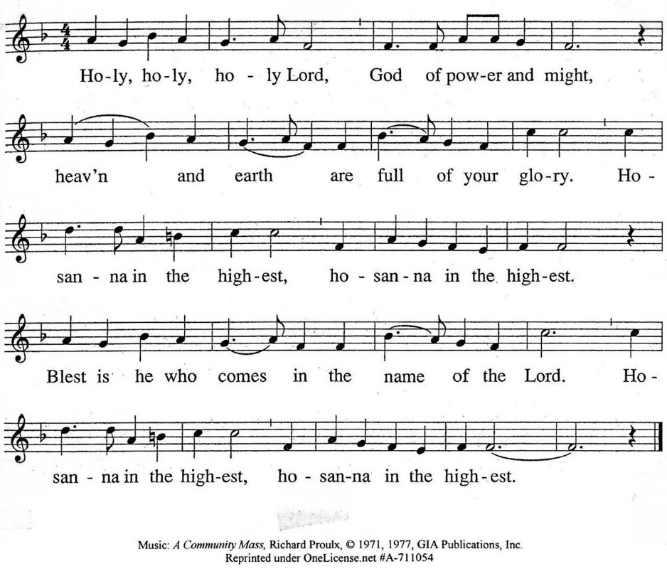

The minister continues the Thanksgiving…
“Together we proclaim the great mystery of faith:”
According to Christ’s commandment
We remember his death,
We proclaim his resurrection,
We await his coming in glory.

The minister continues with Intercessions for the Church and the World
and Prayers of the People…
Leader: Lord, in your mercy,
People: hear our prayers.
Our Lord’s Prayer
Our Father who art in heaven, hallowed be thy name. Thy kingdom come,
thy will be done, on earth as it is in heaven. Give us this day our daily bread;
and forgive us our debts, as we forgive our debtors; and lead us not into temptation, but deliver us from evil. For thine is the kingdom and the power
and the glory, forever. Amen.

Words of Institution
Communion
Communion Music: Elegy Alexander Arutiunian

We all will receive communion by coming to the Lord’s Table. Our usher will invite you to come forward by pew, beginning from the back. If you are unable to come forward, a server will come to you after everyone else has received. Choir members will remain seated and receive after the congregation.
Please consume the elements when you are comfortable doing so. You do not need to wait – please do so as the Spirit leads (right away, as you pause after receiving, or back in your seats).
With Christian love we serve gluten-free communion bread and alcohol-free grape juice.
Also with Christian love the elements were prepared with strict attention to health concerns.
You are invited to partake of the prepackaged communion juice and wafer if you choose; we now offer prepackaged cups that include gluten-free wafers.

Prayer after Communion
Hymn 307: God of Grace and God of Glory

Southminster Benediction Response
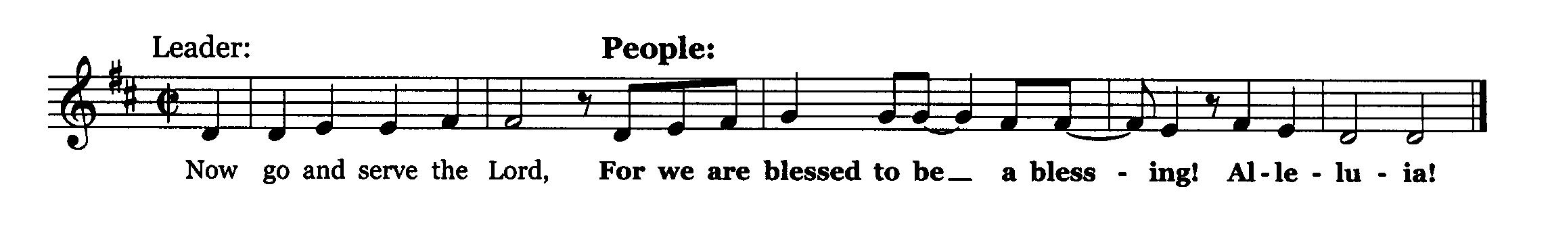

Postlude

Participants and Technical Crew
Rev. Wendy Boden
Liturgist: Sarah Allen
Deacon Greeter/Fellowship: Andrea Davidson
Elder at the Door: Jay Lerch
Musicians: Tom Anderson, the Southminster Choir, David Kozich
Worship Assistant: David Kozich
Tech support: Chris Kozich, Blair Nelson
The flowers today are given by John Pezl in remembrance of his late wife Dawn’s birthday.

Care Notes: “In everything by prayer and supplication with thanksgiving let your requests be made known to God.” -Philippians 4:6
Even though we aren’t all together for worship, we are still collecting prayer requests! Please email or leave a message on our answering machine at 630-469-9149 if you won’t be present to fill out a prayer request slip.

Friends,
Please make a point of sending an email, text, phone call, or filling out a blue prayer request and letting the people of Southminster know who you would like us to keep in prayer. All prayer requests are welcome. We want to be able to know who to talk to in order to follow up on all the people we pray for each week.

New requests and updates are italicized in our prayer list.

On Luminaria Sunday (February 22) we will revise our mourners and cancer care lists. If you would like to continue listing a particular person, please contact the office. We will start new lists after February 22.
Joys and Concerns
The flowers today are given by John Pezl in remembrance of his late wife Dawn’s birthday.
We give thanks to God for joys: (Romans 12:15) “Rejoice with those who rejoice...”
- We are thankful for the presence of Craig Allen as he celebrates his 80th birthday.
- Meagan Severson had a successful liver transplant. We pray for normal blood work and manageable pain as she waits for her GI tract to recover.
We pray for the whole world and our nation: (1 Timothy 2:1-2) “I urge, then, first of all, that petitions, prayers, intercession, and thanksgiving be made for all people…”
- We pray for the state of Minnesota, and we lift up our nation.
- We pray for the family and friends of Alex Jeffrey Pretty, who was pepper sprayed, roughed up, whipped with a cannister, then shot and killed by ICE in Minnesota. |
- We pray for those with family in Minnesota, particularly Heather, Keith, Charles, and their children.
- We pray for the family of Renee Nicole Good, who was shot and killed by ICE in Minneapolis. In particular, we remember her orphaned children.
- We pray for people in prison and detention camps, that they may know you have not forgotten them. We lift up Liam Ramos, a 5-year-old alone in a detention center.
- We pray for transformed hearts for our nation, for members of ICE and other DHS forces, and for ourselves.
Blessed are those who mourn: (Romans 12:15) “...weep with those who weep.”
- Sharla, a dear friend of Jessica Bohi-Parks, who lost her mother and now needs to make care decisions for her dad
- We mourn with Sandy Phee in the death last month of her daughter-in-law, Cherrie, and pray for her son, Bill, as he mourns and is selling his house.
- We also mourn with Angela Smith in the recent death of her dear friend, Shelayne Larson. We offer our prayers and support for Shelayne’s husband, David, and the Larson family along with all her friends.
- We remember Tricia’s dear friend, Patty, who died recently.
- We pray for Tricia Smith and family—Tricia’s sister, Betty, passed away in November.
We continue to lift up the families and friends of:
- Our dear friend, Jack Harris
- Joe McHaley, Carol McHaley’s husband
And all those we name in our hearts and hold dear.
We lift up those affected by cancer, along with their support systems:
- We lift up Amie Cantarella, who came home for Christmas from Marianjoy. May she continue to gain strength and heal.
Please help us pray for your family and friends by updating the church office with information about your loved ones. We support them and you in this journey.
We continue to pray for Alyssa, Bob, Kerri, Margaret F., Anthony H., Bob J., Karen L., Ginny O., Tim O., Cis R., Heidi S., Marta S., Meagan S., Kurt Parent, who is now in palliative care, former President Joe Biden, and those we name in our hearts.
We pray for all who are recovering from or dealing with mental, physical, or other health challenges:
- For all those having surgery
- Jack Thorne is recovering from ankle amputation.
- Angela Smith asks prayers for her friend, Kathleen, at Brookdale, who is declining rapidly from Parkinson’s.
- Emma, having a difficult pregnancy.
- Barb’s sister-in-law, Michaele, debilitated by chronic pain.
- Heidi Shierry, ongoing health issues
- All those seeking meaningful employment
- We lift up people struggling with anxiety and depression.
- Jim Smith, at Brookdale, Betty Eichin in assisted living, and all those in care centers.
Prayers for our worshiping community and the Jeremiah Task Force, who meet this month, as we discern God’s call to SPC for the 21st century. God, bring a harvest and lovers of the harvest. We welcome all, but we long for more children, teens, and families to be blessed by us and to join is in blessing the community. Help us share our stories with one another.
We lift up the men of Southminster as they discern a way to serve our neighbors.

This week at Southminster:
Sunday, February 1
Luminaria orders will be taken through February 8
Bring donations for Souper Bowl
Order Jubilee Bucks gift cards – contact bobbifrey@aol.com before 9:00 p.m.
Worship with communion at 9:30 a.m. in person and also live on Facebook.
Fellowship in the Narthex following worship
Staff Meeting, 11:00 a.m., Pastor’s Office
Adult Ed. Bible Study, 11:15 a.m., McHenry Parlor/Library
Congolese Church, 1:00-3:00 p.m. in Fellowship Hall
Youth: Bowling at Fox Bowl, 4:00-600 p.m.
Monday, February 2 – Pastor’s Sabbath
Tuesday-Friday: Pastor Wendy Boden’s Heart to Heart on Facebook
streams at approximately 5:00 p.m.
Tuesday, February 3
Staff calendar meeting, 12:00 p.m., McHenry Parlor/Library
Mission, 7:00 p.m., McHenry Parlor/Library
A.A., 7:30 p.m., Fellowship Hall
Wednesday, February 4
Women’s Breakfast, 8:30 a.m., Danby’s Station
Pastors’ Study Group, 12:00 p.m., Parlor/Library
February Dialog goes out
Pastor’s Bible Study, 4:30 p.m., home of Lois Stevenson
Thursday, February 5
Choir rehearsal, 7:00 p.m., Sanctuary
Young Adults Video Club, 8:30 p.m.
Friday, February 6
A.A., 6:30 p.m., Fellowship Hall
Saturday, February 7
Congolese Church music practice, 1:00-4:00 p.m. in Fellowship Hall
Next Sunday, February 8
Last day for Luminaria orders
Bring donations for Souper Bowl
Worship at 9:30 a.m. in person and also live on Facebook.
Fellowship in the Narthex following worship
Staff Meeting, 11:00 a.m., Pastor’s Office
Adult Ed. Bible Study, 11:15 a.m., McHenry Parlor/Library
Congolese Church, 1:00-3:00 p.m. in Fellowship Hall
If you are online, we’re glad to have you! Using the comments section on Facebook, you can say hello, ask for words of peace, or request prayers.
If you are present for worship, please wear a name tag; they are on the Mission shelf in the Narthex and on the shelf across from the church offices. Following the service, you are invited by the deacons to gather for a time of fellowship in the narthex.
Our “Comfort Zone” – It is always contagion season, so we continue to have a “comfort zone” toward the back of the sanctuary. You may wear a mask, of course, if you so choose.
Sunday Morning Adult Ed. Bible Study: Enjoy some fellowship time and coffee and then join us at 11:15 a.m. in McHenry Parlor/Library.
You are invited to join us on Facebook (https://www.facebook.com/SouthminsterGlenEllyn/), where most weeks we have a live sharing of “Heart to Heart” with Pastor Wendy Boden Tuesdays through Fridays at approximately 5:00 p.m.
We continue to be live on Sunday morning for worship at 9:30 a.m. (slideshow beginning at 9:15) on YouTube at
https://www.youtube.com/channel/UCPgWICngOvkmR1OXgCG_wiA/live
or on Facebook at https://www.facebook.com/SouthminsterGlenEllyn/
If you are watching from home on Facebook, please check in and say hello so we can see that you have joined us. This is one way to make worship less “remote” and strengthen community at Southminster.
The live video will appear about 15 minutes before the scheduled start time.
If for any reason the feed falters, rest assured that a recording will be posted to Facebook and You Tube as soon as possible.

You can also find links to recordings of the weekday sessions, special services, and Sunday worship posted on our web site: https://www.southminsterpc.org/ or by going to our YouTube channel:
https://www.youtube.com/channel/UCPgWICngOvkmR1OXgCG_wiA/videos
Photo Stories help us feel connected! You can help...
Photo Stories/PowerPoints help us prepare for worship, connect with one another, and make sure that our at-home people get both sound and sight. Here are some opportunities
for you to share your photos:
February 8: “Favorite Football Teams” Please send photos by Thursday, February 5.
February 18 (Ash Wednesday): “Jerusalem” Have you been there? Can you find
photos or art that show Jerusalem now or as it might have looked in Biblical times?
Please send photos by Thursday, February 12.
Send photos to our dedicated email address, used just for photos:
PhotoStory@Southminsterpc.org. (If you only have hard copies of your photos, please leave them in the photo box on Pastor Wendy’s desk, labeled with your name and the date they are to be used.)
A message from Session:
Due to rising costs, the Southminster 2026 preliminary budget is short by $19,770. (Last Sunday it was short by $25,000.) We are inviting the congregation to contribute "extra gifts" over the next few weeks to help balance the budget. Any amount would be appreciated. Thank you in advance for your generosity.
Notes from Blair Nelson:
Adult Education: Proverbial wisdom is just that, proverbial and wise. So, join us at 11:15 a.m. in the Parlor/Library for our study of the book of Proverbs, the wisdom of ancient Israel. Bring your fellowship coffee and snack and your wisest countenance.
Men of Southminster: Our next get-together is Wednesday, Feb. 25, at 7:30 p.m. in the Parlor/Library. Come for fellowship, conversation, yummy snacks, and planning for our grand event.
Youth: Bowling is fun! Join us at Fox Bowl at 4:00 p.m. for some hot competition and lots of good fun. Shoe rental is $5 and bowling is $40/hour/lane. So, $10-$20 per person depending on how long we bowl. We will be done by 6:00 p.m. Be sure to let Blair N know that you are coming.
Chili/Soup Cook Off: Our annual hot (literally) competition for the best chili or soup is coming Feb. 22. Sign-ups for cooks and eaters will be on the Narthex bulletin board starting today. So, dust off grandma’s recipe and bone up on your culinary skills.
Luminaria bags are available today and next Sunday
From the Mission Ministry
On February 22 we will hold our 14th annual Luminaria Sunday service, when we honor and remember those touched by cancer. Luminaria bags will light the sanctuary during the worship service, and the names of those remembered and honored will be read and prayed for during the Prayers of the People. Please join us for this special service.
Luminaria bags will be available for purchase before and after worship starting January 25 and continuing February 1 and 8. The suggested donation is $10 for each person honored or remembered. If ordering by mail, please send your check, made out to the American Cancer Society, by February 9. Please print the name(s) of those you wish to honor (those living who have cancer or have had cancer) and those remembered (those who are deceased who had cancer). For each name, please indicate if the person is to be honored or remembered. Example: “John Jones, remembered, $10. Jane Smith, honored, $10. Total: $20.” Then mail your check and the names to Southminster Presbyterian Church, 680 S. Park Blvd., Glen Ellyn, IL 60137, or drop it off at church at your convenience no later than February 9.
Start getting ready!
Easter Party:
On Saturday, April 4th, Southminster will welcome our church family and the community to a joyous Easter Party, which will conclude with a big Easter egg hunt.
Your help will be very appreciated as we prepare for this outreach event. To start, we will set out rolls of stickers, with the request to cut them into individual stickers. Why now? So that we will have stickers ready to stuff into Easter eggs! Please watch the table under the Flower Chart for take-home projects needed for the Easter party.
From the Children and Family Discipleship Ministry:
It’s cold outside! What’s better when it’s cold than warm soup? On the first two Sundays in February – the 1st and 8th – the kids of Southminster will be collecting soup to donate to People’s Resource Center (PRC). We call it the Souper Bowl to coincide with the Super Bowl. Canned or packaged soup, beef stew, or chili would be great. Please donate as you can to help our neighbors. Look for the specially-marked collection container in the hall by the PRC donation shelf.
Save the date for Carnival—February 15
Mark your calendars now—Sunday, February 15, following worship—for Carnival Fellowship, an intergenerational event to begin our journey with Christ through Lent. (Think Shrove Tuesday and Mardi Gras—other celebrations with the same theme: having festive fun before the seriousness of the Lenten season begins.) Ash Wednesday, February 18, begins Lent. There will be a kings cake, sliced open by our own local King – Victor. There will be crafts, music, storytelling, and suggestions for observing Lent in 2026.
Living Legacy (endowment) Tree leaves will be dedicated on March 2nd. To be included, make Living Legacy contributions by February 15th.
From the Worship Ministry
The worship and music schedule for the first few months of 2026 is posted on the choir room door. Singers and instrumentalists, please sign up for dates you might want to provide an offertory or communion music.
Sign up to donate flowers for worship!
The flower chart for the first half of 2026 is posted in the narthex. The price is the same as last year: $35 per arrangement. If you are unable to sign up at church, contact Sarah Allen (sarah.cleland.allen@gmail.com) with your requests. As of right now, there are openings on February 15 and March 22 and 29.
Online Sign-Up for Valet Parking:
From the Property Ministry: Online Sign-Up for Valet Parking

In order to make it easier to sign up for valet parking for Sunday services we are going to an online sign-up. This will allow you to access the sign-up list from anywhere that you have a phone or computer and an internet connection.
The link to the sign-up sheet is https://volunteersignup.org/Q7W9J
Or use the QR code here (also posted at church on the bulletin board opposite the office)
If you have any questions about signing up or run into a problem when trying to sign up contact Steve Kozich.
All women are invited!
Women’s Breakfast meets the first Wednesday of the month. Join us this Wednesday, February 4, at 8:30 a.m. at Danby’s Station, 750 Roosevelt Road, Glen Ellyn. Come enjoy good food, great conversation, and a refreshing break from your usual routine. All women are always welcome. For more information, contact Gretchen Fleming by phone or text to 630-517-0926.
Presbyterian Women – Friday, February 20
All women of Southminster are invited to join us for our next gathering on Friday, February 20, at 9:30 a.m. in the Parlor. We will be taking a closer look at one of nature’s smallest yet most essential workers, the honeybee. Join us for fellowship, learning and conversation as we travel through nature and all its beauty. ALL are welcome!
Presbyterian readers – Note change of date!
Due to the Ash Wednesday service on February 18, this month’s Zoom meeting will be on the 25th, one week later than usual. February's book is The Extraordinary Life of Sam Hell: A Novel by Robert Dugoni.
Join our Cloud HD Video Meeting on February 25 at 7:00 p.m. through this link:
https://us02web.zoom.us/j/86861724721?pwd=TE0yYXZGZUtUNkdvYWh4UEhaTFc0dz09
Meeting ID: 868 6172 4721 Passcode: 600865
For more information about the Readers, contact Rita Zapel at rboserup@sbcglobal.net.
Community invitation: Let’s support Amie!
Amie Cantarella’s shop, Alla Moda Boutique, is having a “Good Buy” store closing sales event this weekend – it continues today, February 1, 10:00 a.m. to 4:00 p.m. 75% off storewide! Alla Moda Boutique is at 524 Duane Street, Glen Ellyn.
Jubilee Bucks—order today!
(Note: future order dates have changed!)
Today, February 1, is your only opportunity for the next 5 weeks to order Jubilee Bucks gift cards. See Bobbi Frey at church or order any time up to 9:00 Sunday evening by contacting her at bobbifrey@aol.com or 630-643-3858. Remember that gift cards are good for more than giving as gifts! You can always use cards for your own purchases for things like gas, groceries, and eating out. They can also be used in our pastor’s discretionary fund to help others who come needing assistance or for the Easter party.
Note these date changes! Order dates in March and April have been changed to the second Sunday of the month: March 8 (remember to order gift cards for Easter baskets!) and April 12 (the Sunday after Easter).
In May we will return to our normal first Sunday of the month (May 3) for orders to be placed.
We support People’s Resource Center!
People’s Resource Center (PRC) and faith communities share a commitment to compassion, service, and dignity for all neighbors. Each year, PRC supports thousands of low-income DuPage families with food, housing assistance, job skills, and more. Faith groups have long been the backbone of PRC’s volunteer network and one of our most dedicated sources of support. When we respond with generosity and grace, our community grows stronger.
Southminster supports PRC in many ways – the most obvious is through donations of non-perishable food and cleaning supplies/personal care products. Those donations may be left in the containers in the main hallway (across from the pastor’s office).
For some fast facts about PRC’s work in 2025, see the January Dialog.
Caring for you!
Our Congregational Care Committee is ready to assist in time of need. If you need assistance from the Congregational Care Ministry or Helping Hands through February 10, call Deacon Sue Knisely (630-776-7998). You may call Pastor Wendy Boden on her cell or home phone (if she has shared the numbers with you) or leave a message for her at the church office: 630-469-9149. You may email Wendy at wendy@southminsterpc.org. (Please note that she can only read email when she is in the office.) You may also call your deacon if you need help from the church.
Who is your deacon? The assignments have changed. The new list is posted in the narthex – be sure to check there to see who your deacon is. Or you can contact the church (630-469-9149 or admin@southminsterpc.org) and ask.
Regular Office Schedule:
The church office is closed on Mondays and Wednesdays.
Barb’s regular schedule is to be in the office Tuesdays, Thursdays, and Fridays from approximately 9:00 a.m.-3:00 p.m. while her son attends his day program on those days. Mondays and Wednesdays she works from home but can always answer church email – admin@southminsterpc.org – from there.
Grace and peace to you! Remember that we love God, neighbor, and one another. Our address is 680 South Park Blvd., Glen Ellyn, IL 60137 if you would like to set up an online account with your bank or mail in your pledge. Online giving through Vanco is also now an option –for details contact Ron Birchall.

Bearing Fruit – February 1, 2026
Souper Bowl/Super Bowl Sunday, February 8
It is a national event that, in many ways, unites the country—the Super Bowl! Even if people are not football fans, they watch the big game for the halftime show and even the commercials. In honor of the events, Southminster’s children have invited us to donate to the Souper Bowl—an extra gift of canned soups to help support our local food pantries. Feel free to wear your team colors on February 8!
How did the Souper Bowl come to be?
In 1990, Brad Smith, a seminary intern serving at Spring Valley Presbyterian Church in Columbia, SC, delivered a simple prayer: “Lord, even as we enjoy the Super Bowl football game, help us be mindful of those who are without a bowl of soup to eat.” The prayer inspired a youth-led movement to help hungry and hurting people around the world.
The prayer stirred the senior high youth of the congregation, and they invited other area churches to join them in collecting for the hungry. Twenty-two Columbia churches participated that first year, reported their results so a total could be determined, and then sent all $5,700 they had raised to area nonprofits. Since 1990, ordinary young people have generated an extraordinary more than $90 million for soup kitchens, food banks, and other charities in communities across the country.
Our youth and children invite you to join them in sharing God’s love by bringing soup and canned food to next week’s worship for our Souper Bowl collection here at Southminster Presbyterian Church. The donations will go to the People’s Resource Center. Come over to God’s house before the game.

