Southminster Presbyterian Church
2nd Sunday in Lent
March 1, 2026
9:30 a.m.

Find the link for the service on one of these sites:
1) on Facebook: https://www.facebook.com/SouthminsterGlenEllyn/
2) our YouTube channel:
https://www.youtube.com/channel/UCPgWICngOvkmR1OXgCG_wiA/live
3) our web site: https://www.southminsterpc.org/
If the video feed is interrupted during the service, we will continue to record and then post the full video on Facebook and our web site as soon as possible.

For those who are in the sanctuary, please put your phone in airplane mode.

Today we are having communion. Those at home may want to gather the elements (“bread” and “wine” or whatever you have) before the service begins.

Gathering Music/Photo Story: “Endowment”

Welcome, Announcements, and Moment for Mission
Faith Story
Lighting the Candles (John 20:30-31)‬‬‬‬‬‬‬‬‬‬‬‬
Now Jesus did many other signs in the presence of his disciples that are not written in this book. But these are written so that you may continue to believe that Jesus is the Messiah, the Son of God, and that through believing you may have life in his name.

Prelude
[Please remain seated while singing the opening song.]
Hymn: I Am Not There Yet (verses 1, 3) p. 22, gold worship supplement

Call to Worship
Leader: We do not pray alone. All things pray.
People: All pour their souls out in longing.
Leader: The heavens pray; the earth prays.
People: Every creature and every living thing prays.
All: We are living prayers to God as we worship together.

Hymn 520: Taste and See

Prayer of Confession: (unison)
Almighty and loving God, we come before you as a living prayer, knowing that your grace and mercy abound. When we have forgotten the law of love, we ask for forgiveness. Through the power of the Holy Spirit within us, help us to shine with your love in all we do and say. We ask this in the name of Jesus Christ, who is both Savior and Lord. Amen.

(Time of silence for personal prayer and confession)

Declaration of God’s Grace/The Good News of Jesus Christ (Romans 8:34)
Leader: Hear the good news! Who is in a position to condemn?
People: Only Christ and Christ died for us!
Leader: Christ rose for us!
People: Christ reigns in power for us, Christ prays for us.
Leader: Friends, believe the good news of the gospel.
All: In Jesus Christ, we are forgiven!

Response: Kyrie pg. 1, gold supplement
Kyrie, Kyrie eleison.
Kyrie, Kyrie eleison.
Christe, Christe eleison.
Christe, Christe eleison.
Kyrie, Kyrie eleison.
Kyrie, Kyrie eleison, eleison.
(The words are Greek for Lord have mercy, Christ have mercy.)
CCLI Song # 2691048
Antonin Leopold Dvorak | Ruth Elaine Schram
© Words: Public Domain
Music: 1998, 2014 Alfred Publishing Co., Inc. (Admin. by Jubilate Music Group, LLC)
For use solely with the SongSelect® Terms of Use. All rights reserved. www.ccli.com
CCLI License # 21214429

The Passing of the Peace

Word with Children Blair Baldwin
Children worshiping in the sanctuary, please come forward.

As the children leave:
Will You Let Me Be Your Servant (verses 1, 2) Hymnal 727
Verse 1
Will you let me be your servant,
Let me be as Christ to you?
Pray that I might have the grace to
Let you be my servant too.

Verse 2
We are pilgrims on a journey;
We’re together on the road.
We are here to help each other
Walk the mile and bear the load.

CCLI Song # 72673
Richard Gillard
Words: 1977 Universal Music - Brentwood Benson Publishing; Music: 1977 Universal Music - Brentwood Benson Publishing
For use solely with the SongSelect® Terms of Use. All rights reserved. www.ccli.com
CCLI License # 21214429

Prayer for Illumination

Scripture Lessons: John 13:1-17 Pew Bible, p. 107 (N.T.)
Galatians 5:13-16 Pew Bible, p. 190 (N.T.)

Sermon: “We Deserve Love” (Jesus Washes Feet)

Saying What We Believe/Affirmation of Faith (unison)
The Apostles’ Creed [Ecumenical]
I believe in God, the Father almighty, creator of heaven and earth.
I believe in Jesus Christ, God’s only Son, our Lord, who was conceived by the Holy Spirit, born of the Virgin Mary, suffered under Pontius Pilate, was crucified, died, and was buried; he descended to the dead. On the third day he rose again; he ascended into heaven, he is seated at the right hand of the Father, and he will come to judge the living and the dead.
I believe in the Holy Spirit, the holy catholic Church, the communion of saints, the forgiveness of sins, the resurrection of the body, and the life everlasting. Amen.

Hymn: We Pray for Peace Hymn tune: finlandia (Be Still, My Soul, Hymnal 819)
We pray for peace, O God of love and justice,
as once again, we face a time of war.
The meek and humble try — amid the crisis —
to love and build, to nurture and restore.
May leaders hear the truth the prophets teach us —
that gifts of peace are well worth struggling for.

We pray for peace, O Christ who calmed the waters —
who stilled the storm, who stilled disciples' fear.
You spoke with love and with amazing power;
be with us now when trouble is so near.
May leaders see the miracle you offer —
that words and deeds can calm the nations here.

We pray for peace, O Spirit here among us;
your love emboldens, judges and restrains.
Take any hate and acts of impulse from us;
make leaders wise, amid competing claims.
May we seek peace, O God of love and justice;
may love and mercy be our highest aims.

Biblical References: Psalm 34:14; Psalm 85:10; Proverbs 12:20; Isaiah 11:6-8; Matthew 5:9; Luke 8:22-25; Luke 19:41; 1 Corinthians 13:1-13; Galatians 5:22-23
Tune: Jean Sibelius, 1899 ("Be Still, My Soul") (MIDI)
Text: Copyright © 2022 by Carolyn Winfrey Gillette. All rights reserved.
Email: carolynshymns@gmail.com
New Hymns: www.carolynshymns.com/
See also: PCUSA's Prayer for International Crisis.
Permission is given for free use of this hymn, including online.

Offering of Ourselves and Our Gifts
[The offering plate is at the back of the sanctuary. Please leave your gift or pledge
in the plate on your way into or out of worship.]

Offertory Anthem: Ave Verum Corpus W. A. Mozart
The text is Latin:
Ave verum corpus natum de Maria Virgine,
Vere passum, immolatum in cruce pro homine,
Cujus latus perforatum unda fluxit sanguine,
Esto nobis praegustatum in mortis examine.

English translation:
Hail, true body born of the Virgin Mary,
Who truly suffered, sacrificed on the cross for man,
From whose pierced side flowed a stream of blood,
Be for us a foretaste in the trial of death.

*Doxology Hymnal #606
Praise God, from whom all blessings flow;
Praise Him all creatures here below;
Praise Him above, ye heavenly host;
Praise Father, Son, and Holy Ghost. Amen.

Public domain

Prayer of Dedication

Service of the Lord’s Supper
Invitation
[You do not need to wait to consume the elements – please do so as the Spirit
leads (right away, as you pause after receiving, or back in your seats).
We extend an invitation to the Lord’s Supper to all who have been baptized. You do
not need to be a member of this congregation or a Presbyterian to share in this meal.
We remember that access to the Table is not a right conferred upon the worthy, but a
privilege given to believers who come in faith, repentance, and love.]

Great Prayer of Thanksgiving
Leader: The Lord be with you.
People: And also with you.
Leader: Lift up your hearts.
People: We lift them to the Lord.
Leader: Let us give thanks to the Lord our God.
People: It is right to give our thanks and praise.

The minister gives thanks…

The congregation responds by singing together:

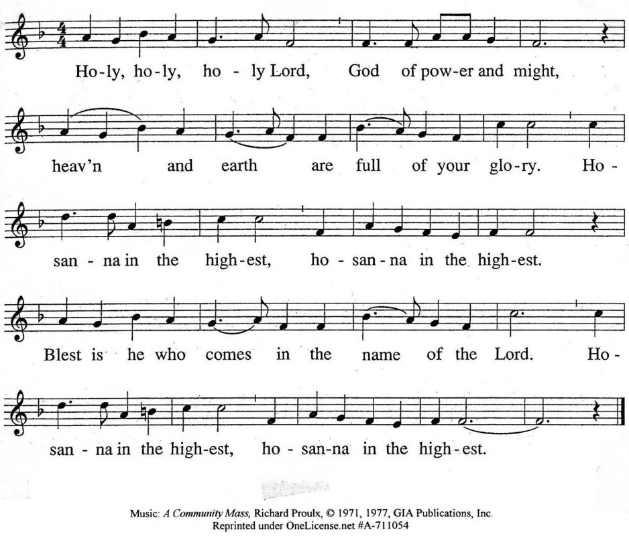

The minister continues the Thanksgiving…
“Together we proclaim the great mystery of faith:”
According to Christ’s commandment
We remember his death,
We proclaim his resurrection,
We await his coming in glory.

The minister continues with Intercessions for the Church and the World
and Prayers of the People…
Leader: Lord, in your mercy,
People: hear our prayers.
Our Lord’s Prayer
Our Father who art in heaven, hallowed be thy name. Thy kingdom come,
thy will be done, on earth as it is in heaven. Give us this day our daily bread;
and forgive us our debts, as we forgive our debtors; and lead us not into temptation, but deliver us from evil. For thine is the kingdom and the power
and the glory, forever. Amen.

Words of Institution
Communion
Communion Music: Reflections on To Love and Serve

We all will receive communion by coming to the Lord’s Table. Our usher will invite you to come forward by pew, beginning from the back. If you are unable to come forward, a server will come to you after everyone else has received. Choir members will remain seated and receive after the congregation.
Please consume the elements when you are comfortable doing so. You do not need to wait – please do so as the Spirit leads (right away, as you pause after receiving, or back in your seats).
With Christian love we serve gluten-free communion bread and alcohol-free grape juice.
Also with Christian love the elements were prepared with strict attention to health concerns.
You are invited to partake of the prepackaged communion juice and wafer if you choose; we now offer prepackaged cups that include gluten-free wafers.

Prayer after Communion
Hymn 203: Jesu, Jesu, Fill Us with Our Love

Charge and Benediction
Leader: Now go and serve the Lord,
People: For we are blessed to be a blessing!
Leader: The cross, All: We shall take it.
Leader: The bread, All: We shall break it.
Leader: The pain, All: We shall bear it.
Leader: The joy, All: We shall share it.
Leader: The Gospel, All: We shall live it.
Leader: The love, All: We shall give it.
Leader: The light, All: We shall cherish it.
Leader: The darkness, All: God shall perish it.
Leader: For Jesus’ sake. All: Amen.

Southminster Lenten Benediction Response
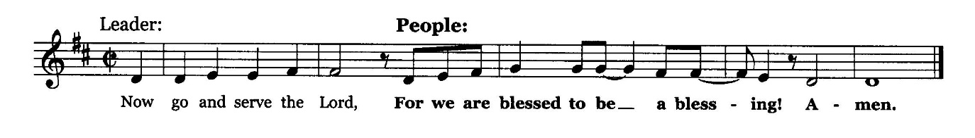

Postlude

Participants and Technical Crew
Rev. Wendy Boden
Liturgist: Angela Smith
Deacon Fellowship: Heather Kralicek
Elder at the Door: Gretchen Fleming
Musicians: Tom Anderson, the Southminster Choir
Worship Assistant: David Kozich
Tech support: Chris Kozich, Blair Nelson
The flowers today are from Lynn Ferino, given with thanks for the blessing of family and friends.

Care Notes: “In everything by prayer and supplication with thanksgiving let your requests be made known to God.” -Philippians 4:6
Even though we aren’t all together for worship, we are still collecting prayer requests! Please email or leave a message on our answering machine at 630-469-9149 if you won’t be present to fill out a prayer request slip.

Friends,
Please make a point of sending an email, text, phone call, or filling out a blue prayer request and letting the people of Southminster know who you would like us to keep in prayer. All prayer requests are welcome. We want to be able to know who to talk to in order to follow up on all the people we pray for each week.

New requests and updates are italicized in our prayer list.

We are starting new mourners and cancer care lists. If you would like to continue listing a particular person, please contact the office.
Joys and Concerns
The flowers today are from Lynn Ferino, given with thanks for the blessing of family and friends.
We give thanks to God for joys: (Romans 12:15) “Rejoice with those who rejoice...”
- Raluca (Bojor) and Nathan Hofmeyer on the birth of their son, Alexander Lucian
- Rita Zapel reports that Tricia Gillenwater is recovering well from knee surgery.
- Steven, the 14-year-old Venezuelan boy with autism who was in detention with his father in Texas since December, came home to Glen Ellyn this past week! “Steven and his mother couldn’t have been happier to see one another.” They await the next steps in their asylum appeal…
We pray for the whole world and our nation: (1 Timothy 2:1-2) “I urge, then, first of all, that petitions, prayers, intercession, and thanksgiving be made for all people…”
- Our sister church in Cuba as they face scarcity
- Peace between the U.S. and Cuba after a recent incident
- Peace between Pakistan and Afghanistan, China and Japan
- The family of kidnapped Nancy Guthrie and all those who have missing family members
- Our nation as we celebrate and give thanks for the contributions African American have made in our nation. We pray for racial reconciliation.
- Advances in heart health care
- We pray for people in prison, detention camps, or in isolating situations that they may know you have not forgotten them.
- We pray for transformed hearts for our nation, for members of ICE and other DHS forces, and for ourselves.
Blessed are those who mourn: (Romans 12:15) “...weep with those who weep.”
- Jennie Buhs, who died after a long battle with cancer
All those we name in our hearts and hold dear.
We lift up those affected by cancer, along with their support systems:
All those for whom we displayed luminaria on February 22
- We continue to pray for Amie C., Margaret F., Karen L., Ginny O., Cis R., Heidi S., Marta S., Meagan S., Kurt Parent, who is now in palliative care, former President Joe Biden, and those we name in our hearts.
We pray for all who are recovering from or dealing with mental, physical, or other health challenges:
- March is National Trisomy Awareness Month, dedicated to raising awareness, supporting families, and fostering research for individuals with an extra chromosome. We lift up families and those affected by having an extra chromosome.
- Jack Thorne is now in isolation while recovering from ankle amputation.
- Jessica Abuseini lifts up Yolanda Villareal, Celeste’s great-great-grandma, now in hospice care.
- Barb Doppelt, seeking relief from knee pain
- For all those having surgery
- Angela Smith asks prayers for her friend, Kathleen, at Brookdale, who is declining rapidly from Parkinson’s. We lift up all who are dealing with Parkinson’s.
- All those seeking meaningful employment
- We lift up people struggling with anxiety and depression.
- Jim Smith, at Brookdale, Betty Eichin in assisted living, and all those in care centers.
Prayers for our worshiping community and the Jeremiah Task Force, who meet this month, as we discern God’s call to SPC for the 21st century. God, bring a harvest and lovers of the harvest. We welcome all, but we long for more children, teens, and families to be blessed by us and to join is in blessing the community. Help us share our stories with one another.
We lift up the men of Southminster as they discern a way to serve our neighbors.

This week at Southminster:
Sunday, March 1 – 2nd Sunday in Lent
Endowment Sunday
Note that Jubilee Bucks will not be sold today but next Sunday, March 8.
Worship at 9:30 a.m. in person and also live on Facebook
Fellowship in the Narthex following worship; egg stuffing for the Easter Party
No Staff meeting – Pastor Wendy Boden is leaving after worship and will be
away through March 4.
Adult Ed. Bible Study, 11:15 a.m., Parlor/Library (Class will end early: 12:00
rather than 12:15)
Congolese Church, 1:00-3:00 p.m. in Fellowship Hall
Tuesday, March 3
No Staff calendar meeting
No Heart to Heart (Pastor Wendy away)
Mission, 7:00 p.m., McHenry Parlor/Library
A.A., 7:30 p.m., Fellowship Hall
Wednesday, March 4
Women’s Breakfast, 8:30 a.m., Danby’s Station
No Heart to Heart (Pastor Wendy away)
March Dialog goes out
Thursday-Friday: Pastor Wendy Boden’s Heart to Heart on Facebook
streams at approximately 5:00 p.m.
Thursday, March 5
Hawthorn Garden Club, 12:00 p.m., Fellowship Hall
Staff calendar meeting, 12:30 p.m., McHenry Parlor/Library
Choir rehearsal, 7:00 p.m., Sanctuary
Young Adults Video Club, 8:30 p.m.
Friday, March 6
A.A., 6:30 p.m., Fellowship Hall
Saturday, March 7
Congolese Church music practice, 1:00-4:00 p.m. in Fellowship Hall
Don’t forget to set your clocks to “spring forward” 1 hour before you
fall asleep
Next Sunday, March 8 – 3rd Sunday in Lent
Daylight Saving Time begins
Order Jubilee Bucks gift cards; contact bobbifrey@aol.com by 9:00 p.m.
Worship at 9:30 a.m. in person and also live on Facebook
Fellowship in the Narthex following worship; egg stuffing/Easter party prep
Staff meeting, 11:00 a.m., Pastor’s office
Adult Ed. Bible Study, 11:15 a.m., Parlor/Library
Congolese Church, 1:00-3:00 p.m. in Fellowship Hall
Looking ahead:
Monday, March 9 – Narrative reports are due for the annual reports packets
If you are online, we’re glad to have you! Using the comments section on Facebook, you can say hello, ask for words of peace, or request prayers.
If you are present for worship, please wear a name tag; they are on the Mission shelf in the Narthex and on the shelf across from the church offices. Following the service, you are invited by the deacons to gather for a time of fellowship in the narthex.
Our “Comfort Zone” – It is always contagion season, so we continue to have a “comfort zone” toward the back of the sanctuary. You may wear a mask, of course, if you so choose.
Sunday Morning Adult Ed. Bible Study: Enjoy some fellowship time and coffee and then join us at 11:15 a.m. in McHenry Parlor/Library.
You are invited to join us on Facebook (https://www.facebook.com/SouthminsterGlenEllyn/), where most weeks we have a live sharing of “Heart to Heart” with Pastor Wendy Boden Tuesdays through Fridays at approximately 5:00 p.m. This week Pastor Wendy will be away and will only share Heart to Heart on Thursday and Friday.
We continue to be live on Sunday morning for worship at 9:30 a.m. (slideshow beginning at 9:15) on YouTube at
https://www.youtube.com/channel/UCPgWICngOvkmR1OXgCG_wiA/live
or on Facebook at https://www.facebook.com/SouthminsterGlenEllyn/
If you are watching from home on Facebook, please check in and say hello so we can see that you have joined us. This is one way to make worship less “remote” and strengthen community at Southminster.
The live video will appear about 15 minutes before the scheduled start time.
If for any reason the feed falters, rest assured that a recording will be posted to Facebook and You Tube as soon as possible.

You can also find links to recordings of the weekday sessions, special services, and Sunday worship posted on our web site: https://www.southminsterpc.org/ or by going to our YouTube channel:
https://www.youtube.com/channel/UCPgWICngOvkmR1OXgCG_wiA/videos
Photo Stories/PowerPoints help us feel connected!
Photo Stories/PowerPoints help us prepare for worship, connect with one another, and make sure that our at-home people get both sound and sight. Here are some opportunities for you to share your photos:
March 15: “Luminaria Sunday” Did you take photos on February 22 – the sanctuary was
beautiful! Please send photos by Thursday, March 12).
March 22: “Basketball” By this time you will have your brackets chosen for March
Mission Madness – now hype your favorite teams! Please send photos by Thursday,
March 19.
Send photos to our dedicated email address, used just for photos:
PhotoStory@Southminsterpc.org.
Session has set the Annual Meeting of the Congregation to be held at the conclusion of worship on Palm Sunday, March 29. That means the annual reports booklets must be available the previous Sunday, March 22. All narrative reports for the annual reports booklets will be due no later than Monday, March 9. If you are responsible for writing a report and you want to see a report from a previous year, send Barb an email so she can provide you with a copy.
Notes from Blair Nelson:
Adult Education: We continue our study in Proverbs today. It will be a slightly shorter session this time, ending at noon instead of 12:15.
Youth: We are working on a date for an escape room. Watch for messages from Blair N.
Chili/Soup Cook-Off: Thanks to all who cooked, ate, and voted at our Cook-Off last Sunday. We raised $633 for the Youth Mission Trip to a workcamp in Wausau this July! John Pezl, Shelly Barlow, Sue Knisely, Wendy Boden, and Blair Nelson were the contestants. Blair and Wendy took 1st and 2nd, with John’s batch taking 3rd. (An investigation is pending). Special thanks to the deacons who had the brilliant idea of having fellowship in Fellowship Hall to help us with the tight timeline.
Our next fundraiser is the annual Talent Show on Sunday, April 12, so get your act together.
From the Mission Ministry
One Great Hour of Sharing
For over seventy years, Presbyterians have participated in One Great Hour of Sharing during Lent and culminating on Easter. In a world where many of our brothers and sisters lack access to sustainable food sources, clean water, education, and opportunity, the three programs supported by One Great Hour of Sharing supports three programs. These programs are Presbyterian Disaster Assistance, the Presbyterian Hunger Program, and Self Development of People. These all work in different ways to serve individuals and communities in need.

Presbyterian Disaster Assistance works to provide relief to those affected by natural or manmade disasters. The Presbyterian Hunger Program helps to provide food for the hungry. Self Development of People helps provide resources to communities working to cast of the bonds of poverty and oppression.

One Great Hour of Sharing envelopes are available in the sanctuary. Please give generously.
Coming soon: March Mission Madness!
Selection Sunday is March 15. If you’re a fan of college basketball – and of supporting Southminster missions – you’ll want to see the sign-up instructions in the March Dialog coming out this Wednesday so you can enter your brackets and follow the excitement.
Southminster’s Easter Party
Preparations for the Saturday, April 4th Easter party are well under way!
Look for bags of eggs to stuff at home, and please return completed bags of Easter eggs when you are done – the Easter party prep area is the table and floor beneath the flower sign-up poster, in the Narthex.
After-worship egg stuffing continues in the Narthex this Sunday, March 1st. Sunday school kids are also stuffing Easter eggs for us. Thank you, kiddos and Blair Baldwin!
What is next? We are requesting the following donations:
· Wrapped candy to stuff in plastic eggs – no nuts, no peanut butter, no chewing gum and no hard candies, please
· Plastic table cloths in bright or pastel colors (we will use these disposable coverings for the craft tables)
· Artificial flowers – any type (we will use these for an Easter bonnet craft)
Soon, we will be looking for Easter party volunteers, and also volunteers to bring breakfast food items.
Remember, Southminster’s Easter Party is free and open to the public. Think about who you could invite!
From the Worship Ministry
The Easter flowers signup sheet is posted in the narthex. Due to rising flower costs, we are ordering slightly differently this year. Thank you for supporting the Worship Ministry in beautifying the sanctuary for Easter Sunday with Easter lilies, pink azaleas, and tulips (new this year). For questions, call Sarah Allen at 630-988-8231.
The worship and music schedule for the first few months of 2026 is posted on the choir room door. Singers and instrumentalists, please sign up for dates you might want to provide an offertory or communion music.
Online Sign-Up for Valet Parking:
From the Property Ministry: Online Sign-Up for Valet Parking

In order to make it easier to sign up for valet parking for Sunday services we are going to an online sign-up. This will allow you to access the sign-up list from anywhere that you have a phone or computer and an internet connection.
The link to the sign-up sheet is https://volunteersignup.org/Q7W9J
Or use the QR code here (also posted at church on the bulletin board opposite the office)
If you have any questions about signing up or run into a problem when trying to sign up contact Steve Kozich.
All women are invited!
Women’s Breakfast meets the first Wednesday of the month. Join us on March 4
at 8:30 a.m. at Danby’s Station, 750 Roosevelt Road, Glen Ellyn. Come enjoy good food, great conversation, and a refreshing break from your usual routine. All women are always welcome. For more information, contact Gretchen Fleming by phone or text to 630-517-0926.
Jubilee Bucks—Schedule change! Next order date is March 8
Thanks to everyone who ordered Jubilee Bucks in February. Our total to date of “free” money earned is $285.28.
Note these date changes! Order dates in March and April have been changed to the second Sunday of the month: March 8 (remember to order gift cards for Easter baskets!) and April 12 (the Sunday after Easter).
Remember that you can order Jubilee Bucks at any time by contacting bobbifrey@aol.com; Bobbi will hold on to your order until the next scheduled order date.
In May we will return to our normal first Sunday of the month (May 3) for orders to be placed.
People’s Resource Center
Southminster Church has long supported the People’s Resource Center (PRC) by bringing donations of food, personal care items, Souper Bowl offerings, and Share the Spirit gifts. Here is some background information about PRC from their website:
“People’s Resource Center (PRC) and faith communities share a commitment to compassion, service, and dignity for all neighbors. Each year, PRC supports thousands of low-income DuPage families with food, housing assistance, job skills, and more. Faith groups have long been the backbone of PRC’s volunteer network and one of our most dedicated sources of support. When we respond with generosity and grace, our community grows stronger.”
Caring for you!
Our Congregational Care Committee is ready to assist in time of need. If you need assistance from the Congregational Care Ministry or Helping Hands through March 10, call Deacon Sue Knisely (630-776-7998). You may call Pastor Wendy Boden on her cell or home phone (if she has shared the numbers with you) or leave a message for her at the church office: 630-469-9149. You may email Wendy at wendy@southminsterpc.org. (Please note that she can only read email when she is in the office.) You may also call your deacon if you need help from the church.
Pastor Wendy Boden will be away from Sunday afternoon through Wednesday. You may call or text her while she is away, but if you need immediate help, contact Blair Nelson (630-6035). Note that there will be no Heart to Heart on Tuesday or Wednesday this week.
Who is your deacon? The assignments have changed. The new list is posted in the narthex – be sure to check there to see who your deacon is. Or you can contact the church (630-469-9149 or admin@southminsterpc.org) and ask.
Regular Office Schedule:
The church office is closed on Mondays and Wednesdays.
Barb’s regular schedule is to be in the office Tuesdays, Thursdays, and Fridays from approximately 9:30 a.m.-3:30 p.m. while her son attends his day program on those days. Mondays and Wednesdays she works from home but can always answer church email – admin@southminsterpc.org – from there.
Grace and peace to you! Remember that we love God, neighbor, and one another. Our address is 680 South Park Blvd., Glen Ellyn, IL 60137 if you would like to set up an online account with your bank or mail in your pledge. Online giving through Vanco is also now an option –for details contact Ron Birchall.

Bearing Fruit – March 1, 2026
The Endowment Fund is a living legacy.
How do we bear the fruit of God’s love into the future?
Southminster’s Living Legacy Fund is an endowment that pools donations, invests them, and uses the income to support capital projects, innovation, and mission. Since 2005, it has received $440,823 in contributions and generated $237,356 in returns; $143,141, including $31,520 this year, has been allocated for Session-approved projects like the website, video streaming, and sound system. Gifts can be made while living, as part of estate plans, insurance, retirement accounts, or memorials, resulting in a leaf on the donor tree. All gift sizes are welcomed and recognized.
Today we are adding leaves to our Endowment Tree for Alicia Rasnic, Bobette Barfod, Frank Barfod, Richard Cresswell, Floyd Rogers, Joan Koska, and Donna Marton. We are delighted to say that Donna Marton’s gift is a living gift. She is still an active member of our congregation.
If you would like to bear the fruit of God's love, please consider including Southminster Living Legacy Fund as part of your estate plan. The Living Legacy Fund provides an opportunity to make a lasting statement of faith that will help strengthen and extend Southminster's ministry for generations to come.

