Southminster Presbyterian Church
Easter/The Day of Resurrection
April 5, 2026
9:30 a.m.

Find the link for the service on one of these sites:
1) on Facebook: https://www.facebook.com/SouthminsterGlenEllyn/
2) our YouTube channel:
https://www.youtube.com/channel/UCPgWICngOvkmR1OXgCG_wiA/live
3) our web site: https://www.southminsterpc.org/
If the video feed is interrupted during the service, we will continue to record and then post the full video on Facebook and our web site as soon as possible.

For those who are in the sanctuary, please put your phone in airplane mode.

Today we are having communion. Those at home may want to gather the elements (“bread” and “wine” or whatever you have) before the service begins.

Gathering Music/Photo Story: “Resurrection of Our Lord Artwork”

Welcome and Announcements
Faith Story
Lighting the Candles (John 20:30-31)‬‬‬‬‬‬‬‬‬‬‬‬
Now Jesus did many other signs in the presence of his disciples that are not written in this book. But these are written so that you may continue to believe that Jesus is the Messiah, the Son of God, and that through believing you may have life in his name.

Prelude: An Easter Medley

Call to Worship
Leader: The Lord is risen!
People: He is risen indeed!
All: We are messengers of the Resurrection! Alleluia!

Hymn 232: Jesus Christ Is Risen Today (all)

Prayer of Confession: (unison)
Lord Jesus Christ, you are the risen one! Sometimes we believe that we are not good enough to be welcomed here, as if we do not deserve your love. Mend our hearts and minds, so that we can not only receive your love but share it with others. We ask this in the name of Jesus Christ, who is both Savior and Lord. Amen.

(Time of silence for personal prayer and confession)

Declaration of God’s Grace/The Good News of Jesus Christ (Romans 8:33-34)
Leader: Hear the good news! Who is in a position to condemn?
People: Only Christ and Christ died for us;
Leader: Christ rose for us; Christ reigns in power for us,
People: Christ intercedes for us.
All: In Jesus Christ, we are forgiven! Alleluia!

Response 240: Alleluia, Alleluia! Give Thanks (verse 1)
Alleluia, alleluia! Give thanks to the risen Lord.
Alleluia, alleluia! Give praise to his name.
Jesus is the Lord of all the earth.
He is the King of creation.
Alleluia, alleluia! Give thanks to the risen Lord.
Alleluia, alleluia! Give praise to his name.

Text and Music: Donald Fishel, 1971 © 1973 International Liturgy Publications
Reprinted/Streamed with permission under OneLicense.net #A-739517. All rights reserved.

The Passing of the Peace

Word with Children Blair Baldwin
Children worshiping in the sanctuary, please come forward.

As the children leave:
Let There Be Peace on Earth
Let there be peace on earth
And let it begin with me.
Let there be peace on earth
The peace that was meant to be.
With God as our Father
Brothers all are we;
Let me walk with my brother
In perfect harmony.
Let peace begin with me
Let this be the moment now.
With ev'ry step I take
Let this be my solemn vow:
To take each moment
And live each moment
In peace eternally.
Let there be peace on earth
And let it begin with me.

© 1955. Renewed 1983 Jan - Lee Music
For use solely with the SongSelect® Terms of Use. All rights reserved. www.ccli.com
CCLI License # 21214429

Prayer for Illumination

Scripture Lessons: John 20:1-18 Pew Bible, p. 114 (N.T.)
Revelation 21:1-7 Pew Bible, p. 259 (N.T.)

Sermon: “Death Does Not Have the Final Word” Pastor Wendy Boden

Saying What We Believe/Affirmation of Faith (responsive) The Apostles’ Creed
Leader: Do you believe in God the Father?
All: I believe in God, the Father almighty, creator of heaven and earth.
Leader: Do you believe in Jesus Christ, the Son of God?
All: I believe in Jesus Christ, God’s only Son, our Lord, who was
conceived by the Holy Spirit, born of the Virgin Mary, suffered
under Pontius Pilate, was crucified, died, and was buried; he
descended to the dead. On the third day he rose again; he ascended
into heaven, he is seated at the right hand of the Father, and he will
come to judge the living and the dead.
Leader: Do you believe in God the Holy Spirit?
All: I believe in the Holy Spirit, the holy catholic Church, the communion
of saints, the forgiveness of sins, the resurrection of the body, and the
life everlasting. Amen.

Easter Prayer (unison)
Gracious God, by water and the Spirit, you claimed us as your own, cleansing us from sin, and giving us new life. You made us members of your body, the church, calling us to be your servants in the world. Renew in us the covenant you made in our baptism. Continue the good work you have begun in us. Send us forth in the power of your Spirit to love and serve you with joy, and to strive for justice and peace in all the earth, in the name of Jesus Christ our Lord. Amen.

Hymn 248: Christ Is Risen! Shout Hosanna! (verse 1)

Offering of Ourselves and Our Gifts
[The offering plate is at the back of the sanctuary. Please leave your gift or pledge
in the plate on your way into or out of worship.]

Offertory Anthem: Glory to the King of Kings Gilbert M. Martin

*Doxology Hymnal #606
Praise God, from whom all blessings flow;
Praise Him all creatures here below;
Praise Him above, ye heavenly host;
Praise Father, Son, and Holy Ghost. Amen.

Public domain

Prayer of Dedication

Service of the Lord’s Supper
Invitation
[You do not need to wait to consume the elements – please do so as the Spirit
leads (right away, as you pause after receiving, or back in your seats).
We extend an invitation to the Lord’s Supper to all who have been baptized. You do
not need to be a member of this congregation or a Presbyterian to share in this meal.
We remember that access to the Table is not a right conferred upon the worthy, but a
privilege given to believers who come in faith, repentance, and love.]

Great Prayer of Thanksgiving
Leader: The Lord be with you.
People: And also with you.
Leader: Lift up your hearts.
People: We lift them to the Lord.
Leader: Let us give thanks to the Lord our God.
People: It is right to give our thanks and praise.

The minister gives thanks…

The congregation responds by singing together:

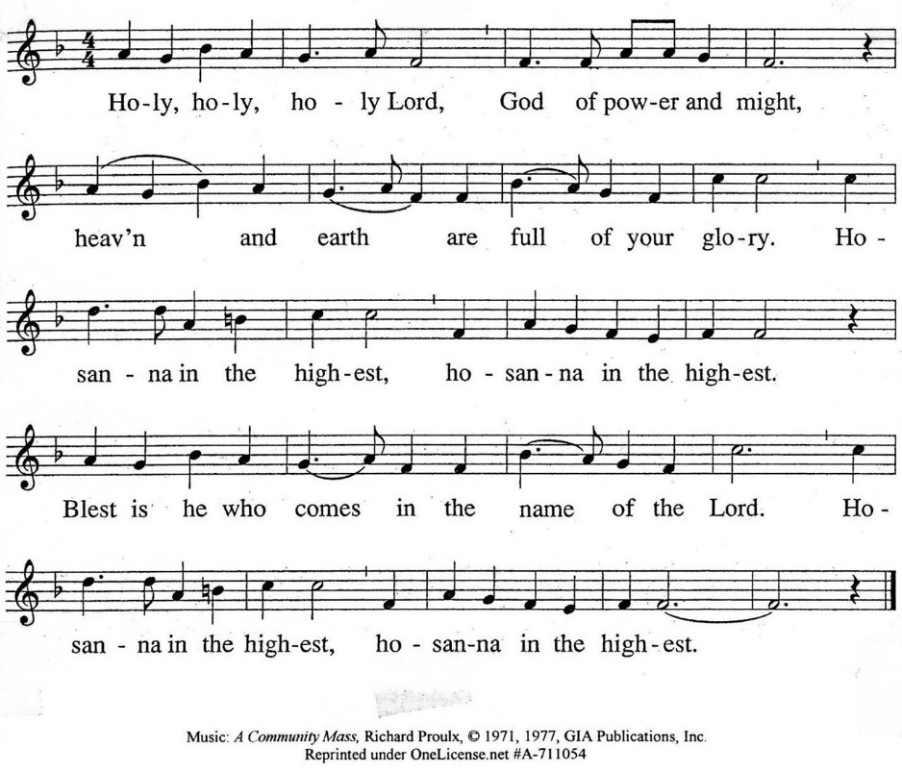

The minister continues the Thanksgiving…
“Together we proclaim the great mystery of faith:”
According to Christ’s commandment
We remember his death,
We proclaim his resurrection,
We await his coming in glory.

The minister continues with Intercessions for the Church and the World
and Prayers of the People…
Leader: Lord, in your mercy,
People: hear our prayers.
Our Lord’s Prayer
Our Father who art in heaven, hallowed be thy name. Thy kingdom come,
thy will be done, on earth as it is in heaven. Give us this day our daily bread;
and forgive us our debts, as we forgive our debtors; and lead us not into temptation, but deliver us from evil. For thine is the kingdom and the power
and the glory, forever. Amen.

Words of Institution
Communion
Communion Music: And This Is Love/And Can It Be

We all will receive communion by coming to the Lord’s Table. Our usher will invite you to come forward by pew, beginning from the back. If you are unable to come forward, a server will come to you after everyone else has received. Choir members will remain seated and receive after the congregation.
Please consume the elements when you are comfortable doing so. You do not need to wait – please do so as the Spirit leads (right away, as you pause after receiving, or back in your seats).
With Christian love we serve gluten-free communion bread and alcohol-free grape juice.
Also with Christian love the elements were prepared with strict attention to health concerns.
You are invited to partake of the prepackaged communion juice and wafer if you choose; we now offer prepackaged cups that include gluten-free wafers.

Prayer after Communion

Hymn 245: Christ the Lord Is Risen Today! (verses 1, 2)

Charge and Benediction

Southminster Benediction Response
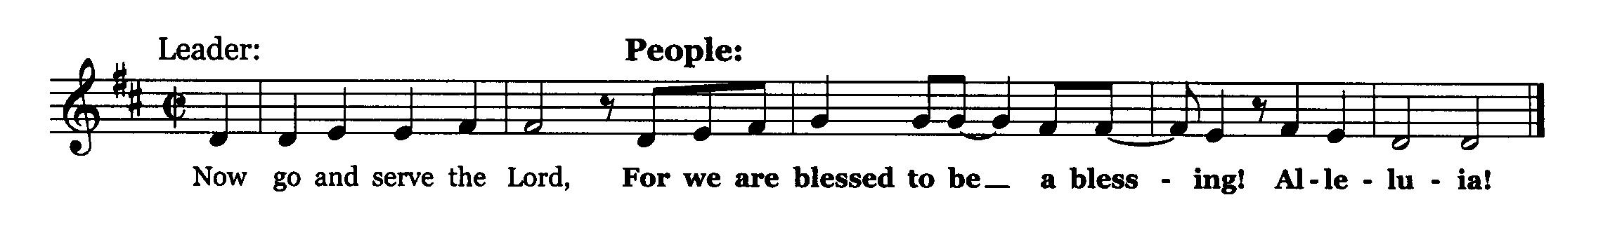

Leader: The cross, All: We shall take it.
Leader: The bread, All: We shall break it.
Leader: The pain, All: We shall bear it.
Leader: The joy, All: We shall share it.
Leader: The Gospel, All: We shall live it.
Leader: The love, All: We shall give it.
Leader: The light, All: We shall cherish it.
Leader: The darkness, All: God shall perish it.
Leader: For the Lord is risen! All: He is risen indeed!
Leader: For Jesus’ sake! All: Amen. Alleluia!

Postlude

Participants and Technical Crew
Rev. Wendy Boden
Liturgist: Dr. Blair Nelson
Fellowship: all the Deacons
Elder at the Door: Angela Smith
Musicians: Tom Anderson, the Southminster Choir
Worship Associate: David Kozich
Tech support: Chris Kozich, Cathy Hosek

The Easter flowers today are given by the following people:
Craig and Sarah Allen Victor King
Wendy Boden and Sue Knisely
Blair Nelson the Kozich Family
Deb Bohi Ralph Linde
Lynn Ferino John Pezl
Gretchen Fleming Lanny Russell
Bobbi and Tom Frey Steve and Kathy Sanders
the Hammer Family Angela Smith
Elise and Steve Henkels Julie Storey
Paul Jeziorski Diane Swiss

Care Notes: “In everything by prayer and supplication with thanksgiving let your requests be made known to God.” -Philippians 4:6
Even though we aren’t all together for worship, we are still collecting prayer requests! Please email or leave a message on our answering machine at 630-469-9149 if you won’t be present to fill out a prayer request slip.

Friends,
Please make a point of sending an email, text, phone call, or filling out a blue prayer request and letting the people of Southminster know who you would like us to keep in prayer. All prayer requests are welcome. We want to be able to know who to talk to in order to follow up on all the people we pray for each week.

New requests and updates are italicized in our prayer list.

We have started new mourners and cancer care lists. If you would like to continue listing a particular person, please contact the office.
Joys and Concerns
The flowers today are from the people listed above. We thank God for the joy of Resurrection Day!
We give thanks to God for joys: (Romans 12:15) “Rejoice with those who rejoice...”
- We are thankful that Sandy’s sister, Theresa, had successful heart surgery.
- Louanne Jourdan is now home after successful gallbladder surgery. She will be moving to Brookdale in April.
- Jack Thorne is recovering at Tabor Hills.
We pray for the whole world and our nation: (1 Timothy 2:1-2) “I urge, then, first of all, that petitions, prayers, intercession, and thanksgiving be made for all people…”
- The safe flight out and back home for Artemis and its crew
- The nation of Cuba
- Peace in the Middle East, and between China and Japan
- Advances in heart health care
- We pray for racial reconciliation.
- We pray for people in prison, detention camps, or in isolating situations that they may know you have not forgotten them.
- We pray for transformed hearts for our nation, for members of ICE and other DHS forces, and for ourselves.
Blessed are those who mourn: (Romans 12:15) “...weep with those who weep.”
- the family of Glenn Long, who died March 6
- Jessica Abuseini and family on the death of Yolanda Villareal, her great-grandmother
All those we name in our hearts and hold dear.
We lift up those affected by cancer, along with their support systems:
- We continue to pray for Bob, Amie C., Margaret F., Karen L., Ginny O., Cis R., Heidi S., Marta S., Meagan S., Rebecca S., Kurt Parent, who is now in palliative care, former President Joe Biden, and those we name in our hearts.
We pray for all who are recovering from or dealing with mental, physical, or other health challenges:
- Please pray for Jayne.
- Jim and Lynnda Nelson, recovering after a very serious car accident (hit by a semi)
- Sandy Phee’s sister, Linda, who has a detached retina
- For all those having surgery and tests
- Angela Smith’s friend, Kathleen, who is declining rapidly from Parkinson’s. We lift up all who are dealing with Parkinson’s.
- All those seeking meaningful employment
- We lift up people struggling with anxiety and depression.
- Jim Smith, at Brookdale, Betty Eichin in assisted living, and all those in care centers.
Prayers for our worshiping community and the Jeremiah Task Force, who meet this month, as we discern God’s call to SPC for the 21st century. God, bring a harvest and lovers of the harvest. We welcome all, but we long for more children, teens, and families to be blessed by us and to join is in blessing the community. Help us share our stories with one another.
We lift up the men of Southminster as they seek to reach out and in to our neighbors.

This week at Southminster:
Sunday, April 5 – Easter Sunday/The Resurrection of the Lord
Worship at 9:30 a.m. in person and also live on Facebook
Fellowship in the Narthex following worship
No staff meeting or adult ed.
Congolese Church, 1:00-3:00 p.m., Fellowship Hall
Monday, April 6 – Pastor’s Sabbath
Tuesday-Friday: Pastor Wendy Boden’s Heart to Heart on Facebook
streams at approximately 5:00 p.m.
Tuesday, April 7
Staff calendar meeting, 12:30 p.m., McHenry Parlor/Library
Mission, 7:00 p.m., McHenry Parlor/Library
A.A., 7:30 p.m., Fellowship Hall
Wednesday, April 8
All-Church Event: Cribbage Night, 7:30 p.m., Parlor/Library
Thursday, April 9
Young Adults Video Club, 8:30 p.m.
Friday, April 10
A.A., 6:30 p.m., Fellowship Hall
Saturday, April 11
Spring Clean-Up Day, 9:00 a.m.-1:00 p.m. Come when you can; stay as long as
you are able!
Congolese Church music practice, 1:00-4:00 p.m. in Fellowship Hall
Next Sunday, April 12
Order Jubilee Bucks gift cards – email bobbifrey@aol.com by 9:00 p.m.
Worship at 9:30 a.m. in person and also live on Facebook
Fellowship in the Narthex following worship
Staff meeting, 11:00 a.m., Pastor’s office
Adult Ed. Bible Study, 11:15 a.m., McHenry Parlor/Library
Congolese Church, 1:00-3:00 p.m. in Fellowship Hall
Talent Show and Dinner, 5:30 p.m., Fellowship Hall
If you are online, we’re glad to have you! Using the comments section on Facebook, you can say hello, ask for words of peace, or request prayers.
If you are present for worship, please wear a name tag; they are on the Mission shelf in the Narthex and on the shelf across from the church offices. Following the service, you are invited by the deacons to gather for a time of fellowship in the narthex.
Our “Comfort Zone” – It is always contagion season, so we continue to have a “comfort zone” toward the back of the sanctuary. You may wear a mask, of course, if you so choose.
Sunday Morning Adult Ed. Bible Study will not meet today.
You are invited to join us on Facebook (https://www.facebook.com/SouthminsterGlenEllyn/), where most weeks we have a live sharing of “Heart to Heart” with Pastor Wendy Boden Tuesdays through Fridays at approximately 5:00 p.m.
We continue to be live on Sunday morning for worship at 9:30 a.m. (slideshow beginning at 9:15) on YouTube at
https://www.youtube.com/channel/UCPgWICngOvkmR1OXgCG_wiA/live
or on Facebook at https://www.facebook.com/SouthminsterGlenEllyn/
If you are watching from home on Facebook, please check in and say hello so we can see that you have joined us. This is one way to make worship less “remote” and strengthen community at Southminster.
The live video will appear about 15 minutes before the scheduled start time.
If for any reason the feed falters, rest assured that a recording will be posted to Facebook and You Tube as soon as possible.

You can also find links to recordings of the weekday sessions, special services, and Sunday worship posted on our web site: https://www.southminsterpc.org/ or by going to our YouTube channel:
https://www.youtube.com/channel/UCPgWICngOvkmR1OXgCG_wiA/videos
Photo Stories/PowerPoints help us feel connected!
Photo Stories/PowerPoints help us prepare for worship, connect with one another, and make sure that our at-home people get both sound and sight. Here are some opportunities for you to share your photos:
May 15: “Mom and Me” Photos that celebrate moms (or grandmothers or women who
are “like a mom” for Mothers Day. Please send photos by Thursday, May 12).

Send photos to our dedicated email address, used just for photos:
PhotoStory@Southminsterpc.org. (If you only have hard copies of your photos, please leave them in the photo box on Pastor Wendy’s desk, labeled with your name and the date they are to be used.)
Notes from Blair Nelson:
Adult Education: Our Sunday-after-worship Bible class is not meeting today. We will continue our study of Proverbs on April 12. Join us then, at 11:15 a.m. in the Parlor/Library.

Men of Southminster: Join us for our next get-together, Wednesday, April 29 at 7:30 p.m. We will enjoy each other’s company, some treats, and discuss details of our Big Project—exciting! Please let Blair N know whether you will be there—gotta get a good count for the snacks.

Youth: Talent Show is coming next Sunday, April 12. We will be setting up on that day. Time to be announced, but likely starting around 3:00 p.m. You all get to be the judges, so bring your best eye for talent to the show. You get to decide!

Talent Show – Next Sunday!
Southminster’s annual talent show and spaghetti dinner are almost here! Join us at 5:30 p.m. in Fellowship Hall on April 12 for a delicious meal and an amazing show hosted by the man in the red vest! There are two sign-up sheets in the Narthex, one for performers and one for eaters not performing. Cost of admission is a donation to the Youth Mission Team, heading to a workcamp in Wausau, WI, this July.

Cribbage Night: You are cordially invited to an evening of Cribbage hosted by the Men of Southminster this Wednesday, April 8, at 7:30 p.m. If you know the game, come and bring a deck of cards and a board, if you have them. If you don’t, come and learn. Most importantly, there will be snacks.
From the Mission Ministry
One Great Hour of Sharing
For over seventy years, Presbyterians have participated in One Great Hour of Sharing during Lent and culminating on Easter. In a world where many of our brothers and sisters lack access to sustainable food sources, clean water, education, and opportunity, the three programs supported by One Great Hour of Sharing supports three programs. These programs are Presbyterian Disaster Assistance, the Presbyterian Hunger Program, and Self Development of People. These all work in different ways to serve individuals and communities in need.

Presbyterian Disaster Assistance works to provide relief to those affected by natural or manmade disasters. The Presbyterian Hunger Program helps to provide food for the hungry. Self Development of People helps provide resources to communities working to cast of the bonds of poverty and oppression.

One Great Hour of Sharing envelopes are available in the sanctuary. Please give generously. This offering will be dedicated next Sunday.
March Mission Madness
March Madness and March Mission Madness are almost over! The Men’s Final Four is down to Illinois vs. UConn and Michigan vs. Arizona; the championship game will be April 6. The Women’s Final Four will be UConn vs. South Carolina and UCLA vs Texas, with the championship on April 5. Our March Mission Madness winners will be announced in worship next Sunday, April 12.

Do you still have a bracket in the competition? Even if yours is busted and you aren’t one of the top finishers, take consolation in knowing that the winners in the end are the missions and projects we support!
There are several brackets that have not yet been paid for. If you haven’t yet contributed your money, please write a check to Southminster for $15 for each bracket you entered. You know who you are… and so does our treasurer, Tom Frey. You really don’t want him to come looking for you!

April collection: Gently-used clothing for Repeat Boutique
Starting next Sunday, April 12, and for the rest of April, there will be a large box in the coat room in which you may place your donations of gently used clothing as well as sheets and towels for Repeat Boutique. This shop serves people referred by non-profit organizations —World Relief, PADS, Peoples Resource Center, as well as other charitable organizations in DuPage County—who need financial help providing for themselves and their families. Eligible persons may shop every three months for a year at no cost to themselves. This year they especially need women’s clothing in larger sizes, men’s clothing (especially jeans), as well as sheets and towels.

From the Worship Ministry
Easter flowers: A big thank you to everyone who signed up for Easter flowers! If you haven’t already paid, please write a check to Southminster with “Easter flowers” on the memo line. Please take your flowers home with you after the service today. Flowers from those marked on the chart with check marks beside their name will remain in the sanctuary.
From the Property Ministry:
Clean-Up Day is next Saturday, April 11, 9:00 a.m.-1:00 p.m.! We can use your help!
Our Spring Clean-Up Day is slated for Saturday, April 11, from 9:00 a.m. until 1:00 p.m. We’ll have a formidable list of outside and inside projects waiting for volunteers. Any amount of time you can help, even if it is just an hour or 2 will be appreciated. The Property Ministry will provide snacks and drinks (coffee & water). Rain date is April 19.
Online Sign-Up for Valet Parking

In order to make it easier to sign up for valet parking for Sunday services we are going to an online sign-up. This will allow you to access the sign-up list from anywhere that you have a phone or computer and an internet connection.
The link to the sign-up sheet is https://volunteersignup.org/Q7W9J
Or use the QR code here (also posted at church on the bulletin board opposite the office)
If you have any questions about signing up or run into a problem when trying to sign up, contact Steve Kozich.

Presbyterian Readers will meet on Wednesday, April 15, at 7:00 p.m. via Zoom. April's book is Atmosphere by Taylor Jenkins Reid, a 2025 novel about a physics professor who becomes one of the first female astronauts in NASA’s 1980s Space Shuttle program.

May's book is The Queens of Crime by Marie Benedict
Join our Cloud HD Video Meeting on Wednesday, April 15, at 7:00 p.m. through this link:
https://us02web.zoom.us/j/86861724721?pwd=TE0yYXZGZUtUNkdvYWh4UEhaTFc0dz09
Meeting ID: 868 6172 4721 Passcode: 600865
For more information about the Readers, contact Rita Zapel at rboserup@sbcglobal.net.
Presbyterian Women plan April 17 museum outing
The next meeting of the Presbyterian Women will be held on Friday, April 17. We will continue our exploration of nature by visiting the Lizzadro Museum of Lapidary Art located at 1220 Kensington Road, Oak Brook.

We will meet in the church parking lot at 9:45 a.m. and carpool from there to the museum. After touring the museum and shop, we will meet at Lazy Dog Restaurant for lunch. Lazy Dog is located at 1775 22nd Street, Oak Brook. Use the Costco entrance and turn left at the first opportunity, the restaurant is just across the entrance road from Costco.

If you are interested in attending, please register on the sign-up sheet found on the Presbyterian Women’s bulletin board. This will help us determine how many cars will be needed for carpooling and lunch reservations. All women of the church and their guests are invited.
Our deacons invite you to a Baby “Sprinkle”
Join the deacons and Christian Ed for a casual "Baby Sprinkle" on Sunday, April 19, for the sweet baby girls, Evelyn and Celeste, with their moms Becca and Jessica A. People have loved seeing the little ones at church and watching them grow over the last several months!

We will be in the parlor at 11:00 a.m. following the church service for light treats and beverages. Women are invited to stay and join us for the fun, as we sprinkle the babies and moms with love! We're hoping that some of the kiddos from Sunday school will stay, too. (Gifts are not necessary but if you'd like to, consider practical items such as diapers, wipes, bibs, books, or a small gift card for the moms.)

Jubilee Bucks: order next Sunday!
Note this date change! The order date in April will not be the first Sunday (which is Easter!) but the following Sunday, April 12. In May we will return to our normal first Sunday of the month (May 3) for orders to be placed.
Remember that gift cards are not just for giving away! You can also order for purchases you regularly make for yourself (i.e. for groceries, gas, dining out, and more). You can order Jubilee Bucks at any time by contacting Bobbi Frey at bobbifrey@aol.com; Bobbi will hold on to your order until the next scheduled order date. To order on April 12, you need to contact her by 9:00 p.m. - use the email address above or call or text Bobbi at 630-643-3858. In May we will return to ordering on the first Sunday of the month—May 3.
People’s Resource Center
Southminster Church has long supported the People’s Resource Center (PRC) by bringing donations of food, personal care items, Souper Bowl offerings, and Share the Spirit gifts. Here is some background information about PRC from their website:
“People’s Resource Center (PRC) and faith communities share a commitment to compassion, service, and dignity for all neighbors. Each year, PRC supports thousands of low-income DuPage families with food, housing assistance, job skills, and more. Faith groups have long been the backbone of PRC’s volunteer network and one of our most dedicated sources of support. When we respond with generosity and grace, our community grows stronger.”
Caring for you!
Our Congregational Care Committee is ready to assist in time of need. If you need assistance from the Congregational Care Ministry or Helping Hands through May 12, call Deacon Elise Henkels (630-740-0473). You may call Pastor Wendy Boden on her cell or home phone (if she has shared the numbers with you) or leave a message for her at the church office: 630-469-9149. You may email Wendy at wendy@southminsterpc.org. (Please note that she can only read email when she is in the office.) You may also call your deacon if you need help from the church.
Who is your deacon? The assignments have changed. The new list is posted in the narthex – be sure to check there to see who your deacon is. Or you can contact the church (630-469-9149 or admin@southminsterpc.org) and ask.
Regular Office Schedule:
The church office is closed on Mondays and Wednesdays.
Barb’s regular schedule is to be in the office Tuesdays, Thursdays, and Fridays from approximately 9:30 a.m.-3:30 p.m. while her son attends his day program on those days. Mondays and Wednesdays she works from home but can always answer church email – admin@southminsterpc.org – from there.
Grace and peace to you! Remember that we love God, neighbor, and one another. Our address is 680 South Park Blvd., Glen Ellyn, IL 60137 if you would like to set up an online account with your bank or mail in your pledge. Online giving through Vanco is also now an option –for details contact Ron Birchall.

Bearing Fruit – April 5, 2026
Easter Clothes!
Ours is a faith born out of memory of God’s mighty acts, relationships, and waiting for the fullness of time when the Kingdom of God fully comes. We believe that God reached out to us through the people of Abraham and Sarah, whom God called to an unknown future and with the promise that they were blessed to be a blessing. We are heirs to the promise of

blessing, which we as a congregation and community pass on to one another and to our world.
Scripture tells us that in the fullness of time, God came to us in Jesus Christ. During Holy Week, which is the week from Palm/Passion Sunday through Resurrection/Easter, we remember and rehearse the story of Christ’s life, death, and resurrection together.
On Maundy Thursday we remember the commandment to love one another and the approaching darkness of that night of betrayal.
On Good Friday we sit at the foot of the cross and remember the last seven words of Christ from the cross.
On Holy Saturday we invite the community to hear the story of Holy Week while we celebrate the Resurrection with crafts, an egg hunt, and light breakfast bites. We even offer an Easter bonnet craft – remembering the Easter tradition of new clothes!
On Resurrection Sunday, we rejoice! One way people rejoice is with new clothing. From the earliest times Christians would wear new clothes to honor the new of the resurrection. This year we have a new take on Easter clothes. Beginning April 12th Southminster will collect not new but gently-used clothing for Repeat Boutique. As you clean out your closet for spring, remember people whose clothes would be refreshed by yours. Look for more information in the announcements.
Remembering Christ’s gift, worshiping together with the events of Holy Week, inviting others to share in our worship and our Easter Party, and bringing clothes to share with others are all ways of bearing the fruit of God’s love.

