Southminster Presbyterian Church
5th Sunday of Easter
May 3, 2026
9:30 a.m.

Find the link for the service on one of these sites:
1) on Facebook: https://www.facebook.com/SouthminsterGlenEllyn/
2) our YouTube channel:
https://www.youtube.com/channel/UCPgWICngOvkmR1OXgCG_wiA/live
3) our web site: https://www.southminsterpc.org/
If the video feed is interrupted during the service, we will continue to record and then post the full video on Facebook and our web site as soon as possible.

For those who are in the sanctuary, please put your phone in airplane mode.

Today we are having communion. Those at home may want to gather the elements (“bread” and “wine” or whatever you have) before the service begins.

Gathering Music/Photo Story: “Baby Sprinkle”

Welcome, Announcements, and Moment for Mission
Faith Story
Lighting the Candles (Acts 2:42)‬‬‬‬‬‬‬‬‬‬‬‬
They devoted themselves to the apostles’ teaching and to fellowship,
to the breaking of bread and to prayer.

Prelude

Hymn: Christ, Our Hope in Life and Death pg. 7, gold worship supplement

Call to Worship (Romans 8:31-37)
Leader: The Holy One is in our midst
People: Equipping us for life in the service of Christ.
Leader: May the all-surpassing grace of our Lord Jesus Christ be with us all,
People: And the unshakable love of God be with all of us.
All: Together we worship God.

Hymn 43: You Who Dwell in the Shelter of the Lord (On Eagle’s Wings) (all)

Prayer of Confession: (unison)
God, we struggle to accept that your mercy and grace are meant for us. Help us trust and believe. Sometimes our lives are a mess because of the choices we’ve made or those others have made. We trust that amid all of this, you are present. We believe you are with us, walking beside us when we stray, guiding us back to the right path, slowing us down when we get ahead of you, and waiting for us when we fall behind. Thank you. Through the power of your Spirit alive within us and the forgiveness we find in the name of Jesus Christ, enable us to walk the walk of faith and trust. Amen.

(Time of silence for personal prayer and confession)

Declaration of God’s Grace/The Good News of Jesus Christ (Romans 8:33-34)
Leader: Hear the good news! Who is in a position to condemn?
People: Only Christ and Christ died for us;
Leader: Christ rose for us; Christ reigns in power for us,
People: Christ intercedes for us.
All: In Jesus Christ, we are forgiven! Alleluia!

Response 240: Alleluia, Alleluia! Give Thanks (verse 1)
Alleluia, alleluia! Give thanks to the risen Lord.
Alleluia, alleluia! Give praise to his name.
Jesus is the Lord of all the earth.
He is the King of creation.
Alleluia, alleluia! Give thanks to the risen Lord.
Alleluia, alleluia! Give praise to his name.

Text and Music: Donald Fishel, 1971 © 1973 International Liturgy Publications
Reprinted/Streamed with permission under OneLicense.net #A-739517. All rights reserved.

The Passing of the Peace

Word with Children Blair Baldwin
Children worshiping in the sanctuary, please come forward.

As the children leave:
Let There Be Peace on Earth
Let there be peace on earth
And let it begin with me.
Let there be peace on earth
The peace that was meant to be.
With God as our Father
Brothers all are we;
Let me walk with my brother
In perfect harmony.
Let peace begin with me
Let this be the moment now.
With ev'ry step I take
Let this be my solemn vow:
To take each moment
And live each moment
In peace eternally.
Let there be peace on earth
And let it begin with me.

© 1955. Renewed 1983 Jan - Lee Music
For use solely with the SongSelect® Terms of Use. All rights reserved. www.ccli.com
CCLI License # 21214429

Prayer for Illumination

Scripture Lessons: Romans 8:31-37 Pew Bible, p. 158 (N.T.)
Acts 9:1-5, 8-10 Pew Bible, p. 127 (N.T.)

Sermon: “A Rough Road”

Saying What We Believe/Affirmation of Faith (unison)
The Apostles’ Creed [Ecumenical]
I believe in God, the Father almighty, creator of heaven and earth.
I believe in Jesus Christ, God’s only Son, our Lord, who was conceived by the Holy Spirit, born of the Virgin Mary, suffered under Pontius Pilate, was crucified, died, and was buried; he descended to the dead. On the third day he rose again; he ascended into heaven, he is seated at the right hand of the Father, and he will come to judge the living and the dead.
I believe in the Holy Spirit, the holy catholic Church, the communion of saints, the forgiveness of sins, the resurrection of the body, and the life everlasting. Amen.

Hymn 840: When Peace Like a River (It Is Well with My Soul) (all)

Offering of Ourselves and Our Gifts
[The offering plate is at the back of the sanctuary. Please leave your gift or pledge
in the plate on your way into or out of worship.]

Offertory Anthem: Asante Sana, Yesu (Thank You, Jesus) arr. by Mark Burrows

*Doxology Hymnal #606
Praise God, from whom all blessings flow;
Praise Him all creatures here below;
Praise Him above, ye heavenly host;
Praise Father, Son, and Holy Ghost. Amen.

Public domain

Prayer of Dedication

Service of the Lord’s Supper
Invitation
[You do not need to wait to consume the elements – please do so as the Spirit
leads (right away, as you pause after receiving, or back in your seats).
We extend an invitation to the Lord’s Supper to all who have been baptized. You do
not need to be a member of this congregation or a Presbyterian to share in this meal.
We remember that access to the Table is not a right conferred upon the worthy, but a
privilege given to believers who come in faith, repentance, and love.]

Great Prayer of Thanksgiving
Leader: The Lord be with you.
People: And also with you.
Leader: Lift up your hearts.
People: We lift them to the Lord.
Leader: Let us give thanks to the Lord our God.
People: It is right to give our thanks and praise.

The minister gives thanks…

The congregation responds by singing together:

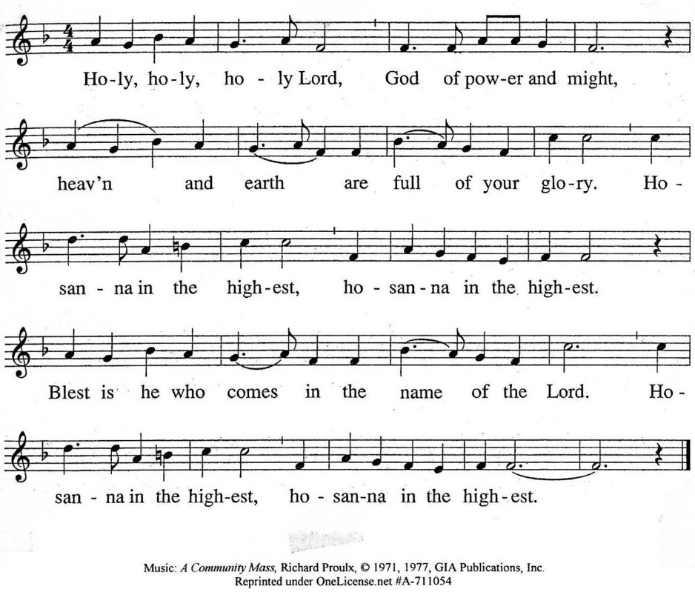

The minister continues the Thanksgiving…
“Together we proclaim the great mystery of faith:”
According to Christ’s commandment
We remember his death,
We proclaim his resurrection,
We await his coming in glory.

The minister continues with Intercessions for the Church and the World
and Prayers of the People…
Leader: Lord, in your mercy,
People: hear our prayers.
Our Lord’s Prayer
Our Father who art in heaven, hallowed be thy name. Thy kingdom come,
thy will be done, on earth as it is in heaven. Give us this day our daily bread;
and forgive us our debts, as we forgive our debtors; and lead us not into temptation, but deliver us from evil. For thine is the kingdom and the power
and the glory, forever. Amen.

Words of Institution
Communion
Communion Music: You’ll Never Walk Alone Richard Rodgers

We all will receive communion by coming to the Lord’s Table. Our usher will invite you to come forward by pew, beginning from the back. If you are unable to come forward, a server will come to you after everyone else has received. Choir members will remain seated and receive after the congregation.
Please consume the elements when you are comfortable doing so. You do not need to wait – please do so as the Spirit leads (right away, as you pause after receiving, or back in your seats).
With Christian love we serve gluten-free communion bread and alcohol-free grape juice.
Also with Christian love the elements were prepared with strict attention to health concerns.
You are invited to partake of the prepackaged communion juice and wafer if you choose; we now offer prepackaged cups that include gluten-free wafers.

Prayer after Communion

Hymn 834: Precious Lord, Take My Hand (all)

Charge and Benediction

Southminster Benediction Response
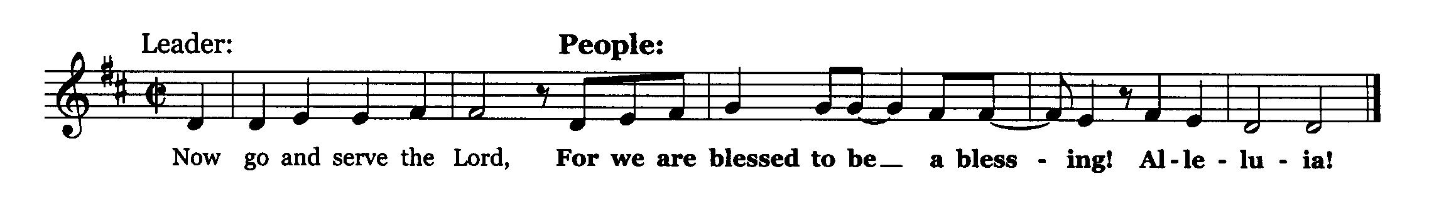

Leader: The cross, All: We shall take it.
Leader: The bread, All: We shall break it.
Leader: The pain, All: We shall bear it.
Leader: The joy, All: We shall share it.
Leader: The Gospel, All: We shall live it.
Leader: The love, All: We shall give it.
Leader: The light, All: We shall cherish it.
Leader: The darkness, All: God shall perish it.
Leader: For the Lord is risen! All: He is risen indeed!
Leader: For Jesus’ sake! All: Amen. Alleluia!

Postlude

Participants and Technical Crew
Rev. Wendy Boden
Liturgist: Terry Kline
Fellowship: Kathy Sanders
Elder at the Door: Steve Sanders
Musicians: Tom Anderson; the Southminster Choir; David Kozich, trumpet
Worship Associate: David Kozich
Tech support: Chris Kozich, Blair Nelson

The flowers today are given by Julie Storey in honor of the anniversary of her parents, Virginia and Lloyd Gross.

Bearing Fruit – May 3, 2026

We are having communion today. If you are worshiping online, you may want to prepare for worship by collecting symbols of bread and wine for your at-home worship.
Our photo story today is of the “baby sprinkle” we had for Evelyn and Celeste, with their moms, Becca and Jessica A.
“Gifts Grow”—Hands-on Ministry
During the month of May, you have the opportunity to contribute to our missions, and your gifts will be matched by the Mission Ministry up to a total of $8,300 for the entire event.
Throughout May, Bearing Fruit will offer brief sketches of our various outreach ministries. This is not an endorsement or recommendation, but a little bit of extra information about some of our missions and how we bear the fruit of God’s love. Our missions are: Bridge Communities, Cuba Sister Church, DuPage PADS, Metropolitan Family Services, People’s Resource Center, Walk-In Ministry, World Relief, and the Youth Mission Trip.
Southminster Presbyterian Church has always been a congregation that reaches out in love to those around them. Today, we are focusing on several of the ministries where we have had direct involvement. Next week, we will showcase other “Gifts Grow” opportunities and organizations where we also participate hands-on. Presbyterians believe that everything we do is to the glory of God. This is one way we worship during the week.
Youth Mission Trip: Annually, the youth and some young adults of SPC continue the SPC tradition of service by refurbishing homes for the elderly and the poor in various communities across the United States. This year, we are going to Racine, WI. Traveling away from home and caring for people outside their local community is one way for our youth to serve others while stepping outside their comfort zone. And don’t forget the rummage sale and car wash on June 6 and 7, a fundraiser for the mission trip.
Cuba Sister Church: Since 2006, SPC has maintained a special relationship with the Presbyterian Reformed Church of Guanabacoa, Cuba. This ministry focuses on relationship and support. SPC is the only official sister church of Guanabacoa and provides their primary support for ministry. Many members of SPC have visited, and you are encouraged to consider a visit as well. You are also invited to join a faith and interest group that plans events on behalf of the mission ministry for our sister church.
Metropolitan Family Services (formerly Family Shelter Service) supports families who need support as they transition from abusive situations or economic hardship. One of our members volunteers in their thrift store to help raise funds.
Walk In Ministry provides emergency assistance to local residents, including gas vouchers, food cards, prescription help, and car repair/insurance payments. Southminster is one of the local churches supporting Walk-In Ministry; we have people who serve there and on the board.
World Relief: Over 68 million people worldwide have been displaced and cannot return home. World Relief partners with churches and community groups across the United States to support immigrants and refugees in finding a new home. Local offices help refugees secure housing, jobs, and education. They also provide immigration legal services to refugees and others who have immigrated to the United States, offering legal clinics and counseling to guide them toward U.S. citizenship. Members of SPC volunteer in various ways.
Together we bear the fruit of God’s love by sharing in the Lord’s Supper, enjoying our youngest family members, and supporting missions of compassion both near and far.

