Southminster Presbyterian Church
2nd Sunday after Pentecost
June 7, 2026
9:30 a.m.

Find the link for the service on one of these sites:
1) on Facebook: https://www.facebook.com/SouthminsterGlenEllyn/
2) our YouTube channel:
https://www.youtube.com/channel/UCPgWICngOvkmR1OXgCG_wiA/live
3) our web site: https://www.southminsterpc.org/
If the video feed is interrupted during the service, we will continue to record and then post the full video on Facebook and our web site as soon as possible.

For those who are in the sanctuary, please put your phone in airplane mode.

Today we are having communion. Those at home may want to gather the elements (“bread” and “wine” or whatever you have) before the service begins.

Prelude/Gathering Music/Photo Story: “Officers”

Welcome and Announcements
Faith Story
Lighting the Candles ‬‬‬‬‬‬‬‬‬‬‬
Congregational Prayer of Dedication for Gifts Grow donations (unison)
Creator of all good, thank you for your abundant generosity to us. We dedicate these Gift Grow gifts to spreading your gospel of love, grace, and mercy throughout our community, and beyond. Multiply these resources to support those in need, and bring the light of Christ to everyone. Use our giving to build your Kingdom, bringing peace and healing to a hurting world. It is in the name of Jesus Christ that we pray. Amen.

Hymn 314: Longing for Light, We Wait in Darkness (all)
(Christ Be Our Light)

Call to Worship
Leader: As our candles give light, so may our lives give light to all.
People: Their brightness reminds us of the light of Christ.
All: Jesus is the light of the world. Let us worship God.

Hymn 192: Lord, the Light of Your Love Is Shining (Shine, Jesus, Shine) (all)

Prayer of Confession: (unison)
Source of light and truth, help us experience the grace to live as faithful followers of Christ. Lead us to consider the words we shall speak into our hearts and our lives. For the moments when we forget who we are and whose we are, forgive us. By the power of your Holy Spirit, help us to be transformed more and more into your likeness and reflecting your light. In the name of Jesus, who is both Lord and Savior, we pray. Amen.

(Time of silence for personal prayer and confession)

Declaration of God’s Grace/The Good News of Jesus Christ (Romans 8:33-34)
Leader: Hear the good news! Who is in a position to condemn?
People: Only Christ and Christ died for us;
Leader: Christ rose for us; Christ reigns in power for us,
People: Christ intercedes for us.
All: In Jesus Christ, we are forgiven! Alleluia!

Response 288: Spirit of the Living God
Spirit of the living God, fall afresh on me.
Spirit of the living God, fall afresh on me.
Melt me; mold me; fill me; use me.
Spirit of the living God, fall afresh on me.

CCLI Song # 23488
Daniel Iverson
© Words: 1935. Renewed 1963 Birdwing Music (Admin. by Capitol CMG Publishing)
Music: 1935. Renewed 1963 Birdwing Music (Admin. by Capitol CMG Publishing)
For use solely with the SongSelect® All rights reserved.
CCLI License # 21214429

The Passing of the Peace

Word with Children Blair Baldwin
Children worshiping in the sanctuary, please come forward.

As the children leave:
This Little Light of Mine (one verse)
This little light of mine,
I'm gonna let it shine.
This little light of mine,
I'm gonna let it shine.
This little light of mine,
I'm gonna let it shine.
Let it shine, let it shine, let it shine.

Prayer for Illumination

Scripture Lessons: Genesis 15:4-6 Pew Bible, p. 12 (O.T.)
John 8:12 Pew Bible, p. 101 (N.T.)
Philippians 2:12-15 Pew Bible, p. 197 (N.T.)

Sermon: “Promise: You Are ‘Starshine’”

Saying What We Believe/Affirmation of Faith (unison)
The Apostles’ Creed [Ecumenical]
I believe in God, the Father almighty, creator of heaven and earth.
I believe in Jesus Christ, God’s only Son, our Lord, who was conceived by the Holy Spirit, born of the Virgin Mary, suffered under Pontius Pilate, was crucified, died, and was buried; he descended to the dead. On the third day he rose again; he ascended into heaven, he is seated at the right hand of the Father, and he will come to judge the living and the dead.
I believe in the Holy Spirit, the holy catholic Church, the communion of saints, the forgiveness of sins, the resurrection of the body, and the life everlasting. Amen.

Hymn 377: I Want to Walk as a Child of the Light (all)

Offering of Ourselves and Our Gifts
[The offering plate is at the back of the sanctuary. Please leave your gift or pledge
in the plate on your way into or out of worship.]

Offertory: Stars from Les Miserables Claude-Michel Schönberg

*Doxology Hymnal #606
Praise God, from whom all blessings flow;
Praise Him all creatures here below;
Praise Him above, ye heavenly host;
Praise Father, Son, and Holy Ghost. Amen.

Public domain

Prayer of Dedication

Service of the Lord’s Supper
Invitation
[You do not need to wait to consume the elements – please do so as the Spirit
leads (right away, as you pause after receiving, or back in your seats).
We extend an invitation to the Lord’s Supper to all who have been baptized. You do
not need to be a member of this congregation or a Presbyterian to share in this meal.
We remember that access to the Table is not a right conferred upon the worthy, but a
privilege given to believers who come in faith, repentance, and love.]

Great Prayer of Thanksgiving
Leader: The Lord be with you.
People: And also with you.
Leader: Lift up your hearts.
People: We lift them to the Lord.
Leader: Let us give thanks to the Lord our God.
People: It is right to give our thanks and praise.

The minister gives thanks…

The congregation responds by singing together:

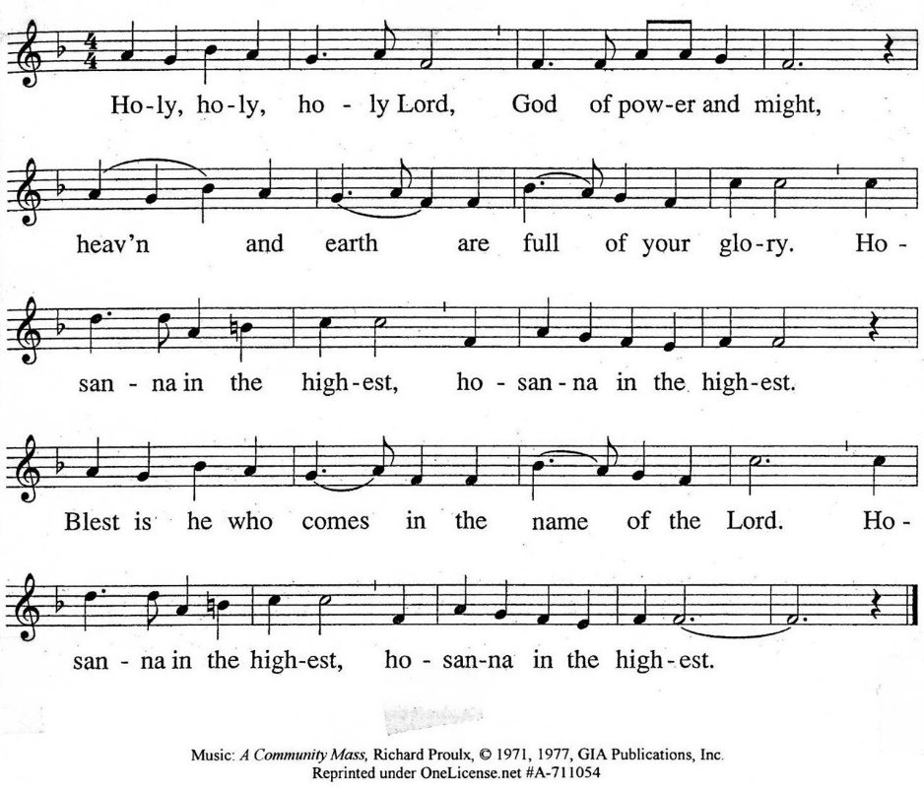

The minister continues the Thanksgiving…
“Together we proclaim the great mystery of faith:”
According to Christ’s commandment
We remember his death,
We proclaim his resurrection,
We await his coming in glory.

The minister continues with Intercessions for the Church and the World
and Prayers of the People…
Leader: Lord, in your mercy,
People: hear our prayers.
Our Lord’s Prayer
Our Father who art in heaven, hallowed be thy name. Thy kingdom come,
thy will be done, on earth as it is in heaven. Give us this day our daily bread;
and forgive us our debts, as we forgive our debtors; and lead us not into temptation, but deliver us from evil. For thine is the kingdom and the power
and the glory, forever. Amen.

Words of Institution
Communion
Communion Music: Bring Him Home from Les Miserables
Claude-Michel Schönberg

We all will receive communion by coming to the Lord’s Table. Our usher will invite you to come forward by pew, beginning from the back. If you are unable to come forward, a server will come to you after everyone else has received. Choir members will remain seated and receive after the congregation.
Please consume the elements when you are comfortable doing so. You do not need to wait – please do so as the Spirit leads (right away, as you pause after receiving, or back in your seats).
With Christian love we serve gluten-free communion bread and alcohol-free grape juice.
Also with Christian love the elements were prepared with strict attention to health concerns.
You are invited to partake of the prepackaged communion juice and wafer if you choose; we now offer prepackaged cups that include gluten-free wafers.

Prayer after Communion

Hymn 707: Take Our Minds, Dear Lord (all)

Charge and Benediction

Southminster Benediction Response
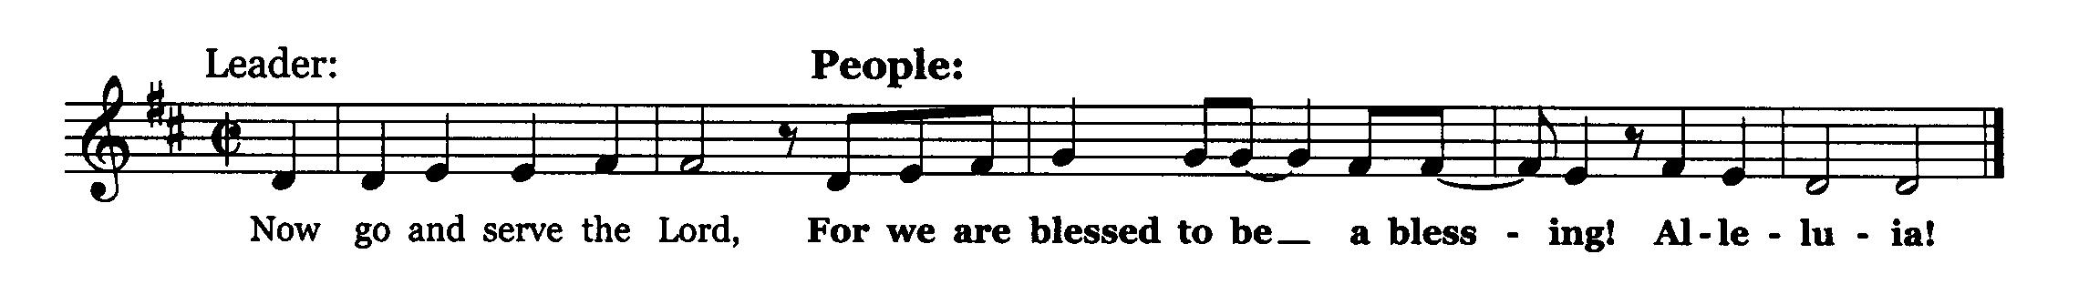

Postlude

Participants and Technical Crew
Rev. Wendy Boden
Liturgist: Angela Smith
Fellowship: Kathy Sanders
Elder at the Door: Deb Bohi
Musicians: Tom Anderson, Victor King, David Kozich
Worship Associate: David Kozich
Tech support: Chris Kozich, Blair Nelson

The flowers today are given by John Pezl in loving memory of what would have been his wife Dawn's and his 50th wedding anniversary on June 12th.

Care Notes: “In everything by prayer and supplication with thanksgiving let your requests be made known to God.” -Philippians 4:6
Even though we aren’t all together for worship, we are still collecting prayer requests! Please email or leave a message on our answering machine at 630-469-9149 if you won’t be present to fill out a prayer request slip.

Friends,
Please make a point of sending an email, text, phone call, or filling out a blue prayer request and letting the people of Southminster know who you would like us to keep in prayer. All prayer requests are welcome. We want to be able to know who to talk to in order to follow up on all the people we pray for each week.

New requests and updates are italicized in our prayer list.
Joys and Concerns
The flowers today are from John Pezl in loving memory of what would have been his wife Dawn's and his 50th wedding anniversary on June 12th.
We give thanks to God for joys: (Romans 12:15) “Rejoice with those who rejoice...”
- Congratulations to friends of Rita’s who have had infertility issues and now are expecting their second child.
We pray for the whole world and our nation: (1 Timothy 2:1-2) “I urge, then, first of all, that petitions, prayers, intercession, and thanksgiving be made for all people…”
- We lift up our elected officials.
- Peace in the world and for our sister church in Cuba
- We pray for transformed hearts for our nation.
Blessed are those who mourn: (Romans 12:15) “...weep with those who weep.”
- The families and friends of construction workers killed last weekend
- The family of former long-time member Barbara Miller. We have received word that she died on April 7. The family is holding a memorial service for her on Saturday, June 13, 11:00 a.m. at Faith Lutheran Church, 3000 Liberty Street, Aurora, IL 60502. An informal luncheon with the family will follow.
- All those we name in our hearts and hold dear.
We lift up those affected by cancer, along with their support systems:
- We continue to pray for Bob, Amie C., Margaret F., Karen L., Ginny O., Cis R., Heidi S., Marta S., Meagan S., Rebecca S., Kurt Parent, who is now in palliative care, former President Joe Biden, and those we name in our hearts.
We pray for all who are recovering from or dealing with mental, physical, or other health challenges:
- For all those having surgery and tests
- For all who are dealing with Parkinson’s disease
- All those seeking meaningful employment
- We lift up people struggling with anxiety and depression.
- Jim Smith, Betty Eichin, and all those in care or rehab centers, and those in isolating situations

This week at Southminster:
Sunday, June 7
Order Jubilee Bucks gift cards; contact bobbifrey@aol.com by 9:00 p.m.
Worship at 9:30 a.m. in person and also live on Facebook.
Fellowship in the Narthex following worship
Rummage Sale and Car Wash, 11:00-3:00 p.m.
Artists’ Reception, 12:30-2:00 p.m., Hallway Gallery/Narthex/Parlor
Congolese Church, 1:00-3:00 p.m. in Fellowship Hall
Monday, June 8 – Pastor’s Sabbath
Tuesday-Friday: Pastor Wendy Boden’s Heart to Heart on Facebook streams
at approximately 5:00 p.m.
Tuesday, June 9
Knitting Circle, 10:00 a.m., McHenry Parlor/Library
Staff calendar meeting, 12:30 p.m., Parlor/Library
Deacons, 7:00 p.m., McHenry Parlor/Library
A.A., 7:30 p.m., Fellowship Hall
Wednesday, June 10
Property, 7:00 p.m., McHenry Parlor/Library/Narthex
Thursday, June 11
Session docket deadline, noon
Young Adults Video Club, 8:30 p.m.
Friday, June 12
A.A., 6:30 p.m., Fellowship Hall
Saturday, June 13
Congolese Church music practice, 1:00 p.m., Fellowship Hall
Next Sunday, June 14
Worship at 9:30 a.m. in person and also live on Facebook.
Fellowship in the Narthex following worship
Program Ministries meeting, 11:00 a.m., McHenry Parlor/Library
No Adult Ed.
Congolese Church, 1:00-3:00 p.m. in Fellowship Hall
If you are online, we’re glad to have you! Using the comments section on Facebook, you can say hello, ask for words of peace, or request prayers.
If you are present for worship, please wear a name tag; they are on the Mission shelf in the Narthex and on the shelf across from the church offices. Following the service, you are invited by the deacons to gather for a time of fellowship in the narthex.
Our “Comfort Zone” – It is always contagion season, so we continue to have a “comfort zone” toward the back of the sanctuary. You may wear a mask, of course, if you so choose.
Sunday Morning Adult Ed. Bible Study will not meet today (Rummage Sale/Car Wash) or next Sunday (Blair needs to attend another meeting.)
You are invited to join us on Facebook (https://www.facebook.com/SouthminsterGlenEllyn/), where most weeks we have a live sharing of “Heart to Heart” with Pastor Wendy Boden Tuesdays through Fridays at approximately 5:00 p.m.
We continue to be live on Sunday morning for worship at 9:30 a.m. (slideshow beginning at 9:15) on YouTube at
https://www.youtube.com/channel/UCPgWICngOvkmR1OXgCG_wiA/live
or on Facebook at https://www.facebook.com/SouthminsterGlenEllyn/
If you are watching from home on Facebook, please check in and say hello so we can see that you have joined us. This is one way to make worship less “remote” and strengthen community at Southminster.
The live video will appear about 15 minutes before the scheduled start time.
If for any reason the feed falters, rest assured that a recording will be posted to Facebook and You Tube as soon as possible.

You can also find links to recordings of the weekday sessions, special services, and Sunday worship posted on our web site: https://www.southminsterpc.org/ or by going to our YouTube channel:
https://www.youtube.com/channel/UCPgWICngOvkmR1OXgCG_wiA/videos
Photo Stories/PowerPoints help us feel connected!
Photo Stories/PowerPoints help us prepare for worship, connect with one another, and make sure that our at-home people get both sound and sight. Here are some opportunities for you to share your photos:
June 21: “Dad and Me” Photos of you as a child with your dad (or grandfather or
someone who has been “like a dad”) for Fathers Day. Please send photos by Thursday,
June 18) to PhotoStory@Southminsterpc.org.
June 28: “Gardens” Yours or someone else’s, in all their summer splendor! Please
send photos by Thursday, June 25) to PhotoStory@Southminsterpc.org.

(If you only have hard copies of your photos, please leave them in the photo box on Pastor Wendy’s desk, labeled with your name and the date they are to be used.)
Notes from Blair Nelson:
Adult Education: No adult Bible class this week or next. We will resume our study of Proverbs on June 21.

Men of Southminster: Our next get together is Wednesday, June 24, and we will be getting the wheels turning on our big project now that we have a date. Be sure to be there at 7:30 p.m. in the Parlor/Library. Of course, there will be yummy food, as well.

Youth: We continue the Rummage Sale right after worship.

Rummage Sale and Car Wash ends today at 3:00 p.m. So, be sure to get in on the good deals and/or get your car washed, weather permitting.
From the Welcome and Outreach Ministry: Meet the Artists!
Join us for an Artists’ Reception next Sunday, June 7, from 12:30-2:00 p.m. There will be a light lunch with beverages and finger desserts. Jim Perona, a talented musician, will be performing; he offers refined, classical and Spanish guitar performances. Each performance is carefully prepared to suit the tone, setting, and flow of the specific event. Invite a friend (You can shop the rummage sale and get your car washed, too, all this afternoon.)
From the Mission Ministry
Gifts Grow Results 2026
Thank you to all who contributed!
 | Donations | Match | Total Payout
Bridge Communities | $ 475 | $ 464 | $ 939
Cuba Sister Church | $ 2,275 | $ 2,209 | $ 4,484
DuPage PADS | $ 525 | $ 513 | $ 1,038
Metropolitan Family Services | $ 575 | $ 561 | $ 1,136
Peoples' Resource Center | $ 675 | $ 647 | $ 1,322
Walk In Ministry | $ 1,745 | $ 1,692 | $ 3,437
World Relief | $ 905 | $ 872 | $ 1,777
Youth Mission Trip | $ 1,375 | $ 1,343 | $ 2,718
Total | $ 8,550 | $ 8,300 | $ 16,850

From the Worship Ministry
The worship and music schedule for Summer 2026 is posted on the choir room door. Singers and instrumentalists, please sign up for dates you might want to provide an offertory or communion music.
Sign up to donate flowers for worship!
The flower chart for the remainder of 2026 is posted in the Narthex. The price remains $35 per arrangement. If you are unable to sign up at church, contact Sarah Allen (sarah.cleland.allen@gmail.com) with your requests.
From the Property Ministry:
Online Sign-Up for Valet Parking

In order to make it easier to sign up for valet parking for Sunday services we are going to an online sign-up. This will allow you to access the sign-up list from anywhere that you have a phone or computer and an internet connection.
The link to the sign-up sheet is https://volunteersignup.org/Q7W9J
Or use the QR code here (also posted at church on the bulletin board opposite the office)
If you have any questions about signing up or run into a problem when trying to sign up, contact Steve Kozich.
Presbyterian Readers: Read and discuss with us!
Presbyterian Readers will meet on Wednesday, June 17, at 7:00 p.m. via Zoom. June's book is My Friends by Fredrik Backman. “The #1 New York Times bestselling author returns with an unforgettably funny, deeply moving tale of four teenagers whose friendship creates a bond so powerful that it changes a complete stranger’s life twenty-five years later.”
Join our Cloud HD Video Meeting on Wednesday, June 17, at 7:00 p.m. through this link:
https://us02web.zoom.us/j/86861724721?pwd=TE0yYXZGZUtUNkdvYWh4UEhaTFc0dz09
Meeting ID: 868 6172 4721 Passcode: 600865
We will not meet in July.
For more information about the Readers, contact Rita Zapel at rboserup@sbcglobal.net.
Jubilee Bucks—Order today!
Today is your only chance this month to order Jubilee Bucks gift cards. Remember that gift cards are not just for giving away! You can also order for purchases you regularly make for yourself (i.e. for groceries, gas, dining out, and more). Contact Bobbi Frey before 9:00 tonight at bobbifrey@aol.com or by call or text to 630-643-3858.
And don’t forget that the Easter Party planners are asking for Amazon gift cards throughout the year, not just in the weeks leading up to the event. There are Easter Party Jubilee Bucks order forms on the nametag shelf across from the pastor’s office.
Your next chance to order will be July 5.
People’s Resource Center: Consider the volunteer opportunities!
Southminster has supported People’s Resource Center (PRC) with food donations for many years. PRC not only takes food donations, they also take clothing, old Chromebooks, and iPads. It is also a wonderful place to volunteer if you have extra time on your hands. You can tutor people, help with ESL, assist in the computer lab with courses or updating donations, sort clothing donations, or assist clients during clothing closet hours, assist with food clients, sort and shelve food donations, pick up food donations from stores, or help with art classes. Check their web site, peoplesrc.org for volunteer opportunities. Clients, volunteers, and employees are all wonderful to interact with!

Want to know more about volunteering at PRC? Long-time volunteer Bobbi Frey is always happy to talk about her experiences there. Or check the PRC website: https://www.peoplesrc.org/volunteer/.
Caring for you!
Our Congregational Care Committee is ready to assist in time of need. If you need assistance from the Congregational Care Ministry or Helping Hands until August 11, call Deacon Barb Kocinski (630-710-4703). You may call Pastor Wendy Boden on her cell or home phone (if she has shared the numbers with you) or leave a message for her at the church office: 630-469-9149. You may email Wendy at wendy@southminsterpc.org. (Please note that she can only read email when she is in the office.) You may also call your deacon if you need help from the church.
Who is your deacon? The assignments will change after the ordination and installation of new officers. The new list will be posted in the narthex – in the meantime, you can check there to see who your current deacon is. Or you can contact the church (630-469-9149 or admin@southminsterpc.org) and ask.
Regular Office Schedule:
The church office is closed on Mondays and Wednesdays.
Barb’s regular schedule is to be in the office Tuesdays, Thursdays, and Fridays from approximately 9:30 a.m.-3:30 p.m. while her son attends his day program on those days. Mondays and Wednesdays she works from home but can always answer church email – admin@southminsterpc.org – from there.
Grace and peace to you! Remember that we love God, neighbor, and one another. Our address is 680 South Park Blvd., Glen Ellyn, IL 60137 if you would like to set up an online account with your bank or mail in your pledge. Online giving through Vanco is also now an option –for details contact Ron Birchall.

Community Invitations!

“Summer Folk for Summer Folk”
A benefit concert for the Glen House Food Pantry
(formerly the Glen Ellyn Food Pantry)
This Friday, June 12, 7:00-8:00 p.m.

Join is for an evening of fantastic music by Pastor Dave and the Trustees (Pastor Dave Price of GE First United Methodist), who will be joined by a duo called The PR Department for originals, spirituals, and covers. Come to Mahon Hall at St. Mark’s Episcopal Church, 393 N. Main Street, Glen Ellyn – enter through door #1 Tickets are $10 per person.
Go to https://www.geumc.org/event-details/summer-folk-for-summer-folk to secure your tickets.

Peoples Community Church
and the Glen Ellyn Interfaith Prayer Foundation
invite you to a Juneteenth Celebration!
Friday, June 19, 6:00-8:00 p.m.
BBQ, Music, Worship


“Join us as we celebrate the culture of African Americans on Juneteenth through food, music, and ceremony to celebrate freedom and culture!” Use the QR code to RSVP.

Peoples Community Church
670 S. Lambert Rd.
Glen Ellyn
630-790-5590

Bearing Fruit – June 7, 2026
Gifts Grew!
In May, we had the opportunity to contribute to our ministry matching program, Gifts Grow, which concluded on May 31.
Since 2002, matching funds have been included in the Mission budget, matched by friends and members of Southminster for our sponsored Mission ministries. The initial goal in 2002 was $3,166. Last year, 2025, the goal was $5,800, but the amount collected was $7,876, resulting in a distribution of $13,6776.
In recent years, contributions through the Gifts Grow program have exceeded the budgeted amount. Our challenge this year was $8,300 for the entire event. This was a significant leap for the Mission Ministry.
The Mission Ministry was quite curious and a bit restless at last Tuesday night's meeting. As of last Sunday morning, May 31, it looked like we would not reach our goal, but we did! In fact, we exceeded expectations. By the end of the day, the donations raised totaled $8,550, leading to a distribution of $16,850 to local missions. Please see the table below for the results.
 | Donations | Match | Total Payout
Bridge Communities | $ 475 | $ 464 | $ 939
Cuba Sister Church | $ 2,275 | $ 2,209 | $ 4,484
DuPage PADS | $ 525 | $ 513 | $ 1,038
Metropolitan Family Services | $ 575 | $ 561 | $ 1,136
Peoples' Resource Center | $ 675 | $ 647 | $ 1,322
Walk In Ministry | $ 1,745 | $ 1,692 | $ 3,437
World Relief | $ 905 | $ 872 | $ 1,777
Youth Mission Trip | $ 1,375 | $ 1,343 | $ 2,718
Total | $ 8,550 | $ 8,300 | $ 16,850
Southminster Presbyterian Church has always been a congregation that reaches out in love to those around them. Together, we bear the fruit of God’s love by participating in worship, the Lord’s Supper, and supporting missions of compassion both near and far. Thank you for supporting Southminster’s Gift Grow Program.

