Southminster Presbyterian Church
6th Sunday after Pentecost
July 5, 2026
9:30 a.m.

Find the link for the service on one of these sites:
1) on Facebook: https://www.facebook.com/SouthminsterGlenEllyn/
2) our YouTube channel:
https://www.youtube.com/channel/UCPgWICngOvkmR1OXgCG_wiA/live
3) our web site: https://www.southminsterpc.org/
If the video feed is interrupted during the service, we will continue to record and then post the full video on Facebook and our web site as soon as possible.

For those who are in the sanctuary, please put your phone in airplane mode.

Today we are having communion. Those at home may want to gather the elements (“bread” and “wine” or whatever you have) before the service begins.

Prelude/Gathering Music/Photo Story: “Founders”

Welcome, Announcements, and Moment for Mission
Faith Story
Lighting the Candles (Philippians 1:9)
And this is my prayer, that your love may overflow more and more
with knowledge and full insight…

Hymn 337: My Country, ‘Tis of Thee (all)

Call to Worship (Psalm 33)
Leader: Blessed is the nation whose God is the Lord,
whose people are known by his name.
People: Let your unfailing love surround us, O God,
for our hope is in you alone.
All: Together we worship God.

Hymn 339: Lift Every Voice and Sing (all)

Prayer of Confession: (unison)
Lord God, Father of light, through the grace of our Lord Jesus Christ and in the indwelling of the Holy Spirit, may your light shine in us so that we may truly become the salt and the light of the world. We pray that your light may shine on all the earth. However limited we are, let our words and actions reflect the light of your love, in the name of Jesus Christ, who is our Lord and Savior, we pray. Amen.

(Time of silence for personal prayer and confession)

Declaration of God’s Grace/The Good News of Jesus Christ (2 Corinthians 5:16-17)
Leader: So, from now on, we regard no one from a worldly point of view.
People: Though we once regarded Christ in this way, we do so no longer.
Leader: Therefore, if anyone is in Christ, the new creation has come;
People: The old has gone, the new is here!
All: In the name of Jesus Christ, we are forgiven.

Response 288: Spirit of the Living God
Spirit of the living God, fall afresh on me.
Spirit of the living God, fall afresh on me.
Melt me; mold me; fill me; use me.
Spirit of the living God, fall afresh on me.

CCLI Song # 23488
Daniel Iverson
© Words: 1935. Renewed 1963 Birdwing Music (Admin. by Capitol CMG Publishing)
Music: 1935. Renewed 1963 Birdwing Music (Admin. by Capitol CMG Publishing)
For use solely with the SongSelect® All rights reserved.
CCLI License # 21214429

The Passing of the Peace

Word with Children Blair Baldwin
Children worshiping in the sanctuary, please come forward.

As the children leave:
This Little Light of Mine
This little light of mine,
I’m gonna let it shine.
This little light of mine,
I’m gonna let it shine.
This little light of mine,
I’m gonna let it shine,
Let it shine, let it shine, let it shine.

Public domain

Prayer for Illumination

Scripture Lessons: Joshua 5:13-15 Pew Bible, p. 197 (O.T.)
Matthew 5:13-16 Pew Bible, p. 4 (N.T.)

Sermon: “Rev. John Witherspoon”

Saying What We Believe/Affirmation of Faith (unison)
The Apostles’ Creed [Ecumenical]
I believe in God, the Father almighty, creator of heaven and earth.
I believe in Jesus Christ, God’s only Son, our Lord, who was conceived by the Holy Spirit, born of the Virgin Mary, suffered under Pontius Pilate, was crucified, died, and was buried; he descended to the dead. On the third day he rose again; he ascended into heaven, he is seated at the right hand of the Father, and he will come to judge the living and the dead.
I believe in the Holy Spirit, the holy catholic Church, the communion of saints, the forgiveness of sins, the resurrection of the body, and the life everlasting. Amen.

Hymn 340: This Is My Song (all)

Offering of Ourselves and Our Gifts
[The offering plate is at the back of the sanctuary. Please leave your gift or pledge
in the plate on your way into or out of worship.]

Offertory: This Land Is My Land Woody Guthrie

*Doxology Hymnal #606
Praise God, from whom all blessings flow;
Praise Him all creatures here below;
Praise Him above, ye heavenly host;
Praise Father, Son, and Holy Ghost. Amen.

Public domain

Prayer of Dedication

Service of the Lord’s Supper
Invitation
[You do not need to wait to consume the elements – please do so as the Spirit
leads (right away, as you pause after receiving, or back in your seats).
We extend an invitation to the Lord’s Supper to all who have been baptized. You do
not need to be a member of this congregation or a Presbyterian to share in this meal.
We remember that access to the Table is not a right conferred upon the worthy, but a
privilege given to believers who come in faith, repentance, and love.]

Great Prayer of Thanksgiving
Leader: The Lord be with you.
People: And also with you.
Leader: Lift up your hearts.
People: We lift them to the Lord.
Leader: Let us give thanks to the Lord our God.
People: It is right to give our thanks and praise.
Leader: As we remember the birth of our nation,
and the gifts of life, liberty, and the pursuit of happiness,
Let us offer our thanks and prayers to God,
the giver of all good gifts.
For the tribes and nations that inhabit this land
for generation upon generation,
People: We thank you, Lord.
Leader: For the brave women and men
who braved the long journey by sea to come to this new world,
People: We thank you, Lord.
Leader: For patriots who dreamed of, and fought for, a free nation,
People: We thank you, Lord.
Leader: For the men and women who laid the foundation of our democracy,
and who pledged liberty and justice for all,
People: We thank you, Lord.
Leader: For those who built this country brick by brick,
road by road, and town by town,
People: We thank you, Lord.
Leader: For the brave soldiers who have fought for our country,
for all who paid for our freedom by their service,
and those who paid by their sacrifice,
People: We thank you, Lord.
Leader: For the innovators and artists, poets and teachers,
farmers and factory workers;
for all who labor and provide for the common good,
People: We thank you, Lord.
Leader: For this land, with its peaks and valleys,
coasts and deserts, fields and meadows,
People: We thank you, Lord.
Leader: For our own community, for those who came before us in this place,
and for our neighbors near and far,
People: We thank you, Lord.
Leader: Lord, we pray for these United States,
that we might always be a nation that defends and promotes
liberty and freedom, truth and justice.
People: We pray to you, Lord.
Leader: That we might always be a nation where all are free
to worship and pray,
People: We pray to you, Lord.
Leader: That we might be a beacon of freedom
to all those who live under the shadow of terror and hopelessness,
People: We pray to you, Lord.
Leader: That those who are elected to govern and lead
would be guided by you,
and be ever aware of the trust that has been given to them,
People: We pray to you, Lord.
Leader: That we would be a people who repent from our sins,
and who always return to you and to your grace,
People: We pray to you, Lord.
Leader: Gracious God, Father of all nations,
bless and defend us and our land;
prosper the work of our hands,
and increase in us your grace and compassion,
and our offerings of thanks to you,
our rock and our salvation;
through Jesus Christ our Lord. Amen.

The minister gives thanks…

The congregation responds by singing together:

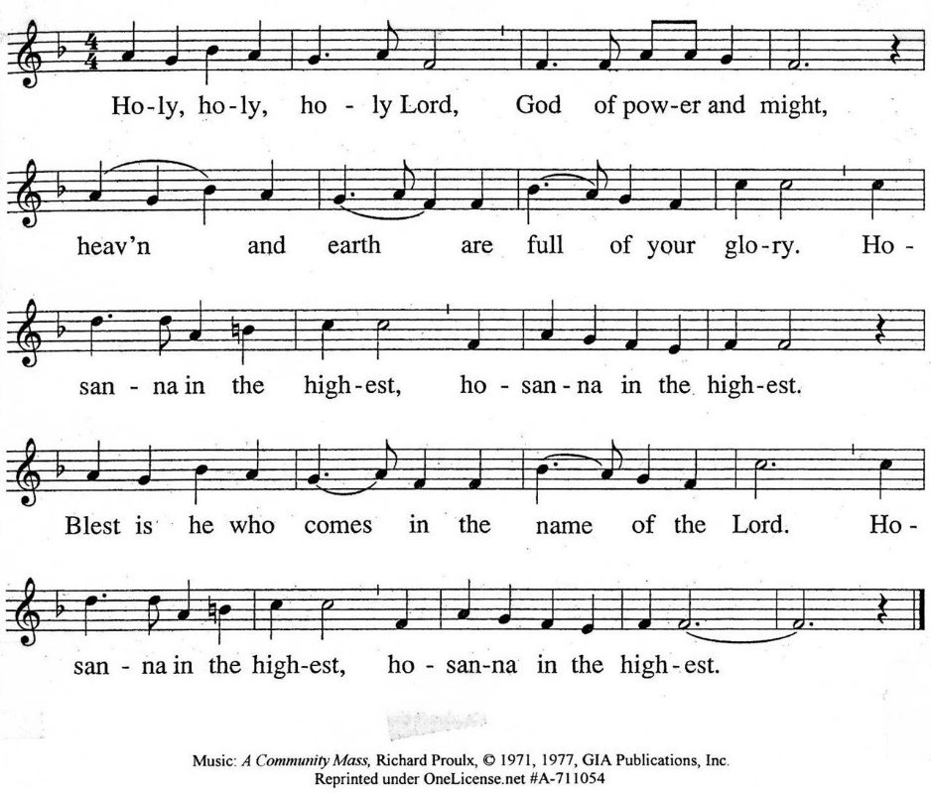

The minister continues the Thanksgiving…
“Together we proclaim the great mystery of faith:”
According to Christ’s commandment
We remember his death,
We proclaim his resurrection,
We await his coming in glory.

The minister continues with Intercessions for the Church and the World
and Prayers of the People…
Leader: Lord, in your mercy,
People: hear our prayers.
Our Lord’s Prayer
Our Father who art in heaven, hallowed be thy name. Thy kingdom come,
thy will be done, on earth as it is in heaven. Give us this day our daily bread;
and forgive us our debts, as we forgive our debtors; and lead us not into temptation, but deliver us from evil. For thine is the kingdom and the power
and the glory, forever. Amen.

Words of Institution
Communion
Communion Music: Battle Hymn of the Republic

We all will receive communion by coming to the Lord’s Table. Our usher will invite you to come forward by pew, beginning from the back. If you are unable to come forward, a server will come to you after everyone else has received.
Please consume the elements when you are comfortable doing so. You do not need to wait – please do so as the Spirit leads (right away, as you pause after receiving, or back in your seats).
With Christian love we serve gluten-free communion bread and alcohol-free grape juice.
Also with Christian love the elements were prepared with strict attention to health concerns.
You are invited to partake of the prepackaged communion juice and wafer if you choose; we now offer prepackaged cups that include gluten-free wafers.

Prayer after Communion

Hymn 338: O Beautiful for Spacious Skies (all)

Charge and Benediction

Southminster Benediction Response
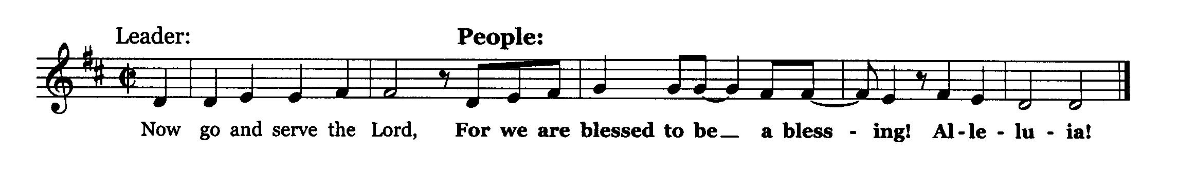

Postlude

Participants and Technical Crew
Rev. Wendy Boden
Liturgist: Andrea Schmidt
Elder at the Door: Gretchen Fleming
Fellowship: Anny Davidson
Musicians: Tom Anderson, Paul Jeziorski, David Kozich
Worship Associate: David Kozich
Tech support: Chris Kozich, Blair Nelson

The flowers today are given by Rita Zapel: “Happy 250th birthday, America!”.

Care Notes: “In everything by prayer and supplication with thanksgiving let your requests be made known to God.” -Philippians 4:6
Even though we aren’t all together for worship, we are still collecting prayer requests! Please email or leave a message on our answering machine at 630-469-9149 if you won’t be present to fill out a prayer request slip.

Friends,
Please make a point of sending an email, text, phone call, or filling out a blue prayer request and letting the people of Southminster know who you would like us to keep in prayer. All prayer requests are welcome. We want to be able to know who to talk to in order to follow up on all the people we pray for each week.

New requests and updates are italicized in our prayer list.
Joys and Concerns
The flowers today are from Rita Zapel: “Happy 250th birthday, America!”
We give thanks to God for joys: (Romans 12:15) “Rejoice with those who rejoice...”
- Evelyn and Rebecca Storey’s birthdays
We pray for the whole world and our nation: (1 Timothy 2:1-2) “I urge, then, first of all, that petitions, prayers, intercession, and thanksgiving be made for all people…”
- All those who have been affected by natural disasters: earthquakes in Venezuela, floods in Kentucky, fires in Utah, extreme heat in Europe
- for Ernesto
- We lift up our elected officials.
- Peace in the world and for our sister church in Cuba
- We pray for transformed hearts for our nation.
Blessed are those who mourn: (Romans 12:15) “...weep with those who weep.”
- the family of former member Glenn Long, whose service will be at Southminster this coming Saturday, July 11; visitation at 10:00 a.m., service at 11:00
- the family of former member Bob Reinecke, who died June 11 in Scottsdale, AZ
- Deb Bohi and her family on the death of her brother, Tom Grimsey - All those we name in our hearts and hold dear.
We lift up those affected by cancer, along with their support systems:
- Rita Zapel asks prayers for Paul Stoffels, who has been diagnosed with cancer and Parkinson’s
- We continue to pray for Colin B., Amie C., Margaret F., Karen L., Ginny O., Cis R., Heidi S., Marta S., Meagan S., Kurt Parent, who is now in palliative care, former President Joe Biden, and those we name in our hearts.
We pray for all who are recovering from or dealing with mental, physical, or other health challenges:
- Delmar Meester, who had shoulder replacement on Monday
- Cat Gaddis, who is quite ill and seeking a diagnosis
- For all those having surgery and tests
- For all who are dealing with Parkinson’s disease
- All those seeking meaningful employment
- We lift up people struggling with anxiety and depression.
- Jim Smith, Betty Eichin, and all those in care or rehab centers, and those in isolating situations.

This week at Southminster:
Sunday, July 5
Order Jubilee Bucks gift cards; contact bobbifrey@aol.com by 9:00 p.m.
Worship with communion at 9:30 a.m. in person and also live on Facebook.
Fellowship in the Narthex following worship
Staff meeting, 11:00 a.m., Kids’ Korner
Adult Ed. Bible Study, 11:15 a.m., McHenry Parlor/Library
Congolese Church, 1:00-3:00 p.m. in Fellowship Hall
Monday, July 6 – Pastor’s Sabbath
Tuesday-Friday: Pastor Wendy Boden’s Heart to Heart on Facebook
streams at approximately 5:00 p.m.
Tuesday, July 7
Staff calendar meeting, 12:30 p.m., McHenry Parlor/Library
Mission Ministry visit to PADS Interim Housing Center, 7:00 p.m.
A.A., 7:30 p.m., Fellowship Hall
Thursday, July 9
Young Adults Video Club, 8:30 p.m.
Friday, July 10
A.A., 6:30 p.m., Fellowship Hall
Saturday, July 11
Visitation and service for Glenn Long
Visitation, 10:00 a.m., Narthex
Service, 11:00 a.m., Sanctuary
Congolese Church music practice, 1:00 p.m., Fellowship Hall
Youth Mission Trip packing the van, 4:00 p.m.
Next Sunday, July 12
Youth Mission Team leaves at 7:30 p.m. – come pray with them
Worship at 9:30 a.m. in person and also live on Facebook.
Fellowship in the Narthex following worship
Staff meeting, 11:00 a.m., Kids’ Korner
No Adult Ed. Bible Study
Congolese Church, 1:00-3:00 p.m. in Fellowship Hall
If you are online, we’re glad to have you! Using the comments section on Facebook, you can say hello, ask for words of peace, or request prayers.
If you are present for worship, please wear a name tag; they are on the Mission shelf in the Narthex and on the shelf across from the church offices. Following the service, you are invited by the deacons to gather for a time of fellowship in the narthex.
Our “Comfort Zone” – It is always contagion season, so we continue to have a “comfort zone” toward the back of the sanctuary. You may wear a mask, of course, if you so choose.
Sunday Morning Adult Ed. Bible Study meets at 11:15 a.m. in the Parlor/Library but will not meet next week because of the youth mission trip.
You are invited to join us on Facebook (https://www.facebook.com/SouthminsterGlenEllyn/), where most weeks we have a live sharing of “Heart to Heart” with Pastor Wendy Boden Tuesdays through Fridays at approximately 5:00 p.m.
We continue to be live on Sunday morning for worship at 9:30 a.m. (slideshow beginning at 9:15) on YouTube at
https://www.youtube.com/channel/UCPgWICngOvkmR1OXgCG_wiA/live
or on Facebook at https://www.facebook.com/SouthminsterGlenEllyn/
If you are watching from home on Facebook, please check in and say hello so we can see that you have joined us. This is one way to make worship less “remote” and strengthen community at Southminster.
The live video will appear about 15 minutes before the scheduled start time.
If for any reason the feed falters, rest assured that a recording will be posted to Facebook and You Tube as soon as possible.

You can also find links to recordings of the weekday sessions, special services, and Sunday worship posted on our web site: https://www.southminsterpc.org/ or by going to our YouTube channel:
https://www.youtube.com/channel/UCPgWICngOvkmR1OXgCG_wiA/videos
Photo Stories/PowerPoints help us feel connected!
Photo Stories/PowerPoints help us prepare for worship, connect with one another, and make sure that our at-home people get both sound and sight. Here are some opportunities for you to share your photos:
July 12: “Parks of DuPage” If you haven’t been to a park lately, it’s time to get out
there… and take photos. Please send your photos by Thursday, July 9).
July 19: “Pets” Are you convinced yours are the prettiest, handsomest, funniest,
furriest, largest, smallest, dirtiest, or… whatever? Convince us with a photo or two.
Please send photos by Thursday, July 16).
August 2: “Favorite Foods” Summer picnic and BBQ food? Chocolate in all its many
forms? Fresh fruits and garden produce? Fancy restaurant fare? Please send photos
of your faves by Thursday, July 30).

Send photos to PhotoStory@Southminsterpc.org. (If you only have hard copies of your photos, please leave them in the photo box on Pastor Wendy’s desk, labeled with your name and the date they are to be used.)
Notes from Blair Nelson:
Adult Education: Join us in the Parlor/Library at 11:15 for a time spent with the book of Proverbs, the wisdom of ancient Israel. Remember that we don't meet next week, July 12.

Men of Southminster: Our next get-together is Wednesday, July 29, 7:30 p.m. We are well into the execution stages of our Sept. 12 outreach event, so now is the time to get involved. See you then.

Youth Mission Team: Our trip is almost here! Remember to have most of your stuff, tools and luggage at church on Saturday the 11th to load the van. See the Group Mission Trips packing and tools list for guidance. Remember that the church stuff has most of the painting equipment that we need. We have no overnight stop, and the local sponsor in Wausau is feeding us lunch when we arrive, so you won't need much travel money. Remember to be wearing your team T-shirt. Hope your tie-dying turned out well. Eugene is delighted.

Pray Us Out: The Youth Mission Team is leaving for workcamp in Wausau, WI, at 7:30 a.m. next Sunday, July 12. We would love it if a few folks prayed with us and saw us off. We will be returning the morning of the 18th.

Youth: Join us for Pizzaless Games on July 26th, 4:00-6:00 p.m. Be sure to let Blair N know that you are coming.

Outreach Project: Please read the article in the July Dialog about the men's outreach event. The Men of Southminster are hosting the Cat Gaddis Project, a wonderful R&B band, for a concert at 1:00 p.m., Saturday, Sept. 12, followed by a meet and greet and refreshments. This will be promoted aggressively in our area, and the goal is to raise local folk's awareness of who and where we are. It will be a lot of fun, but more important, it is a tool to reach our community. Here is what you can do to help: 1) attend the concert and meet new people during the meet and greet. Show them the love of God and warm Southminster hospitality.
2) Invite your friends and neighbors--there will be promotional material available closer to the date. 3) Pray for Cat Gaddis; she is quite ill right now and going through the process of diagnosis.
From the Mission Ministry
On Tuesday, July 7, at 7:00 p.m. the Mission Ministry invites you to join them for a tour of the IHC (Interim Housing Center) of DuPagePADS. Please RSVP today to Gretchen Fleming by email to gretchen_fleming@yahoo.com or by phone or text to 630-517-0926.
School supplies for World Relief:
In July we will again this year collect backpacks and school supplies for refugee families’ children. Please look at the bulletin board in the Narthex promoting the collection of backpacks and school supplies for World Relief during the month of July. Feel free to get whatever you want that is on the list and then drop those supplies off any time during the month of July in the plastic bins in the cloak room. The suggested list of donations is included in the July Dialog, or take a copy from the bulletin board in the Narthex. Also, you may purchase Walmart gift cards through Jubilee Bucks on Sunday, July 5, which will be used toward the purchase of back packs.
From the Children and Family Discipleship Ministry
Holy Innovations! Family Fun Day - Saturday, August 1, 2026, from 11 a.m. to 4:00 p.m. Join us at Southminster for a day filled with learning, fun, and fellowship. All ages are welcome.
There will be activities for all age groups! A pasta bar lunch will be provided, including a variety of gluten-free and vegan options. This is a free event and open to the public. Please note: Registration is required. Please register by July 25 on the SPC website (https://www.southminsterpc.org/). If you are interested in volunteering or have questions, please contact Blair Baldwin at blairbaldwin@southminsterpc.org or call the office.
Holy Innovations! Family Fun Day is a one-day STEM-themed fellowship event for families and children of all ages, open to everyone! Children under kindergarten age must be accompanied by an adult. We will be collecting school supplies as a mission project.
We would appreciate donations of Jubilee Bucks gift cards to support this event. We can use Sam’s Club/Walmart (any amount), Jewel (any amount), or Michael’s ($25). Your only chance to purchase Jubilee Bucks before Holy Innovations is July 5 – if you won’t be here over the holiday weekend, you can place your order with Bobbi Frey any time by 9:00 p.m. on the 5th, or fill out an order form today and leave it in the office (the bottom left slot in the mailboxes). If you’re also ordering cards for yourself, be sure Bobbi knows which are which!
From the Worship Ministry
The worship and music schedule for Summer 2026 is posted on the choir room door. Singers and instrumentalists, please sign up for dates you might want to provide an offertory or communion music. Still available: August 30 and September 6.
Sign up to donate flowers for worship!
The flower chart for the remainder of 2026 is posted in the Narthex. There are openings in July, August, and November! The price remains $35 per arrangement. If you are unable to sign up at church, contact Sarah Allen (sarah.cleland.allen@gmail.com) with your requests.

From the Property Ministry:
Online Sign-Up for Valet Parking

In order to make it easier to sign up for valet parking for Sunday services we are going to an online sign-up. This will allow you to access the sign-up list from anywhere that you have a phone or computer and an internet connection.
The link to the sign-up sheet is https://volunteersignup.org/Q7W9J
Or use the QR code here (also posted at church on the bulletin board opposite the office)
If you have any questions about signing up or run into a problem when trying to sign up, contact Steve Kozich.
Jubilee Bucks—order today, July 5!
Today is your only chance to order Jubilee Bucks gift cards in July. Contact Bobbi Frey any time before 9:00 tonight (by email to bobbifrey@aol.com or call/text to 630-643-3858) or leave an order form today in the Jubilee Bucks mailbox in the office (the bottom left mail slot).
We have requests from two ministries for gift card donations, but these requests are for this month only!
Mission Ministry, for school supplies for World Relief: Walmart (any amount)
Children and Family Ministry, for “Holy Innovations” Family Fun Day: Walmart (any amount), Jewel (any amount), or Michael’s ($25).
Be sure to let Bobbi know whether the cards are for yourself or for one of these ministries.
Your next chance to order will be August 2.
People’s Resource Center: Consider the volunteer opportunities!
Southminster has supported People’s Resource Center (PRC) with food donations for many years. PRC not only takes food donations, they also take clothing, old Chromebooks, and iPads. It is also a wonderful place to volunteer if you have extra time on your hands. You can tutor people, help with ESL, assist in the computer lab with courses or updating donations, sort clothing donations, or assist clients during clothing closet hours, assist with food clients, sort and shelve food donations, pick up food donations from stores, or help with art classes. Check their web site, peoplesrc.org for volunteer opportunities. Clients, volunteers, and employees are all wonderful to interact with!

Want to know more about volunteering at PRC? Long-time volunteer Bobbi Frey is always happy to talk about her experiences there. Or check the PRC website: https://www.peoplesrc.org/volunteer/.
Caring for you!
Our Congregational Care Committee is ready to assist in time of need. If you need assistance from the Congregational Care Ministry or Helping Hands until August 11, call Deacon Barb Kocinski (630-710-4703). You may call Pastor Wendy Boden on her cell or home phone (if she has shared the numbers with you) or leave a message for her at the church office: 630-469-9149. You may email Wendy at wendy@southminsterpc.org. (Please note that she can only read email when she is in the office.) You may also call your deacon if you need help from the church.
Who is your deacon? The assignments have changed after the ordination and installation of new officers. The new list is posted in the narthex – you can check there to see who your current deacon is. Or you can contact the church (630-469-9149 or admin@southminsterpc.org) and ask.
Regular Office Schedule:
The church office is closed on Mondays and Wednesdays.
Barb’s regular schedule is to be in the office Tuesdays, Thursdays, and Fridays from approximately 9:30 a.m.-3:30 p.m. while her son attends his day program on those days. Mondays and Wednesdays she works from home but can always answer church email – admin@southminsterpc.org – from there.
Grace and peace to you! Remember that we love God, neighbor, and one another. Our address is 680 South Park Blvd., Glen Ellyn, IL 60137 if you would like to set up an online account with your bank or mail in your pledge. Online giving through Vanco is also now an option –for details contact Ron Birchall.

Bearing Fruit – July 5, 2026
Archbishop John Carroll’s Prayer for Government
One way we can bear the fruit of God’s love is by praying for others. How about praying for our nation on federal holidays? Instead of a simple day off, create a moment to pray for our home, these United States.
On the Sundays of a holiday weekend, we move our flag to the chancel to remind us that even if we are not all citizens, we pray for our home. We seek the welfare of the nation.
How might you pray on the following national holidays?

New Year's Day | January 1
Martin Luther King Jr. Day | January 19
Washington's Birthday (Presidents Day) | February 16
Memorial Day | May 25
Juneteenth National Independence Day | June 19
Independence Day | July 4*
Labor Day | September 7
Columbus Day | October 12
Veterans Day | November 11
Thanksgiving Day | November 26
Christmas Day | December 25

How might you have prayed for the inauguration of the first president of this new nation? Below is the prayer composed by Archbishop John Carroll for George Washington’s inauguration (April 30, 1789).

Composed for the Inauguration of George Washington
by a Catholic Archbishop for an Anglican President

We pray you, O God of might, wisdom, and justice,
through whom authority is rightly administered,
laws are enacted, and judgment decreed,
assist with your Holy Spirit of counsel and fortitude
the President of these United States,
that his administration may be conducted in righteousness,
and be eminently useful to your people, over whom he presides;
by encouraging due respect for virtue and religion;
by a faithful execution of the laws in justice and mercy;
and by restraining vice and immorality.
Let the light of your divine wisdom direct
the deliberations of Congress,
and shine forth in all the proceedings and laws
framed for our rule and government,
so that they may tend to the preservation of peace,
the promotion of national happiness,
the increase of industry, sobriety, and useful knowledge;
and may perpetuate to us the blessing of equal liberty.
We pray for the governor of this state,
for the members of the assembly,
for all judges, magistrates, and other officers
who are appointed to guard our political welfare,
that they may be enabled, by your powerful protection,
to discharge the duties of their respective stations
with honesty and ability.
We recommend likewise, to your unbounded mercy,
all our fellow citizens throughout the United States,
that we may be blessed in the knowledge
and sanctified in the observance of your most holy law;
that we may be preserved in union,
and in that peace which the world cannot give;
and after enjoying the blessings of this life,
be admitted to those which are eternal.
Grant this, we beseech you, O Lord of mercy,
through Jesus Christ, our Lord and Savior. Amen
May we bear the fruit of God’s love by praying for our nation.

