Southminster Presbyterian Church
19th Sunday after Pentecost
World Communion Sunday
October 4, 2026
9:30 a.m.

Find the link for the service on one of these sites:
1) on Facebook: https://www.facebook.com/SouthminsterGlenEllyn/
2) our YouTube channel:
https://www.youtube.com/channel/UCPgWICngOvkmR1OXgCG_wiA/live
3) our web site: https://www.southminsterpc.org/
If the video feed is interrupted during the service, we will continue to record and then post the full video on Facebook and our web site as soon as possible.

For those who are in the sanctuary, please put your phone in airplane mode.

Today we are having communion. Those at home may want to gather the elements (“bread” and “wine” or whatever you have) before the service begins.

Gathering Music: Variations on I Will Rise.
Photo Story: “Breads of the World”

Welcome, Announcements, and Moment for Stewardship
Faith Story/Congregational Prayer of Dedication for the World Communion Offering
(unison)
O God, who is our rock, may our firmly-planted feet give us courage to listen for and act upon your call to give food to those who are hungry, help those in need, and execute justice for the oppressed. Give us the strength to trust in your faithfulness, even when the world feels unsteady, and to live as people of hope. We will pursue what makes for peace as we dedicate this offering today. Amen.

Opening Sentences (Deuteronomy 7:9)
“Know therefore that the Lord your God is God,
the faithful God who maintains covenant loyalty
with those who love him and keep his commandments,
to a thousand generations”

[Please remain seated while singing the opening song.]
Hymn 505: The Trumpets Sound, the Angels Sing

Call to Worship
Leader: We are invited to a joyful feast, hosted by Jesus Christ.
People: Come home and find the bread of life.
Leader: Come and find a fountain of grace.
People: All who are lost will find safety here.
Leader: All who are lonely will find a friend here.
People: All who are broken will find healing here.
Leader: All who have been wandering will find a home at the Lord’s Table.
All: Let us worship God! You are invited to the table!

Hymn 509: All Who Hunger Gather Gladly (all)

Prayer of Confession: (unison)
God of Grace, we grieve that the church which shares one Spirit, one faith, one hope, and one calling has become a broken communion in a broken world. The one body spans all time, place, race, and language, but in our fear, we have fled from and fought one another, and in our pride we have mistaken our part for the whole. Forgive our sins as we commit ourselves to seeking and showing the unity of the body of Christ, in whose name we pray. Amen.

(Time of silence for personal prayer and confession)

Declaration of God’s Grace/The Good News of Jesus Christ (Ephesians 2:8)
Leader: What is the good news of Jesus Christ?
People: For by grace we have been saved through faith.
And this is not our own doing!
Leader: It is the gift of God!
All: In Jesus Christ we are forgiven.

Response 582: Glory to God, Whose Goodness Shines on Me
Glory to God, whose goodness shines on me,
And to the Son, whose grace has pardoned me,
And to the Spirit, whose love has set me free.
As it was in the beginning, is now and ever shall be. Amen.
World without end, without end. Amen.
World without end, without end. Amen.
World without end, without end. Amen.
As it was in the beginning, is now and ever shall be. Amen.

Text Adapt. and Music ©2008 Paul M. Vasile
Reprinted/Streamed with permission under OneLicense.net #A-739517. All rights reserved.

The Passing of the Peace

Word with Children
Children worshiping in the sanctuary, please come forward.

As the children leave:
O God, You Are My God (Step By Step) Hymnal 743
Sing 2 times
O God, you are my God, and I will ever praise you.
O God, you are my God, and I will ever praise you.
I will seek you in the morning,
And I will learn to walk in your ways.
And step by step you'll lead me,
And I will follow you all of my days.

CCLI Song # 696994
David (Beaker) Strasser
© 1991 Kid Brothers Of St. Frank Publishing (Admin. by Brentwood-Benson Music Publishing, Inc.)
Universal Music - Brentwood Benson Publishing (Admin. by Brentwood-Benson Music Publishing, Inc.)
For use solely with the SongSelect® Terms of Use. All rights reserved. www.ccli.com
CCLI License # 21214429

Prayer for Illumination

Scripture Lessons: Revelation 7:9-10 Pew Bible, p. 249 (N.T.)
Matthew 26:17-19, 26-30 Pew Bible, p. 30 (N.T.)
Exodus 16:1-4 Pew Bible, p. 62 (O.T.)

Sermon: “Promise of Bread”

Saying What We Believe/Affirmation of Faith (unison)
The Apostles’ Creed [Ecumenical]
I believe in God, the Father almighty, creator of heaven and earth.
I believe in Jesus Christ, God’s only Son, our Lord, who was conceived by the Holy Spirit, born of the Virgin Mary, suffered under Pontius Pilate, was crucified, died, and was buried; he descended to the dead. On the third day he rose again; he ascended into heaven, he is seated at the right hand of the Father, and he will come to judge the living and the dead.
I believe in the Holy Spirit, the holy catholic Church, the communion of saints, the forgiveness of sins, the resurrection of the body, and the life everlasting. Amen.

Hymn: I Will Rise (all) pg. 28, gold worship supplement

Offering of Ourselves and Our Gifts
[The offering plate is at the back of the sanctuary. Please leave your gift or pledge
in the plate on your way into or out of worship.]

Offertory: His Love Endures Forever Burgess, arr. Rouse

*Doxology Hymnal #606
Praise God, from whom all blessings flow;
Praise Him all creatures here below;
Praise Him above, ye heavenly host;
Praise Father, Son, and Holy Ghost. Amen.

Public domain

Prayer of Dedication

Service of the Lord’s Supper
Invitation
[You do not need to wait to consume the elements – please do so as the Spirit
leads (right away, as you pause after receiving, or back in your seats).
We extend an invitation to the Lord’s Supper to all who have been baptized. You do
not need to be a member of this congregation or a Presbyterian to share in this meal.
We remember that access to the Table is not a right conferred upon the worthy, but a
privilege given to believers who come in faith, repentance, and love.]

Great Prayer of Thanksgiving
Leader: The Lord be with you.
People: And also with you.
Leader: Lift up your hearts.
People: We lift them to the Lord.
Leader: Let us give thanks to the Lord our God.
People: It is right to give our thanks and praise.

The minister gives thanks…

The congregation responds by singing together:

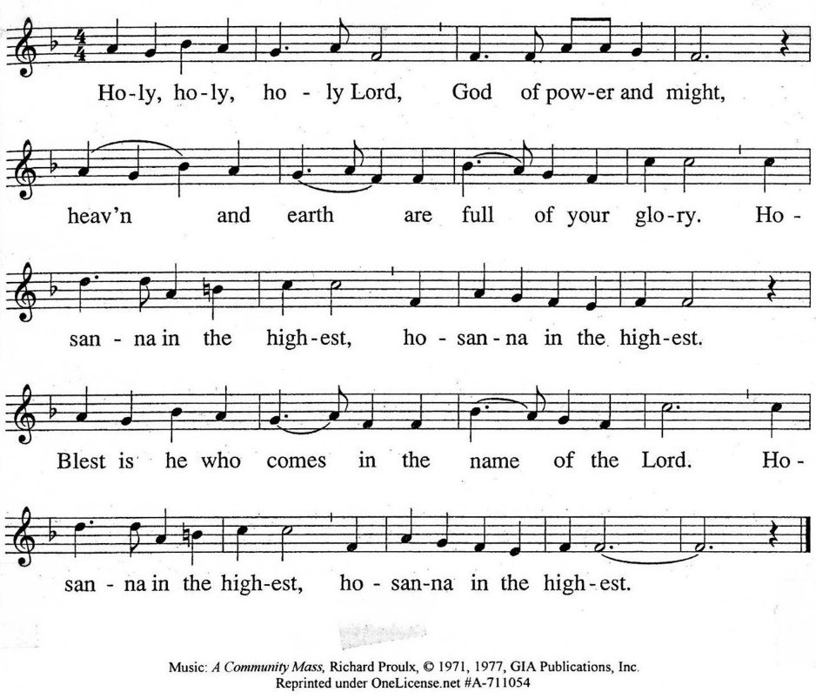

The minister continues the Thanksgiving…
“Together we proclaim the great mystery of faith:”
According to Christ’s commandment
We remember his death,
We proclaim his resurrection,
We await his coming in glory.

The minister continues with Intercessions for the Church and the World
and Prayers of the People…
Leader: Lord, in your mercy,
People: hear our prayers.
Our Lord’s Prayer
Our Father who art in heaven, hallowed be thy name. Thy kingdom come,
thy will be done, on earth as it is in heaven. Give us this day our daily bread;
and forgive us our debts, as we forgive our debtors; and lead us not into temptation, but deliver us from evil. For thine is the kingdom and the power
and the glory, forever. Amen.

Words of Institution
Communion
Communion Music: Let Us Break Bread Together

We all will receive communion by coming to the Lord’s Table. Our usher will invite you to come forward by pew, beginning from the back. If you are unable to come forward, a server will come to you after everyone else has received. Choir members will remain seated and receive after the congregation.
Please consume the elements when you are comfortable doing so. You do not need to wait – please do so as the Spirit leads (right away, as you pause after receiving, or back in your seats).
With Christian love we serve gluten-free communion bread and alcohol-free grape juice.
Also with Christian love the elements were prepared with strict attention to health concerns.
You are invited to partake of the prepackaged communion juice and wafer if you choose; we now offer prepackaged cups that include gluten-free wafers.

Prayer after Communion
Hymn 526: Let Us Talents and Tongues Employ (all)

Charge and Benediction
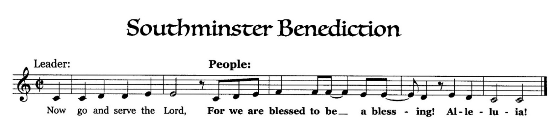

Postlude

Participants and Technical Crew
Rev. Wendy Boden
Liturgist: Lois Stevenson
Elder at the Door: Melissa Hammer
Deacon Fellowship: Elise Henkels
Children in Worship: Blair Baldwin, Jessica Abuseini
Musicians: Tom Anderson, the Southminster Choir, David Kozich
Worship Assistant: David Kozich
Tech support: Chris Kozich, Blair Nelson
The flowers today wish happy birthdays to Anna and Nicole Nelson
from the Boden-Nelson family.

Care Notes: “In everything by prayer and supplication with thanksgiving let your requests be made known to God.” -Philippians 4:6
Even though we aren’t all together for worship, we are still collecting prayer requests! Please email or leave a message on our answering machine at 630-469-9149 if you won’t be present to fill out a prayer request slip.

Friends,
Please make a point of sending an email, text, phone call, or filling out a blue prayer request and letting the people of Southminster know who you would like us to keep in prayer. All prayer requests are welcome. We want to be able to know who to talk to in order to follow up on all the people we pray for each week.

New requests and updates are italicized in our prayer list.
Joys and Concerns
The flowers today are from the Boden-Nelson family wishing happy birthday to Anna and Nicole.
We give thanks to God for joys: (Romans 12:15) “Rejoice with those who rejoice...”
- Our volunteers who gave of their time yesterday at Feed My Starving Children
- Paul Davidson was able to go on an Honor Flight. Thank you, Paul, for your service!
- Gratitude for new beginnings
We pray for the whole world and our nation: (1 Timothy 2:1-2) “I urge, then, first of all, that petitions, prayers, intercession, and thanksgiving be made for all people…”
- All those who have been affected by natural disasters; floods on the East coast of the U.S. and in Asia; hurricanes in Hawaii and Mexico
- We lift up our elected officials.
- Peace in the world and for our sister church in Cuba and our next trip to visit our sister church November 11-17.
- We pray for transformed hearts for our nation.
Blessed are those who mourn: (Romans 12:15) “...weep with those who weep.”
- All those who mourn the passing of Tom Grimsey, brother of Deb Bohi – his wife, Pat, and the Bohi-Parks and Batt families, who lost their uncle
- All those we name in our hearts and hold dear.
We lift up those affected by cancer, along with their support systems:
- Barb Doppelt’s friend, Ginny O., who is recovering from surgery for a life-threatening sinus infection that has spread to her brain. The infection is fungal, very aggressive, and treatment options are limited.
- Heidi Shierry’s uncle, Gary Hall, has been diagnosed with colon cancer.
- We continue to pray for Dean, Colin B., Tracy B., Colin, J., Miles, Amie C., Rick C., Margaret F., Tammy H., Karen L., Joanne O., Cis R., Heidi S., Marta S., Meagan S., Paul S., Kurt Parent, who is now in palliative care, former President Joe Biden, and those we name in our hearts.
We pray for all who are recovering from or dealing with mental, physical, or other health challenges:
- Barb Cross, who is in the hospital
- Louanne Jourdan asked prayers on Sunday for her son, Justin, who fell and had a brain bleed; he was helicoptered to Loyola for treatment. Praise God; as of Tuesday, Justin shared, “I’m fine.”
- Ashley, a young neighbor of Maykel Soloman, who is in a coma
- Bill Kralicek, Heather’s husband, had eye surgery for a detached retina, and is anticipating a procedure in November for his other eye
- Continuing prayers for Jack Thorne, who had a recent scare
- Heidi Shierry asks prayers for her friends Keisha and Philip as they go through difficult times.
- Continued prayers for healing for Sandy Patterson, who is slowly improving after a bad fall
- Kathy Davidson asks continued prayers for Ray Briggs, who has been moved to long-term care following a brain injury.
- Heidi Shierry asks prayers for a friend going through a divorce and for the entire family, asking God to surround them with His light, peace, and protection as they navigate this difficult path.
- For reconciliation among family members who are estranged from one another
- All who live with chronic, debilitating pain
- For all those who are missing family
- Ernesto and his family
- For all those having surgery and tests
- For all who are dealing with Parkinson’s disease
- All those seeking meaningful employment
- We lift up people struggling with anxiety and depression.
- Jim Smith, Betty Eichin, and all those in care or rehab centers, and those in isolating situations.
This week at Southminster:
Sunday, October 4 – World Communion Sunday
Order Jubilee Bucks gift cards – contact bobbifrey@aol.com before 9:00 p.m.
Choir rehearsal, 8:30 a.m., Sanctuary
Worship at 9:30 a.m. in person and also live on Facebook.
October Birthday Fellowship in the Narthex following worship
Staff meeting, 11:00 a.m., Kids’ Corner
Adult Ed. Bible Study, 11:15 a.m., McHenry Parlor/Library
Congolese Church, 1:00-3:00 p.m. in Fellowship Hall
Monday, October 5 – Pastor’s Sabbath
Tuesday-Friday: Pastor Wendy Boden’s Heart to Heart on Facebook
streams at approximately 5:30 p.m.
Tuesday, October 6
Staff calendar meeting, 12:30 p.m., McHenry Parlor/Library
Mission, 7:00 p.m., McHenry Parlor/Library
A.A., 7:30 p.m., Fellowship Hall
Wednesday, October 7
Women’s Breakfast, 8:30 a.m., Seven Dwarfs Restaurant
October Dialog goes out
All-Church Cribbage Night, 7:00 p.m., Parlor/Library
Thursday, October 8
Young Adults Video Club, 8:30 p.m., online
Friday, October 9
A.A., 6:30 p.m., Fellowship Hall
Saturday, October 10
Men of Southminster, 9:00 a.m., Parlor/Library
Congolese Church music practice, 1:00 p.m., Fellowship Hall
Next Sunday, October 11
Choir rehearsal, 8:30 a.m., Sanctuary
Worship at 9:30 a.m. in person and also live on Facebook.
Fellowship in the Narthex following worship
Staff meeting, 11:00 a.m., Kids’ Corner
Adult Ed. Bible Study, 11:15 a.m., McHenry Parlor/Library
Congolese Church, 1:00-3:00 p.m. in Fellowship Hall
If you are online, we’re glad to have you! Using the comments section on Facebook, you can say hello, ask for words of peace, or request prayers.
If you are present for worship, please wear a name tag; they are on the Mission shelf in the Narthex and on the shelf across from the church offices. Following the service, you are invited by the deacons to gather for a time of fellowship in the narthex.
Our “Comfort Zone” – It is always contagion season, so we continue to have a “comfort zone” toward the back of the sanctuary. You may wear a mask, of course, if you so choose.
Sunday Morning Adult Ed. Bible Study meets at 11:15 a.m. in McHenry Parlor/Library.
You are invited to join us on Facebook (https://www.facebook.com/SouthminsterGlenEllyn/), where most weeks we have a live sharing of “Heart to Heart” with Pastor Wendy Boden Tuesdays through Fridays at approximately 5:30 p.m.
We continue to be live on Sunday morning for worship at 9:30 a.m. (slideshow beginning at 9:15) on YouTube at
https://www.youtube.com/channel/UCPgWICngOvkmR1OXgCG_wiA/live
or on Facebook at https://www.facebook.com/SouthminsterGlenEllyn/
If you are watching from home on Facebook, please check in and say hello so we can see that you have joined us. This is one way to make worship less “remote” and strengthen community at Southminster.
The live video will appear about 15 minutes before the scheduled start time.
If for any reason the feed falters, rest assured that a recording will be posted to Facebook and You Tube as soon as possible.

You can also find links to recordings of the weekday sessions, special services, and Sunday worship posted on our web site: https://www.southminsterpc.org/ or by going to our YouTube channel:
https://www.youtube.com/channel/UCPgWICngOvkmR1OXgCG_wiA/videos

Photo Stories/PowerPoints help us feel connected!
Photo Stories/PowerPoints help us prepare for worship, connect with one another, and make sure that our at-home people get both sound and sight. Here are the next opportunities for you to share your photos:
All through October: “Stewardship: Time, Talents, Treasure” Photos of yourself and
others giving of themselves while participating in the life of this church community.
Send photos now through October 22.
November 1: “All Saints: We Remember…” On All Saints Sunday we remember
loved ones and friends who died during the past year. You are invited to share the name
and date of death of anyone you want to remember who died since November 1 last
year, and also send a photo of that person. (See the article under “Worship” for more
information.) Please send photos by Thursday, October 22. (It takes more time than
usual to put this PhotoStory together.)
November 15: “Southminster Grounds Year Round” Dig out your photos of
Southminster in various seasons… or take some now. Then send in your photos by
Thursday, November 12.
November 22: “Fall Colors” Some trees are half bare already; others fall colors are still
to come. Take some photos as those colors intensify and send them by Thursday,
November 19.
Send photos to PhotoStory@Southminsterpc.org. (If you only have hard copies of your photos, please leave them in the photo box on Pastor Wendy’s desk, labeled with your name and the date they are to be used.)
Notes from Blair Nelson:
Adult Education: Our study of 1 Corinthians continues today at 11:15 a.m. in the Parlor/Library. Join us as we learn about how to be God’s people together.
Men of Southminster: Be sure to join us next Saturday, Oct. 10, at 9:00 a.m. to be a part of our adventures. Next project: Mardi Gras!!!
Youth: Have you or your parent replied to Blair N’s email? We will get events on the calendar as soon as we have feedback from the interested parties. You interested? Also, let Blair N. know that you are doing Sleep Out Saturday (Nov. 7) so he can register you.
Cribbage, Anyone? The Men of Southminster are hosting another Cribbage Night this Wednesday, Oct. 7, at 7:00 p.m. All are invited. It does not matter whether you are an expert or a beginner, we will help you learn the game. Bring a board, if you have one and cards, and enjoy some mildly competitive but fully enjoyable fellowship. And, yes, there will be snacks.
From the Worship and Music Ministry:
New time for choir rehearsals!
We have started our new choir rehearsal schedule – we now rehearse at 8:30 on Sunday mornings and sing on communion Sundays and special occasions; no more Thursday evening rehearsals! Join us early on Sunday mornings and “make a joyful noise to the Lord!”
In addition, we have posted a schedule on the choir room door where you can sign up to provide vocal or instrumental offerings for other Sundays. Solos, duets, family groups… we welcome all musicians, so please sign up!
All Saints Sunday: Remembering those we have lost this past year
Part of being a church family is stepping up and sharing love in moments of loss and grief. One of those moments can be the final time we say goodbye, a memorial service or a funeral.

We also use All Saints Sunday, November 1, as a way to acknowledge our grief by giving it to God as we renew our hope in God through Jesus Christ. Death does not have the last word! On this Sunday we draw close to God and to one another. We remember the hope that we are called to as Christ’s people. We will conclude our worship that day by gathering in our Memorial Garden and blessing the new memorial bricks that have been placed there during the past year.

If you would you like to add the name of a loved one who died during the past year (they don't need to be a member of the Southminster faith community), please send a picture and their name to PhotoStory@Southminsterpc.org by October 22. If you would like their name to be printed in the Bearing Fruit and mentioned in prayers, please send their name and date of death to admin@Southminsterpc.org by October 22, as well.

From the Mission Ministry
World Communion Offering: All during September we collected the World Communion Offering, which we are dedicating today, World Communion Sunday. This is a new offering of the Presbyterian Church USA, replacing the former Peace and Global Witness Offering of the past years; it funds many of the same kinds of projects: racial justice, gender justice, global witness, and ecumenical and interfaith engagement. Envelopes are still out today for last-minute contributions to this offering.

Southminster Trip to Visit our Sister Church: The Session recently approved a motion from the Mission Ministry to send Wendy Boden, Sarah Allen and Gretchen Fleming to visit our sister church in Cuba November 12-17, 2026. As many of you know, this is a particularly difficult time economically and politically for Cuba, but the churches there are still asking for visits from their partner churches, mainly because of the spiritual lift this time in fellowship together provides to their congregations. From November 1-8 we will have a collection of needed items we can take – the detailed list will be available soon. We will be able to use Jubilee Bucks (like to Walmart and Target) to buy OTC medications in bulk.

From the Property Ministry:
Save the date: Saturday, October 17 – Fall Clean-Up Day!
We’ll work from 9:00 a.m. until about 1:00 p.m., indoors and out. We invite your assistance! There will be plenty of tasks, suitable for all ability levels, and we’ll provide refreshments. (Rain date – the following Saturday, October 24)
Online Sign-Up for Valet Parking

In order to make it easier to sign up for valet parking for Sunday services we are going to an online sign-up. This will allow you to access the sign-up list from anywhere that you have a phone or computer and an internet connection.
The link to the sign-up sheet is https://volunteersignup.org/Q7W9J
Or use the QR code here (also posted at church on the bulletin board opposite the office)
If you have any questions about signing up or run into a problem when trying to sign up, contact Steve Kozich.
Women’s Breakfast meets the first Wednesday of the month. Join us this Wednesday,
October 7, at 8:30 a.m. at our new destination: Seven Dwarfs Family Restaurant, 917 E. Roosevelt Road, Wheaton (just west of President). Come enjoy good food, great conversation, and a refreshing break from your usual routine. All women are welcome! For more information, contact Gretchen Fleming by phone or text to 630-517-0926.
PW on the move – to the Morton Arboretum!
Our next adventure takes us to the Morton Arboretum – to board the Acorn Express Tram! Join us as we experience the beauty and wonder of the Arboretum’s 1,700 acres on a guided tram tour aboard the Acorn Express. Narrated by naturalists with a deep knowledge of the trails and ecology of The Morton Arboretum, these one-hour rides take you on an adventure through woodlands, wetlands, and prairies. After our tour, we plan to enjoy lunch in the Ginkgo Restaurant.
Friday, October 16, 9:15 a.m., we will meet in the parking lot for ride sharing.
Cost for entrance to the Morton Arboretum  - Members – free  - Adults (18-64) - $18.95  - Seniors (65+) - $12.95 | Cost for the Acorn Express Tram  - Adults - $10, members $8  - Seniors - $9, member $7
A sign-up sheet is available on the PW bulletin board. Please join us for this outdoor adventure.
A community invitation to all!
The Glen Ellyn Interfaith Prayer Breakfast
Save the date – Wednesday, October 28, at 7:00 a.m. – 9:00 a.m. for the annual Glen Ellyn Interfaith Prayer Breakfast at the Abbington. Our speaker will be Dr. Muddassir Siddiqi, President of COD. His Keynote is “Freedom to Learn, Courage to Understand”.
Again this year, Pastor Wendy Boden is reserving two tables for the friends and members of Southminster. You are invited to be her guest, or you may donate $30.00. If you are interested in joining the Southminster group at the event, please send an email to our administrator, Barb, at admin@southminsterpc.org or call 630-469-9149.
Jubilee Bucks: Order today!
Today is your only chance this month to order Jubilee Bucks gift cards. See Bobbi Frey after worship or contact her before 9:00 tonight: email bobbifrey@aol.com or call/text her at 630-643-3858. If you want to plan ahead to donate to the items our mission team will take to Cuba in November, they can use Walmart and Target cards, any denomination.
Your next chance to order will be November 1.
People’s Resource Center:
Since 1975, People's Resource Center (PRC) has been bringing neighbors together to respond to hunger and poverty in DuPage County. We at Southminster have supported PRC for decades by donating non-perishable food items and personal care products. But did you know these things about the PRC?
- more than 600 families receive food each week
- last year over 4 million pounds of groceries were shared
- over 22,579 neighbors get food
- so far this year, 2,285,933 pounds of food were rescued from local grocery stores
- the Food Market is the most utilized resource. Other services include Job Assistance, Computer Access and Training, Adult Learning and Literacy, Art Classes, Clothing Closet
Caring for you!
Our Congregational Care Committee is ready to assist in time of need. If you need assistance from the Congregational Care Ministry or Helping Hands through October 13, call Elder Angela Smith (630-235-1376). You may call Pastor Wendy Boden on her cell or home phone (if she has shared the numbers with you) or leave a message for her at the church office: 630-469-9149. You may email Wendy at wendy@southminsterpc.org. (Please note that she can only read email when she is in the office.) You may also call your deacon if you need help from the church.
Who is your deacon? The lists are posted in the narthex – you can check there to see who your current deacon is. Or you can contact the church (630-469-9149 or admin@southminsterpc.org) and ask.
Regular Office Schedule:
The church office is closed on Mondays and Wednesdays.
Barb’s regular schedule is to be in the office Tuesdays, Thursdays, and Fridays from approximately 9:30 a.m.-3:30 p.m. while her son attends his day program on those days. Mondays and Wednesdays she works from home but can always answer church email – admin@southminsterpc.org – from there.
Grace and peace to you! Remember that we love God, neighbor, and one another. Our address is 680 South Park Blvd., Glen Ellyn, IL 60137 if you would like to set up an online account with your bank or mail in your pledge. Online giving through Vanco is also now an option –for details contact Ron Birchall.

Bearing Fruit – October 4, 2026
World Communion Sunday and Communion Offering
Jesus Christ invites everyone to the Table of the Lord.
One meaningful image of our Lord’s Table is that many will come from the east and the west to sit at the table with the Lord. Today our Lord’s Table features bread from around the world, reminding us that God’s people are all united in Christ.
The first Sunday in October is designated as World Communion Sunday, celebrating our unity in Christ with brothers and sisters worldwide. Paul reminds us to “discern the body” when we take Holy Communion, recognizing our relationship with all in Christ during the service. (1 Cor. 11:21). Thus, World Communion Sunday also features the annual Communion Offering, continuing the Christian tradition of loving both neighbors, friends, and enemies.
This day is a gift from the Presbyterian Church to the broader ecumenical community. The first observance took place at Shadyside Presbyterian Church in Pittsburgh, PA, in 1933, with Dr. Hugh Thompson Kerr serving as pastor.
Dr. Kerr first conceived the idea of World Communion Sunday during his year as moderator of the General Assembly (1930). His younger son, the Rev. Dr. Donald Craig Kerr, who was sixteen in 1933, recalls that it was an effort to unite churches in a service of Christian unity — where everyone could gain both inspiration and information, and most importantly, to emphasize how vital the Church of Jesus Christ is, and how each congregation is interconnected.
The idea spread very gradually at first. People didn’t think much about it. It was during the Second World War that the spirit truly took hold as we worked to keep the world united. World Wide Communion represented that effort to stay connected spiritually. It highlighted that we are one in the Spirit and in the Gospel of Jesus Christ.
As we receive the gift of the Lord’s Supper today, may we consider the best way for each of us to bear the fruit of God’s love individually and as a member or friend of Southminster.

